P.j. Ellis

1/6/2023

Module 1.2 Assignment

***Link to GitHub Repository***

<https://github.com/sparty916/csd-340.git>

***Screenshot of GitHub Repository***

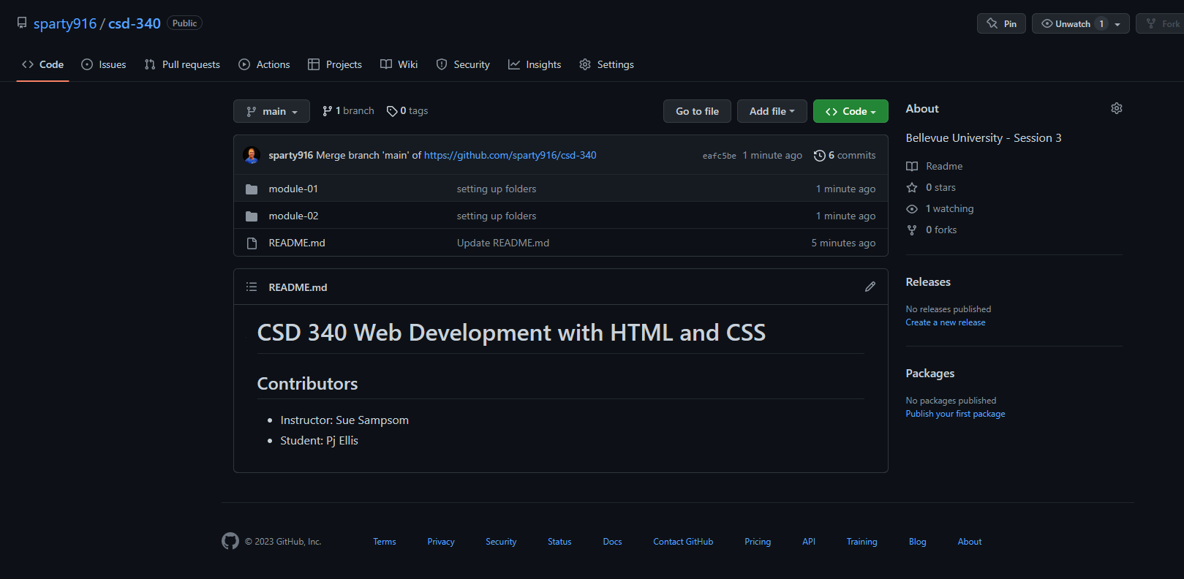

***Screenshot of local directory***

