P.j. Ellis

1/6/2023

Module 2.2 Assignment

***GitHub Link***

<https://github.com/sparty916/csd-340.git>

***Screenshots***

*Step 1*

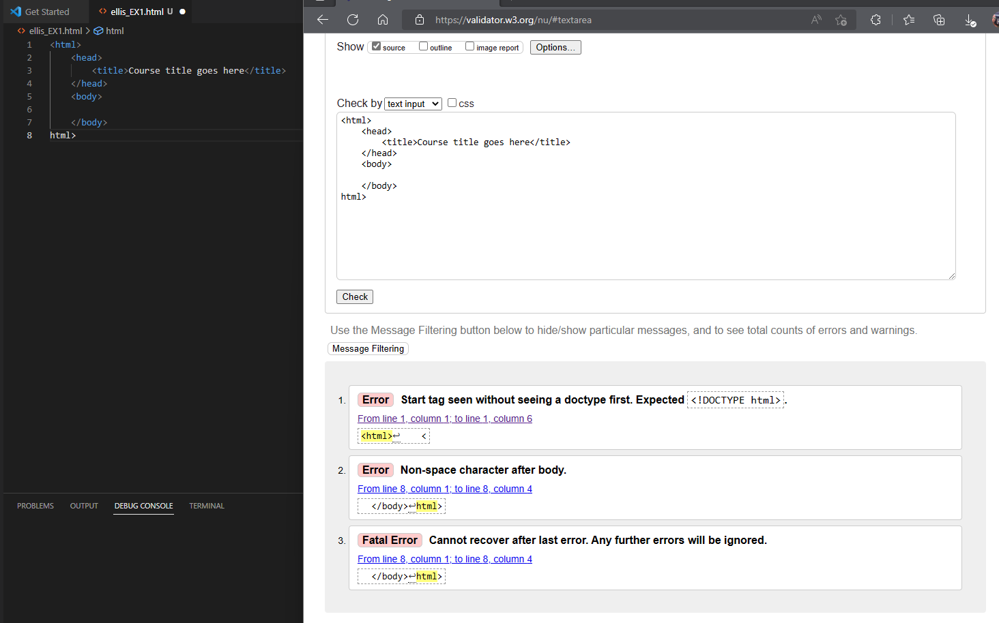

*Step 2*

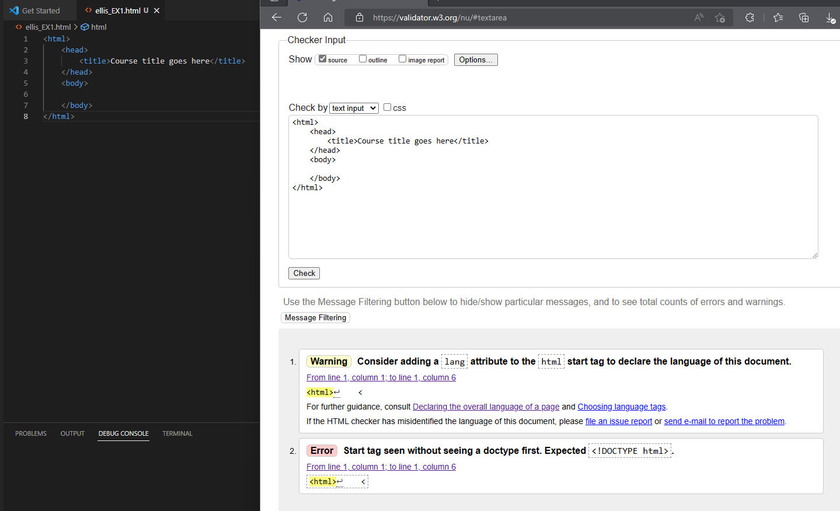

*Step 3*

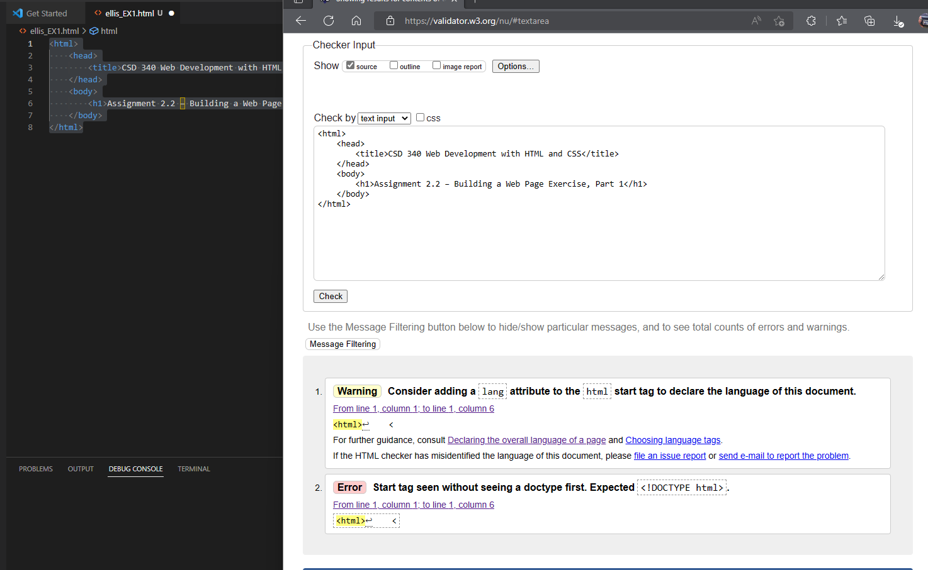

*Step 4*

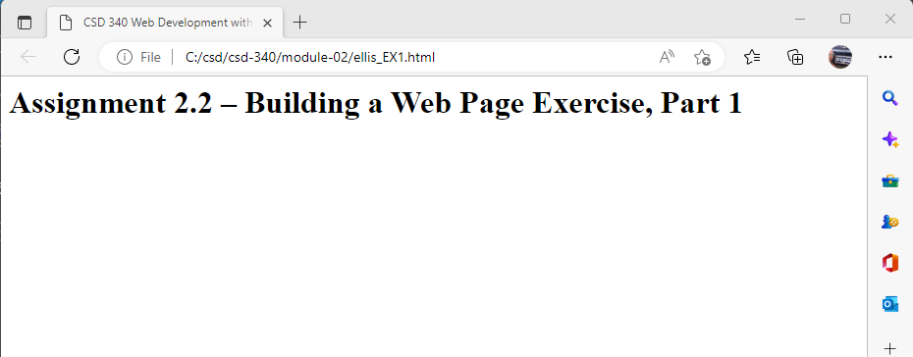

*Even thou it is still giving errors, the code works, and no matter what I tried to type differently these two errors kept showing up, and even if I added the lang attribute, it would still give me that one error:*

