P.j. Ellis

Module 4.2 Assignment

1/21/2023

**GitHub Repository Link:**

[sparty916/csd-340: Bellevue University - Session 3 (github.com)](https://github.com/sparty916/csd-340)

**URL Link To The Github Pages Landing Page:**

[Pj Ellis's 340 Landing Page (sparty916.github.io)](https://sparty916.github.io/csd-340/)

**SCREENSHOT OF VALIDATORS RESULTS:**

**HTML:**

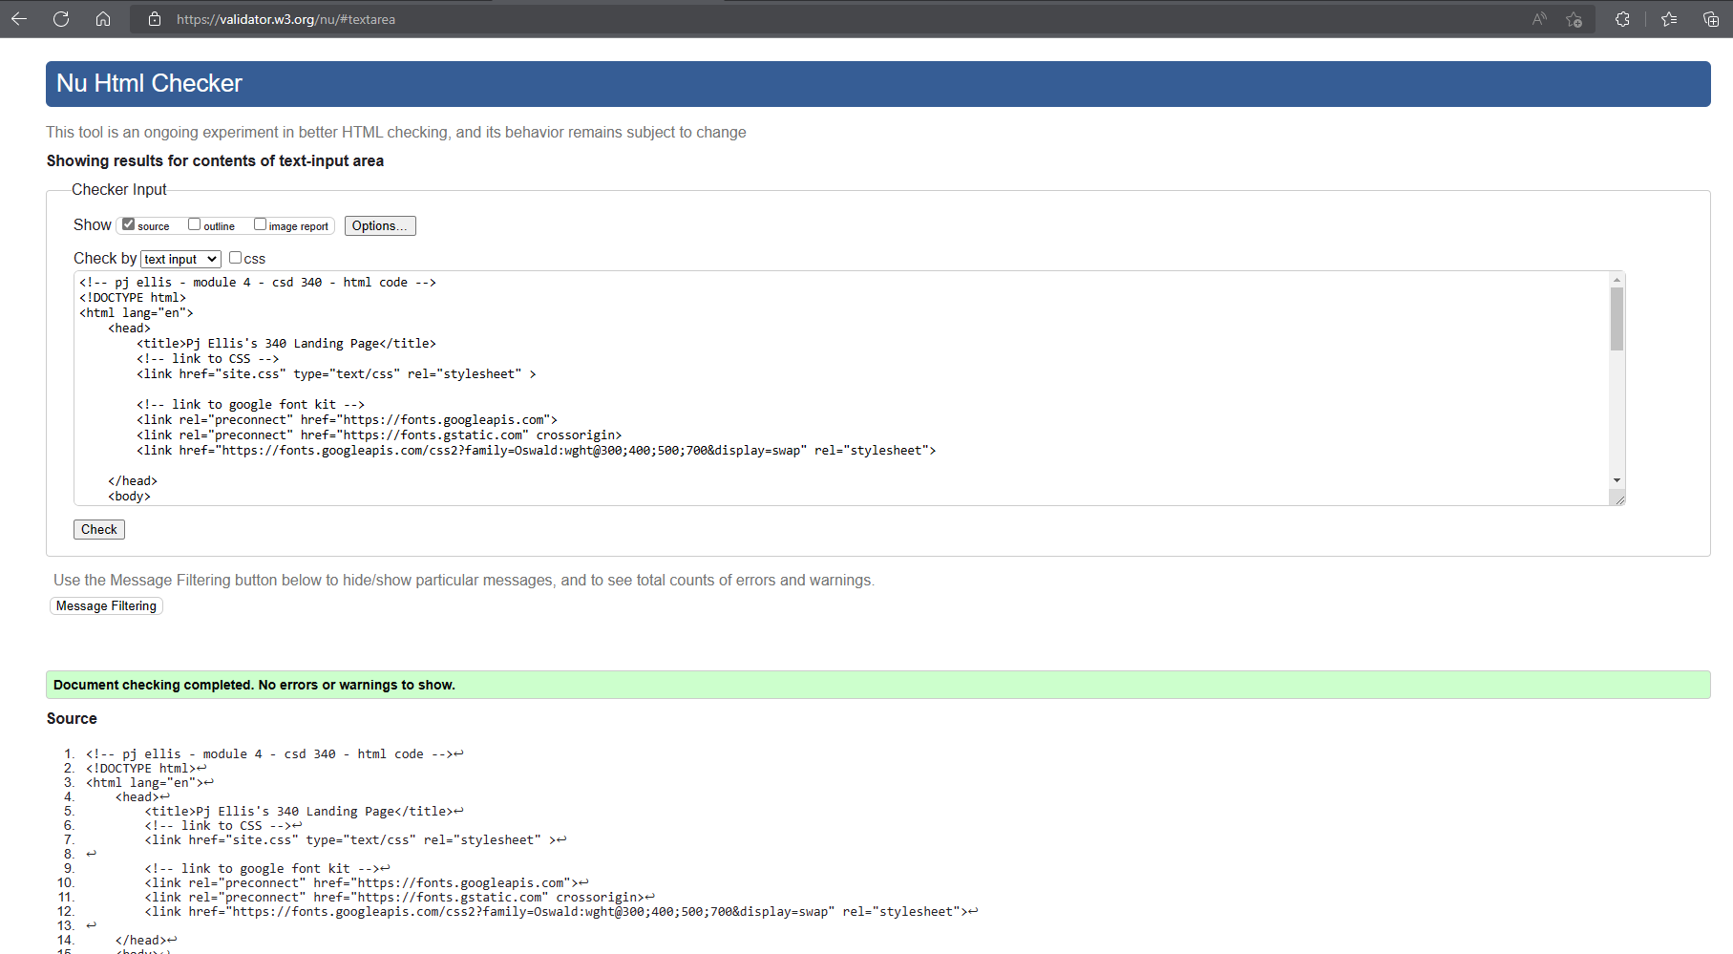

**CSS:**

*Needed to use a different validator due to errors with the w3.org site… (it was discussed about in the discord chat, and this site was recommended so used that one)

