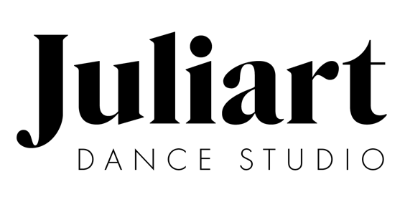

Important Studio Dates 2022-2023

## September –

6– Classes begin

## October –

1 – Tuition due

31 – Halloween (studio closed)

## November –

1 – Tuition due

30 – Costume deposit of $60 per class due

23-27– Thanksgiving break (studio closed)

## December –

1 – Tuition due

19-Jan 2 – Christmas break (studio closed)

## January –

1 – Tuition due

3 – Classes resume

10 – All costume money due

16- MLK Jr. day (studio closed)

## February –

1 – Tuition due

20-21– Mid-Winter Break (studio closed)

## March –

1 – Tuition due

27- April 3– Spring Break (studio closed)

## April –

1 – Tuition due

2– Classes resume

## May –

1 – Tuition due

Recital Pictures date TBD

29– Memorial Day (studio closed)

### June –

1 – Tuition due

Dress Rehearsal Dates TBD

Recital Dates TBD

**July**

5-August 9th Summer Classes