VisionLab fMRI Pipeline Optimization
Zhivago, Pramod, Aakash | December 13, 2017

[Each numbered list item indicates a choice in SPM that we have looked at to finalize the preprocessing codes. For the final preprocessing pipeline, see runspm.m]

- SPM8 vs SPM12
  - Run default parameters and compare split-half for LOC ROI
  - If split-half & normalization is similar, just go with SPM12
Ran the pipeline with default parameters for one subject in SPM8 & SPM12 and found that the split-halfs observed in LOC were identical in numbers. Hence, we have decided to go with SPM12 and we selected 1 good and 1 bad subject each from SYM & READING for further comparisons.
- Realign Estimate Reslice
  - Quality : No need to change
  - Separation: fix at 3mm
  - Smoothing: Default
  - Estimate Interpolation: Increase n-th degree interpolation until things don't change
  - Reslice Interpolation: Same as above.

Took one subject with bad motion (SYM_SUB02). There was almost no difference between estimate_2ndorder_reslice_4thorder and estimate_7thorder_reslice_7thorder. The results looked a little worse for estimate_7thorder_reslice_7thorder when it was followed by estimate_7thorder_reslice_7thorder when compared to the former, but there was very negligible motion left to be corrected. Hence we have decided to go with estimate_2ndorder_reslice_4thorder, which is the default.

only estimate_2ndorder_reslice_4thorder
only estimate_7thorder_reslice_7thorder
From the two plots shown above, we can see that the motion estimates are very similar. How much motion is still left to be estimated? Since we do not know how to estimate the actual motion, we ran the realign step again to compare residual motion between different interpolation orders.

estimate_2ndorder_reslice_4thorder followed by estimate_7th order_reslice_7th order
estimate_7thorder_reslice_7th order followed by estimate_7th order_reslice_7thorder

It is evident from the above plots that the residual motion estimated on the lower order filtered data (2nd order estimate and 4th order reslice) is slightly smaller than that estimated on higher order filtered data (7th order estimate and 7th order reslice). Moreover, the magnitude of estimated residual error is 10 fold smaller than the original motion estimates. Thus, we can stick with the default parameters for interpolation.

- Realign & Unwarp:
This is where we might correct using GRE_Fieldmap but we are leaving this.
- Slice Timing:
Nothing to optimize thankfully.

- Coregister
  - Separation: Check whether to change.
Sticking to the default Separation since it didn’t seem like the code was considering more than 1 separation value.

  - Objective Function: Try different methods and use checkreg
SPM has four different coregistration objective functions –
Mutual Information (MI)
Normalized Mutual Information (NMI)
Entropy Cross Correlation (ECC)
Normalized Cross Correlation (NCC)
We went through realign-estimate-write and slice-timing and then tried all these objective functions. The plots show the same slices across structural and related co-registered functional volumes.
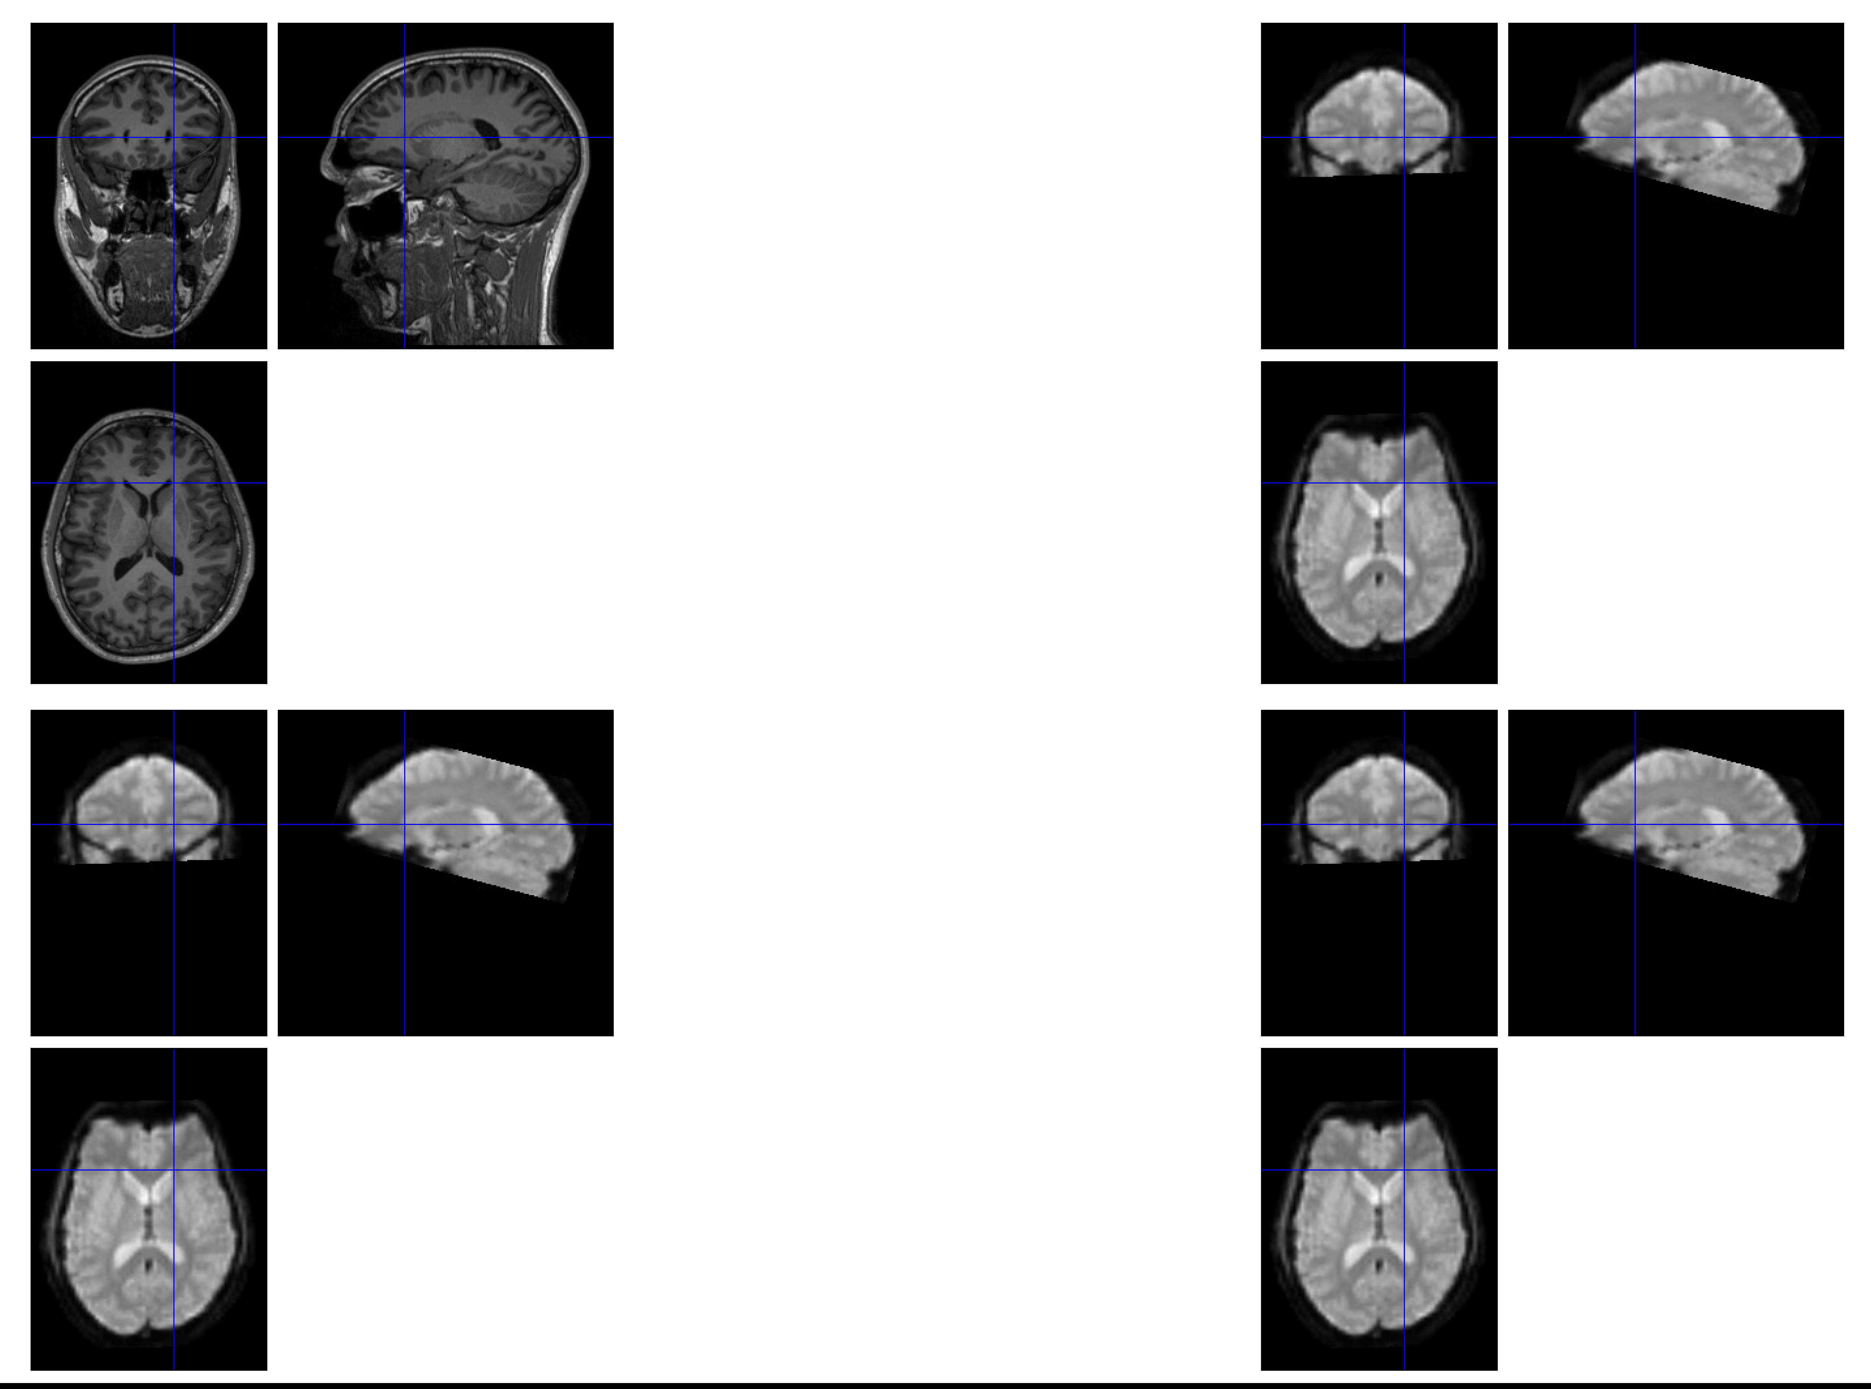
ANAT
MI
NMI
ECC
MEAN
NCC
MI, NMI, and ECC arrived at very similar coregistration parameters and the coregistration between structural and functional volumes looked pretty good (CheckReg utility in SPM), while coregistration parameters were different and CheckReg looked quite bad for NCC. Hence, we have decided to go with NMI.
- Segment: Nothing to optimize here.

- Normalize:
- Transform functional data from subject-space into normalized space
- Transform anatomical masks from normalized space into subject-space

- Smooth:
Do only for BLK data not EVT

- Estimating betas
  - Compared voxel split-half with and without glmdenoise for:
    - Whole brain
    - Common voxels in raw and glmdenoised LOC ROIs

We checked this for 8 SYM subjects and found that the denoised-merged GLM split-half correlation was at least twice that of any other model. Hence, we have decided to always denoised the data and merge the GLM’s. However we will always fit denoised individual GLM’s for purposes of decoding analyses, etc.

SYM: Whole brain split-half
SYM: Common voxels in LOC defined from raw-single & denoised-merged GLMs

READING: Whole brain split-half

  - Check whether to estimate HRF or use standard HRF in SPM
    - Estimating separate HRF (FIR) for each image gives poor split-halfs

We took an FIR filter of length 20s (order = 10) and ran the GLM which generated 10 betas per condition. We tried different time points in the estimated betas (2nd, 3rd, average of 2nd and 3rd …) and then calculated split-half correlation. These were typically far worse than estimating a single beta and a standard HRF.

    - Compare split-half for standard SPM HRF vs HRF from glmdenoise
The spm canonical hrf and glmdenoise hrf are very similar and therefore no point in comparing betas from these two HRFs. Thus the improvement we see with denoised data is most likely due to denoising rather than the HRF used.

  - Does the GLM give any quality-of-fit measure for each voxel?

NO. But split-half will be low if the GLM is overfitting.

  - Betas from glmdenoise are highly correlated with SPM GLM merged

Distribution of correlation coefficients between the two betas for each SYM subject in LOC

  - Without denoise, why does merging help for some subjects and not for others? This should be because of some run-related noise or artifacts. Is there some direct way to see this?
We looked at humidity, raw data (dicom) and motion estimates – none of them were related to split-half patterns across subjects (data not shown).

