LLM-Guided Drone Object Search
Research foundations, updated method and algorithmic contribution

Goal
Given a target object category or short natural-language query, locate a matching object in an initially unmapped indoor environment as efficiently as possible. The agent uses RGB-D observations and a localized pose to discover rooms, infer their function, and balance semantic search value against travel cost. The objective is rapid target acquisition, not exhaustive mapping of every room or floor.

What each paper gives us
MORE (arXiv:2505.03035) — an LLM-based mobile-manipulation planner. We re-implement: BEV occupancy → sparsified Voronoi graph → cut at doors → rooms → hierarchical scene graph → LLM-based room labeling. We drop all manipulation sub policiess and add a real door detector (MORE assumes ground-truth doors).
RPT* (arXiv:2601.12701) — an optimal solver for the Hamiltonian Path Problem with Probabilistic Terminals. Given a graph in which each vertex carries a probability of containing the target, RPT* returns the visit order that minimizes the expected time-to-find. We re-implement it (no public code yet) and embed it in a HATS-U-style replanning loop.
The two descriptions above are retained verbatim from the original document; the implementation specification below supersedes their older implementation details.

Our method
1. Synchronous perception. Each observation is processed in order: RGB-D and pose acquisition, YOLO-World bounding boxes, depth projection and object association, occupancy integration, and scene-graph geometry. Room evidence uses deduplicated landmarks confirmed in at least two distinct frames. A target hypothesis takes priority through bounded approach and multi-view verification; success is declared only when it is confirmed and sufficiently close.
2. Room-level state. Maintain separate observed occupancy maps and persistent state for each discovered floor. Watershed-based geometric segmentation, aided by confirmed door cues, defines room regions; an LLM revises each room label using its accumulated confirmed objects. Track room area, objects, search effort, recency and accessible frontier clusters. A geometrically known room without sufficient semantic evidence remains an explicit unknown-labelled room.

Our method — planning and contribution
3. Bounded exploration. Begin with N₀ = 10 discovery actions over the current floor. Thereafter, a selected room receives at most N = 10 local exploration actions per turn, ending earlier when no usable local frontier remains. Frontier utility rewards cluster size and discounts geodesic travel and heading change. Only clearance-qualified, reachable frontiers count; recently retired goals are an additional action-selection filter. Reaching the budget triggers reassessment, not compulsory departure.
4. Semantic search value. At a decision point, first revise room labels, then ask a separate LLM oracle to estimate pᵢ: the chance that searching node i finds the target. Candidate nodes are known rooms, including unknown-labelled rooms, and eligible seen staircase connections to other floors—not one extra node for every frontier. The oracle receives observed objects, room type and area, accessible-frontier counts, search effort and floor history. Probabilities have no ten-action horizon and are not normalized to sum to one; travel cost is handled by the planner.
5. Cost-aware ordering. Represent a room by its nearest admissible reachable frontier goal, falling back to a reachable centroid-based entry when no such frontier exists. Build geodesic costs from the current pose and between entries. Add per-node search service cost and a staircase leaf cost comprising flight length plus a floor-change penalty on both entering and leaving arcs. RPT* orders the eligible nodes; weighted A* plans execution to the selected entry.
J(π) = ∑ᵢ₌₀ᵐ⁻¹ [ ∏ⱼ₌₁ⁱ (1 − pπⱼ) ] Cπᵢ,πᵢ₊₁
Here π₀ is the current-pose depot, C includes travel and service costs, and an empty product equals one. This is RPT*’s independent-terminal approximation, not a categorical distribution over mutually exclusive object locations.
6. Closed-loop execution. Execute one action, sense again, and update the graph. Reassess at budget/exhaustion boundaries and meaningful new-room or object-kind discoveries, including during transit. A semantic replan that retains the active task preserves its remaining local allowance; a completed burst may authorize a fresh turn in the same room. Route commitment, failed-room deferral, stair cost and an arrival-return guard discourage oscillation. Service/planning failures invoke bounded, reachable-frontier exploration and retry backoff.

Our innovation
The contribution is the coupling of commonsense semantic inference, online spatial evidence and probabilistic routing: object observations determine revisable room hypotheses; room and floor histories determine search-success estimates; observed reachability and travel costs turn those estimates into actionable visit orders. Unknown rooms and staircase nodes let the planner compare further discovery against searching an already recognized room. Short exploration turns and event-driven reassessment continually correct the plan without discarding a still-useful commitment.
This is an integrated search-policy contribution, not a claim of a new detector, language model or routing solver. The probabilities are model estimates, not experimentally calibrated guarantees, and RPT* optimality applies only to the supplied routing instance when the bounded solver certifies it—not to the complete partially observed search problem.
Current evaluation scope: the benchmark supplies localized poses; stair detection/traversal uses visibility-gated simulator connector geometry and known floor-level metadata. These privileges must be disclosed in experiments. The remaining room/object geometry is observation-derived; no surveyed building bounding box is required as prior knowledge.

Method diagram
Sequential perception, semantic reasoning and receding decision points
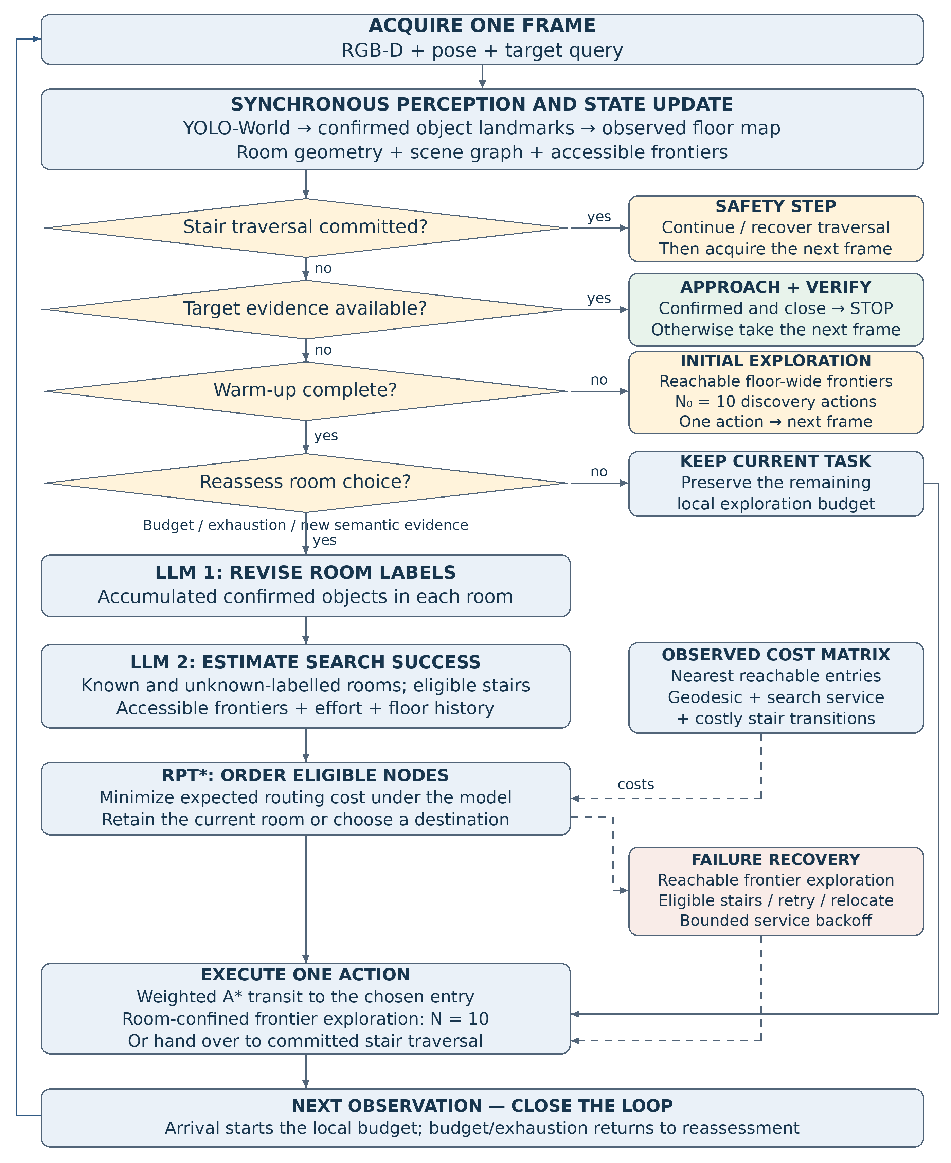
Figure 1. Solid arrows show control flow; dashed arrows show cost input or failure transitions. Every action returns to a fresh observation. Reasoning is synchronous: no environment action is emitted while an LLM response is pending. The drawing summarizes the main policy; safety and target acquisition outrank room scheduling.

Formal algorithm
Algorithm 1. Synchronous semantic-guided object search
Input: target q; RGB-D/pose stream; warm-up N₀ = 10; local budget N = 10; episode budget B.
Output: FOUND after verified acquisition, or NOT FOUND WITHIN BUDGET.
State: observed maps M and scene graph G; active node v; phase σ; local counter k; discovery counter n₀; persistent route and room/floor histories. Fᵃᶜᶜ denotes the accessible-frontier inventory.
1 | Initialize M, G, histories; (v, σ, k, n₀) ← (∅, SELECT, 0, 0).
2 | for t = 0, …, B − 1 do
3 | zₜ ← AcquireRGBDAndPose(); Dₜ ← YOLOWorld(zₜ.RGB).
4 | (M, G) ← UpdateObservedState(M, G, zₜ, ConfirmAndAssociate(Dₜ, zₜ)).
5 | Fᵃᶜᶜ ← ReachableFrontiers(M, zₜ.pose, robot clearance).
6 | mode ← ∅.
7 | if StairTraversalCommitted() then
8 | (a, mode) ← (TraversalSafetyStep(zₜ), SAFETY).
9 | else if TargetConfirmedAndClose(q, zₜ) then return FOUND.
10 | else if FreshTargetHypothesis(q, G) then
11 | (a, mode) ← (BoundedApproachAndVerify(q, zₜ), TARGET).
12 | else if n₀ < N₀ then
13 | (a, mode) ← (FloorFrontierExplore(Fᵃᶜᶜ, zₜ), WARMUP).
14 | else
15 | if TurnEnded(v, σ, k, N, Fᵃᶜᶜ) then
16 | (v, σ, k) ← ReleaseAndRecord(v, σ, k).
17 | if σ = SELECT or NewSemanticEvidence(G) then
18 | V ← ∅; (L, ok) ← AwaitRoomClassifier(confirmed room objects).
19 | if ok then
20 | V ← EligibleRooms(G, L) ∪ EligibleSeenStairs(G).
21 | (V, E, C) ← ReachableEntriesAndCosts(V, M, Fᵃᶜᶜ, zₜ.pose).
22 | (p, ok) ← AwaitNodeOracle(q, G, L, Fᵃᶜᶜ, search/floor histories).
23 | if not ok or V = ∅ then
24 | (a, mode) ← (ExplorationFallback(M, G, zₜ), FALLBACK).
25 | else
26 | pᵢ ← clamp(pᵢ, 0, 1 − ε) for each i ∈ V; do not normalize.
27 | π ← BoundedRPT*(V, p, C, depot = zₜ.pose).
28 | (v, σ, k) ← CommitOrRetain(π₁, v, σ, k, E).
29 | if mode = ∅ then
30 | (a, σ, k, mode) ← AdvanceTask(v, σ, k, M, Fᵃᶜᶜ, zₜ).
31 | ExecuteOneAction(a); update route progress and search histories.
32 | n₀ ← n₀ + 𝟙[mode = WARMUP]; k ← k + 𝟙[mode = LOCAL].
33 | return NOT FOUND WITHIN BUDGET.
AdvanceTask: follow the committed weighted-A* route; on room arrival set k ← 0 and enter LOCAL exploration; for a staircase, hand control to committed traversal. Exhaustion, budget completion and route failure create a new decision point. CommitOrRetain preserves k when a semantic replan keeps the same task. Failed reasoning/route generation uses fallback and bounded service backoff. All Await operations block action execution.
(Optional extension — doorway peeking: for a newly discovered, unentered nearby room, step just inside a reachable threshold, scan 180°, then synchronously classify and replan. Suspend and restore the previous task without consuming its remaining local allowance; never interrupt target pursuit or committed stair safety. The mechanism is switchable and is excluded from Algorithm 1.)

