Repository
Community
Community
Application
Access Point
Figure 1: A possible data environment architecture. Information and data flows from Repositories to Applications through Access Points and Gateways. In this model, any Access Point or Gateway may be considered an instance of a Virtual Observatory. The portions of the system using SPASE-Data-Model-based messages are indicated with the
.

Gateway
Application
S
S
S
S
S
S
Community
List Card
CompressionClosedIdentifiers for methods for removing redundancies in digital data to reduce the amount that must be stored or transmitted.
ZIPAn open standard for compression which is a variation of the LZW method and was originally used in the PKZIP utility. GZIPA open standard algorithm distributed by GHU based on LZ77 and Huffman coding. See or
Name: The name of the list.

Type: Indicates the type of list. A "closed" list has elements defined in the current dictionary. An "open" list has elements defined by an external control authority.
Description: A description of the list.

Element: The name and description of the element in the list. .

Element Card

ContactContainerThe person who is in a position to give you special assistance or serve as a channel for communication for additional information about the product.

Attributes: URL
Sub-elements:Name
Institution
Role
E-mail
Phone

Name: The name of the element.

Type: Indicates the type of value which may be assigned to this element. Possible types are listed below.

Definition: A description of the element.

Attribute: Extra information which may be associated with an instance of the element.
Sub-elements: A list of elements which may be specified in this element.

Data Type Card

AttributeExtra information regarding the element on which it appears. It is tightly coupled to the element.

Name: The name of the item.

Definition: A description of the item.

IV. The Data Model presented hierarchically
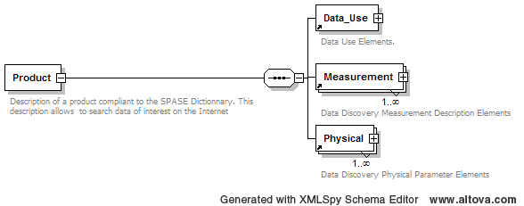

Legend :
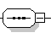 | Sequence of
 | Choice of
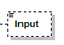 | This element is optionnal
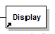 | This element is mandatory

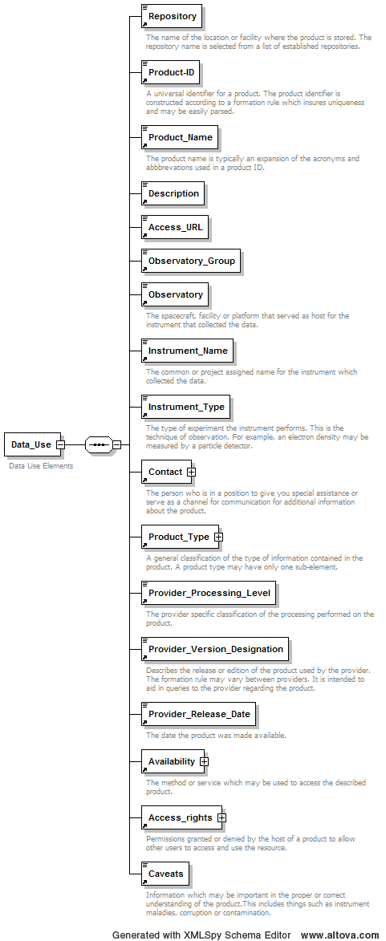
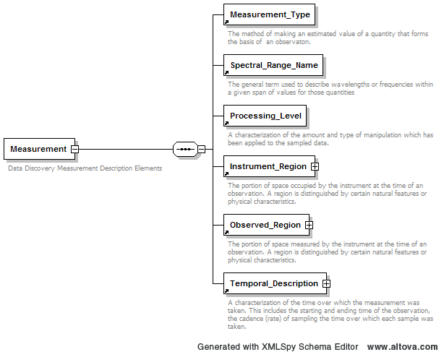
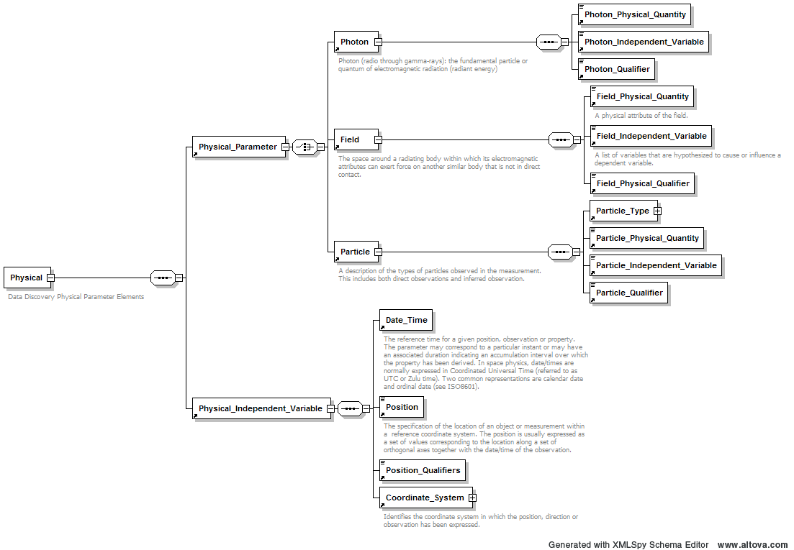

Appendix A – Comparison of Spectrum Domains

Electromagnetic Spectrum Domains
(all wavelengths given in nanometers)
Band | Wavelength  [ISO 21348] |  | Wavelength  [EGSO] |  | Wavelength  [VSO]
 | min | max | min | max | min | max
Gamma | 0.00001 | 0.001 | - | 0.025
X | 0.001 | 10 | 0.025 | 10 | 0.02 | 15
HXR | 0.001 | 0.1 | 0.025 | 0.25 | 0.02 | 1
SXR1 | 0.1 | 10 | 0.25 | 10 | 1 | 10
EUV | 10 | 121 | 10 | 90 | 10 | 100
UV | 100 | 400 | 90 | 320 | 90 | 380
Visible | 380 | 760 | 320 | 700 | 350 | 1000
IR | 760 | 10⁶ | 700 | 10⁶ | 700 | 3.5*10⁵
Near IR | 760 | 1400 | 700 | 25*10² | 700
Mid IR | 1400 | 3000 | 25·10² | 5·10⁴
Far IR | 3000 | 10⁶ | 5·10⁴ | 10⁶ | 3.5*10⁵
Microwaves | 10⁶ | 1.5*10⁷ | 10⁶ | 10⁹
Radio | 10⁵ | 10¹¹ | 10⁹ | - | 10⁷ | 10⁹
1 Also called “XUV” in ISO 21348

