EVPrime
Test cases: EVPrime
Test case 1: SingUp
-Request sent to EVPrime API “localhost:8080/SignUp”
-Request body:
{
"email": "email value", //email must be of a format "emailValue@provider.com" must contaion @
"password": "password value"
}
Expected result:
-Response body (successful, status code: 201 Created):
{
"message": "User created.",
"user": {
"id": "id value", //id example: 853310f8-b896-426a-9b45-05b67afe5008
"email": "email value"
},
"token": "token value"
}

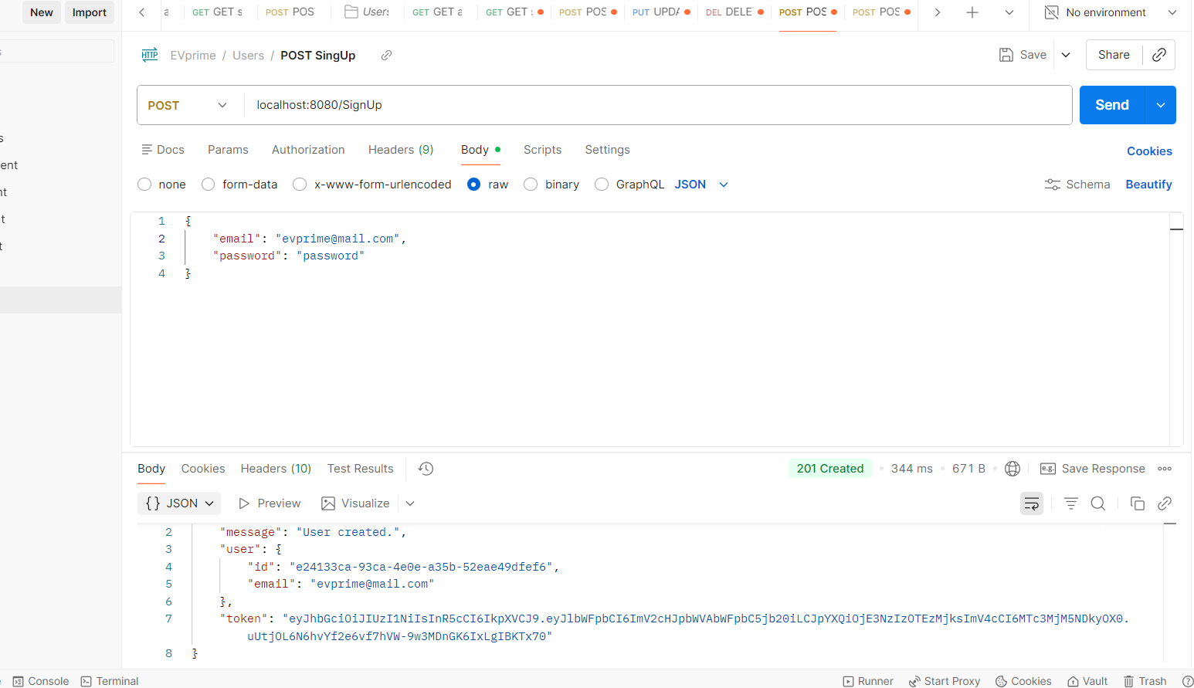

Test case 2: SingUp
-Request sent to EVPrime API “localhost:8080/SignUp”
-Request body:
{
"email": "invalid email value", //email must be of a format "emailValue@provider.com" must contaion @
"password": "password value"
}
Expected result:
-Response body (unsucessful: wrong email format, status code: 422 Unprocessable Entity):
{
"message": "User signup failed due to validation errors.",
"errors": {
"email": "Invalid email."
}
}
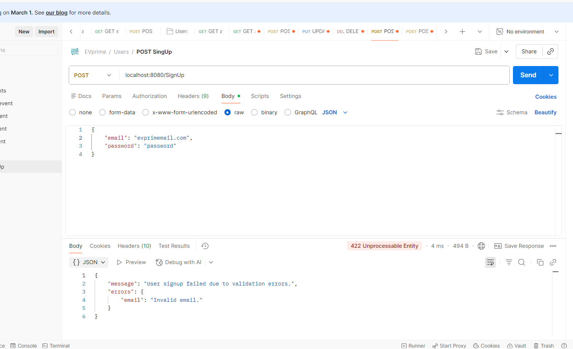

Test case 3: SingUp
-Request sent to EVPrime API “localhost:8080/SignUp”
-Request body:
{
"email": "email value", //email must be of a format "emailValue@provider.com" must contaion @
"password": "password value"
}
Expected result:
-Response body (unsucessful: email already exists in database, status code: 422 Unprocessable Entity):
{
"message": "User signup failed due to validation errors.",
"errors": {
"email": "Email exists already."
}
}

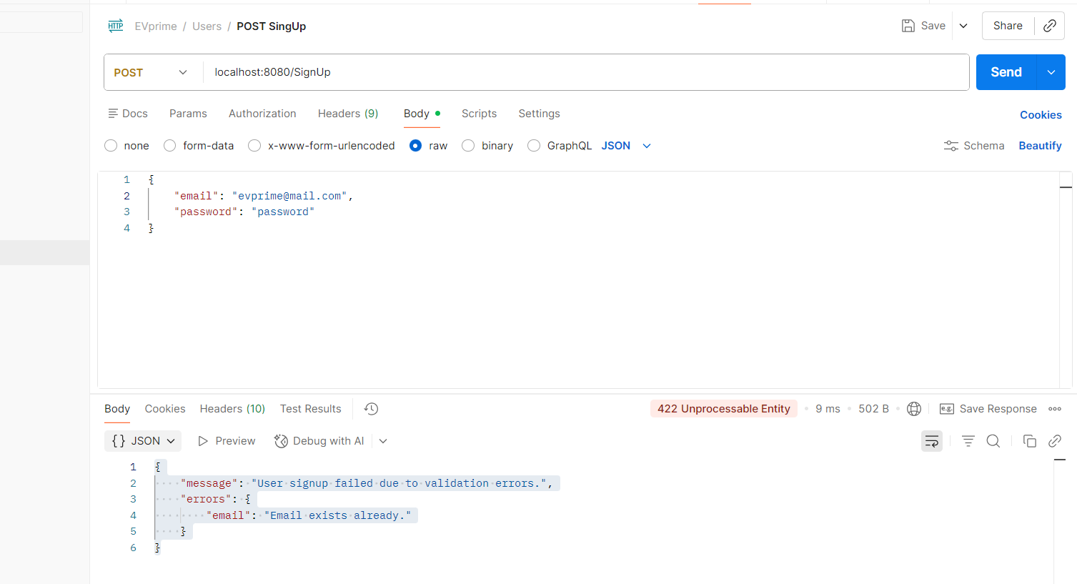

Test case 4: SingUp
-Request sent to EVPrime API “localhost:8080/SignUp”
-Request body:
{
"email": "email value", //email must be of a format "emailValue@provider.com" must contaion @
"password": "invalid password value"
}
Expected result:
-Response body (unsucessful: email already exists in database / Invalid password. Must be at least 6 characters long, status code: 422 Unprocessable Entity):
{
"message": "User signup failed due to validation errors.",
"errors": {
"email": "Email exists already.",
"password": "Invalid password. Must be at least 6 characters long."
}
}

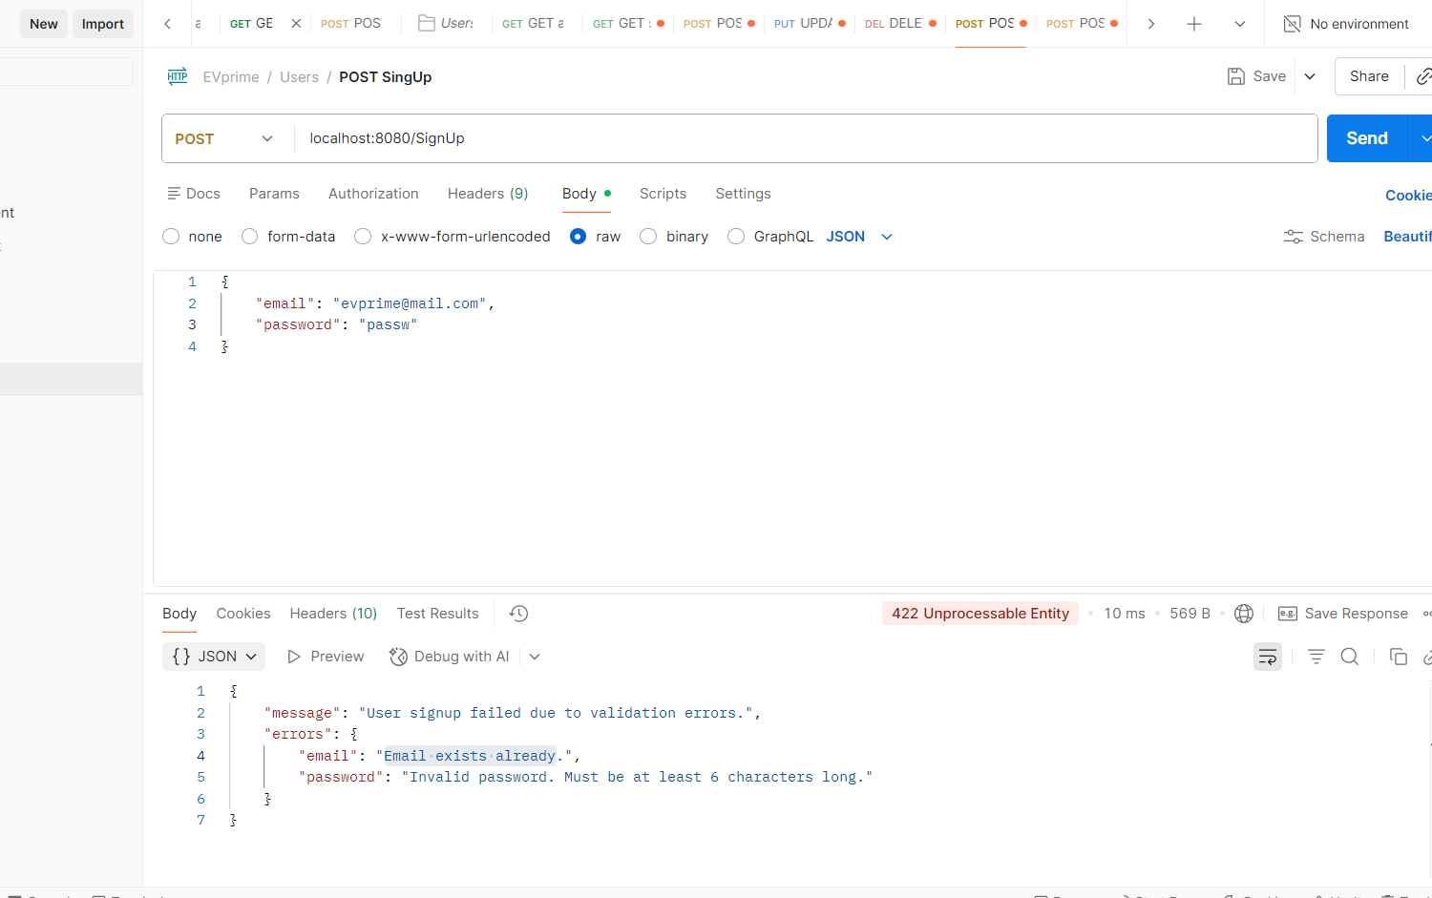

Test case 5: SingUp
-Request sent to EVPrime API “localhost:8080/SignUp”
-Request body:
{
"email": "email value", //email must be of a format "emailValue@provider.com" must contaion @
"password": "invalid password value"
}
Expected result:
-Response body (unsucessful: Invalid password. Must be at least 6 characters long, status code: 422 Unprocessable Entity):
{
"message": "User signup failed due to validation errors.",
"errors": {
"password": "Invalid password. Must be at least 6 characters long."
}
}

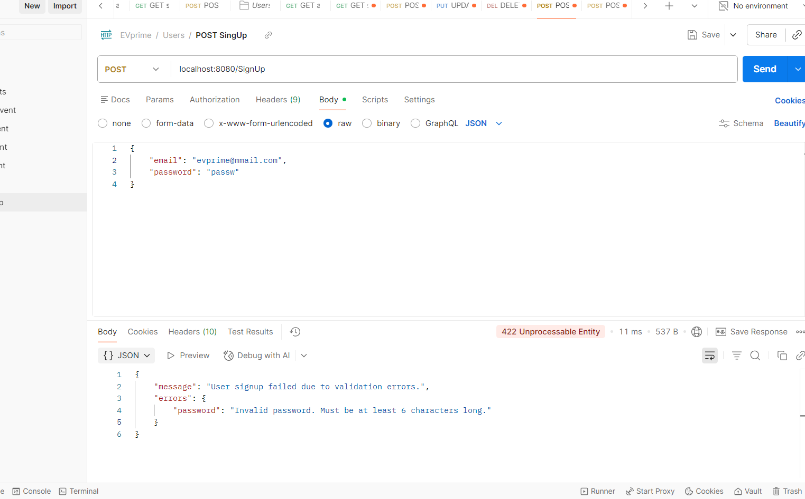

Test case 6: SingUp
-Request sent to EVPrime API “localhost:8080/SignUp”
-Request body:
{
"email": "",
"password": ""
}
Expected result:
-Response body (unsucessful: Invalid email / Invalid password. Must be at least 6 characters long, status code: 422 Unprocessable Entity):
{
"message": "User signup failed due to validation errors.",
"errors": {
"email": "Invalid email.",
"password": "Invalid password. Must be at least 6 characters long."
}
}

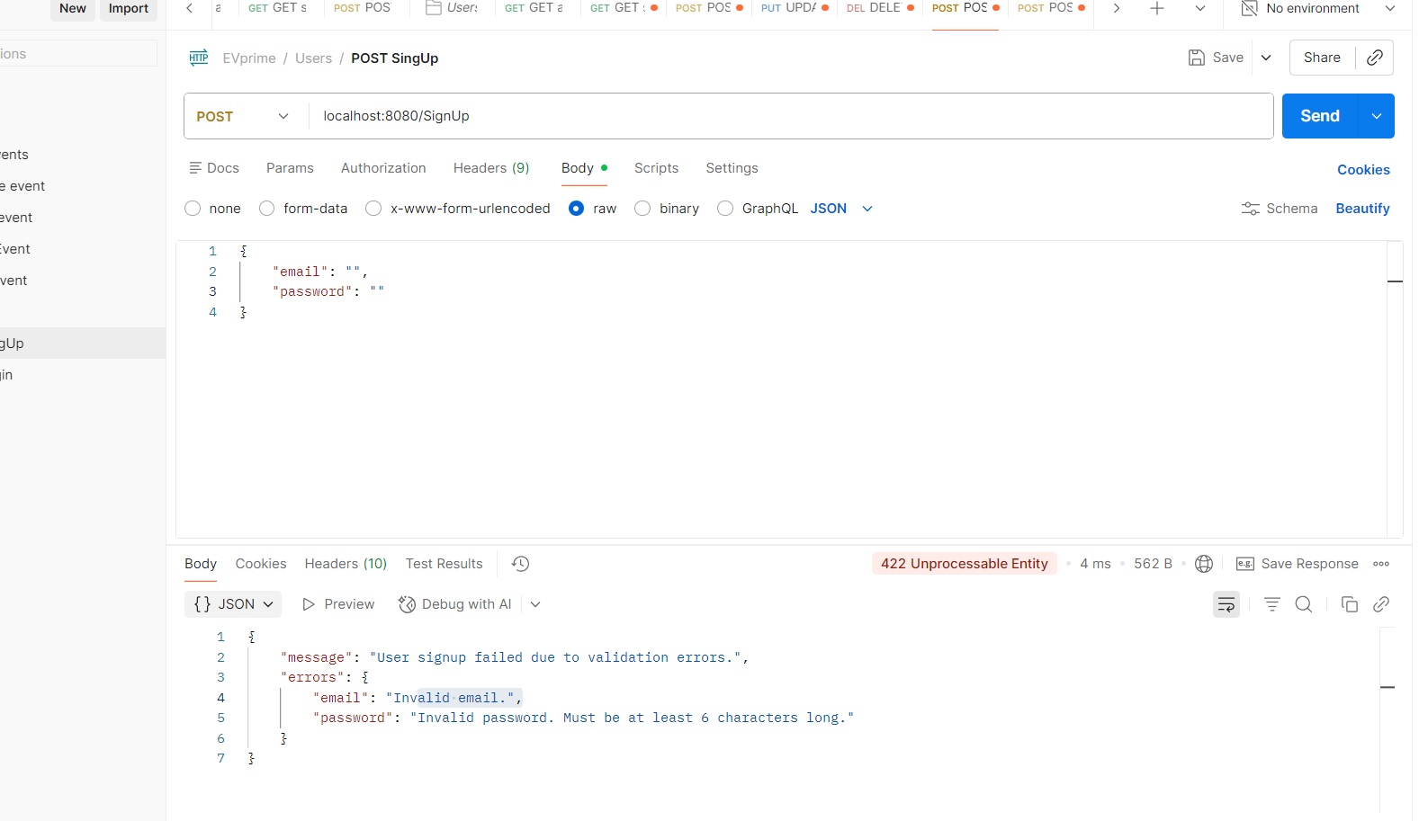

Test case 7: Login
- Request sent to EVPrime API “localhost:8080/Login”
-Request body:
{
"email": "email value",
"password": "invalid password value"
}
Expected result:
-Response body (successful, status code: 200 OK):
{
"token":"token value",
"expirationTime": "expiration time value " //expiration time example: 2024-03-28T16:34:42.655Z
}
