**[PROFESSIONALISM](http://lecenthealthcare.com/alohadetox/)**

We assure 100 % professional & high quality services for you.

[**SUPPORT 24/7**](http://lecenthealthcare.com/alohadetox/)

You can call us any time of the day. We are always ready to support you in any difficult situation.

[**WORK EXPERIENCE**](http://lecenthealthcare.com/alohadetox/)

We have years of experience in the same area, working with people who have problems.

[**DEVELOPMENT**](http://lecenthealthcare.com/alohadetox/)

We try to develop and reach new heights.

[**RELIABILITY**](http://lecenthealthcare.com/alohadetox/)

We will never leave you in a difficult moment. Call us right now and make an appointment.

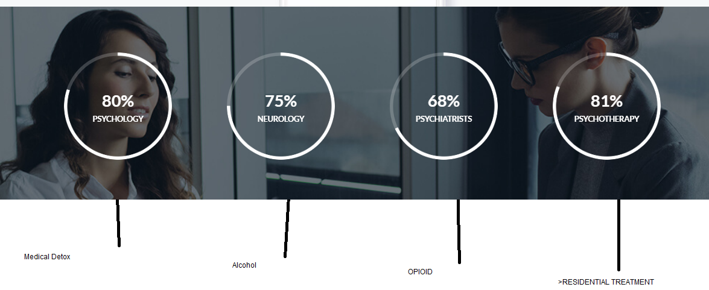

**02**

~~Training & Education~~

~~I have training and experience in the main evidence-based psychotherapeutic modalities~~

02

Therapies

Individual therapy is implemented by a trained professional.

**03**

Best Treatment

~~I use different therapeutic methods to help people overcome their problems~~

We use different therapeutic methods to help people overcome their problems

01

Treatment Program

Aloha Detox provides comprehensive, innovative and compassionate treatment programs

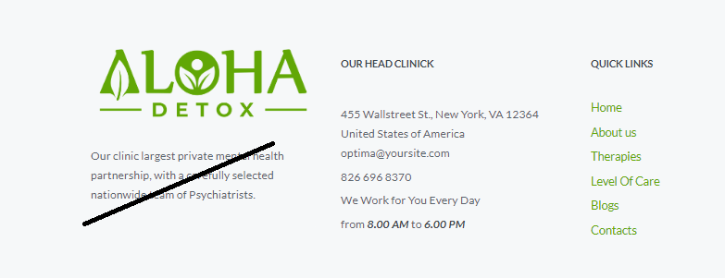

Unique program for Alcohol Detox, Medical Detox, OpiOid Detox, Stimulants Detox, INTENSIVE INPATIENT TREATMENT, RESIDENTIAL TREATMENT.