Shivam Patel

COMP 343

Dordal

Assignment 10: Chapter 10-#5,6,7; Chapter 13-#3,4,5,7

5. Suppose P, Q and R are ISPs with respective CIDR address blocks (with bytes in decimal) 51.0.0.0/8, 52.0.0.0/8 and 53.0.0.0/8. P then has customers A and B, to which it assigns address blocks as follows:

A: 51.10.0.0/16

B: 51.23.0.0/16

Q has customers C and D and assigns them address blocks as follows:

C: 52.14.0.0/16

D: 52.15.0.0/16

1. Give forwarding tables for P, Q and R assuming they connect to each other and to each of their own customers.

P’s Table Q’s Table

|  |  |
| --- | --- |
| **Destination** | **Next Hop** |
| 52.0.0.0/8 | Q |
| 53.0.0.0/8 | R |
| 51.10.0.0/16 | A |
| 51.23.0.0/16 | B |

|  |  |
| --- | --- |
| **Destination** | **Next Hop** |
| 51.0.0.0/8 | P |
| 53.0.0.0/8 | R |
| 52.14.0.0/16 | C |
| 51.15.0.0/16 | D |

R’s Table

|  |  |
| --- | --- |
| Destination | Next Hop |
| 51.0.0.0/8 | P |
| 52.0.0.0/8 | Q |

1. Now suppose A switches from provider P to provider Q, and takes its address block with it. Give the changes to the forwarding tables for P, Q and R; the longest-match rule will be needed to resolve conflicts.

P’s Tables Q’s Table

|  |  |
| --- | --- |
| **Destination** | **Next Hop** |
| 52.0.0.0/8 | Q |
| 53.0.0.0/8 | R |
| 51.23.0.0/16 | B |
| A | Q |

|  |  |
| --- | --- |
| **Destination** | **Next Hop** |
| 51.0.0.0/8 | P |
| 51.10.0.0/16 | A |
| 53.0.0.0/8 | R |
| 52.14.0.0/16 | C |
| 51.15.0.0/16 | D |

R’s Table

|  |  |
| --- | --- |
| Destination | Next Hop |
| 51.0.0.0/8 | Q |
| 52.0.0.0/8 | P |
| A | Q |

6. Suppose P, Q and R are ISPs as in exercise 5.0. P and R do not connect directly; they route traffic to one another via Q. In addition, customer B is multihomed and has a secondary connection to provider R; customer D is also multihomed and has a secondary connection to provider P. R and P use these secondary connections to send to B and D respectively; however, these secondary connections are not advertised to other providers. Give forwarding tables for P, Q and R.

P’s Tables Q’s Table

|  |  |
| --- | --- |
| **Destination** | **Next Hop** |
| 52.0.0.0/8 | Q |
| 51.10.0.0/16 | A |
| 51.23.0.0/16 | B |
| 51.15.0.0/16 | D |

|  |  |
| --- | --- |
| **Destination** | **Next Hop** |
| 53.0.0.0/8 | R |
| 52.14.0.0/16 | C |
| 51.15.0.0/16 | D |
| 51.0.0.0/8 | P |

R’s Tables

|  |  |
| --- | --- |
| Destination | Next Hop |
| 52.0.0.0/8 | Q |
| 51.23.0.0/16 | B |

7. Consider the following network of providers P-S, all using BGP. The providers are the horizontal lines; each provider is its own AS.

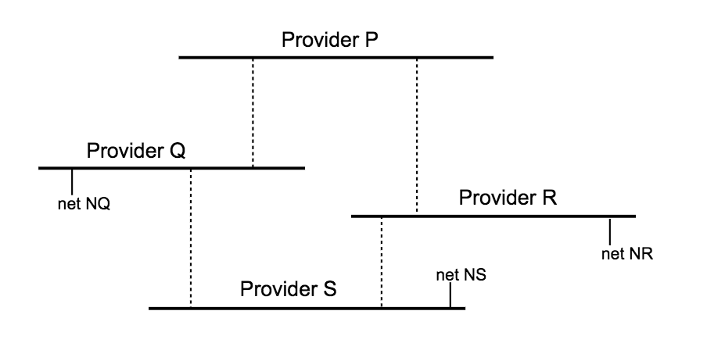

1. What routes to network NS will P receive, assuming each provider exports all its routes to its neighbors without filtering? For each route, list the AS-path.

P will receive a route from Q with AS-path ⟨Q,S⟩, and a route from R with AS-path ⟨R,S⟩.

1. What routes to network NQ will P receive? For each route, list the AS-path.

P will receive a route from Q to NQ with AS path <Q,P>, P will also receive a route from P to NQ with AS Path (Q,S,R)

1. Suppose R now uses export filtering so as not to advertise any of its routes to P, though it does continue to advertise its routes to S. What routes to network NR will P receive, with AS-paths?

P will receive a route from Q to NR with AS path <R,S,Q>

Chap 13

3. Repeat the previous problem, except assume R’s queue size is 2. Assume no **re**transmission mechanism is used at all (no timeouts, no fast retransmit), and that A sends new data only when it receives new ACKs (dupACKs, in other words, do not trigger new data transmissions). With these assumptions, new data transmissions will eventually cease; continue the table until all transmitted data packets are received by B.

|  |  |  |  |  |
| --- | --- | --- | --- | --- |
| Time | A Sends | R Queue’s | R sends | B receives |
| 0 | 1 |  | 1 |  |
| 1 | 2,3 | 3 | 2 | 1 |
| 2 | 4,5 | 4,5 | 3 | 2 |
| 3 | 6,7 | 5,6(drop 7) | 4 | 3 |
| 4 | 8,9 | 6,8(drop 9) | 5 | 4 |
| 5 | 10,11 | 8,10(drop11) | 6 | 5 |
| 6 | 12,13 | 10,12 | 8 | 6 |
| 7 | dupACK6 | 12 | 10 | 8/ack6 |
| 8 | dupACK6 |  | 12 | 10/ack6 |
| 9 |  |  |  | 12/ack6 |
| 10 |  |  |  |  |
| 11 |  |  |  |  |
| 12 |  |  |  |  |

4. Suppose a connection starts with cwnd=1 and increments cwnd by 1 each RTT with no loss, and sets cwnd to cwnd/2, rounding down, on each RTT with at least one loss. Lost packets are not retransmitted, and propagation delays dominate so each windowful is sent more or less together. Packets 5, 13, 14, 23 and 30 are lost. What is the window size each RTT, up until the first 40 packets are sent? What packets are sent each RTT? Hint: in the first RTT, Data[1] is sent. There is no loss, so in the second RTT cwnd = 2 and Data[2] and Data[3] are sent.

|  |  |  |
| --- | --- | --- |
| **RTT** | **Packets Sent** | **Cwnd** |
| 1 | 1 | 1 |
| 2 | 2, 3 | 2 |
| 3 | 4, 5, 6 | 3 |
| 4 | 5 | 1 |
| 5 | 6, 7 | 2 |
| 6 | 8, 9, 10 | 3 |
| 7 | 11, 12, 13, 14 | 4 |
| 8 | 13, 14 | 2 |
| 9 | 15, 16, 17 | 3 |
| 10 | 18, 19, 20, 21 | 4 |
| 11 | 22, 23, 24, 25, 26 | 5 |
| 12 | 23, 24 | 2 |
| 13 | 25, 26, 27 | 3 |
| 14 | 28, 29, 30, 31 | 4 |
| 15 | 30, 31 | 2 |
| 16 | 32, 33, 34 | 3 |
| 17 | 35, 36, 37, 38 | 4 |
| 18 | 39, 40 | 5 |

5. Suppose TCP Reno is used to transfer a large file over a path with a bandwidth of one packet per 10 µsec and an RTT of 80 ms. Assume the receiver places no limits on window size. Note the bandwidth×delay product is 8,000 packets.

1. How many RTTs will it take for the window size to first reach ~8,000 packets, assuming unbounded slow start is used and there are no packet losses?

13 RTT’s

b). Approximately how many packets will have been sent and acknowledged by that point?

1/13 x 8000 = Around 615 packets

c). What fraction of the total bandwidth will have been used up to that point? Hint: the total bandwidth is 8,000 packets per RTT.

1/13

7. Suppose the window size is 100, and Data[1001] is lost. There will be 99 dupACK[1000]’s sent, which we may denote as dupACK[1000]/1002 through dupACK[1000]/1100. TCP Reno is used.

(a). At which dupACK[1000]/N does the sender start sending new data?

New data will be sent after the sender has retransmitted Data[1001], which will happen after the third dupACK[1000].

(b). When the retransmitted data[1001] arrives at the receiver, what ACK is sent in response?

The receiver would send ACK for data[1100] since all the packets between data[1001] and data [1100] would have been received.

(c). When the acknowledgment in (b) arrives back at the sender, what data packet is sent?

The window size when the ACK arrives would be 50 + 96 = 146

Data[1101] + 146 = 1247. So Data[1247] would be sent