Shivam Patel

COMP 343

Dordal

Assignment 11: Chap 10 - #8,9,10; Chap 13 - #6,9,11,13

8. Consider the following network of Autonomous Systems AS1 through AS6, which double as destinations. When AS1 advertises itself to AS2, for example, the AS-path it provides is ⟨AS1⟩.

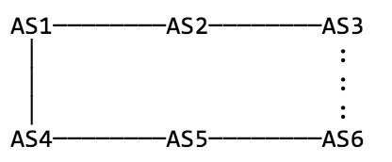

1. If neither AS3 nor AS6 exports their AS3–AS6 link to their neighbors AS2 and AS5 to the left, what routes will AS2 receive to reach AS5? Specify routes by AS-path.

AS2 will receive a path from AS1 with AS-path <AS5,AS4,AS1>

1. What routes will AS2 receive to reach AS6?

AS2 will receive a path from AS1 with AS path<AS6,AS5,AS4,AS1>

1. Suppose AS3 exports to AS2 its link to AS6, but AS6 continues not to export the AS3–AS6 link to AS5. How will AS5 now reach AS2? How will AS2 now reach AS6? Assume that there are no local preferences in use in BGP best-path selection, and that the shortest AS-path wins.

AS5 will still reach AS2 via AS-path <AS2,AS1,AS4>

AS2 will reach AS6 via AS-path <AS6,AS3>

9. Suppose that Internet routing in the US used geographical routing, and the first 12 bits of every IP address represent a geographical area similar in size to a telephone area code. Megacorp gets the prefix 12.34.0.0/16, based geographically in Chicago, and allocates subnets from this prefix to its offices in all 50 states. Megacorp routes all its internal traffic over its own network.

1. Assuming all Megacorp traffic must enter and exit in Chicago, what is the route of traffic to and from the San Diego office to a client also in San Diego?

San Diego 🡪 Chicago 🡪 Client

Client 🡪 Chicago 🡪 San Diego

1. Now suppose each office has its own link to a local ISP, but still uses its 12.34.0.0/16 IP addresses. Now what is the route of traffic between the San Diego office and its neighbor?

The outbound traffic can go directly to San Diego but incoming traffic must go through Chicago

1. Suppose Megacorp gives up and gets a separate geographical prefix for each office. What must it do to ensure that its internal traffic is still routed over its own network.

Make sure the IP prefixes aren’t the same.

10. Suppose we try to use BGP’s strategy of exchanging destinations plus paths as an interior routing-update strategy, perhaps replacing distance-vector routing. No costs or hop-counts are used, but routers attach to each destination a list of the routers used to reach that destination. Routers can also have route preferences, such as “prefer my link to B whenever possible”.

1. ../Desktop/Screen%20Shot%202016-11-18%20at%208.34.18%20PM.pngConsider the network of [9.2   Distance-Vector Slow-Convergence Problem](http://intronetworks.cs.luc.edu/current/html/routing.html#dvscp): The D–A link breaks, and B offers A what it thinks is its own route to D. Explain how exchanging path information prevents a routing loop here.

BGP solves the loop problem by having routers exchange, not just destination information, but also the entire path used to reach each destination. Despite the exchange of AS-path information, temporary routing loops may still exist. However, as soon as they export these paths to one another, they will detect the loop in the AS-path and reject the new route, and so both will switch back to ⟨AS0⟩ as soon as they announce to each other the change in what they use. A will not be able to use the AS path because it already is in it.

1. 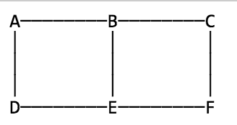Suppose the network is as below, and initially each router knows about itself and its immediately adjacent neighbors. What sequence of router announcements can lead to A reaching F via A→D→E→B→C→F, and what individual router preferences would be necessary? (Initially, for example, A would reach B directly; what preference might make it prefer A→D→E→B?)

Links A-->B and E-->F are advertised but have a high cost, E will hear of the route to F from F directly and from B, but it will choose the last one.

1. Explain why this method is equivalent to using the hopcount metric with either distance-vector or link-state routing, if routers are not allowed to have preferences and if the router-path length is used as a tie-breaker.

If you’re using path length as a metric, that’s exactly the same as hop count

Chap 13

6. a) Repeat the diagram in [13.4   TCP Reno and Fast Recovery](http://intronetworks.cs.luc.edu/current/html/reno.html#fast-recovery), done there with cwnd=10, for a window size of 8. Assume as before that the lost packet is Data[10]. There will be seven dupACK[9]’s, which it may be convenient to tag as dupACK[9]/11 through dupACK[9]/17. Be sure to indicate clearly when sending resumes.

Send ACK[9]

Send dupACK[9]/11

Send dupACK[9]/12

Send dupACK[9]/13

Send dupACK[9]/14

Send dupACK[9]/15

Send dupACK[9]/16

Send dupACK[9]/17

Get Data[18] send dupACK[9]/18

Get data[10] send ACK[18]

Data[9]

Data[10]

Data[11]

Data[12]

Data[13]

Data[14]

Data[15]

Data[16]

Data[17]

Get ACK[9] / send Data [18]

dupACK[9]

dupACK[9]

3rd dupACK[9] resend data[10]

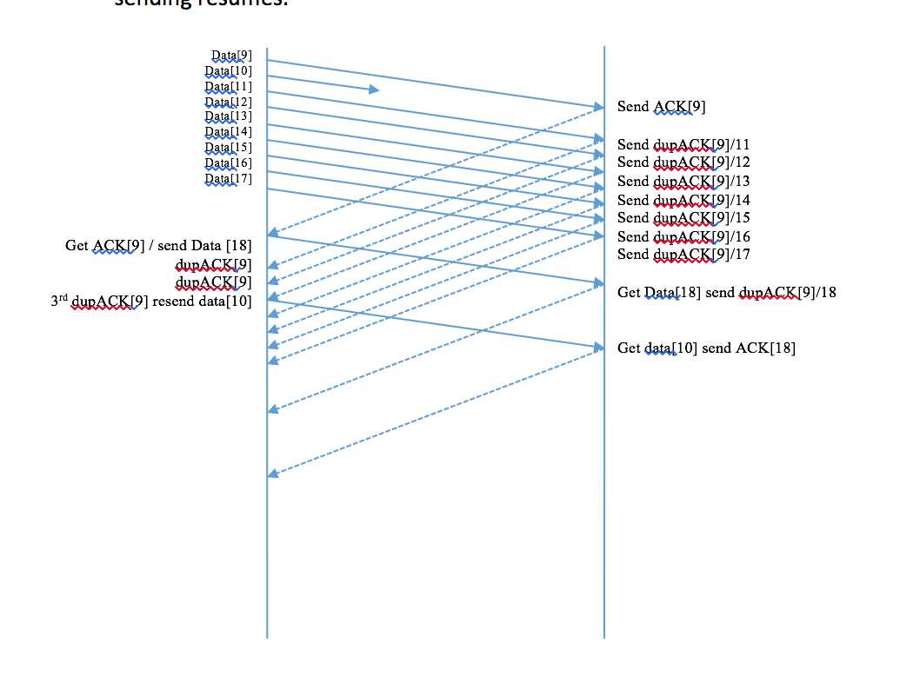incase diagram format isn’t correct.

Sender resends Data[10] and gets back ACK[17]. At that point, cwnd should be 4, so the sender should be about to send Data[17+4] = Data[21]. Therefore, the sender must already have sent Data[18], Data[19], Data[20]

Data[20] – dupACK[9]/17 Last Fast Recovery packet Sent

Data[19] – dupACK[9]/16

Data[18] – dupACK[9]/15

b) Suppose you try to do this with a window size of 6. Is this window size big enough for Fast Recovery still to work? If so, at what dupACK[9]/N does new data transmission begin? If not, what goes wrong?

Yes the window size is big enough for Fast Recovery to work. At dupACK[9]/14 data transmission begins.

9. Suppose slow-start is modified so that, on each arriving ACK, three new packets are sent rather than two; cwnd will now triple after each RTT.

1. For each arriving ACK, by how much must cwnd now be incremented?

For each ACK we want to send 3 packets. One we get by virtue of sliding windows; for the other two we have to increment cwnd by 2

1. Suppose a path has mostly propagation delay. Progressively larger windowfuls are sent, until a cwnd is reached where a packet loss occurs. What window size can the sender be reasonably sure does work, based on earlier experience?

For the doubling case, successive window sizes are 1,2,4,8,16,32

If we get a size that doesn’t work, retreat to the previous size, which did work

11. Suppose in the example of [13.5   TCP NewReno](http://intronetworks.cs.luc.edu/current/html/reno.html#tcp-newreno), Data[1] and Data[2] had been lost, but not Data[4].

1. The third dupACK[0] is sent in response to what Data[N]?

Data[5]

1. When the retransmitted Data[1] reaches the receiver, ACK[1] is the response. When this ACK[1] reaches the sender, which Data packets are sent in response?

Data[2] is retransmitted.

13. In [13.2.1   Per-ACK Responses](http://intronetworks.cs.luc.edu/current/html/reno.html#per-ack-responses) we stated that the per-ACK response of a TCP sender was to increment cwndas follows:

cwnd = cwnd + 1/cwnd

1. What is the corresponding formulation if the window size is in fact measured in bytes rather than packets? Let SMSS denote the sender’s maximum segment size, and let bwnd = SMSS×cwnd denote the congestion window as measured in bytes. Hint: solve this last equation for cwnd and plug the result in above.

Cwnd = cwnd +1/cwnd

Bwnd = smss x cwnd --> cwnd = bwnd/SMSS

Bwnd/SMSS = bwnd/SMSS + SMSS/bwnd

1. What is the appropriate formulation of cwnd = cwnd + 1/cwnd if delayed ACKs are used ([12.14   TCP Delayed ACKs](http://intronetworks.cs.luc.edu/current/html/tcp.html#delayed-acks)) and we still want cwnd to be incremented by 1 for each windowful? Assume we are back to measuring cwndin packets.

Delayed ACK’s --> cwnd = cwnd + 2/cwnd