Shivam Patel

COMP 343

Dordal

Assignment 12 – Chap 14: #1,4,6,8,9,10

1. Consider the following network, where the bandwidths marked are all in packets/ms. C is sending to D using sliding windows and A and B are idle.

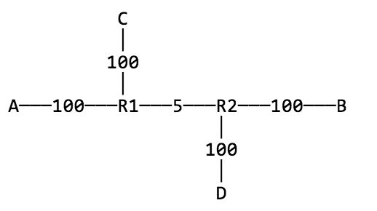

Suppose the propagation delay on the 100 packet/ms links is 1 ms, and the propagation delay on the R1–R2 link is 2 ms. The RTTnoLoad for the C–D path is thus about 8 ms, for a bandwidth×delay product of 40 packets. If C uses winsize = 50, then the queue at R1 will have size 10.

Now suppose A starts sending to B using sliding windows, also with winsize = 50. What will be the size of the queue at R1?

Queue at R1 is 30 since 20 packets will be in transit.

4.  Suppose we have the network layout below of [14.2.4   Example 4: cross traffic](http://intronetworks.cs.luc.edu/current/html/dynamics.html" \l "cross-traffic)

[and RTT variation](http://intronetworks.cs.luc.edu/current/html/dynamics.html" \l "cross-traffic), except that the R1–R2 bandwidth is 6 packets/ms and the R2–R3 bandwidth is 3. Suppose also that A and C have settled upon window sizes so that each contributes 30 packets to R1’s queue – and thus each has 50% of the bandwidth. R2 will then be sending 3 packets/ms to R3 and so will have no queue.

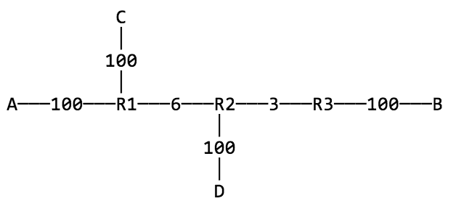Now A’s winsize is incremented by 10, initially, at least, leading to A contributing more than 50% of R1’s queue. When the steady state is reached, how will these extra 10 packets be distributed between R1 and R2? Hint: As A’s winsize increases, A’s overall throughput cannot rise due to the bandwidth restriction of the R2–R3 link.

When the steady state is reached, the 10 packets pile up at R2. Due to the restriction on the overall throughput from rising, C’s queue at R1 cannot change and, therefore, A’s queue at R1 also cannot change. So, the packets pile up at R2.

6. One way to address the reduced bandwidth TCP Reno gives to long-RTT connections is for all connections to use an increase increment of RTT2 instead of 1; that is, everyone uses AIMD(RTT2,1/2) instead of AIMD(1,1/2) (or AIMD(k×RTT2,1/2), where k is an arbitrary scaling factor that applies to everyone).

a) Construct a table in the style of of [14.3.2   Example 3: Longer RTT](http://intronetworks.cs.luc.edu/current/html/dynamics.html#longer-rtt) above, showing the result of two connections using this strategy, where one connection has RTT = 1 and the other has RTT = 2. Start the connections with cwnd=RTT2, and assume a loss occurs when cwnd1 + cwnd2 > 24.

|  |  |  |
| --- | --- | --- |
| **T** | **A-C** | **B-D** |
| 0 | 4 | 1 |
| 1 |  | 2 |
| 2 | 8 | 3 |
| 3 |  | 4 |
| 4 | 12 | 5 |
| 5 |  | 6 |
| 6 | 16 | 7 |
| 7 |  | 8 |
| 8 | 20 | 9 First Loss |
| 9 |  | 2 |
| 10 | 24 | 3 Second Loss |
| 11 |  | 9 |
| 12 | 28 | 10 Third loss |
| 13 |  | 11 |
| 14 | 32 | 12 |

b) Explain why this strategy might not be desirable if one connection is over a direct LAN with an RTT of 1 ms, while the second connection has a very long path and an RTT of 1.0 sec.

There would be huge increases between the slow and fast connections which would cause a traffic issues. The slow connection would increment cwnd by an unrealistically large value in order to keep up. Large increases in cwnd basically result in large bursts of packets which are contributors to congestion.

8.  Suppose two TCP flows compete. The flows have the same RTT. The first flow uses AIMD(𝛼1,𝛽1) and the second uses AIMD(𝛼2,𝛽2); neither flow is necessarily TCP-Reno-friendly. The two connections, however, compete fairly with one another; that is, they have the same average packet-loss rates. Show that 𝛼1/𝛽1 = (2-𝛽2)/(2-𝛽1) × 𝛼2/𝛽2. Assume regular losses, and use the methods of [14.7   AIMD Revisited](http://intronetworks.cs.luc.edu/current/html/dynamics.html#aimd-revisited).

Hint: first, apply the argument there to show that the two flows’ teeth must have the same width w and same average height. The average height is no longer 3w/2, but can still be expressed in terms of w, 𝛼 and 𝛽: start with average_height = h×(1−𝛽/2), with h as in the diagram of [14.7   AIMD Revisited](http://intronetworks.cs.luc.edu/current/html/dynamics.html#aimd-revisited), and then use the 𝛼w = 𝛽h relationship to eliminate h.

Both teeth have the same width w and same average height H, not necessarily 3/2 w, and right-edge heights h1 and h2. Average height = h x(1- 𝛽/2

Goal: 𝛼 1/𝛽1 = (2- 𝛽2)/(2- 𝛽1) x 𝛼2/𝛽2

We know 𝛼1w = 𝛽1h1 and 𝛼2w = 𝛽2h2

--> so 𝛼1w/𝛽1 = h1 and 𝛼2w/𝛽2 = h2

Also, H = h1(1- 𝛽1/2) = h2(1- 𝛽2/2)

So 𝛼1w/𝛽1(1- 𝛽1/2) = 𝛼2w/𝛽2(1- 𝛽2/2)

9.  Suppose two 1KB packets are sent as part of a packet-pair probe, and the minimum time measured between arrivals is 5 ms. What is the estimated bottleneck bandwidth?

1KB / 5 ms = 200KB / 1 sec = 1.6 MB / 1 sec

10. Consider the following three causes of a 1-second network delay between A and B. In all cases, assume ACKs travel instantly from B back to A.

(i) An intermediate router with a 1-second-per-packet bandwidth delay; all other

bandwidth delays negligible

(ii) An intermediate link with a 1-second propagation delay; all bandwidth delays negligible

(iii) An intermediate router with a 100-ms-per-packet bandwidth delay, and a steadily replenished queue of 10 packets, from another source (as in the diagram in [14.2.4   Example 4: cross traffic and RTT variation](http://intronetworks.cs.luc.edu/current/html/dynamics.html#cross-traffic)).

How might a sender distinguish between these three cases? Hint: consider packet pairs, or some variant.

If you send 2 packets in each scenario

Case 1 will take 1 second for each packet to send

Case 2 will take 1 second for both packets to send

Case 3 will take 1 second for the first and 1.1 seconds for the second packet to send