Shivam Patel

COMP 343

Dordal

Homework 13: Chap 13-#12; Chap14-#14,18; Chap 15-#2,3,13

**Chap 13**

12. Suppose two TCP connections have the same RTT and share a bottleneck link, on which there is no other traffic. The size of the bottleneck queue is negligible when compared to the bandwidth × RTTnoLoad product. Loss events occur at regular intervals, and are completely synchronized. Show that the two connections together will use 75% of the total bottleneck-link capacity, as in [13.7   TCP and Bottleneck Link Utilization](http://intronetworks.cs.luc.edu/current/html/reno.html#bottleneck-link-utilization) (there done for a single connection).

Cnwd = cwnd + 1/cwnd and bwnd = SMSSxcwnd (cwnd = bwnd/SMSS)

Bwnd/SMSS = bwnd/SMSS + SMSS/bwnd

Bwnd = bwnd + SMSS2 / bwnd

**Chap 14**

14. Suppose TCP Reno has regularly spaced sawtooth peaks of the same height, but the packet losses come in pairs, with just enough separation that both losses in a pair are counted separately. N is large enough that the spacing between the two losses is negligible. The net effect is that each large-scale tooth ranges from height N/4 to N. As in [14.5   TCP Reno loss rate versus cwnd](http://intronetworks.cs.luc.edu/current/html/dynamics.html#tcp-loss-rate-versus-cwnd), cwndmean = K/√p for some constant K. Find the constant. Note that the loss rate here is p = 2/(number of packets sent in one tooth).

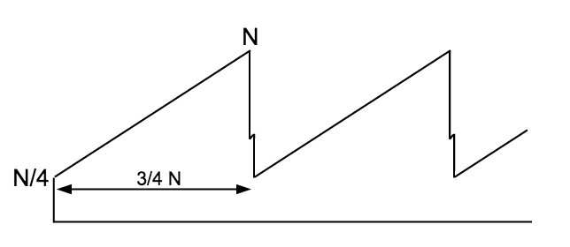

Height of tooth = mean cwnd = (5/8) N

# of packets per tooth = (15/32)N2

Loss ratio = p = 2/(15/32)N2

1/p = (15/64)N2

1/sqrt(p) = (sqrt(15)/8) N

k/sqrt(p) = (5/8)N

So K (sqrt(15)/8) = (5/8)

K = (5/8) / (sqrt(15)/8)

18. Suppose two TCP connections have the same RTT and share a bottleneck link, for which there is no other competition. The size of the bottleneck queue is negligible when compared to the bandwidth × RTTnoLoad product. Loss events occur at regular intervals.

In Exercise 12.0 of the previous chapter, you were to show that if losses are synchronized then the two connections together will use 75% of the total bottleneck-link capacity

Now assume the two TCP connections have no losses in common, and, in fact, alternate losses at regular intervals as in the following diagram.

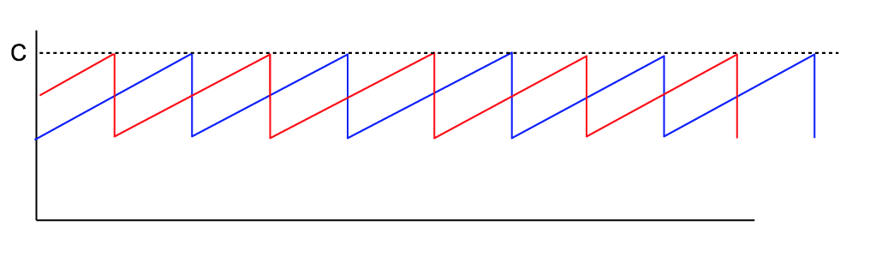

Both connections have a maximum cwnd of C. When Connection 1 experiences a loss, Connection 2 will have cwnd = 75% of C, and vice-versa.

(a). What is the combined transit capacity of the paths, in terms of C? (Because the queue size is negligible, the transit capacity is approximately the sum of the cwnds at the point of loss.)

At point of loss, transit capacity is 100% used, and is C + .75C = 1.75C

After each loss --> total cwnd = 1.25C

Average total cwnd = 1.5C

(b). Find the bottleneck-link utilization. Hint: it should be at least 85%.

Cqueue – Ctransit/2 + Ctransit = minimum cwnd

(1.5C – Ctransit)/2 + C transit = .85C

1.5C – Ctransit + 2Ctransit = 1.7C

Ctransit = 0.2

**Chap 15**

2. Suppose a TCP Vegas connection from A to B passes through a bottleneck router R. The RTTnoLoad is 50 ms and the bottleneck bandwidth is 1 packet/ms.

(a). If the connection keeps 4 packets in the queue (eg𝛼=3, 𝛽=5), what will RTTactual be? What value of cwnd will the connection choose? What will be the value of BWE?

RTT Actual = 54ms; Cwnd = 54 packets; BWE = 1 packet/ms

(b). Now suppose a competing (non-Vegas) connection keeps 6 packets in the queue to the Vegas connection’s 4, eventually meaning that the other connection will have 60% of the bandwidth. What will be the Vegas connection’s steady-state values for RTTactual, cwnd and BWE?

BWE x RTT = 20

RTT Actual= 60 ms ; cwnd =20 + 4=24 packets ; BWE= 0.4packets/ms

3. Suppose a TCP Vegas connection has R as its bottleneck router. The transit capacity is M, and the queue utilization is currently Q>0 (meaning that the transit path is 100% utilized, although not necessarily by the TCP Vegas packets). The current TCP Vegas cwnd is cwndV. Show that the number of packets TCP Vegas calculates are in the queue, queue_use, is

**queue_use = cwndV×Q/(Q+M)**

queue_usage = throughput × (RTTactual − RTTnoLoad)

                            = winsize × (1 − RTTnoLoad/RTTactual)

RTTactual/RTTnoLoad = winsize/transit_capacity

= (transit_capacity + queue_usage) / transit_capacity = (M+Q)/M

So RTTnoLoad/RTTactual = M/(M+Q)

1 – RTTnoLoad/RTTactual = Q/M+Q)

13. Suppose a TCP Westwood connection has the path A───R1───R2───B. The R1–R2 bandwidth is 1 packet/ms, and RTTnoLoad is 200 ms. At T=0, with cwnd = 300 so the queue at R1 has 100 A–B packets, the R1─R2 throughput for A’s packets falls to 1 packet / 2 ms, perhaps due to competition. At that same time, and perhaps also due to competition, a single A–B packet is lost at R1.

(a). Suppose A responds to the loss using the original BWE of 1 packet/ms. What transit capacity will A calculate, and how will A update its cwnd?

Transit = 200 packets

Westwood reduces cwnd to 200 not 150

(b). Now suppose A uses the new throughput of 1 packet / 2 ms as its BWE. What transit capacity will A calculate, and how will A update its cwnd?

Transit cap = 100 packets;

Westwood reduces cwnd 150

(c). Suppose A calculates BWE as cwnd/RTT. What value of BWE does A obtain by measuring the RTT of the packet just before the one that was lost?

BWE = 1 packet/ms