Shivam Patel

COMP 343

Dordal

Assignment 1

Chapter 1, exercises: 1, 2, 3, 4, 5, 7

_______________________________________________________________

1. Give forwarding tables for each of the switches S1-S4 in the following network with destinations A, B, C, D. For the next_hop column, give the neighbor on the appropriate link rather than the interface number.

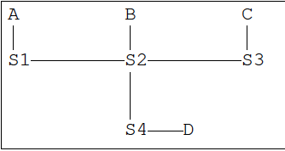

|  |  |
| --- | --- |
| S1 | |
| Destination | Next_Hop |
| A | A |
| B | S2 |
| C | S2 |
| D | S2 |

|  |  |
| --- | --- |
| S2 | |
| Destination | Next_Hop |
| A | S1 |
| B | B |
| C | S3 |
| D | S4 |

|  |  |
| --- | --- |
| S4 | |
| Destination | Next_Hop |
| A | S2 |
| B | S2 |
| C | S2 |
| D | D |

|  |  |
| --- | --- |
| S3 | |
| Destination | Next_Hop |
| A | S2 |
| B | S2 |
| C | C |
| D | S4 |

1. Give forwarding tables for each of the switches S1-S4 in the following network with destinations A, B, C, D. Again, use the neighbor form of next_hop rather than the interface form. Try to keep the route to each destination as short as possible. What decision has to be made in this exercise that did not arise in the preceding exercise?

Deciding between two different paths; having choices

|  |  |
| --- | --- |
| S1 | |
| Destination | Next_Hop |
| A | A |
| B | S2 |
| C | S2 |
| D | S4 |

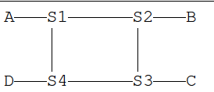

|  |  |
| --- | --- |
| S2 | |
| Destination | Next_Hop |
| A | S1 |
| B | B |
| C | S3 |
| D | S1 |

|  |  |
| --- | --- |
| S3 | |
| Destination | Next_Hop |
| A | S4 |
| B | S2 |
| C | C |
| D | S4 |

|  |  |
| --- | --- |
| S4 | |
| Destination | Next_Hop |
| A | S1 |
| B | S1 |
| C | S3 |
| D | D |

1. Consider the following arrangement of switches and destinations. Give forwarding tables (in neighbor form) for S1-S4 that include default forwarding entries; the default entries should point toward S5. Eliminate all table entries that are implied by the default entry (that is, if the default entry is to S3, eliminate all other entries for which the next hop is S3).

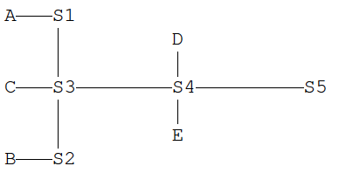

|  |  |
| --- | --- |
| S1 | |
| Destination | Next_Hop |
| A | A |
| Default | S3 |

|  |  |
| --- | --- |
| S2 | |
| Destination | Next_Hop |
| B | B |
| Default | S3 |

|  |  |
| --- | --- |
| S3 | |
| Destination | Next_Hop |
| A | S1 |
| B | S2 |
| C | C |
| Default | S4 |

|  |  |
| --- | --- |
| S4 | |
| Destination | Next_Hop |
| D | D |
| E | E |
| Default | S3 |

1. Four switches are arranged as below. The destinations are S1 through S4 themselves.
2. Give the forwarding tables for S1 through S4 assuming packets to adjacent nodes are sent along the connecting link, and packets to diagonally opposite nodes are sent clockwise.

|  |  |
| --- | --- |
| S1 | |
| Destination | Next_Hop |
| S1 | S1 |
| S2 | S2 |
| S3 | S2 |
| S4 | S4 |

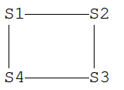

|  |  |
| --- | --- |
| S2 | |
| Destination | Next_Hop |
| S1 | S1 |
| S2 | S2 |
| S3 | S3 |
| S4 | S3 |

|  |  |
| --- | --- |
| S3 | |
| Destination | Next_Hop |
| S1 | S4 |
| S2 | S2 |
| S3 | S3 |
| S4 | S4 |

|  |  |
| --- | --- |
| S4 | |
| Destination | Next_Hop |
| S1 | S1 |
| S2 | S1 |
| S3 | S3 |
| S4 | S4 |

1. Give the forwarding tables for S1 through S4 assuming the S1–S4 link is not used at all, not even for S1 <-> S4 traffic.

|  |  |
| --- | --- |
| S2 | |
| Destination | Next_Hop |
| S1 | S1 |
| S2 | S2 |
| S3 | S3 |
| S4 | S3 |

|  |  |
| --- | --- |
| S1 | |
| Destination | Next_Hop |
| S1 | S1 |
| S2 | S2 |
| S3 | S2 |
| S4 | S2 |

|  |  |
| --- | --- |
| S4 | |
| Destination | Next_Hop |
| S1 | S3 |
| S2 | S3 |
| S3 | S3 |
| S4 | S4 |

|  |  |
| --- | --- |
| S3 | |
| Destination | Next_Hop |
| S1 | S2 |
| S2 | S2 |
| S3 | S3 |
| S4 | S4 |

1. Suppose we have switches S1 through S4; the forwarding-table destinations are the switches themselves. The tables

S2: <S1,S1> <S3,S3> <S4,S3>

S3: <S1,S2> <S2,S2> <S4,S4>

1. Must S1 and S4 be directly connected? If so, explain; if not, give a network in which there is no direct link between them, consistent with the tables above.

S1 and S4 are most likely not connected since switch 2’s forwarding table has S3 as the next hop for destination S4.

S3--------S4

**|**

S1-------S2

1. Now suppose S3’s table is changed to the following. Find a network layout consistent with these tables in which S1 and S4 are not directly connected.

S3: <S1,S4> <S2,S2> <S4,S4>

S1 ------ S2 -------S4

| |

----------S3

7.Consider the following arrangement of switches

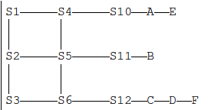

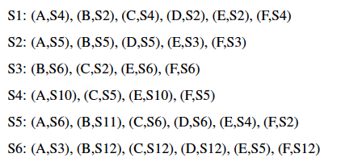Suppose S1-S6 have the forwarding tables below. For each destination A,B,C,D♢,E,F, suppose a packet is sent to the destination from S1. Give the switches it passes through, including the initial switch S1, up until the final switch S10-S12.

A : S1🡪S4🡪S10

B : S1🡪S2🡪S5🡪S11

C : S1🡪S4🡪S5🡪S6🡪S12

D : S1🡪S2🡪S5🡪S6🡪S12

E : S1🡪S2🡪S3🡪S6🡪S5🡪S4🡪S10

F : S1🡪S4🡪S5🡪S2🡪S3🡪S6🡪S12