Shivam Patel

COMP 343

Dordal

Assignment 3: Chapter 3: Exercises 3, 4, 5b

Chapter 4: Exercises 1 & 4

Chapter 5: Exercises 1, 2, 5, 7

**CHAPTER 3**

3. Token Bus was a proprietary Ethernet-based network. It worked like Token Ring in that a small token packet was sent from one station to the next in agreed-upon order, and a station could transmit only when it had just received the token.

1. If the data rate is 10 Mbps and the token is 64 bytes long (the 10-Mbps Ethernet minimum packet size), what is the average wait to receive the token on an idle network with 40 stations? (The average number of stations the token must pass through is 40/2 = 20.) Ignore the propagation delay and the gap Ethernet requires between packets.

64x8/10=51.2

51.2 x 20 token passes =1024 microseconds

1. Sketch a protocol by which stations can sort themselves out to decide the order of token transmission; that is, an order of the stations S0 ... Sn-1 where station Si sends the token to station S(i+1) mod n .

S0 ------------ S1 -------------S2……….

Smallest MAC Address ---------------- > larger MAC Addresses

4. The IEEE 802.11 standard states “transmission of the ACK frame shall commence after a SIFS period, without regard to the busy/idle state of the medium”; that is, the ACK sender does not listen first for an idle network. Give a scenario in which station A has just finished transmitting a packet to station C, and C would fail to transmit its ACK frame in the absence of this rule (due to interference from a third station B), but with the rule would disregard the interference and transmit anyway. Hint: this is another example of the hidden-node problem, 3.7.1.4 Hidden-Node Problem, with station C again the “middle” station.

|

A-------------> C ----|----B

|

B cannot see A’s transmission because it’s too far

5. Suppose the average contention interval in a Wi-Fi network (802.11g) is 64 SlotTimes. The average packet size is 1 KB, and the data rate is 54 Mbps. At that data rate, it takes about (8x1024)/54 = 151 μsec to transmit a packet.

b.What fraction of the total potential bandwidth is lost to contention? (See 2.1.11 Analysis of Classic Ethernet for a similar example).

150 = transmission

300 = contention

total = 450

transmission: 150 /450= 1/3; contention: 300/450 = 2/3

**CHAPTER 4**

1. What is encoded by the following NRZI signal? The first two bits are shown.

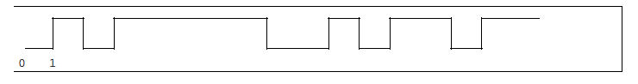

1 1 0 0 0 0 0 1 0 1 1 1 0 1 1 0

NRZI Encoding: 1 = transition, 0 = no transition

4. What three ASCII letters (bytes) are encoded by the following 4B/5B pattern? (Be careful about uppercase vs lower-case.)

010110101001110101010111111110

01011 01010 01110 10101 01111 11110

0101 0100 0110 0011 0111 0000

T c p

**CHAPTER 5**

1. Suppose a link has a propagation delay of 20 μsec and a bandwidth of 2 bytes/μsec.
2. How long would it take to transmit a 600-byte packet over such a link?

600/2 = 300 μsec + 20 μsec = **320 μsec**

1. How long would it take to transmit the 600-byte packet over two such links, with a store-and-forward switch in between?

320 μsec + 320 μsec = **630 μsec**

1. Suppose the path from A to B has a single switch S in between: A-----S----- B. Each link has a propagation delay of 60 μsec and a bandwidth of 2 bytes/μsec.
2. How long would it take to send a single 600-byte packet from A to B?

600/2 = 300 μsec + 60 μsec = 360 μsec + 360 μsec = **720 μsec**

1. How long would it take to send two back-to-back 300-byte packets from A to B?

300/2 = 150 μsec

(3x150) + (2x60)= **570 μsec**

1. How long would it take to send three back-to-back 200-byte packets from A to B?

200/2 = 100 μsec

(2x100) + (3x60) = **380 μsec**

5. Suppose in the previous exercise, the A–S link has the smaller bandwidth of 3 bytes/μsec

and the S–B link has the larger bandwidth of 5 bytes/μsec. Now how long does it take to

send two back- to-back 300-byte packets from A to B?

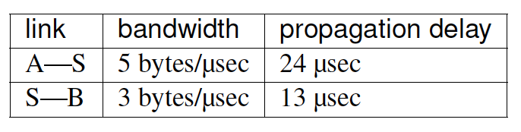

300/3= 100x2 = 200 + 24= 224

300/5= 60 + 13 =73---------> 73

Total time=**297 μsec**

7. Suppose there are N equal-bandwidth links on the path between A and B, as in the diagram below, and we wish to send M consecutive packets.

../Desktop/Screen%20Shot%202016-09-19%20at%2012.42.46%20AM.png

Let BD be the bandwidth delay of a single packet on a single link, and let PD be the propagation delay on a single link. Show that the total bandwidth delay is (M+N-1)xBD, and the total propagation delay is NxPD. Hint: the total time is the sum of the time A takes to begin transmitting the last packet, and the time that last packet (or any other packet) takes to travel from A to B. Note that no packets ever have to wait at any Si because the ith packet takes exactly as long to arrive as the (i-1)th packet takes to depart.

A ------------- S1 -------------- S2 -------------- S3 ----------- S4 ----------- B

A sends packet: 5 bandwidth delays and 5 propagation delays

1st packet starts at T=0

2nd packet starts after 1 bandwidth delay

3rd packet starts after 2 bandwidth delays

total = 7 bandwidth delays + 5 Propagation delays

Bandwidth = packet size/bandwidth= BD

Propagation delay = PD

Mth packet leaves at MxBD

N= bandwidth links

Bandwidth delay= (MxBD) + ((N-1)xBD) = BDx(M + N-1)

Propagation delay = NxPD