Shivam Patel

COMP 343

Dordal

Assignment 6: Chap 9 - #6,8

6. Consider the network in [9.2.1.1   Split Horizon](http://intronetworks.cs.luc.edu/current/html/routing.html#split-horizon):, using distance-vector routing

updates. B and C’s table entries for destination D are shown. All link costs are 1.

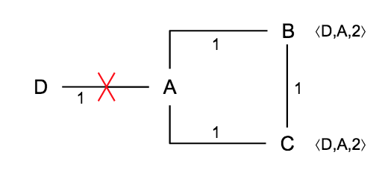

Suppose the D–A link breaks and then

* A reports ⟨D,∞⟩ to B (as before)
* C reports ⟨D,2⟩ to B (as before)
* A now reports ⟨D,∞⟩ to C (instead of B reporting ⟨D,3⟩ to A)

A : <D,1> <B,1> <C,1>

B: <A,1> <C,1> <D,A,2> => <D,A, ∞> => <D,C,3>

C: <A,1> <B,1> <D,A,2> => <D,A, ∞>

a). What reports (a pair should suffice) will lead to the formation of the routing loop?

C reports <D, A, ∞> to B and B reports <D, C,3> to A

(b). What (single) report will eliminate the possibility of the routing loop?

A reporting <D, ∞> to C

8. Suppose the routers are A, B, C, D, E and F, and all link costs are 1. The distance-vector

forwarding tables for A and F are below. Give the network with the fewest links that is

consistent with these tables. Hint: any destination reached at cost 1 is directly connected; if

X reaches Y via Z at cost 2, then Z and Y must be directly connected.

