Shivam Patel

Comp 343

Dordal

Assignment 8: Chap3: #9,10,11; Chap9: #11,12; Chap12: #7,8,9

9. In the example in [3.4   Virtual Circuits](http://intronetworks.cs.luc.edu/current/html/otherLANs.html#virtual-circuits), give the VCI table for switch S5.

Switch S5

|  |  |  |  |  |
| --- | --- | --- | --- | --- |
| VC1in | portin | VC1out | portout | connection |
| 8 | 0 | 5 | 1 | A --> F #1 |
| 9 | 0 | 2 | 1 | A --> F #2 |

10. Suppose we have the following network:

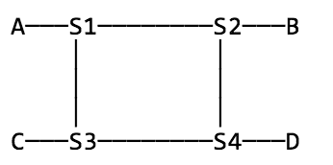

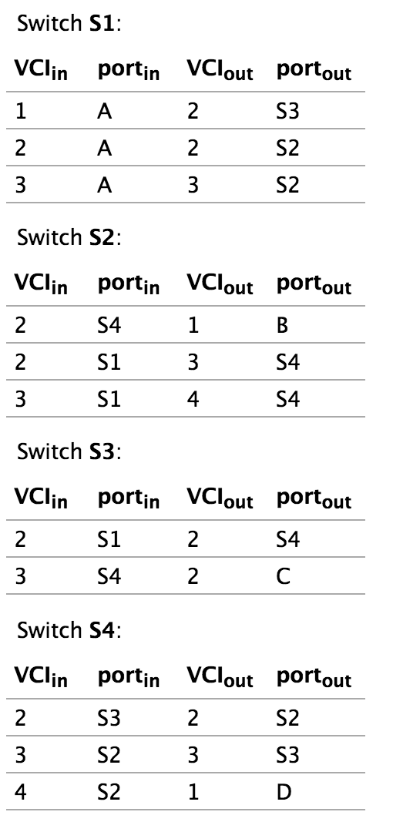The virtual-circuit switching tables are below. Ports are identified by the node at the other end. Identify all the connections. Give the path for each connection and the VCI on each link of the path.

S1: 1,A 2,S3

S3: 2,S1 2,S4

S4: 2,S3 2,S2

S2: 2,S4 1,B

________________________

S1: 2,A 2,S2

S2: 2,S1 3,S4

S4: 3,S2 3,S3

S3: 3,S3 2,C

________________________

S1: 3,A 3,S2

S2: 3,S1 4,S4

S4: 4,S2 1,D

11. Suppose we have the following network:

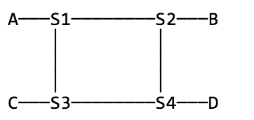

Give virtual-circuit switching tables for the following connections. Route via a shortest path.

(a). A–D

A–-2–- S1 –- 4 –- S2 –- 6 –- S4 –- 8 -- D

|  |  |  |  |  |
| --- | --- | --- | --- | --- |
|  | VC1 in | Port in | VC1 out | Port out |
| S1 | 2 | A | 4 | S2 |
| S2 | 4 | S1 | 6 | S4 |
| S4 | 6 | S4 | 8 | D |

(b). C–B, via S4

C—1—S3—3—S4—5—S2—2—B

|  |  |  |  |  |
| --- | --- | --- | --- | --- |
|  | VC1 in | Port in | VC1 out | Port out |
| S3 | 1 | C | 3 | S4 |
| S4 | 3 | S3 | 5 | S2 |
| S2 | 5 | S4 | 2 | B |

(c). B–D

B—4—S2—3—S4—2--D

|  |  |  |  |  |
| --- | --- | --- | --- | --- |
|  | VC1 in | Port in | VC1 out | Port out |
| S2 | 4 | B | 3 | S4 |
| S4 | 3 | S2 | 2 | D |

(d). A–D, via whichever of S2 or S3 was *not* used in part (a)

A—2—S1—5—S3—7—S4—3--D

|  |  |  |  |  |
| --- | --- | --- | --- | --- |
|  | VC1 in | Port in | VC1 out | Port out |
| S1 | 2 | A | 5 | S3 |
| S3 | 6 | S1 | 7 | S4 |
| S4 | 7 | S3 | 3 | D |

Chap 9

11. It was mentioned in [9.5   Link-State Routing-Update Algorithm](http://intronetworks.cs.luc.edu/current/html/routing.html#link-state) that link-state routing might give rise to an ephemeral routing loop. Give a concrete scenario illustrating creation (and then dissolution) of such a loop.

if one router has received a LSP but another has not, they may have an inconsistent view of the network and thus route to one another. However, as soon as the LSP has reached all routers involved, the loop should vanish. There are no “race conditions”, as with distance-vector routing, that can lead to persistent routing loops.

12. Use the Shortest Path First algorithm to find the shortest path from A to E in the network below. Show the sets **R** and **T**, and the node **current**, after each step.

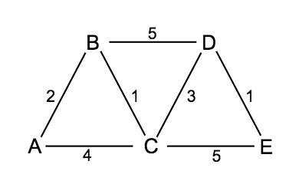

A-B-C-D-E

2 + 1 + 3 + 1 = 7

Current = A, R = {<A,A,0>}, T = {<B,B,2>,<C,C,4>}

Current = B, R = {<B,B,2>}, T = {<C,B,3>,<D,B,6>}

Current = C, R = {<C,B,3>}, T = {<D,C,6>,<E,C,8>}

Current = D, R = {<D,C,6>}, T = {<E,D,7>}

Chap 12

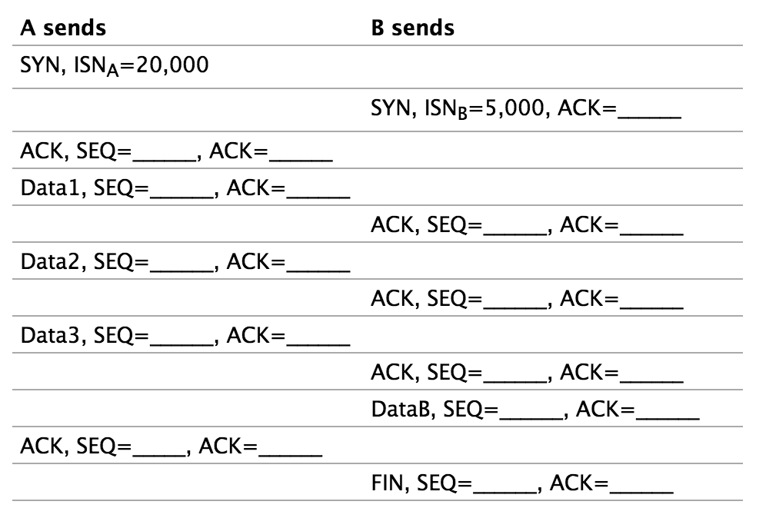7. Suppose A and B create a TCP connection with ISNA=20,000 and ISNB=5,000. A sends three 1000-byte packets (Data1, Data2 and Data3 below), and B ACKs each. Then B sends a 1000-byte packet DataB to A and terminates the connection with a FIN. In the table below, fill in the SEQ and ACK fields for each packet shown.

**23001**

**23001**

**23001**

**23001**

**22001**

**22001**

**21001**

**20001**

**21001**

**20001**

**20001**

8. Suppose you are watching a video on a site like [YouTube](http://www.youtube.com/), where there is a progress bar showing how much of the video has been downloaded (and which hopefully stays comfortably head of the second progress bar showing your position in viewing the video). Occasionally, the download-progress bar jumps ahead by a modest but significant amount, instantaneously fast (much faster than the bandwidth alone could account for). At the TCP layer, what is going on to cause this jump? Hint: what does a TCP receiver perceive when a packet is lost and retransmitted?

Whenever there is high latency and packet loss, it can happen because of a router under heavy load or a service outage, etc. TCP detects these things and resends the packets, hence TCP retransmission. TCP will judge the need for a retransmission based on the RTO or the retransmission timeout. If the packet never receives an ACK in the time frame set, it's retransmitted. The time between the two packets is called the round-trip time. Every time a retransmit happens, the RTO for that packet doubles. Eventually, depending on the senders computer settings, it'll just stop resending.

9. Suppose you are creating software for a streaming-video site. You want to limit the video read-ahead – the gap between how much has been downloaded and how much the viewer has actually watched – to 100 KB; the server should pause in sending when necessary to enforce this. On the other hand, you do want the receiver to be able to read ahead by up to this much. You are assuming that the TCP connection throughput will generally be higher than the actual video-data-consumption rate.

a) If the receiver simply reads each video frame from the TCP connection, displays it, and then pauses briefly before reading the next frame in accordance with the frame rate, how will the flow-control mechanism of 12.16 TCP Flow Control be applied? Explain why the playback application will not have direct control of the read-ahead buffer size.

The receiver will send an ACK wait which will decrease the window size and alert the sender to not send and more data after the previous data has been received. Eventually the receiver will send another ACK notifying the sender to start sending again, and this process will continue. The playback application will not have direct control due to the fact that it doesn’t control how much of the data will be sent and when.

b) What support do you have to add to the playback application to allow it to read ahead by 100 KB but not to exceed this? What support, if any, does the server application have to include?

The application can’t control it unless you add a feature where the server gets some feedback of what the client wants so then it can change the window size. But you would have to give up some flexibility.