Shivam Patel

COMP 343

DORDAL

Assignment 9: Chap 10-#1,2,3,4; Chap 13-#1,2

1. Consider the following IP forwarding table that uses CIDR. IP address bytes are in **hexadecimal**, so each hex digit corresponds to four address bits.

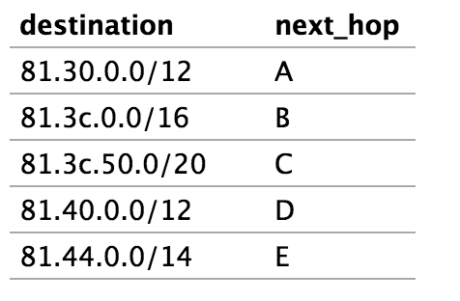

30 --> 0011 0000

3c --> 0011 1100

50 --> 0101 0000

40 --> 0100 0000

44--> 0100 0100

For each of the following IP addresses, indicate to what destination it is forwarded.

(i) 81.3b.15.49 -- Matches A

(ii) 81.3c.56.14 -- Matches B and C but C is a longer match

(iii) 81.3c.85.2e -- Matches B

(iv) 81.4a.35.29 -- Matches D

(v) 81.47.21.97 -- Matches E

(vi) 81.43.01.c0 -- Matches D

1. Consider the following IP forwarding table, using CIDR. As in exercise 1, IP address bytes are in **hexadecimal**.

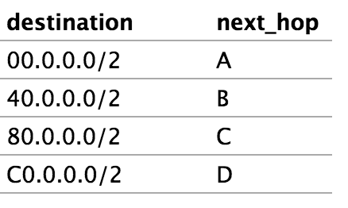

**00**00 0000

**01**00 0000

**10**00 0000

**11**00 0000

a)To what next_hop would each of the following be routed? 63.b1.82.15,

9e.00.15.01, de.ad.be.ef

63.b1.82.15 --> B

9e.00.15.01 --> C

de.ad.be.ef --> D

(b). Explain why every IP address is routed somewhere, even though there is no default entry.

Just because there isn’t a default entry doesn’t mean we don’t have an automatic way of figuring out the entry. Since the destinations are all “/2” there are only four options for the first two bits meaning that the addresses will route to one of the four.

1. Give an IPv4 forwarding table – using CIDR – that will route all Class A addresses (first bit 0) to next_hop A, all Class B addresses (first two bits 10) to next_hop B, and all Class C addresses (first three bits 110) to next_hop C.

**Destination Next_Hop**

**0**000 0000.0.0.0/1 A

**10**00 0000.0.0.0/2 B

**110**0 0000.0.0.0/3 C

1. Suppose a router using CIDR has the following entries. Address bytes are in decimal except for the third byte, which is in binary.

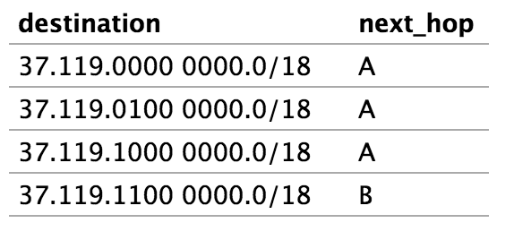

These four entries cannot be consolidated into a single /16 entry, because they don’t all go to the same next_hop. How could they be consolidated into *two* entries?

We can make use of the longest naturals, Rule 1: 37.119.0.0/16 --> A;

Rule 2: 37.119.1100 0000.0/18 --> B. They are nested and so those matching the longer will route to B and all others to A.

Chap 13

1. 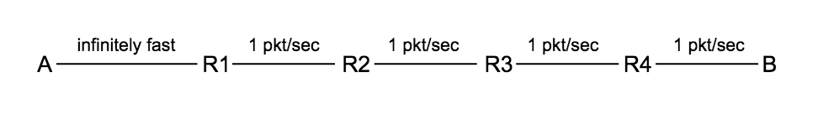Consider the following network, with each link other than the first having a bandwidth delay of 1 packet/second. Assume ACKs travel instantly from B to R (and thus to A). Assume there are no propagation delays, so the RTTnoLoad is 4; the bandwidth×RTT product is then 4 packets. If A uses sliding windows with a window size of 6, the queue at R1 will eventually have size 2.

Suppose A uses threshold slow start with ssthresh = 6, and with cwnd initially 1. Complete the table below until two rows after cwnd = 6; for these final two rows, A will send only one new packet for each ACK received. How big will the queue at R1 grow?

|  |  |  |  |  |  |
| --- | --- | --- | --- | --- | --- |
| **T** | **A sends** | **R1 Queues** | **R1 sends** | **B receives/ACKs** | **cwnd** |
| 0 | 1 | 1 |  |  | 1 |
| 1 |  |  |  |  |  |
| 2 |  |  |  |  |  |
| 3 |  |  |  |  |  |
| 4 | 2,3 | 3 | 2 | 1 | 2 |
| 5 |  |  | 3 |  | 2 |
| 6 |  |  |  |  |  |
| 7 |  |  |  |  |  |
| 8 | 4,5 | 5 | 4 | 2 | 3 |
| 9 |  |  | 5 |  | 4 |
| 10 |  |  |  |  |  |
| 11 |  |  |  |  |  |
| 12 | 6,7 | 7 | 6 | 3 | 4 |
| 13 |  |  | 7 |  | 4 |
| 14 |  |  |  |  |  |
| 15 |  |  |  |  |  |
| 16 | 8,9 | 9 | 8 | 4 | 5 |
| 17 |  |  | 9 |  | 5 |
| 18 |  |  |  |  |  |
| 19 |  |  |  |  |  |
| 20 | 10,11 | 11 | 10 | 5 | 6 |
| 21 |  |  | 11 |  | 6 |
| 22 |  |  |  |  |  |
| 23 |  |  |  |  |  |

1. Consider the following network from [13.2.3   Slow-Start Multiple Drop Example](http://intronetworks.cs.luc.edu/current/html/reno.html#ssmultidrop), with links labeled with bandwidths in packets/ms. Assume ACKs travel instantly from B to R (and thus to A).

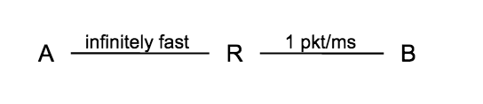

A begins sending to B using slow start, beginning with Data[1] at T=0. Write out all packet deliveries assuming R’s queue size is 5, up until the first dupACK triggered by the arrival at B of a packet that followed a packet that was lost.

A B

Cwnd = 1

Cwnd = 2

Cwnd = 3

Cwnd = 4

Cwnd = 5

Cwnd = 6

1 RTT, 1 Packet

1 RTT, 2 Packets

1 RTT, 3 Packets

1 RTT, 4 Packets

1 RTT, 5 Packets

1 RTT, 5 Packets

(pipe is full)

**Dup ACKs**

**JPEG ANSWER TO NUMBER 2 INCASE FORMAT OF GRAPH IS OUT OF PLACE**

