1. Is this ADC too noisy for our application?

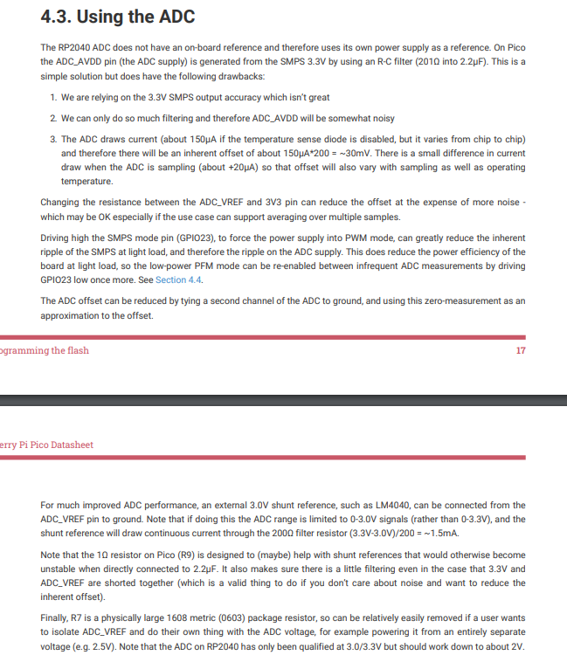

1. How do we convey location information via Bluetooth to a coordinator XBee?
   1. Firstly, can such a wide range be covered by Bluetooth?
   2. Should we use GPS info or configure a string payload with field details such as plot name while we are on-site?
   3. Depending on the method we select, can this be done with regular hop messages instead of Bluetooth (send location data along with sensor data every X minutes?)
   4. iBeacon: **We need a license to use this**
      1. iBeacon(TM) is a trademark of Apple Inc. and use of this code must comply with their licence.
      2. <https://en.wikipedia.org/wiki/IBeacon>
      3. License: <https://developer.apple.com/ibeacon/>
2. When in final product form, how will the user initiate Bluetooth beaconing?
   1. Do they open Python and run very user-friendly code or initiate Bluetooth beaconing via a phone app? It may be hard via phone app since the boards will span a large area.
   2. If we had the user press a buttons to initiate/turn off Bluetooth (in which case they don’t compile code and have a REPL console), should we indicate that Bluetooth is functioning with an LCD?
3. Can you send us datasheets of the sensors that will be used?
   1. With that info, we can interpret ADC voltage readings and send appropriate messages.