1. Is this ADC too noisy for our application?

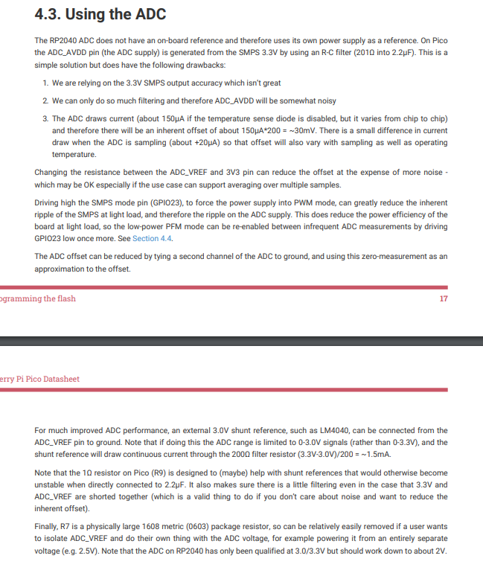

1. How do we convey location information via Bluetooth to a coordinator XBee?
   1. Should we use GPS info or configure a string payload with field details such as plot name while we are on-site?
   2. Depending on the method we select, can this be done with regular hop messages (send location data along with sensor data every X minutes?)
2. When in final product form, how will the user initiate Bluetooth beaconing?
   1. Do they open Python and run very user-friendly code or initiate Bluetooth beaconing via a phone app?
3. Can you send us datasheets of the sensors that will be used?
   1. With that info, we can interpret ADC voltage readings and send appropriate messages.