**Communication protocols:**

XBee3:

* Only supports I2C in Master mode, no Slave mode
* Supports SPI in Slave mode, but only in API mode

ESP8266:

* Only supports I2C in Master mode, no Slave mode
* Only supports SPI in Master mode, no Slave mode

Pros

* Certain ESPs are used with AdaFruit FeatherBoards
* Can communicate with LoRaWan stuff with certain ESPs

Cons

* Does not have many GPIO pins -> have to connect sensors and peripherals to the XBee and ESP rather than just the ESP
  + We are trying to connect everything to the microcontroller since it, rather than the XBee, will be retained in the long run

Solution:

* Operate both in Master mode, but software switch the modes for each board

**SD Card:**

Adafruit MicroSD Card Breakout Board:

* Supports SPI
* Has CircuitPython sample code

CircuitPython vs MicroPython explanation:

* <https://learn.adafruit.com/getting-started-with-raspberry-pi-pico-circuitpython/micropython-or-circuitpython>

**Raspberry Pi Pico:**

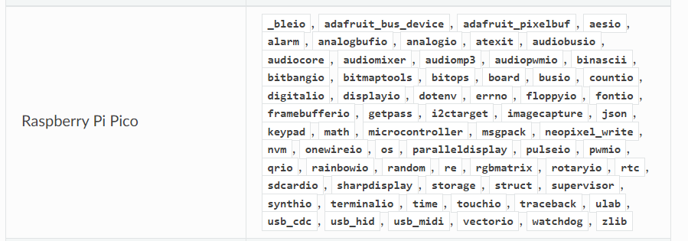

Figure 1: Available CircuitPython modules according to https://docs.circuitpython.org/en/latest/shared-bindings/support_matrix.html

**XBee:**

When setting up UART demo for field testing, you need to press the buttons again to configure them as sensors/coordinator. When the button is pressed and they are connected to a battery, source, they will initiate data transfers.

**Pycharm:**

* Install the 2022 Community Version
  + Problems were encountered with the 2018 version

**Reasons Bluetooth was not used:**

* Can do everything we want Bluetooth to do with the MESH network
* Don’t want to juggle Zigbee, Bluetooth, and LoRaWan protocols simultaneously
* The DigiXBeeMobile app doesn’t really help non-technical users initiate Bluetooth beaconing
  + Can't do the following with the app:
    - Turn XBee Bluetooth on with app->XBee scans (beacons) for other XBees->you turn the XBee off while its scanning (the app has trouble accessing the XBee while its scanning with Bluetooth)
    - Turn XBee's BT on when its Bluetooth off (phone can't discover XBee)

**XBee Operation Modes:**

* Do we set the data sink to REPL or API
  + REPL mode limits the amount of data that can be moved, leading to potential data loss
  + API mode should be used