Fleet Vehicles
Workshop Risk Survey

«CMLTradingName» | Issue date: | «IssueDate»
«AddressLine1» «AddressLine2» | Quote number: | «ProtectionNumber»
«Suburb» «State» «PostCode» | RAM name: | «RAMName»
«Country»
Risk Location
«LocationAddressLine1» «LocationAddressLine2»
«LocationSuburb» «LocationState» «LocationPostcode»
«LocationCountry»

Workshop Risk Photo Requirements
All photos and forms below are required.
Vehicle yard showing any security. | «VY»
Vehicle key storage. | «VK»
Hire vehicle contract supplied. | «HV»

Example photos:
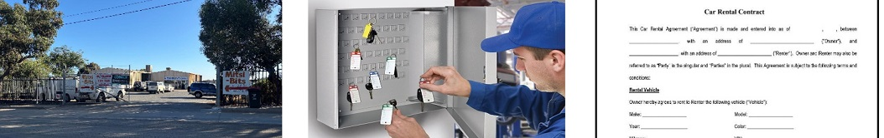
Vehicle yard frontage Key storage Rental contract

Workshop Risk Assessment Questions (detail where relevant)
What year did you commence operations? | «CommenceOperationsYear»
Are vehicles hired on a long or short-term basis? | «VehiclesHiredTerm»
What % of fleet are hired out at one time? | «PercentOfFleetHired»
Are vehicles used for ride-share operations? | «RideShareOperations»
Are there procedures to check a customer’s license validity including any loss of license? | «CustomersLicenseValidity»
Are driver’s other than the hirer accepted to drive the vehicle? | «DriversOtherThanHirer»

