Workshop Risk Photo Requirements
All photos below are required and should be wide shots and multiple angles when necessary.
Frontage from road showing fencing and gates. | «CT1» | Vehicle yard from all angles. | «CT3»
Fuel storage and hot work area(s). | «CT2» | High-risk specialised equipment. | «CT4»
Example photos:
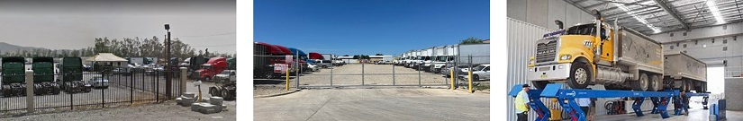
Vehicle yard security Vehicle yard frontage Specialised equipment

Workshop Risk Assessment Questions (detail where relevant)
Percentage of turnover from light vehicles under 10tons: | «Under10Tons»
Percentage of turnover from medium vehicles 10-20tons: | «Under20Tons»
Percentage of turnover from heavy vehicles 20-40tons: | «Under40Tons»
Percentage of turnover from very heavy vehicles 40tons plus: | «Abov40Tons»
Is road testing of prime movers with trailers performed? | «RoadTesting»
Are customer prime mover trailers stored overnight? | «OverNightTrilers»
Are courtesy trucks or trailers supplied? | «SuppliedTrialers»
Percentage of turnover from construction/mining vehicles: | «MiningVehicles»
Is there any high-risk specialised equipment in use? | «SpecializedEquipment»
Is there evidence of adequate fuel storage procedures in place? | «adequatefuelstorage»

