Workshop Risk Photo Requirements
All photos below are required and should be wide shots and multiple angles when necessary.
Frontage from road showing fencing and gates. | «p1» | Standard and EV battery storage area(s). | «p5»
Reception area from multiple angles showing entirety. | «p2» | Internal and external parts storage area(s). | «p6»
Defueling and hot work area(s). | «p3» | Vehicle yard from all angles. | «p7»
Tyre storage area(s). | «p4» | Dismantling area(s) from all angles including floor, fire identification/suppression items and hoist. | «p8»
Example photos:
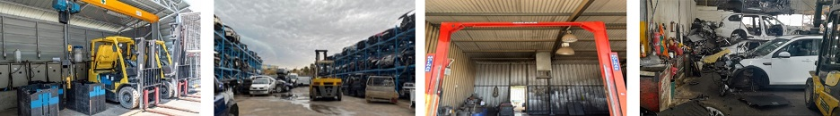
EV battery storage Vehicle yard Defueling area Dismantling area

Workshop Risk Assessment Questions
Description of activities performed by the trade/business: | «DescriptionofActivities»
Storage details of any hazardous goods, standard/EV batteries and fuel: | «StorageDetails»
Does the public have access to the yard? |  | «PublicHaveAccess»
Is depollution conducted inside the main building? (Removal of fuels etc) |  | «Depollution»
Are EV batteries stored within a building? |  | «EVBatteries»
Are Electric Vehicles included in dismantling operations? |  | «ElectricVehicles»
Has the Member been made aware of, and accepted the vehicle dismantler EV clause?  Protection excludes loss or damage caused by or arising from a lithium-ion battery that is designed to power an electric motor of a battery electric vehicle, which, at the time of the loss or damage is stored in or within 10 metres of any Business Buildings. |  | «EVClaues»

