**Assignment #5**

Sudhanshu Pathak

Graphs plotted for N = 5000000

For SimpleRegret, N = 1000, trials = 100

BanditA CumulativeRegret:

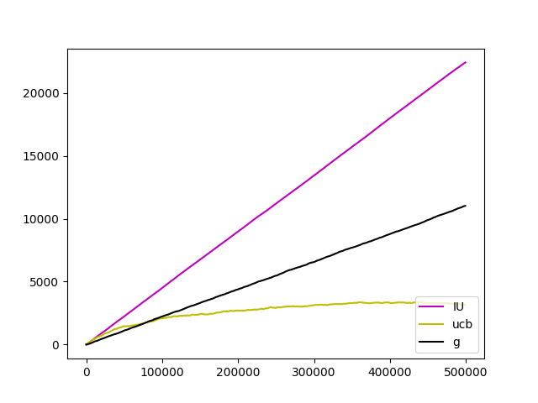

BanditB CumulativeRegret:

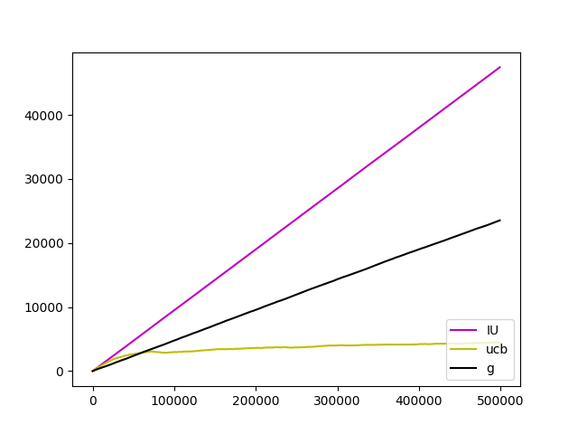

BanditC CumulativeRegret:

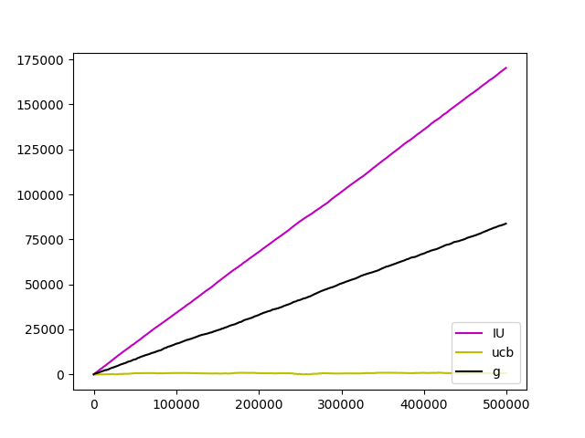

Bandit A Simple Regret:

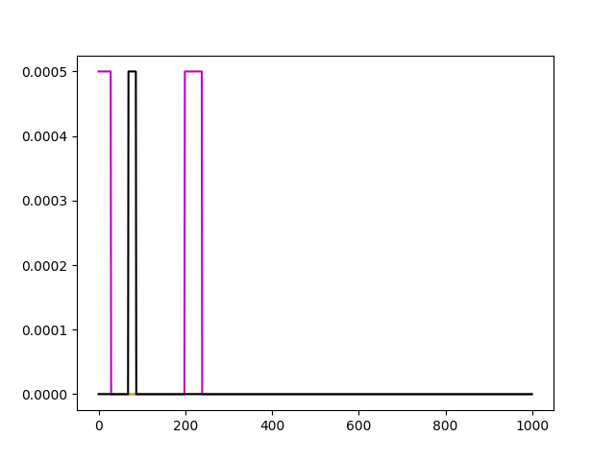

Bandit B Simple Regret:

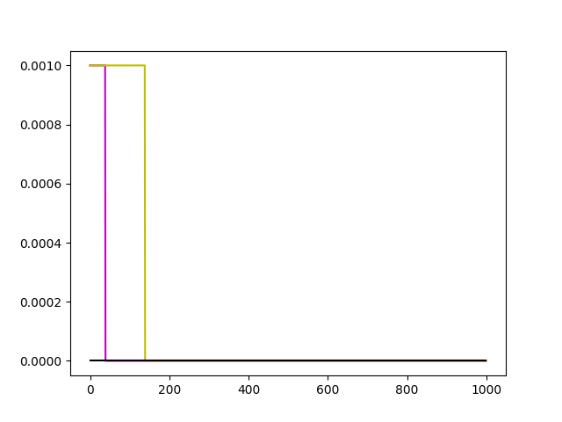

BanditC SimpleRegret:

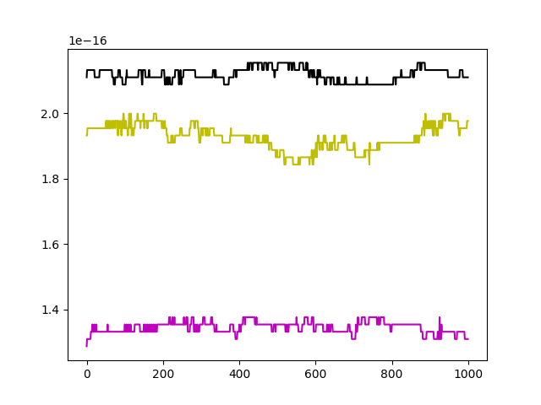

Bandit3 Definition:

Consider bandit with six arms having following probability and reward distribution.

(Reward, Probability) = (6,0.2), (4,0.3), (2,0.6), (1,0.7, (0,0.8)

Observation:

1. Normally UCB algorithm converges faster than other two algorithms in the following order: This can also be seen from the graph.

UCB

Epsilon Greedy

Increment Uniform

1. For simple regret for larger iterations regret is almost close to zero.