Customer Support Knowledge Base
  - Project report | 18 October 2026

1 Executive summary
This project built a Hybrid RAG Customer Support Assistant for fictional smart home products. The system retrieves evidence from FAQs, manuals, and troubleshooting guides, checks whether the evidence supports answering, and generates a cited response through a Streamlit chat interface. It combines semantic retrieval and keyword search with rank fusion, reranking, and explicit validation.
The final retrieval configuration achieved 100% Hit@5, Recall@5, and MRR@5 on 25 answerable synthetic questions. Combined evidence validation correctly classified all 30 benchmark questions, including five that required escalation. These are bounded benchmark results, not evidence of production reliability. Generation remained the main weakness: the later same-judge comparison rated 48% of V1 answers and 44% of V2 answers fully correct despite complete expected-fact coverage.
The principal lesson is that finding relevant sources, deciding whether to answer, and producing a fully supported answer are separate engineering problems. A more restrictive generation prompt did not consistently improve the measured outcome.

Problem and scope
Customer support information is distributed across document types, and customers may describe the same problem using different words or exact technical identifiers. The assistant aims to return useful, traceable troubleshooting guidance while escalating questions that the available documentation cannot support. This is a demonstration using fictional products and synthetic documents; it is not a deployed customer support service.

Dataset boundaries
Material | Source items | Indexed chunks | Role
FAQ records | 60 | 60 | One question and answer per chunk
Product manuals | 5 | 10 | Longer documents split into passages
Troubleshooting guides | 40 | 40 | Resolution and escalation guidance
Support tickets | 150 | 0 | Held out from the knowledge base
Total knowledge base | 105 | 110 | Shared by dense and lexical retrieval

The 150 held-out tickets are distinct from the 30-question evaluation set. No results in this report are claimed to come from evaluating all 150 tickets. Dataset README material was excluded because it describes the dataset rather than providing support evidence. [S1]

2 Architecture and technology stack
The ingestion path creates one consistent corpus for both retrievers. At query time, semantic and keyword retrieval operate on the same question, RRF merges their candidates, and a reranker scores query–passage relevance. Validation runs before generation. A failed check produces an escalation response; a passing check permits generation from the top three passages.
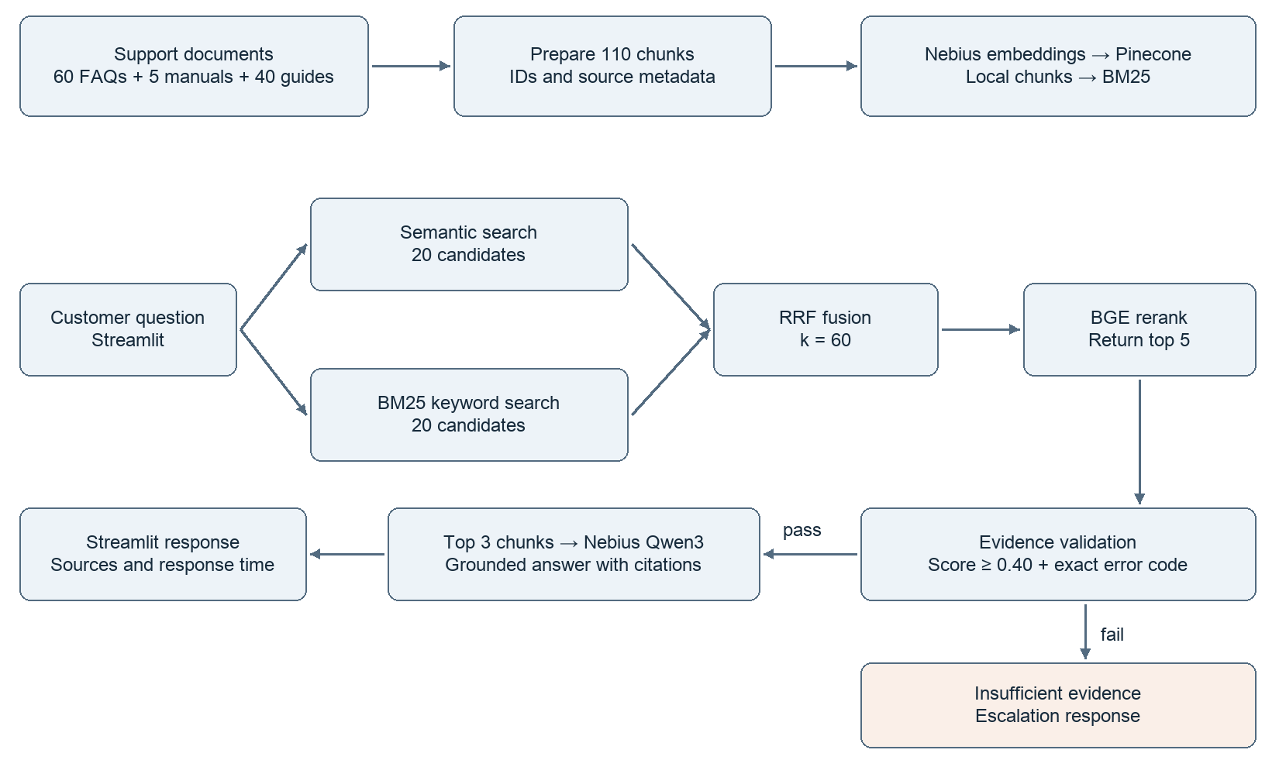
Figure 1. Implemented ingestion and query pipeline.
Component | Implementation and purpose
Embeddings | Nebius Qwen3-Embedding-8B configured for 1,024 dimensions
Vector retrieval | Pinecone index with cosine similarity
Lexical retrieval | Local BM25 over the same chunk corpus
Fusion | Unweighted reciprocal rank fusion with k = 60
Reranking | Pinecone bge-reranker-v2-m3
Generation | Nebius Qwen3-30B-A3B-Instruct
Application | Python pipeline with Streamlit interface
Document splitting | LangChain text splitter only; no LangChain orchestration

The final candidate depth is 20 per retriever, yielding at most 40 unique candidates after deduplication. The updated application helper requests up to 40 fused results before reranking, then returns five. This aligns the application candidate pool with the evaluation design. The numbers 20, 5, and 3 refer to candidate retrieval, returned reranked passages, and generation context respectively. [S1]

3 Implementation and engineering decisions

Ingestion and corpus integrity
FAQ JSONL records were explicitly loaded as individual question–answer chunks. An earlier extension-based loader missed those records, leaving the FAQ content out of the index; this was corrected before the final evaluation. Longer documents used the LangChain text splitter. Source identifiers, source paths, document type, and text allow results to be traced back to evidence. The local chunks.json and Pinecone index must represent the same corpus.
The final audit removed an extra README chunk, leaving 60 FAQ chunks, 40 troubleshooting chunks, and 10 manual chunks. Support tickets were excluded from indexing. Exact splitter size and overlap should be recovered from the original ingestion configuration rather than inferred from the resulting count. [S1]

Why combine retrieval methods
Embeddings support semantic similarity when a customer paraphrases a documented symptom. BM25 supplies lexical matching for product names and identifiers such as E204. Unweighted RRF combines ranks without treating BM25 and cosine scores as comparable numerical scales:
RRF(d) = sum over retrievers r of 1 / (60 + rank_r(d)).
Ranks begin at one, and a document contributes only in lists where it appears. Deduplication uses chunk identity. Equal weighting is a simple baseline, not an empirically proven optimum. The final results show that fusion alone did not beat semantic search; the reranker was essential to the observed improvement.

Candidate depth and reranking
The original depth of 10 per retriever restricted what the reranker could inspect. Debugging the thermostat setup question EVAL_001 showed that expanding the pool recovered the relevant manual and placed it first after reranking. Depth 20 was therefore retained. A reranker can reorder available candidates but cannot recover evidence absent from its input. Increasing depth also increases work and potential inference cost; this project did not quantify that trade-off.

Evidence validation and generation
Validation checks that documents exist, that the highest reranker score is at least 0.40, and that explicit error codes in the question occur in retrieved evidence. Codes matching the implemented E followed by three or four digits pattern are normalized before checking. A high relevance score is not a calibrated probability of answerability.
If validation fails, the pipeline returns an escalated status, a reason, and a support-directed response without relying on free-form generation. If it passes, the top three passages are labeled as sources and sent with the question to Nebius. The shared generation code uses temperature 0 and a 1,000-token output limit. Responses include answer, sources, status, reason, and top score. Prompt instructions prohibit invented procedures and unrelated product details and request [Source N] citations. Citations make claims inspectable; they do not automatically verify them. [S1]

4 Evaluation design and metric definitions
Evaluation was separated into retrieval, evidence validation, and generation so failures could be attributed to the correct stage. Saved rankings and outputs support offline analysis without repeating every API call. This also makes prompt comparisons easier to audit.
Question category | Count | Evaluation purpose
Directly answerable | 10 | Explicit documented requests
Paraphrased | 10 | Alternative wording of supported requests
Exact error code | 5 | Precise technical identifiers
Unanswerable | 5 | Missing evidence and unsupported requests
Total | 30 | 25 answerable and 5 unanswerable

The evaluation.jsonl schema described in the project conversation includes question IDs, categories, answerability, expected facts, structured gold sources, and escalation labels. The saved generation files confirm the 30-question composition. The original evaluation.jsonl and full ranked retrieval records were not accessible for independent recomputation during report preparation. [S1, S4]

Retrieval metrics
Hit@5 is the fraction of answerable questions with at least one labeled relevant source in the first five retrieved chunks. Recall@5 is computed per question as the number of distinct labeled sources found in those five chunks divided by the number of gold sources, then averaged. MRR@5 averages 1/rank of the first relevant source, using zero when none occurs in the first five.
The implementation maps FAQ chunks to individual FAQ identifiers and manuals or guides to normalized source paths. Thus, retrieval evaluation uses source-level relevance within a top-five chunk list. Duplicate chunks from one source do not increase recall, although they occupy rank positions. Finding a labeled manual does not by itself prove that the returned passage contains every needed fact. [S1]

Escalation metrics
Escalation is the positive class: TP means correctly escalating an unanswerable question; FP means escalating an answerable one; FN means allowing an unanswerable one; TN means allowing an answerable one. Precision = TP/(TP+FP), recall = TP/(TP+FN), F1 = 2PR/(P+R), and accuracy = (TP+TN)/N. When no escalation is predicted, the implementation records precision and F1 as zero.

Generation metrics
Expected-fact coverage measures the fraction of required facts judged present. Citation support measures whether evaluated citations support their associated claims. Overall correctness is the judge’s binary assessment per answer. Unsupported claims per answer counts items flagged by the judge; it is not an independently validated hallucination rate. The later V1/V2 comparison averages fact coverage and citation support per answer with nonempty fact or citation lists. It excludes the five unanswerable cases from the 25-answer quality comparison. [S1]

5 Retrieval and escalation results

Final retrieval at depth 20
The following values were checked directly against retrieval_summary(2).csv; retrieval_summary(1).csv contains identical final values. Both are final-run copies, not a depth-10 versus depth-20 pair. The summaries report 25 answerable questions. [S2]
Retrieval method | Hit@5 | Recall@5 | MRR@5
Semantic | 92.0% | 72.0% | 90.0%
BM25 | 88.0% | 69.3% | 77.5%
Hybrid RRF | 88.0% | 68.0% | 82.8%
Hybrid RRF plus reranking | 100.0% | 100.0% | 100.0%

Reranking placed a labeled relevant source first for every answerable question and recovered all labeled sources within the top five under this evaluation. Semantic search alone found at least one relevant source for 23 of 25 questions; BM25 and RRF each did so for 22 of 25.
Reranked configuration | Hit@5 | Recall@5 | MRR@5
Depth 10 per retriever | 96.0% | 90.7% | 96.0%
Depth 20 per retriever | 100.0% | 100.0% | 100.0%

The depth-10 row is a historical result recorded in the conversation, not recomputed from an available original CSV. The changes are +4.0, approximately +9.3, and +4.0 percentage points. This supports retaining the larger pool for this corpus, but is not a general performance guarantee. [S1, S2]

Evidence validation ablation
All confusion counts and derived metrics below were verified against evidence_eval_summary.csv. [S3]
Configuration | TP | FP | FN | TN | Precision | Recall | F1 | Accuracy
No validation | 0 | 0 | 5 | 25 | 0.0% | 0.0% | 0.0% | 83.3%
Threshold 0.40 | 4 | 0 | 1 | 25 | 100% | 80.0% | 88.9% | 96.7%
Threshold plus exact code | 5 | 0 | 0 | 25 | 100% | 100% | 100% | 100%

Baseline accuracy is inflated by the 25 answerable cases: allowing every question achieves 83.3% while missing every required escalation. Thresholding catches four unsupported requests. E999 is the exception: its top score is 0.950503 because related bulb documentation is highly relevant without documenting that code. Exact code validation closes this observed gap. The four other unsupported cases have scores below 0.40; all 25 answerable cases exceed it. [S3]

6 Generation results and interpretation

Controlled comparison of prompt versions
V1 requests grounded, cited support answers. V2 adds more explicit constraints against undocumented durations, app names, technical details, and cross-product procedures. The intended experiment changes the generation prompt while keeping retrieval, validation, model, and judge rubric comparable. Both saved output files contain 30 unique question records: 25 answered and five escalated. [S4]
Metric on 25 answerable questions | V1 | V2 | Change for V2
Mean expected-fact coverage | 1.000 | 1.000 | 0.000
Mean citation support | 0.947 | 0.893 | −0.054
Overall correctness | 0.480 | 0.440 | −0.040
Flagged unsupported claims per answer | 0.880 | 0.960 | +0.080

These later comparison figures are transcribed from the user’s printed summaries in the conversation. The underlying generation_comparison_judgments.jsonl was not available in the exposed attachments, so these aggregates could not be independently recalculated. The posted question-level comparison supports 12/25 correct for V1 and 11/25 for V2: five improved, six regressed, seven were correct in both, and seven were incorrect in both. [S1]

Why earlier numbers differ
The accessible original generation_judgments.jsonl was checked separately. It contains 30 judgments and reports, for the 25 answerable cases, 56/56 expected facts covered, 52/55 supported citations (94.5%), and 13/25 fully correct answers (52%). These are the earlier V1 judgments, not the later rejudged baseline. The 52/55 statistic pools citations; the comparison uses per-answer averages. Mixing the two runs or aggregation methods would create an invalid comparison. [S5]

What the experiment establishes
Both prompts retained the expected facts according to the judge, but extra statements could still be unsupported. Observed concerns include naming the AsterHome app in a Luma Camera answer and introducing an undocumented restart duration. The stricter prompt improved some error-code answers while regressing on other questions. A net difference of one correct answer is too small, on this dataset and with this judge, to establish broad superiority.
The same Nebius model was used for generation and judging, creating a risk of correlated biases. A concrete inconsistency appears in the original EVAL_001 judgment: an item is included under unsupported_claims even though its explanation says the advice is supported. Such entries must be manually adjudicated before being counted as confirmed hallucinations.
The evidence supports retaining V1 as the comparison baseline and prioritizing manual error analysis over further blind prompt expansion. It does not establish which prompt version was ultimately active in the photographed app. Perfect source retrieval and complete fact coverage should not be presented as perfect answer accuracy. [S1, S5]

7 The final Streamlit application
The SmartHome Support Assistant exposes the existing pipeline through a browser-based chat interface. It displays a fictional-data notice, customer messages, generated answers, source citations, response time, and expandable retrieved evidence. Source inspection includes document text, source filename, document type when present, and reranker score.
The sidebar provides a relevance-threshold toggle, a minimum-score slider initially set to 0.40, an exact-error-code validation toggle, a pipeline description, and a clear-conversation button. Escalated responses appear as warnings with a reason; processing exceptions produce a customer-readable error message. These controls make the prototype useful for demonstrations and diagnosis. [S1]
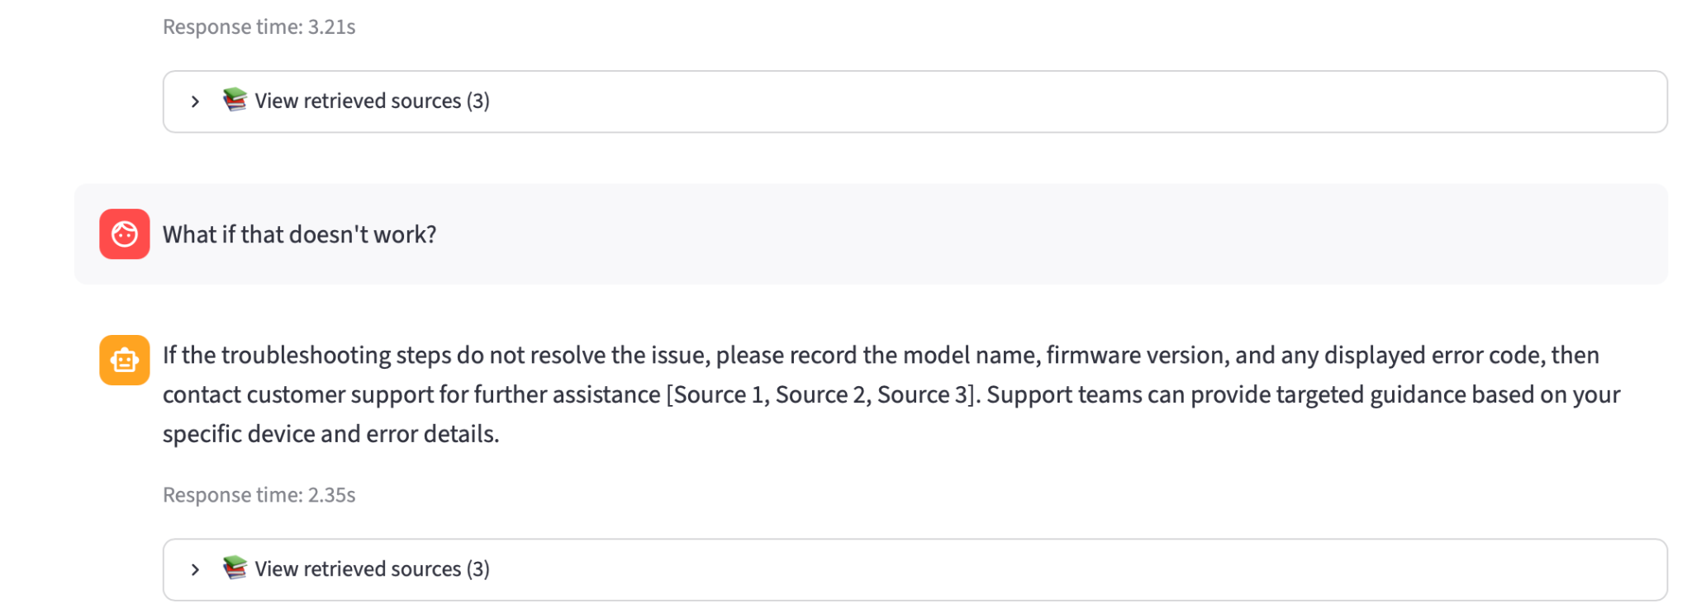
Figure 2. Supplied Streamlit screenshot showing response timing and source controls.

Representative supported question
EVAL_021 asks: “What does E204 mean on my Aster Thermostat T100, and what first steps should I try?” The saved evidence describes a lost Wi-Fi connection and recommends checking the 2.4 GHz network, restarting the router, and reconnecting through Settings > Network. The generated answer provides troubleshooting guidance and source citations. This is an example of the intended retrieval-to-answer path, not a claim that every sentence in the saved output passed grounding review. [S4]

Representative unsupported question
EVAL_030 asks: “How do I fix error E999 on my EchoLight Bulb B500?” Despite the high relevance score of 0.950503, the saved output returns status escalated with reason unsupported_error_code: E999. It states that sufficient documentation was not found and asks the customer to verify details or contact support. It does not substitute instructions for a different error code. [S3, S4]

Conversation display is not conversational memory
Streamlit stores messages in session state for display, but generate_answer receives only the current question. A follow-up such as “What if that doesn’t work?” is independently retrieved and generated without knowing the earlier product or issue. The screenshot shows such a follow-up and a plausible escalation answer, but does not demonstrate contextual understanding. Its 2.35-second response time is one observed interaction, not an aggregate latency benchmark. [S1, S6]

8 Limitations conclusions and future work

Limits of the evidence
The benchmark is small, synthetic, and derived from a narrow fictional corpus. The depth and validation rules were adjusted after inspecting this evaluation set; it therefore functions partly as a development benchmark. No separate untouched test set establishes generalization. The five unanswerable questions provide only limited coverage of unsupported requests.
Source-level retrieval labels can credit a manual even when a selected chunk lacks a needed detail. Evaluation at five passages also differs from generation with three: the final generation context may omit evidence present at ranks four or five. Validation checks five passages before selecting three, so an exact code found only in a discarded passage could pass validation without reaching the generator. Code presence alone also does not establish a valid procedure or correct product association.
Reranker scores are relevance signals, not confidence probabilities. The 0.40 threshold was selected using observed examples rather than a separate calibration set. LLM judgments are not human ground truth; inconsistencies, missing citation evaluation, and shared-model biases can affect scores. No production-scale cost, concurrency, security, reliability, or latency distribution was established.

Conclusions
The project delivers an integrated retrieval, validation, generation, and user-interface prototype with traceable evaluation outputs. Expanding candidate depth and reranking produced the strongest retrieval results on the benchmark. Combining a score threshold with exact-code validation handled the observed unsupported-code failure. Generation quality remained imperfect, showing why retrieval success and citation presence are insufficient measures of end-to-end reliability.

Prioritized next steps
1. Manually review paired answers and judge rationales, especially EVAL_003, EVAL_021, EVAL_001, EVAL_016, and EVAL_025; distinguish actual unsupported claims from judge errors.
2. Create a larger, untouched test set from independently authored questions and selected held-out tickets, including adversarial and ambiguous error-code cases. Tune on a separate development split.
3. Validate the exact context sent to generation. Add product and code association checks and evaluate evidence at passage or claim level rather than source identity alone.
4. Add conversational query rewriting using recent turns, preserving explicit product names and error codes before retrieval. Test both rewriting errors and follow-up retrieval.
5. Compare shorter answer formats and product-aware context selection, then rejudge all versions with a fixed rubric and human adjudication of disputed cases.
6. Record stage-level latency, token usage, API cost, failures, and feedback; separate customer-facing controls from diagnostics before a wider release.
These are proposed improvements, not features claimed to be implemented in the current application.

9 Setup reproducibility and evidence register

Reproducing the project
Use the original project repository and its data files. This report is documentation, not a replacement source-code package. Create an isolated Python environment, install the project dependencies, and configure Nebius and Pinecone credentials locally. The implementation uses an OpenAI-compatible client for Nebius, Pinecone’s client, a BM25 library, python-dotenv, the LangChain text splitter, and Streamlit. Exact dependency versions were not supplied; pin them for a reproducible rerun.
Keep API keys outside version control. Configure the embedding model for 1,024 output dimensions and a matching Pinecone cosine index. Use the project’s actual endpoint, model identifiers, index name, and environment variable names; the shared generation code expects NEBIUS_API_KEY and NEBIUS_CHAT_MODEL. Ensure that chunks.json and the index contain the same 110 chunks before evaluation.
The following commands reflect script names shared in the conversation and require the original project to be present:
python ingest.py
python evaluate_retrieval.py
python evaluate_evidence.py
python evaluate_generation.py
python judge_generation.py
python compare_generation.py
streamlit run app.py
Preserve V1 outputs before changing the generation prompt; save V2 to generation_outputs_v2.jsonl. The comparison script judges saved answers rather than regenerating them. Before rerunning, check resume logic and use separate output paths for changed settings so stale records are not mixed with a new run.
Archive the corpus, chunks, gold labels, rankings, validation details, prompt versions, raw answers, and judgments together. Record candidate depth 20 per retriever, RRF k=60, top-five retrieval evaluation, top-three generation context, threshold 0.40, exact-code checking, model IDs, dependency versions, dates, and any seeds or generation parameters. A zero temperature does not guarantee identical remote-service behavior over time.

Evidence register
ID | Source and verification status
S1 | Nebius Hybrid Search RAG conversation: implementation, dataset counts, historical depth-10 results, and user-posted same-judge summaries. Read during preparation.
S2 | retrieval_summary(1).csv and retrieval_summary(2).csv: identical final summaries; values inspected directly. Raw rankings unavailable.
S3 | evidence_eval_summary.csv and escalation_scores(1)/(2).csv: confusion counts, formulas, and threshold behavior checked.
S4 | generation_outputs.jsonl and generation_outputs_v2.jsonl: 30 records each; answer statuses and representative examples checked.
S5 | generation_judgments.jsonl: earlier V1 judgments; 56/56 facts, 52/55 citations, and 13/25 correctness independently counted.
S6 | image(5).png: supplied screenshot of the running Streamlit conversation; reproduced in this report.

The original evaluation.jsonl, full retrieval rankings, source repository, full corpus, and later comparison-judgment file were not exposed as readable attachments in this session. Consequently, final retrieval summaries are verified as reported aggregates, and the later generation comparison is attributed to the posted run output. No model inference was rerun for this report. This boundary preserves the distinction between inspected artifacts, historical project records, and recommended future work.

