How Run Strabo.Core:

1. Open CMD window
2. Go to the debug folder of Strabo.core; for example:

Cd ..\Strabo.Core\Strabo.Core\bin\Debug

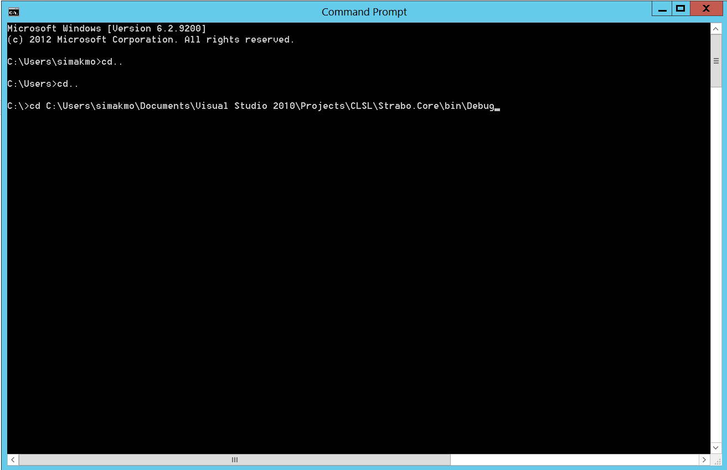

1. Write this command

strabo.core 314100 543800  C:\Users\nhonarva\Documents\strabo-command-line-master\strabo-command-line-master\Strabo.CommandLine\data\intermediate\ C:\Users\nhonarva\Documents\strabo-command-line-master\strabo-command-line-master\Strabo.CommandLine\data\output\ nls-sixinch 4

the project needs 6 parameters as input arguments. The first two numbers (separate by space) are top left point of target Boundingbox. You have to see the following page.

The third and fourth parameters are two paths, one is the intermediate files(images) folder and the other is output files folder. The fifth parameter is the layer name for testing the project on a new layer please follow the instruction of the config file which is attached at the end of this document. the last one is the number of threads.

1. Push this image to any GIS interface (e.g Arcmap or QGIS):

.. \Strabo.Core\bin\Debug\Imagestest\WMSImage.png

1. The Geiojson out file is located at this address:

..\Strabo.Core\bin\Debug\Imagestest\Data\GeojsonGeojsonByPixels.txt

Push GeojsonGeojsonByPixels.txt to the GISinterface too.

You can see the recognized text now!

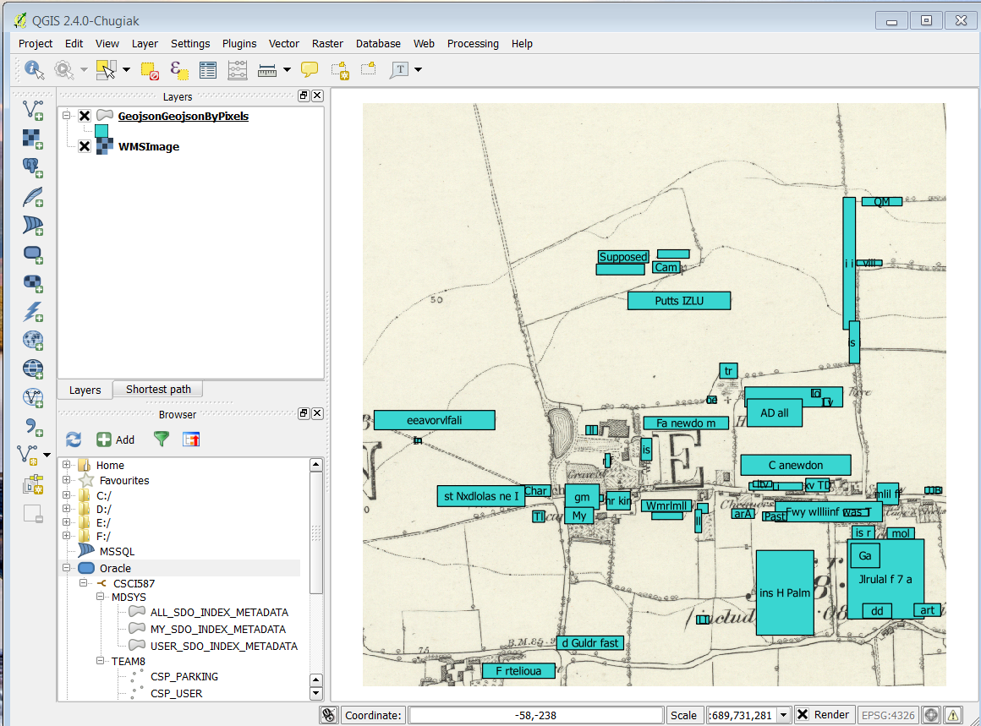

***Config File setting:***

If the user selects the default layer =”nls-sixinch” so for that specific layer the WMS parameters are set:

<add key="URL" value="http://secure.futureclimateinfo.com/api/wms?"/>

<add key="WIDTH" value="1500"/>

<add key="HEIGHT" value="1500"/>

<add key="WIDTHMeter" value="1000"/>

<add key="HEIGHTMeter" value="1000"/>

<add key="RedColorThreshold" value="135"/>

<add key="BlueColorThreshold" value="130" />

<add key="GreeColorThreshold" value="132" />

**WMST Setting and Chinese Map**

Please if you want to have more information or details about WMST follow this link:

[**http://wiki.osgeo.org/wiki/Tile_Map_Service_Specification**](http://wiki.osgeo.org/wiki/Tile_Map_Service_Specification)

The Chinese URL is: <http://gis.sinica.edu.tw/asgis/file-exists.php?img=Tianditu_eva-png-11-516-808>

The last three number are:

11: is the layer number which indicates how much you want to zoom in on the map. The user has to put its zoom number on app.config in front of this key attribute: “Layername:zoom-level” for example:

<add key="Tianditu_eva:zoom-level" value ="11"/>.

516 is the column number and 808 Is the row number. In WMST each tile size is fixed on 256 to 256. In fact we have one big matrix which size depends on how much user is zooming in or out. The user has to put its desired point on command line input (two first inputs).

For all required parameters about WMST connection which are mostly same as the WMS setting the user has to add WMST layer setting to app.config.

There are three more important parameters that have to set on app.config: WMSTStatus, Username and Password.

If the user forgot to set WSMTStatus, then the program can not connect to Map Server and it gives a kind of Authentication message.

A complete WMST setting is mentioned at the bellow for any other layer the user has just to change the layer name which is repeated at the first key attribute name. You need to get a user account (username and password) from the GIS Center at Acdemia Sinica. Once you have the username and password, replace the xxxx in the config file.

<add key="Tianditu_eva:WMSTStatus" value = "true"/>

<add key="Tianditu_eva:URL" value="http://gis.sinica.edu.tw/asgis/file-exists.php?img="/>

<add key="Tianditu_eva:username" value="xxxx"/>

<add key="Tianditu_eva:password" value="xxxx"/>

<add key="Tianditu_eva:zoom-level" value ="11"/>

<!--w equals h should be x*256-->

<add key="Tianditu_eva:WIDTH" value="1024"/>

<add key="Tianditu_eva:HEIGHT" value="1024"/>

<add key="Tianditu_eva:WIDTHSpatialUnit" value="-20037508.34278925"/>

<add key="Tianditu_eva:HEIGHTSpatialUnit" value="20037508.34278925"/>

<add key="Tianditu_eva:RedColorThreshold" value="165"/>

<add key="Tianditu_eva:BlueColorThreshold" value="165" />

<add key="Tianditu_eva:GreeColorThreshold" value="165" />

<add key="Tianditu_eva:srid" value="EPSG:3857" />

<add key="Tianditu_eva:Resize" value="2" />