MINI PROJECT REPORT ON
“Domino Disruption Predictor (DDP)”
SUBMITTED BY
“Mr. Sachin Bhavsing Patil”

UNDER THE GUIDANCE OF
“Prof. Karishma Kamble”

IN PARTIAL FULFILMENT OF
Award of the Degree of
MASTER OF COMPUTER APPLICATION

(Semester-I) SUBMITTED TO


SAVITRIBAI PHULE PUNE UNIVERSITY THROUGH

YASHASWI EDUCATION SOCIETY’S INTERNATIONAL INSTITUTE OF MANAGEMENT SCIENCE
CHINCHWAD, PUNE ACADEMIC YEAR 2025-2026

DECLARATION

I, Sachin Bhavsing Patil, student of International Institute of Management Science, Chinchwad, Pune, hereby declare that this Mini Project report entitled ““Domino Disruption Predictor (DDP)”” is a bonafide record of work done by me for the partial fulfilment of the requirement for the degree of Master of Computer Application (M.C.A) through Savitribai Phule Pune University.
I, hereby, declare that I have adequately referenced the original sources and this is my original work. I also declare that I have adhered to all principles of academic honesty and integrity and have not misrepresented or fabricated or falsified any idea/data/fact/source in my submission. I understand that any violation of the above will be cause for disciplinary action by the Institute and can also evoke penal action from the sources which have thus not been properly cited or from whom proper permission has not been taken when needed.

(Signature)
Sachin Bhavsing Patil
IIMS, Chinchwad, Pune.

ACKNOWLEDGEMENT

I am deeply indebted towards my project guide “Prof. Karishma Kable” who gave me the opportunity and was instrumental in providing me all the knowledge and insight to do the research. It is their inspiration that has kept me motivated all along my project and the discipline and integrity they had expected from a mini project that made me to learn the real live projects.

I would like to express my earnest gratitude and thanks to Dr. Shivaji Mundhe (Director of IIMS) and my project guide “Prof. Karishma Kable”
for providing me all the knowledge and skills, resources, technical support, guidance as required to achieve this Endeavour.

I thank my all faculty members and friends for their support and blessings. The report is the result of contribution of numerous people to mention individually.

I also thank all respondent who have given their value time, views and authentic information for this mini project. I thank each and everybody who has contributed directly or indirectly to the successful completion of this project.

(Signature)
Sachin Bhavsing Patil IIMS,Chinchwad, Pune.



CERTIFICATE

This is to Certify that Mr. Sachin Bhavsing Patil is a Bonafide student of International Institute of Management Science, Chinchwad, Pune, worked on Mini Project title Domino Disruption Predictor (DDP) and has successfully completed project work in partial fulfilment for award of degree Master of Computer Application (MCA) Sem I of Savitribai Phule Pune University.
This report is the record of Student’s own efforts under our supervision and guidelines.

Date:

Prof. Karishma Kamble”
Dr. Ashwini Brahme Dr. Shivaji Mundhe
Internal Guide HOD-MCA Director,IIMS,Chinchwad

Internal Examiner External Examiner



INDEX
Sr. No. | Topic | Page No.
1 | - Introduction  - Introduction  - About Existing system  - Limitations of the System  - Need of System  - Hardware Specifications  - Software Specifications  - Business Objectives  - System Objectives  - Scope of Program  - Objectives of the Project  - Features of new System | 7- 24
2 | System Requirement Specification | 25-27
3 | - Design  - Entity Relationship Diagram  - Class Diagram  - Activity Diagram  - Sequence Diagram for  - Use case Diagram for 3.6  3.7 | 20-26
4 | Screenshot | 27-29
5 | Data Dictionary | 30-33
6 | Reports | 34
7 | Bibliography and References | 35

LIST OF TABLES

Table no. | Table Name | Page no.
1 | Admin/Faculty Login | 30
2 | Batches | 30
3 | Academic Year | 31
4 | Student | 31
5 | Subjects | 32
6 | Add Questions | 32
7 | Semester | 33

LIST OF FIGURES

Graph no. | Graph Name | Page no.
1 | Entity Relationship Diagram | 20
2 | Class Diagram | 21
3 | Activity Diagram | 22
4 | Sequence Diagram | 23
5 | Use case Diagram | 24
6 | Collaboration Diagram | 25
7 | State Chart Diagram | 26

Introduction

In the modern digital era, productivity has become one of the most significant factors influencing the performance and success of individuals, organizations, and institutions. With the widespread use of computers, smartphones, and internet-based platforms, individuals are expected to manage multiple tasks efficiently while maintaining accuracy and speed. However, this digital dependency has also introduced a new challenge in the form of frequent and unavoidable interruptions.

Productivity disruptions can occur in many forms such as system notifications, phone calls, social media alerts, emails, unplanned meetings, background noise, and sudden task switching. These disruptions often occur unexpectedly and interrupt the natural flow of work. Although each interruption may appear small or harmless, repeated interruptions throughout the day result in loss of focus, increased task completion time, and reduced quality of work.

In many cases, productivity loss does not happen due to a single major issue but due to a series of minor disturbances that accumulate over time. One interruption often leads to another, creating a chain reaction that significantly affects efficiency. This phenomenon is similar to a domino effect, where one small disturbance triggers multiple subsequent disruptions. Unfortunately, most individuals fail to recognize this pattern because productivity loss is gradual rather than immediate.

The Domino Disruption Predictor (DDP) is designed to address this problem by providing a structured and systematic approach to identifying productivity disruptions. The system enables users to record disruptions as they occur and store them in an organized manner. By converting abstract productivity issues into measurable data, the system helps users gain a clearer understanding of how disruptions impact their daily activities.

The application focuses not only on recording disruptions but also on analyzing them to identify recurring patterns. By studying these patterns, users can take corrective actions to minimize future interruptions. The Domino Disruption Predictor demonstrates how technology can be effectively used to improve productivity and time management in a data-driven manner.

About Existing System

In the existing scenario, productivity management is generally handled through informal and unstructured methods. Most individuals do not use any dedicated system to track productivity disruptions. Instead, they rely on personal judgment, memory-based analysis, or basic tools such as notebooks and calendars. While these methods may provide a rough understanding of daily activities, they are insufficient for identifying complex productivity patterns.

Some users attempt to track productivity by maintaining handwritten logs or daily journals. However, such methods require continuous effort and discipline. Over time, users tend to lose consistency, resulting in incomplete or inaccurate records. Additionally, handwritten logs do not support automated analysis or long-term data storage, which limits their usefulness.

Spreadsheets are another commonly used method for tracking tasks and productivity-related information. Although spreadsheets offer better organization compared to handwritten notes, they still require manual data entry. This process is time-consuming and prone to errors. Moreover, spreadsheets do not provide real-time insights or automated analysis unless additional effort is made.

Existing systems primarily focus on task completion rather than understanding the causes of productivity loss. They fail to capture the reasons behind interruptions and do not analyze how disruptions affect work efficiency. As a result, users are unable to identify the root causes of productivity issues or implement effective solutions. This highlights the need for a more structured and intelligent system.

Limitations of the system

Although various informal methods are currently used to manage productivity, they suffer from multiple limitations that reduce their effectiveness and reliability. These limitations arise mainly due to the absence of automation, structured data handling, and analytical capabilities. As a result, existing systems fail to provide meaningful insights into productivity disruptions.

Manual and Memory-Based Tracking
Most existing productivity tracking methods depend heavily on manual effort and human memory. Users are expected to remember when a disruption occurred and later record it, which is impractical in real-world scenarios. Human memory is unreliable and selective, leading to missed entries and inaccurate data. Over time, this results in incomplete records that cannot be trusted for analysis.
Lack of Real-Time Data Recording
Existing systems do not support real-time recording of productivity disruptions. Disruptions are usually recorded much later, if at all. This delay causes loss of critical details such as exact time, duration, and context of the interruption. Without real-time data, the accuracy of productivity analysis is significantly reduced.
Unstructured and Scattered Data
Productivity-related information is often scattered across notebooks, diaries, mobile notes, or spreadsheet files. This unstructured storage makes it difficult to consolidate data from multiple sources. As a result, users are unable to view their productivity history in a unified manner, limiting long-term analysis.
Time-Consuming Data Maintenance
Manual systems require continuous effort to maintain records. Users must regularly enter, update, and review data, which itself consumes productive time. Over time, users lose motivation to maintain such records, leading to abandoned or outdated data logs.
Absence of Analytical Capabilities
Existing productivity tracking methods do not provide automated analysis. Users must manually examine records to identify trends or patterns, which is inefficient and often inaccurate. There is no mechanism to calculate total productivity loss, frequent disruption categories, or high-risk time periods.
No Visualization Support
Most traditional systems do not provide graphical representations such as charts, graphs, or dashboards. Without visualization, users find it difficult to interpret large volumes of data. This lack of visual feedback reduces the system’s effectiveness in helping users understand productivity behavior.
No Pattern or Trend Identification
Existing systems fail to identify recurring patterns in productivity disruptions. They do not highlight frequently occurring interruptions or repetitive behavioral issues. Without trend identification, users cannot take preventive actions or improve their productivity habits.
Lack of Predictive or Preventive Features
Traditional systems focus only on recording past events. They do not provide predictive insights or recommendations to prevent future disruptions. As a result, users repeatedly face the same productivity issues without guidance on how to avoid them.

.

Need of System

In the present digital era, the nature of work has changed significantly due to rapid technological advancements and increased reliance on digital tools. Individuals are required to handle multiple responsibilities simultaneously while remaining constantly connected through emails, messaging applications, and online platforms. Although technology has improved accessibility and efficiency, it has also introduced frequent interruptions that negatively impact productivity. These interruptions often occur unexpectedly and disrupt the natural flow of work.

In many cases, productivity loss is not caused by lack of skill or effort but by repeated and unmanaged disruptions. Small interruptions such as notifications, background conversations, or sudden task switching may appear harmless, but when they occur frequently, they result in reduced concentration and increased time required to complete tasks. Over time, this leads to frustration, mental fatigue, and decline in overall performance. Unfortunately, most individuals fail to recognize the cumulative impact of these disruptions.

Traditional productivity management approaches are inadequate in addressing this problem. Existing systems focus mainly on task completion and time tracking rather than understanding the causes of productivity loss. Without identifying the root causes of disruptions, users are unable to take effective corrective measures. This creates a gap between perceived productivity and actual productivity, highlighting the need for a more focused and intelligent system.

There is a strong need for an automated system that can record productivity disruptions in a structured manner. Manual and memory-based tracking methods are unreliable and inconsistent. An automated system ensures that data is recorded accurately and consistently, reducing human error and dependency on memory. By capturing real-time information such as time, duration, and type of disruption, the system provides a reliable data source for analysis.

The Domino Disruption Predictor system fulfills this requirement by offering a centralized platform for logging and managing productivity disruptions. The system enables users to record disruptions as they occur, ensuring that no critical information is lost. Centralized data storage allows users to review historical data and identify recurring disruption patterns over time.

Another important need addressed by the system is awareness. Many individuals underestimate the amount of time lost due to frequent interruptions. By converting disruptions into measurable data and visual reports, the system helps users become aware of their productivity behavior. This awareness plays a crucial role in motivating users to adopt better time management practices and improve focus.

The system also supports analytical and decision-making needs. By analyzing stored data, the system can highlight frequent disruption categories, high-risk time periods, and productivity trends. These insights help users make informed decisions regarding task scheduling, work environment adjustments, and habit formation. Without such analytical support, productivity improvement efforts remain guess-based and ineffective.

In addition, the system addresses the need for consistency and long-term productivity monitoring. Manual methods are difficult to maintain over long periods, leading to incomplete data and unreliable conclusions. The Domino Disruption Predictor provides a sustainable solution that supports continuous usage and long-term analysis, making it suitable.

Hardware Specification

  - Processor – Core i3 or equivalent
  - Hard Disk – 512 GB
  - Ram – 4 GB

Software Specification

- Operating System- Windows 10/11
- IDE-Visual Studio
- Database- My SQL

Technology used

- Front-end: HTML, CSS, JavaScript
- Back-end: Python, Django
- Database: SQLite/PostgreSQL

Business Objective

One of the primary business objectives of the system is to reduce productivity loss caused by frequent disruptions. In many cases, individuals are unaware of how much time is lost due to repeated interruptions. By identifying and recording these disruptions, the system helps reduce wasted time and improve effective work hours.

Another important objective is to provide structured and reliable productivity data. Existing informal methods do not generate data that can be analyzed meaningfully. The Domino Disruption Predictor converts unstructured productivity issues into organized digital records, enabling accurate analysis and long-term tracking.

The system also aims to support better time management and planning. By analyzing disruption patterns, users can identify high-risk time periods and frequent interruption sources. This allows individuals and organizations to plan tasks more effectively and allocate time in a more disciplined manner.

A key business objective is to enable data-driven decision making. Instead of relying on assumptions or subjective judgment, the system provides factual insights based on stored data. These insights help users make informed decisions regarding work schedules, task prioritization, and productivity improvement strategies
.
The Domino Disruption Predictor also aims to improve efficiency and consistency in work processes. By reducing unnecessary interruptions, users can complete tasks more efficiently and maintain consistent performance levels. Improved efficiency contributes to better outcomes in academic, professional, and organizational settings
.
Another objective is to increase awareness and accountability among users. When individuals can clearly see the impact of disruptions on their productivity through reports and dashboards, they become more conscious of their work habits. This awareness encourages responsible behavior and self-discipline.

From an organizational perspective, the system aims to support performance improvement and resource optimization. Productivity loss affects project deadlines, quality of output, and employee satisfaction. By identifying disruption patterns, organizations can implement policies and improvements that enhance overall performance.
.

Scope of Program

The scope of the Domino Disruption Predictor (DDP) defines the boundaries, coverage, and functional extent of the proposed system. It clearly explains what the system is intended to do, how it will be used, and the areas it will address. Defining the scope is important to ensure that the system objectives are achievable within the given time, resources, and technological constraints.

The Domino Disruption Predictor is designed as a web-based application that focuses on identifying, recording, and analyzing productivity disruptions experienced by users during their daily activities. The system is primarily intended for individuals such as students, professionals, and employees who wish to improve their productivity by understanding the factors that interrupt their workflow.

The scope of the system includes user registration and authentication, ensuring that only authorized users can access the application and their respective data. Each user has a unique profile, and all productivity disruption records are associated with the authenticated user. This provides data security, privacy, and personalized analysis.

The system allows users to log productivity disruptions by entering details such as the time of disruption, duration, category, and a brief description. This structured data entry ensures that disruptions are recorded consistently and accurately. The scope includes categorization of disruptions to help identify common sources such as digital notifications, environmental factors, or personal interruptions.

A significant part of the scope involves data storage and management. All disruption records are stored in a centralized database, enabling long-term storage and retrieval of productivity data. The system supports viewing historical records, which helps users analyze productivity behavior over extended periods.

The scope also includes basic data analysis and reporting. The system generates summaries and reports that help users understand total productivity loss, frequently occurring disruptions, and time-based patterns. These reports assist users in identifying high-risk periods and recurring productivity issues.

Another important aspect of the scope is the visual representation of productivity data. The system provides dashboards and charts that present disruption data in an easy-to-understand graphical format. Visualization enhances user understanding and encourages active engagement with the system.

The Domino Disruption Predictor is designed to be user-friendly and accessible through standard web browsers. Users do not need to install additional software, making the system easy to adopt. The scope includes responsive design to ensure usability across different devices such as desktops and laptops.

From a technical perspective, the scope includes the use of modern web technologies such as Python, Django, HTML, CSS, JavaScript, and a relational database. The system architecture is designed to support scalability and future enhancements without major structural changes.

However, certain features are outside the scope of the current system. These include automatic detection of disruptions, mobile application support, integration with third-party productivity tools, and advanced predictive analytics. These features may be considered for future development but are not included in the present implementation to maintain project feasibility.

The scope of the Domino Disruption Predictor is limited to manual disruption logging and basic analytical insights. The system does not monitor user activity automatically, nor does it collect data without user input. This limitation ensures user privacy and keeps the system simple and manageable.

Objective of System

The system objectives of the Domino Disruption Predictor (DDP) define the technical and functional goals that the proposed system aims to achieve. These objectives focus on how the system operates internally, how it handles data, and how it delivers reliable functionality to users. Clearly defined system objectives ensure that the application is designed, implemented, and evaluated in a structured and measurable manner.
One of the primary system objectives is to provide a secure and reliable user authentication mechanism. The system ensures that only authorized users can access the application and their respective productivity data. Authentication mechanisms such as login credentials help maintain data privacy and prevent unauthorized access. This objective is essential for maintaining data integrity and user trust.
Another important objective is to enable structured and accurate logging of productivity disruptions. The system provides a dedicated interface that allows users to record disruptions by entering specific details such as time, duration, category, and description. Structured data entry ensures consistency and eliminates ambiguity, making the data suitable for analysis and reporting.
The system also aims to store productivity disruption data in a centralized and organized database. Centralized data storage allows efficient retrieval, modification, and deletion of records. This objective ensures long-term data availability and supports historical analysis of productivity patterns.
A key system objective is to process and analyze stored data efficiently. The system is designed to perform basic analysis such as calculating total time lost, identifying frequent disruption categories, and determining high-risk time periods. Efficient data processing improves system performance and enhances user experience.
Another objective is to generate meaningful reports and summaries based on recorded data. The system provides users with reports that present productivity insights in a clear and understandable format. These reports help users evaluate their productivity behavior and identify areas for improvement.
The system also aims to provide visual representation of productivity data through dashboards and charts. Visualization helps users interpret complex data quickly and supports better decision-making. This objective improves usability and encourages regular system usage.
From a technical perspective, the system objective includes ensuring scalability and maintainability. The system architecture is designed in a modular manner so that new features can be added in the future without major changes to existing components. This objective supports long-term usability and system evolution.
Another important objective is to ensure system reliability and availability. The system is expected to function consistently without data loss or unexpected failures. Proper error handling and validation mechanisms are included to maintain system stability.
The system also aims to provide a user-friendly and responsive interface. The application is designed to be easy to use, even for users with minimal technical knowledge. A simple and intuitive interface reduces learning time and improves user engagement.
Finally, the system objective includes supporting academic and practical learning outcomes. As an MCA mini project, the system demonstrates the application of software engineering principles, web development technologies, database management, and system design concepts. This objective ensures that the project fulfills both technical and educational requirements.
In conclusion, the system objectives of the Domino Disruption Predictor focus on secure data handling, structured disruption management, efficient analysis, and user-friendly interaction. These objectives guide the design and implementation of the system and ensure that it meets its intended purpose effectively.

Features of The New System

The Domino Disruption Predictor (DDP) provides a set of well-defined features that overcome the limitations of existing productivity management approaches. The features are designed to ensure structured data handling, improved accuracy, secure access, and meaningful productivity analysis.
- Secure user registration and authentication that ensures only authorized users can access the system. Each user is provided with a unique login, which helps maintain privacy, data integrity, and accountability.

- Structured productivity disruption logging that allows users to record disruptions by entering details such as time, duration, category, and description. This structured approach ensures consistency and accuracy in data collection.

- Categorization of productivity disruptions based on their nature, such as digital interruptions, environmental distractions, or personal interruptions. Categorization helps in identifying frequent sources of productivity loss.

- Centralized data storage where all productivity disruption records are stored in a single database. Centralized storage ensures data integrity, easy retrieval, and long-term availability of records.

- Dashboard and visual representation of productivity data using charts and summaries. Visual analytics help users quickly understand productivity patterns and identify high-risk time periods.

- Automated report generation that provides structured reports such as disruption summaries, category-wise analysis, and time-based productivity insights. These reports support data-driven decision-making.

- Data validation mechanisms that ensure only correct and complete data is stored in the system. Validation improves reliability and prevents incorrect analysis.

- User-friendly interface designed to be simple and intuitive. The system can be easily used by individuals with minimal technical knowledge, reducing learning time and improving engagement.

- Scalable and maintainable system architecture that supports future enhancements without major structural changes. This ensures long-term usability of the system.

- Secure data handling practices that protect user credentials and productivity data from unauthorized access. This builds trust and ensures confidentiality.

- Web-based accessibility that allows users to access the system from any device with an internet connection and a standard web browser.

System Requirement Specification
.
1. Introduction

1.1 Purpose of the System
The purpose of the Domino Disruption Predictor system is to provide a structured and automated solution for identifying and managing productivity disruptions.
- To replace manual and informal productivity tracking methods
- To record productivity disruptions accurately
- To analyze disruption patterns
- To support productivity improvement through data-driven insights

1.2 Scope of the System
The scope defines the functional boundaries of the Domino Disruption Predictor system.
- The system is a web-based productivity disruption management application
- The system supports user registration and authentication
- The system allows users to log productivity disruptions
- The system stores and manages disruption data
- The system provides basic analysis and reporting features
- Automatic tracking and mobile application support are outside the scope

1.3 Functional Requirements
Functional requirements describe the actions that the system must perform.
1.3.1 User Management
- The system shall allow new users to register using valid credentials
- The system shall authenticate users during login
- The system shall allow users to securely log out
1.3.2 Disruption Management
- The system shall allow users to log productivity disruptions
- The system shall record disruption details such as time, duration, category, and description
- The system shall allow users to view previously recorded disruptions
1.3.3 Data Management
- The system shall store all disruption records in a centralized database
- The system shall retrieve disruption data on user request
- The system shall maintain data consistency and integrity
1.3.4 Reporting and Analysis
- The system shall analyze stored disruption data
- The system shall generate productivity summary reports
- The system shall display insights using dashboards

1.4 Non-Functional Requirements
Non-functional requirements define quality attributes of the system.
1.4.1 Performance Requirements
- The system shall respond to user requests within acceptable time limits
- The system shall support multiple users without performance degradation
1.4.2 Security Requirements
- The system shall restrict access through authentication
- The system shall protect user data from unauthorized access
1.4.3 Usability Requirements
- The system shall provide a simple and user-friendly interface
- The system shall be easy to use for non-technical users
1.4.4 Reliability Requirements
- The system shall operate without frequent failures
- The system shall prevent data loss during normal operation
1.4.5 Scalability Requirements
- The system shall support future growth in users and data
- The system architecture shall allow future enhancements

1.5 Hardware Requirements
The system requires basic hardware resources.
- Processor: Intel Core i3 or equivalent
- RAM: Minimum 4 GB
- Storage: Minimum 256 GB
- Display: Standard monitor
- Internet connectivity: Required

1.6 Software Requirements
The system uses the following software technologies.
- Operating System: Windows 10/11 or Linux
- Backend: Python with Django framework
- Frontend: HTML, CSS, JavaScript
- Database: SQLite (development), PostgreSQL (production)
- Web Browser: Chrome, Firefox, Edge

1.7 Constraints
The system operates under the following constraints.
- Continuous internet connectivity is required
- The system is limited to web-based access
- Data accuracy depends on user input
- Performance depends on server availability

1.8 Assumptions and Dependencies
The system is developed based on the following assumptions.
- Users have basic knowledge of web applications
- Users provide correct disruption information
- Server and database infrastructure is available
Dependencies include the web server, database server, and network connectivity.

1.9 System Architecture Overview
The Domino Disruption Predictor follows a client-server architecture.
- Users interact with the system through a web browser
- Backend server processes user requests
- Database server stores and retrieves disruption data
This architecture ensures security, scalability, and maintainability.

Design

Entity Relationship Diagram

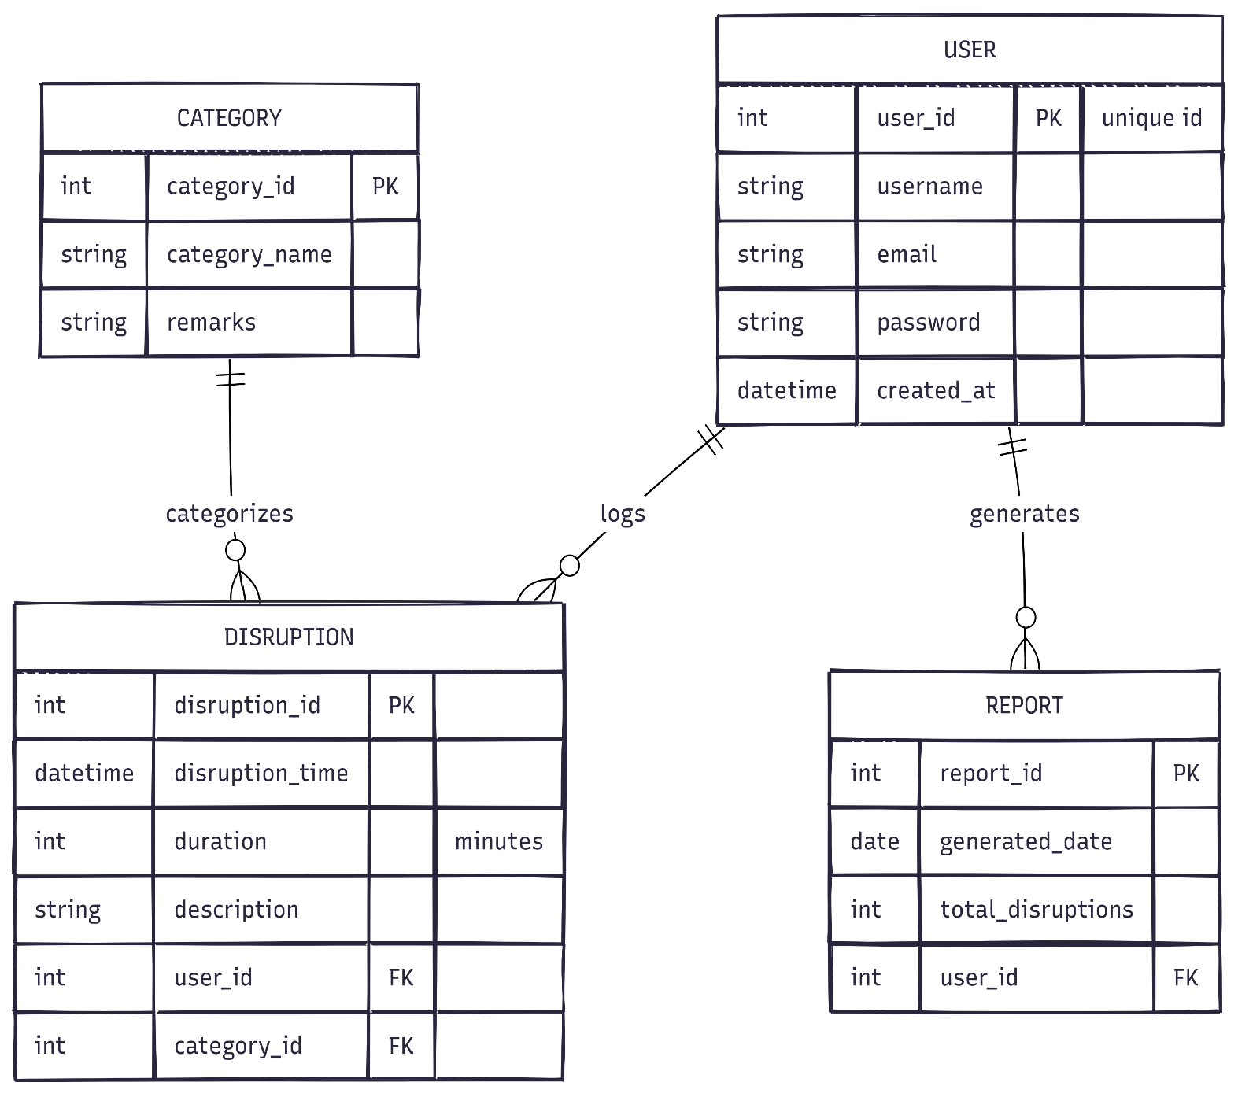

Class Diagram
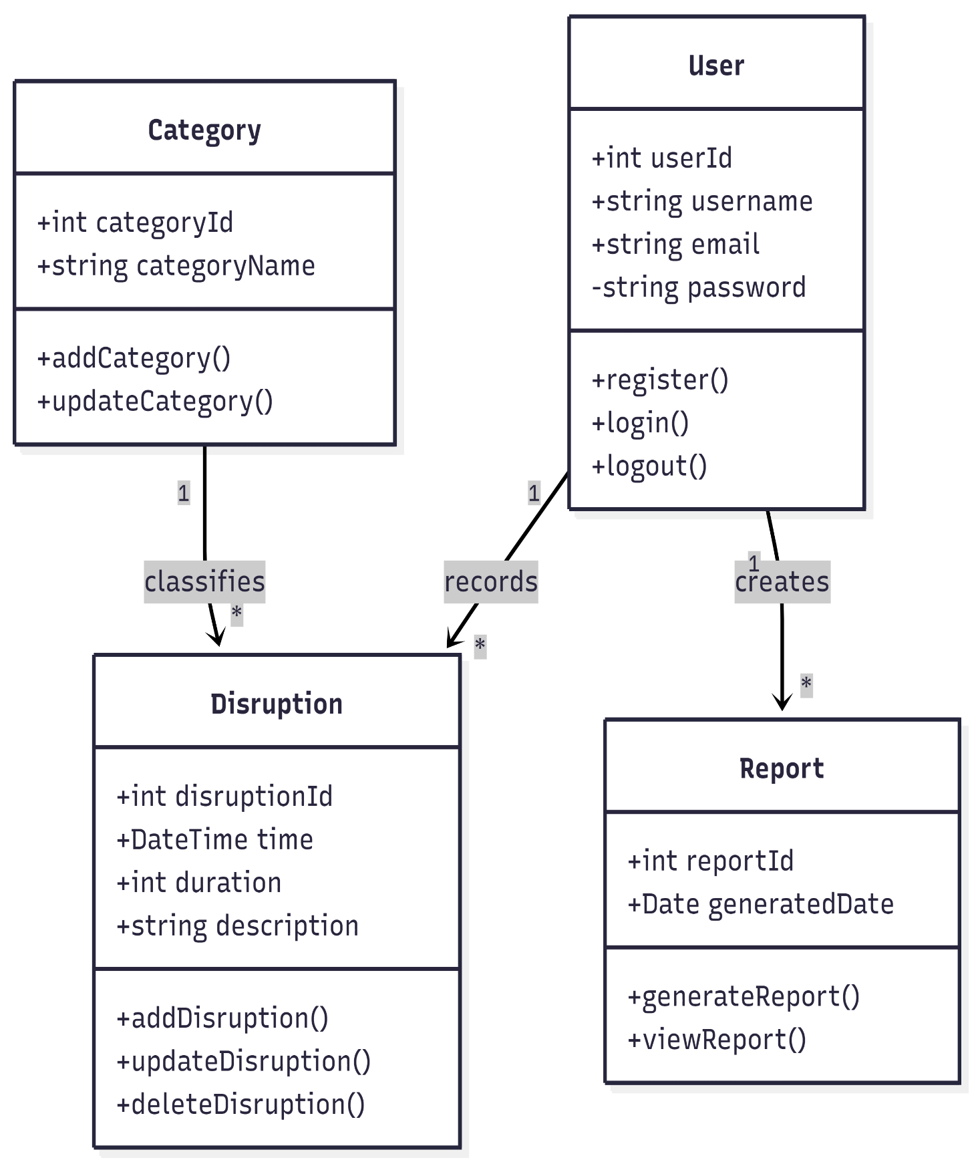
Activity Diagram
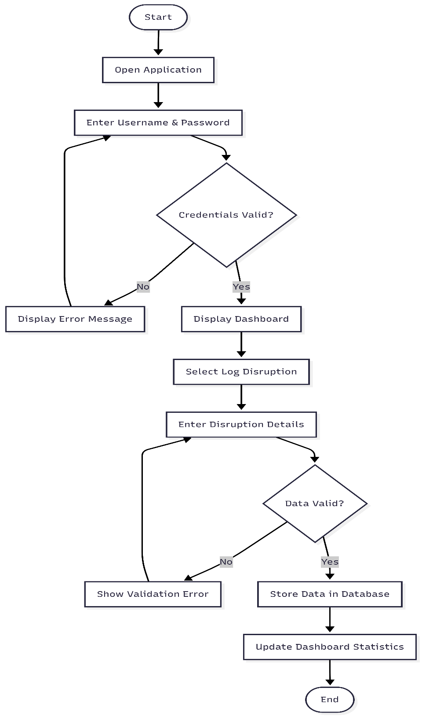

Sequence Diagram
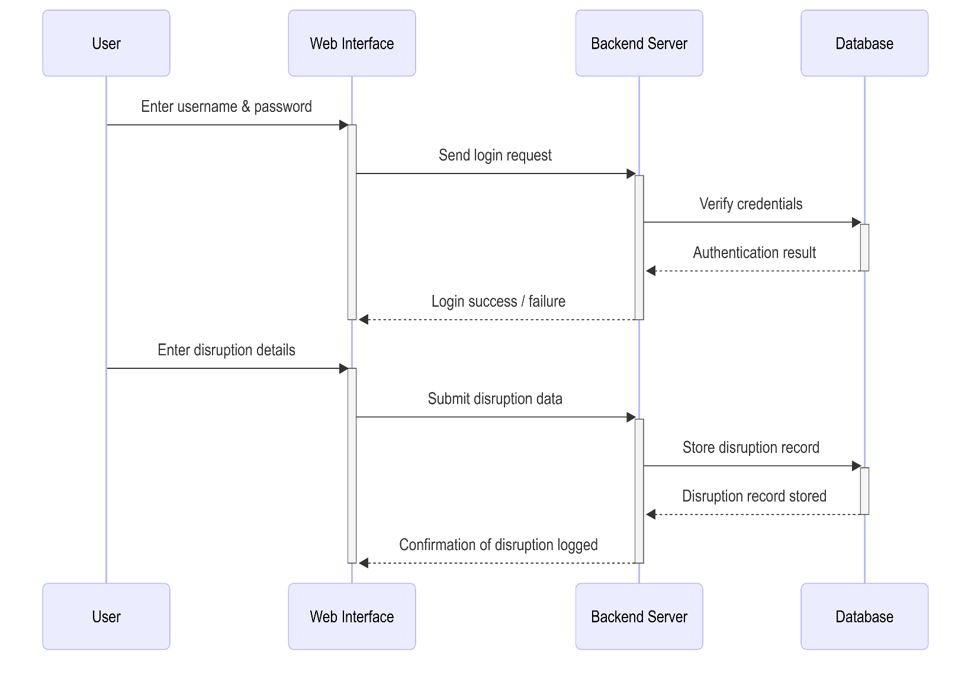

Use Case Diagram

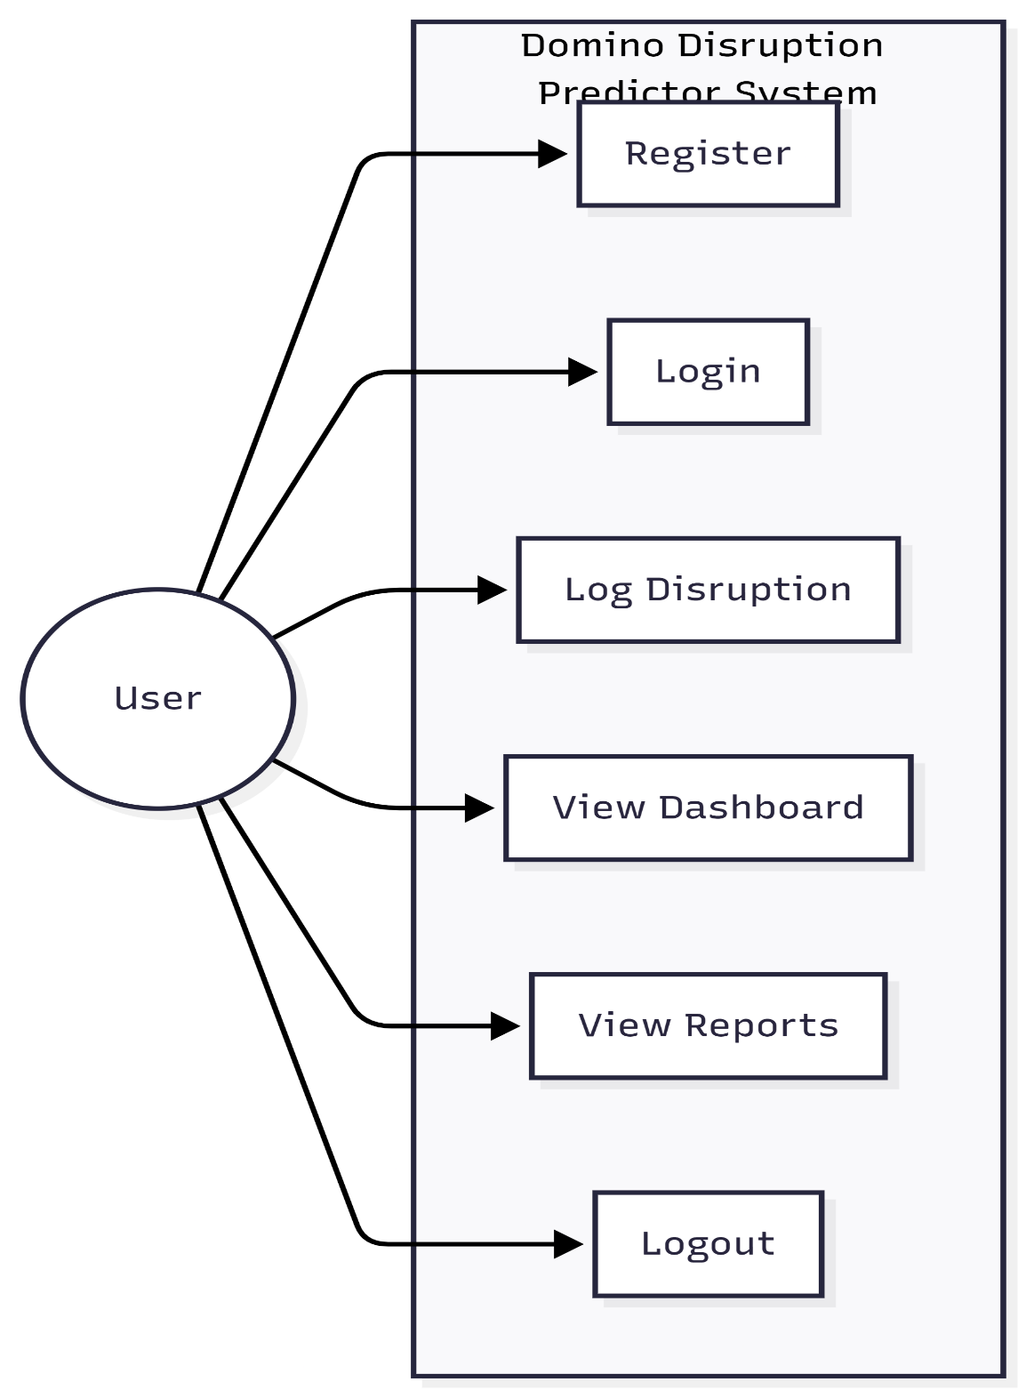

Deployment Diagram

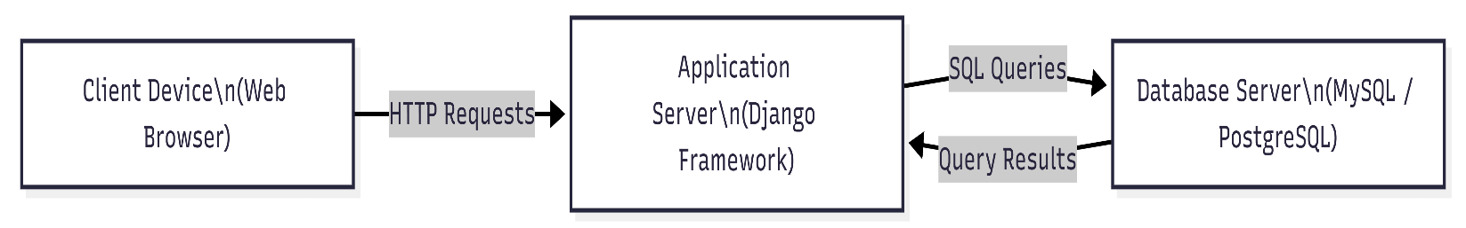

Component Diagram

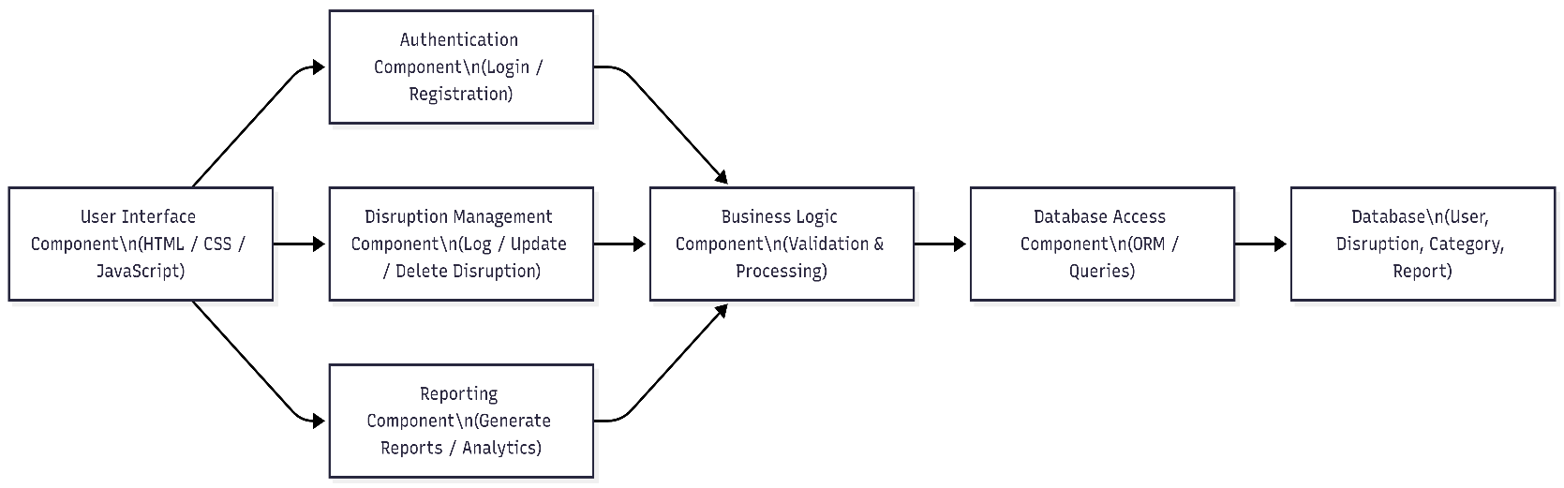

ScreenShots

Login/Sign in Page
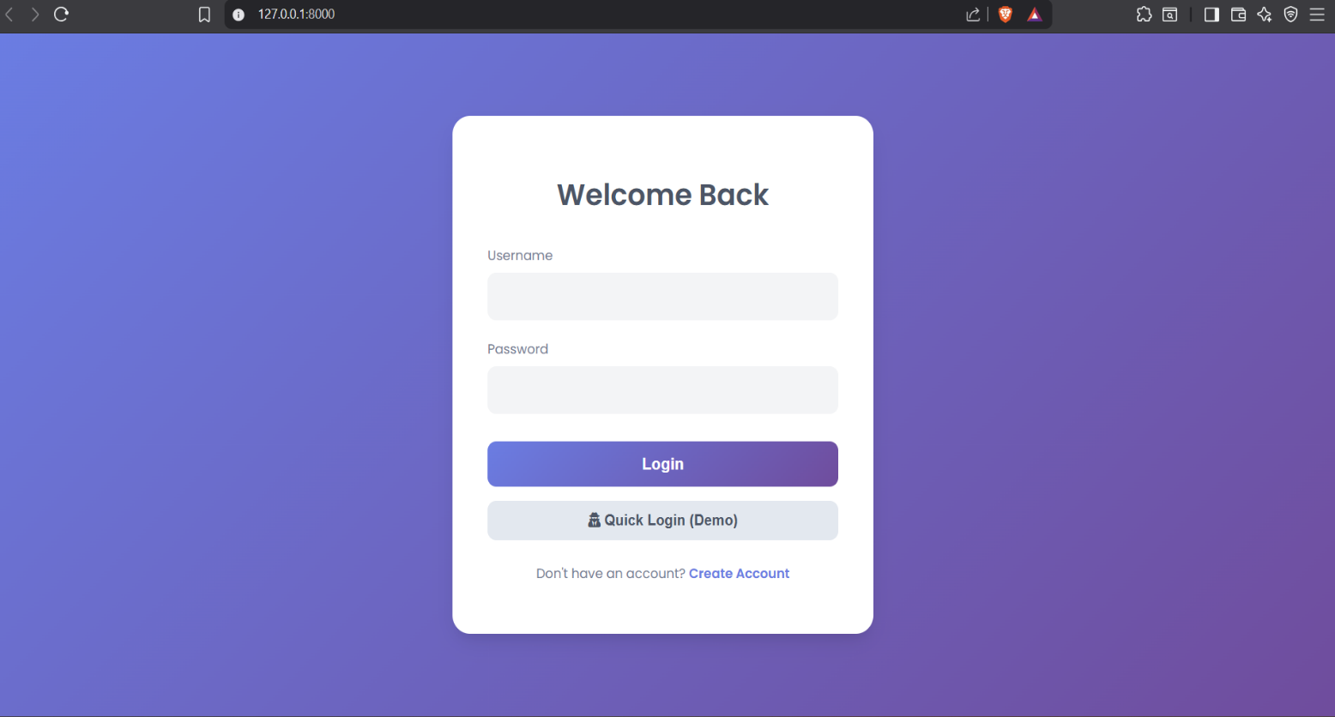
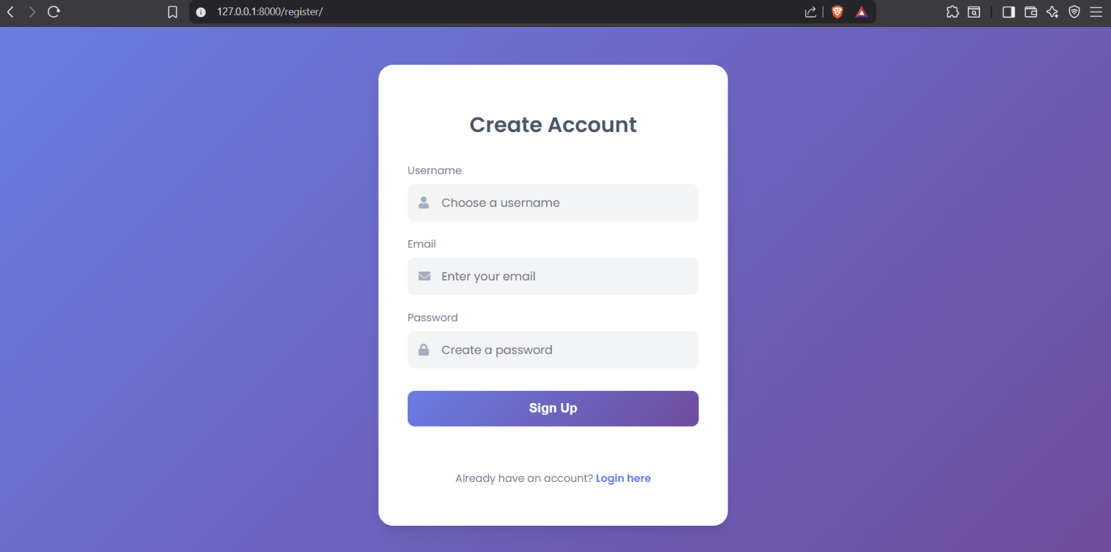
Registration Page

Disruption Log Page
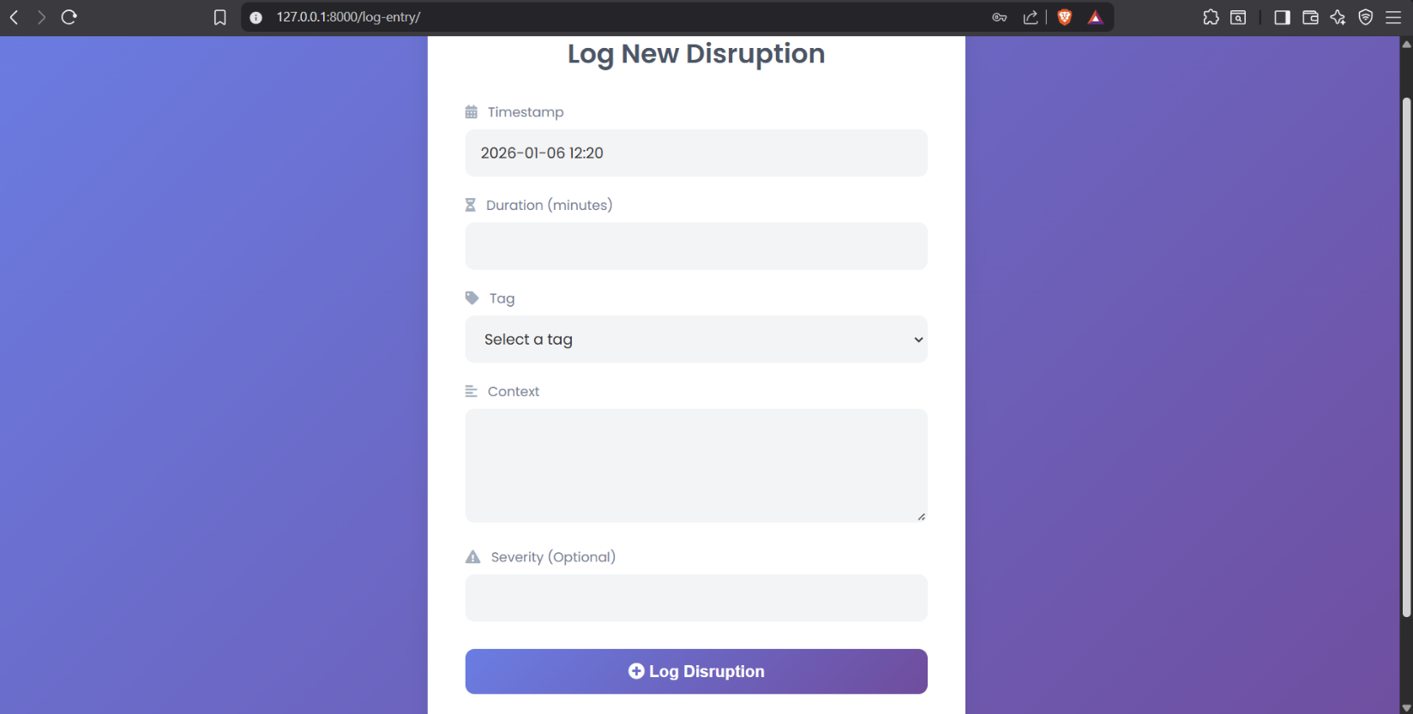

Admin Login
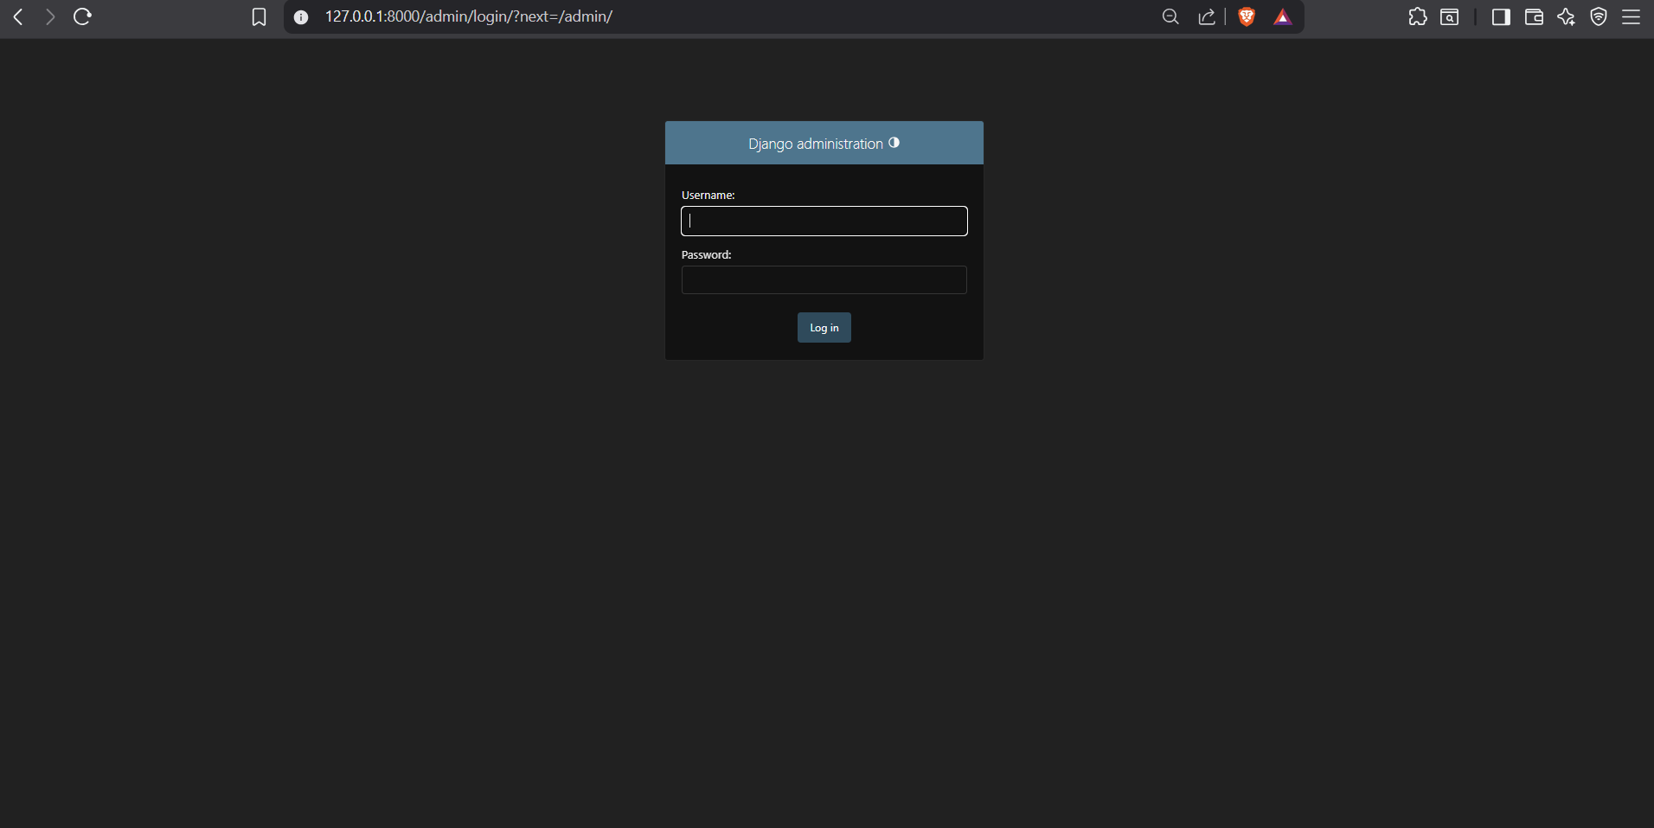

Admin Home
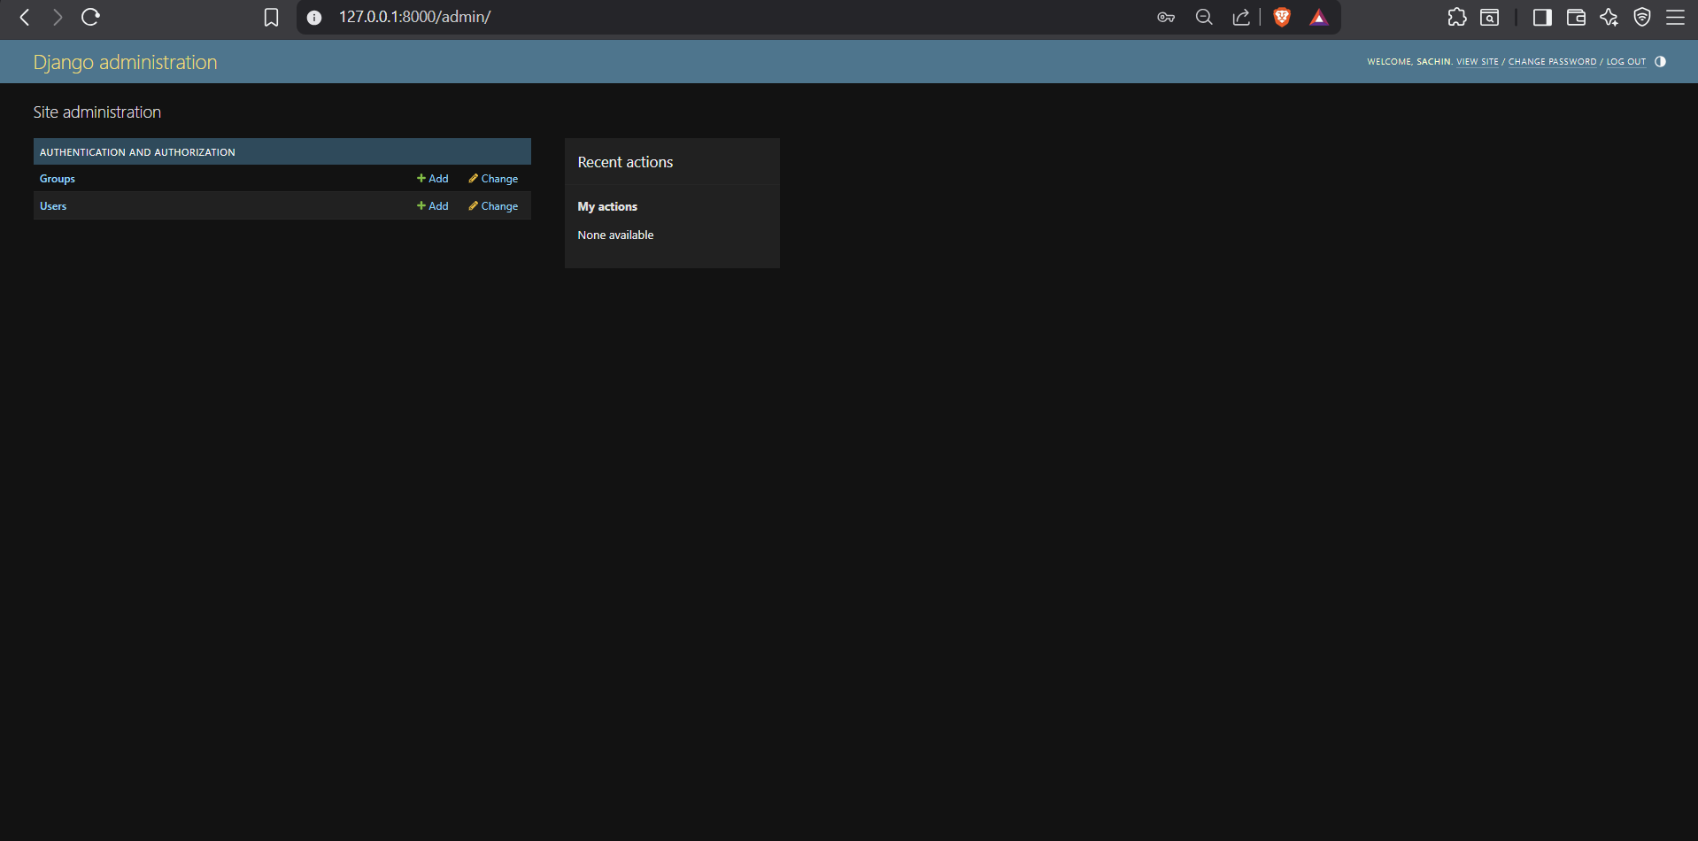
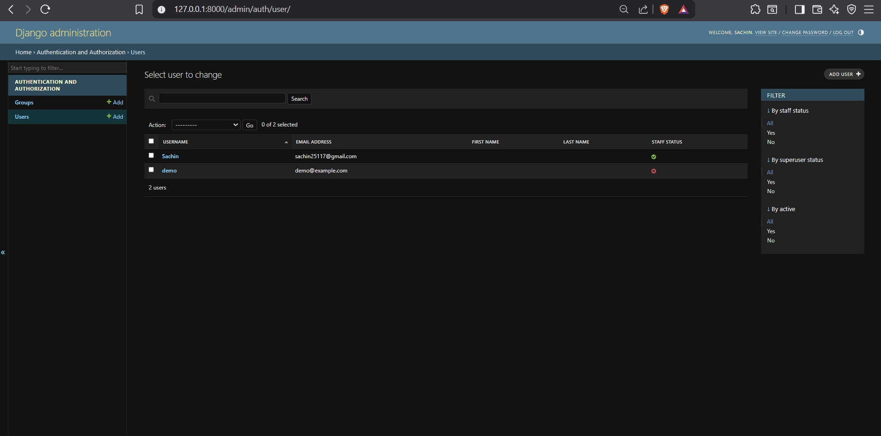
Admin Panel
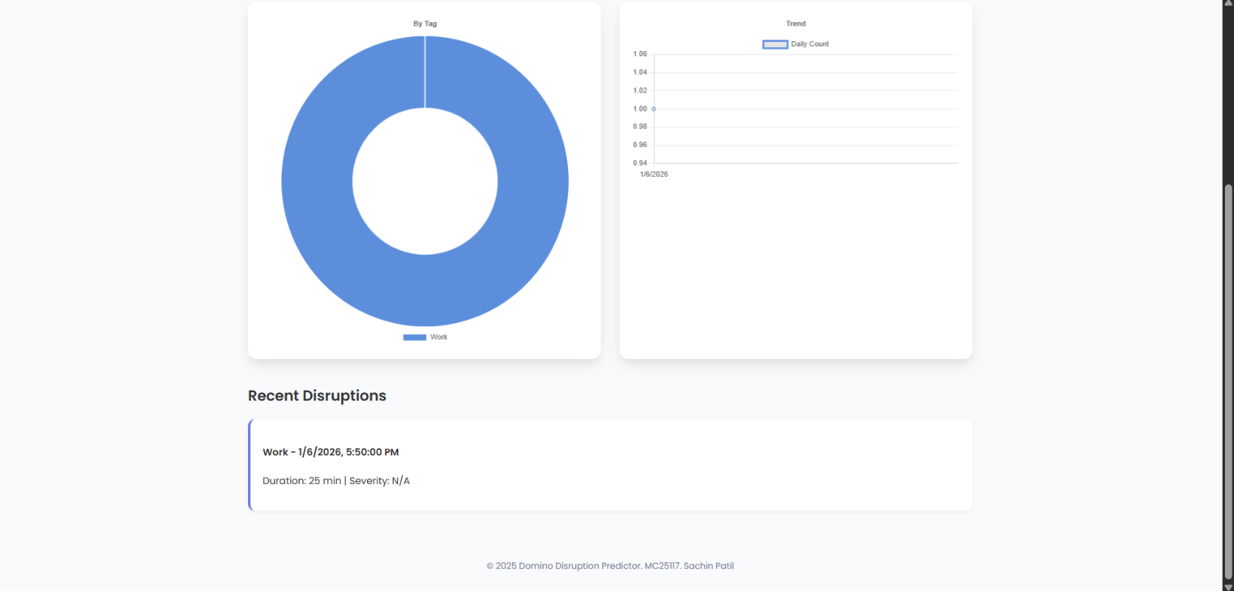
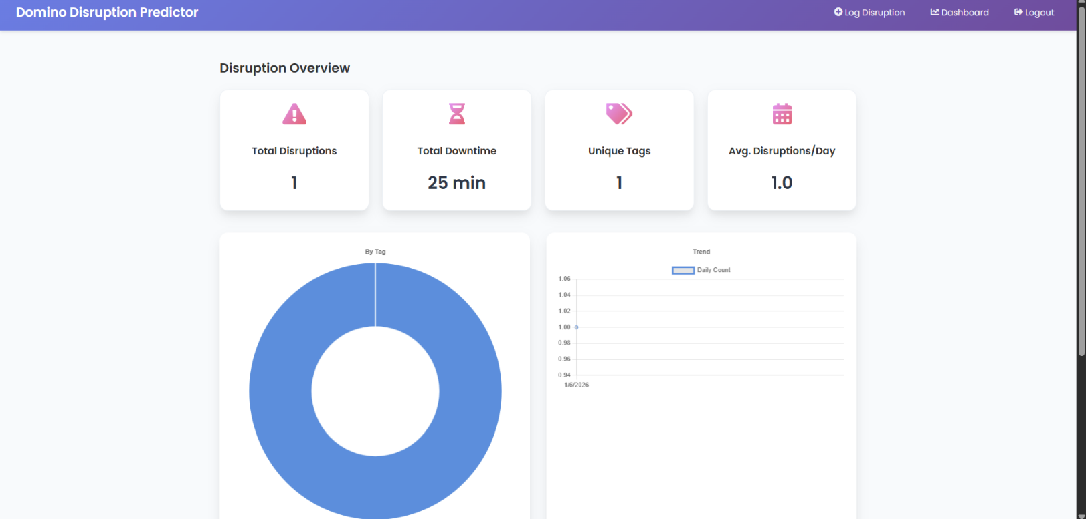
Disruption Dashboard

Data dictionary

User Table:

Field Name | Type | Constraints
User_id | INT | Not null
username | Varchar (50) | Not null
Email | Varchar (100) | Not null
password | Varchar (20) | Not null
Created_at | DateTime | Not null

Disruption Table:

Field Name | Type
disruption_id | INT
user_id | INT
duration | INT
Category_id | INT
description | VARCHAR(255)

Category Table:

Field Name | Type | Constraints
category_id | INT | primary key
Category_name | Varchar (50) | not null
remarks | Varchar(100) | not null

Report Table:

Field Name | Type | Constraints
Report_id | INT | primary key

User_id | Varchar (50) | unique
Generated_date | Date | Not null
Total_disruptions | INT | Not null

Relationship Summary:

Relationship | Description
User-Disruption | One user can log multiple disruptions
Category – Disruption | One category can have multiple disruptions
User – Report | One user can generate multiple reports

Data Constraints:

Constraint Type | Description
Primary Key | Ensures uniqueness of each record
Foreign Key | Maintains relationship between tables
NOT NULL | Prevents empty important fields
Validation | Ensures correct data entry

Reports

- Introduction:
Brief overview of the project and its objectives.
- Project Scope
Define the boundaries and goals of the Domino Disruption Predictor.
- Key Features
List the main features that the system will offer.
- Design and Aesthetics:
- Discuss the design principles and aesthetic considerations incorporated.
- Technological Framework:
Outline the technologies and tools used in developing the system.
- User Experience
Highlight how the system enhances the user experience in DDP.
- Challenges and Solutions

Bibliography And References
Website Reference:

The following websites and online resources were referred to during the study, design, and development of the project. These sources provided conceptual understanding, technical guidance, and academic reference material.

• https://studylib.net/doc/26318288/project

• https://www.studocu.com/in/document/osmania-university/mba/4-tutorialwork/12624017

• https://www.siedykh.com/blog/how-to-implement-user-authentication-and-authorization

• https://www.tandfonline.com/doi/full/10.1080/2331186X.2023.2298607

• https://medium.com/@seekmeai/ai-graded-assessments-the-pros-and-cons-of-automated-grading-00a580e1088e

• https://www.edutopia.org/formative-assessment-part-two

• https://files.eric.ed.gov/fulltext/EJ1337299.pdf

• https://www.geeksforgeeks.org/what-is-scalability-and-how-to-achieve-it-learn-system-design/

• https://teacheducator.com/multiple-choice-questions

