G. NARAYANAMMA INSTITUTE OF TECHNOLOGY AND SCIENCE
(AUTONOMOUS) (For Women)
Shaikpet, Hyderabad - 500 104
II B.Tech. I Semester – II MID Examinations January-2024
Academic Year 2023-2024

SUBJECT: Design and Analysis of Algorithms
SUBJECT CODE: 123AN Max Marks: 30
BRANCH: CSE A, B, C, CSE(AI & ML), CSE(Data Science) Time: 2Hrs
Date: 18-1-2024 (AN)

Blooms Taxonomy Levels:
Level 1 – Remembering, Level 2 – Understanding, Level 3 – Applying, Level 4 – Analyzing,
Level 5 – Evaluating, Level 6 - Creating

PART-A
(Answer all the questions. Each question carries 1 mark) 1 x10 = 10 Marks

S.No.  1 | Question | CO | BT Level
a) | Which algorithmic design technique is used to solve reliability design problem? | CO4 | L-1
b) | Define dominance rule. | CO4 | L-1
c) | Give the time complexity of solving travelling sales person problem using dynamic approach. | CO4 | L-2
d) | What are Explicit and Implicit constraints? | CO5 | L-1
e) | Define an E-Node. | CO5 | L-1
f) | List the three common search strategies used in branch and bound. | CO5 | L-1
g) | What is an Approximation algorithm. | CO5 | L-1
h) | Is P subset of NP? Justify the statement. | CO6 | L-2
i) | List the functions used for writing non- deterministic algorithms. | CO3 | L-1
j) | Give the equation to represent the cost function ‘c ’ satisfying the triangle inequality of TSP problem for all vertices u,v, w Ꞓ V | CO6 | L-1

PART-B
(Answer 04 full questions. Each question carries 5 marks) 4 x 5 = 20 Marks
S.No. | Question | Marks | CO | BT Level
2.a) | Obtain an OBST with equal probabilities for the identifier set (a1,a2,a3)=(if, stop, while) | [3M ] | CO4 | L-3
b) | State weather the Knapsack problem is maximization problem or minimization problem? Justify by elaborating on the problem statement. | [2M ] | CO4 | L-2
3.a) | Compare and contrast Backtracking with Branch and Bound technique. | [2M ] | CO5 | L-2
b) | Draw the portion of the state space tree generated by the following knapsack instance. n=5, (p1, p2, p3, p4. p5) = (10,15,6,8,4),  (w1, w2,w3,w4,w5)=(4,6,3,4,2), m=12. | [3M ] | CO5 | L-3
4.a) | Give the Control abstraction of LC Search strategy. | [2M ] | CO5 | L-1
b) | Solve the travelling salesman problem for the following graph  using branch and bound technique.  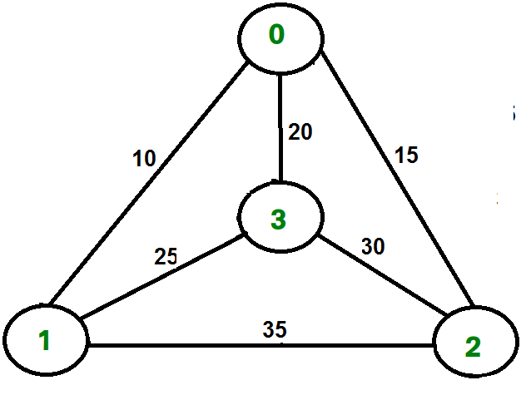 | [3M ] | CO5 | L-3
5.a) | Explain the approximation algorithm to find the vertex cover of a graph, find the minimum vertex cover for the following graph.  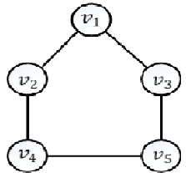 | [3M ] | CO6 | L-2
b) | Define P, NP, NP-Hard, NP-Complete classes and show the relationship between them with a neat sketch. | [2M ] | CO6 | L-1
6.a) | What is triangle-inequality and explain how it is used to solve travelling sales man problem. | [3M ] | CO6 | L-1
b) | Give the deterministic and Non- deterministic algorithms for sorting a set of integers. | [2M ] | CO3 | L-1
7.a) | How many minimum numbers of colors are needed to color the following example graph? Show their assignment by tracing the backtracking algorithm for Graph coloring.  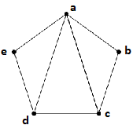 | [3M ] | CO4 | L-3
b) | Prove that satisfiability is in P iff P=NP. | [2M ] | CO6 | L-1

