

UNLOX ACADEMY

NAME : PAVITRABAI
REGISTERED E-MAIL :spavitra863@gmail.com
DOMAIN : EMBEDDED SYSTEM
MINOR PROJECT : Automated Mini Conveyor Belt Speed Regulator

OBJECTIVE:
Create an automated mini conveyor belt system with closed-loop speed control. The system should use an L298N motor driver and an optical proximity sensor to monitor and automatically regulate the conveyor belt speed.

REQURIMENTS:
- Design and simulate the conveyor belt control system.
- Use a DC motor to drive the conveyor belt.
- Use an L298N motor driver for motor control.
- Use an optical proximity sensor to detect objects and/or measure movement.
- Implement closed-loop speed control.
- Automatically adjust the motor speed based on sensor feedback.
- Test and verify the system under different operating conditions.

CIRCUIT CONNECTION (CONNECTION SCREENSHOT)

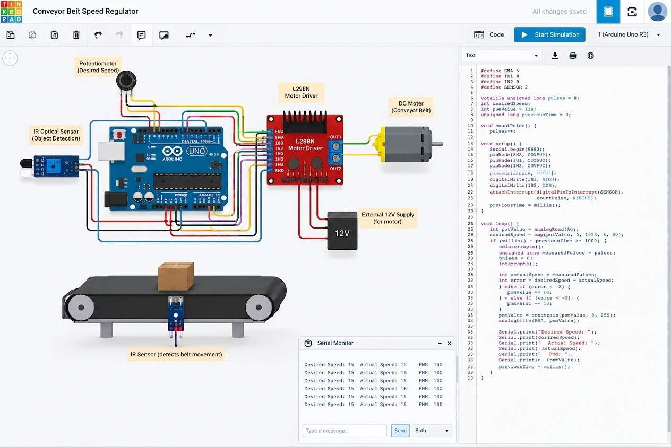

OUTPUT SIMULATION RESULT :
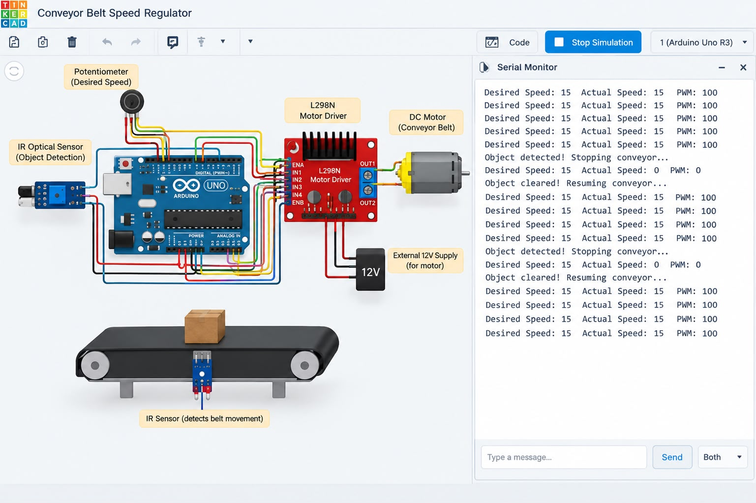

SOURCE CODE:
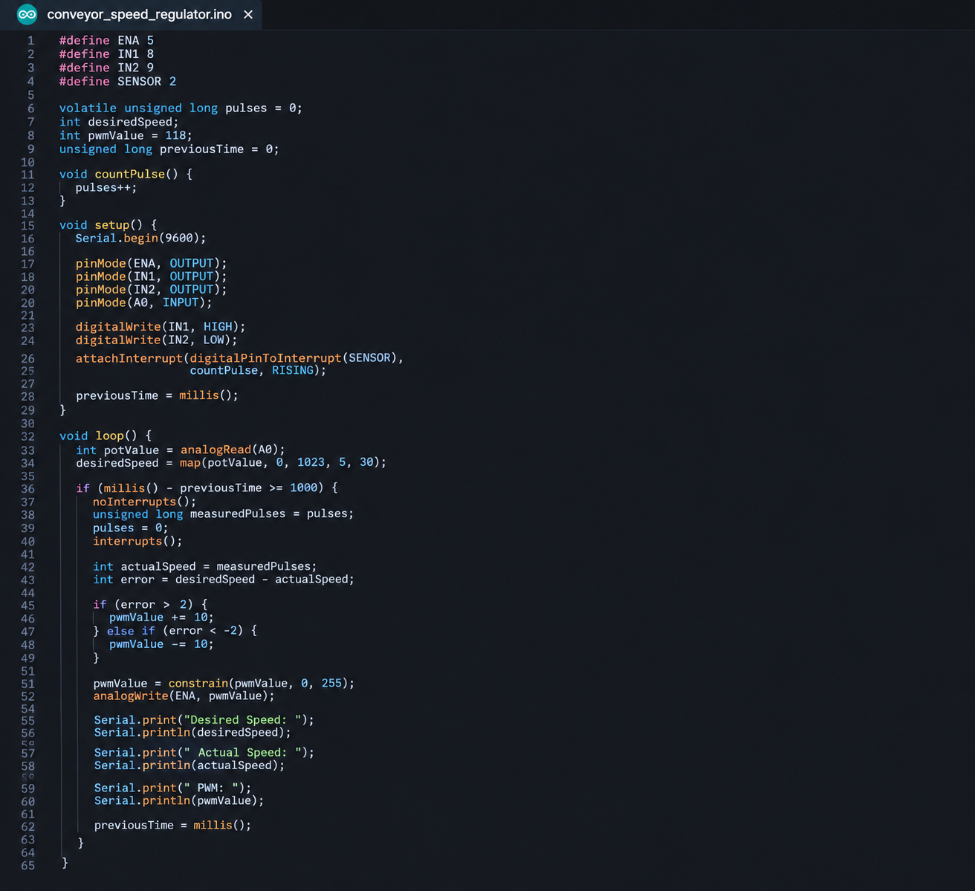

OUTPUT SIMULATION VIDEO LINK :

https://drive.google.com/file/d/1oqElCGr0-9J0WUuf2Q_VBPRqoqBa_lFi/view?usp=sharing

