Neuro Event Labs Oy
Validation of Basic Form Submission
Pavithra Subramaniyam
12-24-2025

Contents
1. Objective 3
2. Interpretation of User Stories 3
3. Scope and rationale 3
3.1. Preferred Locators 4
3.2. Assertions 4
3.3. Determinism 4
3.4. Navigation 4
4. Results of test scenarios 4
4.1. Scenario - 1 5
4.2. Scenario - 2 6
4.3. Scenario - 3 7
5. How to Run the Tests 8
6. Summary 8
Appendix I - Exploratory scenarios 9

Objective
The objective of this assignment was to design and implement automated UI tests based on the provided user stories using Playwright with Typescript. The focus was on validating expected user-interface behavior and demonstrating test-case validation rather than validating the demo application.

Interpretation of User Stories
User stories were treated as the single source of truth. No additional validation rules were assumed beyond these statements. Few requirements like name and email validations were deliberately excluded from tests.
- Scenario: Successful submission with all required fields filled
  - When the user enters a valid value into the First Name field
  - AND the user enters a valid value into the Last Name field
  - AND the user enters a valid email address
  - AND the user submits the form
  - Then the form should be submitted successfully
  - AND no validation error messages should be visible

- Scenario: Submission fails when required fields are empty
  - When the user submits the form without filling ANY fields
  - Then validation error messages should be displayed for required fields
  - AND the form should not be submitted

- Scenario: Invalid email address is rejected
  - When the user enters a valid value into the First Name field
  - AND the user enters a valid value into the Last Name field
  - AND the user enters an invalid email address
  - AND the user submits the form
  - Then a validation error message should be displayed for the Email field
  - AND the form should not be submitted
Still for the clearly visible implementation gaps, few more scenarios were added in the appendix, on my own interest.

Scope and rationale
Each test validates a single behavior to ensure clear failure reasons. Both positive and negative paths were covered as required by the user stories.
- Included:
  - Successful form submission with valid data
  - Required field validation behavior
  - Invalid email format handling
- Excluded:
  - Name field character or length validation
  - Email domain existence validation
  - UI styling or visual checks
These exclusions were intentional due to lack of explicit requirements from the user stories. Functional helper methods were used instead of Page Object Model to reduce complexity while eliminating repetitive code.

Preferred Locators
- Role-based locators (getByRole()) for interactive elements such as buttons and links
- Label-based locators (getByLabel()) for form controls where labels are semantically associated with inputs
- Text-based locators (getByText()) for locating elements that contain given text
In certain cases, semantic locators were not applicable due to the structure of the demo application. In such cases, CSS-based locators were used (e.g. survey root container).

Assertions
Playwright includes test assertions in the form of expect function. To make an assertion, call expect(value) and choose a matcher that reflects the expectation. There are many generic matchers like toEqual, toContain, toBeTruthy that can be used to assert any conditions. The following Playwright assertions are used in this assignment:
- toBeVisible()
- not.toBeVisible()
- toBeDisabled()
- toBeChecked()
- not.toBeChecked()

Determinism
The tests are deterministic because they rely on Playwright’s auto-waiting and UI state assertions rather than fixed delays or timing assumptions.

Navigation
Added navigation to simple form instead of visiting the URL directly to increase reusability (for other forms)

Consistency
All tests in this assignment follow a consistent structure and style. The same test flow, naming conventions, helper and assertion usage are used throughout the suite to keep the code easy to read and maintain.

Results of test scenarios
Some tests are expected to fail because the demo application have not fully implemented the behaviors described in the user stories. These failures highlights identification of missing functionality using the automated testing implementation rather than issues with the application.
Application under test: https://formio.github.io/angular-demo/#/

Scenario - 1
SCENARIO |  | Successful submission with all required fields filled
1 | Script ID |  | TID-01
2 | Objective |  | When all the required fields are filled, the form should be submitted successfully without any validation error messages
3 | Preconditions
 | 1 | User has access to a supported browser
4 | Test Data
 | 1 | Username: Pavithra
 | 2 | Password: Subramaniyam
 | 3 | Email: example@example.com
5 | Script Steps
 | 1 | Open the Form.io demo application
 | 2 | Navigate to the Simple Form
 | 3 | Enter a valid value in the First Name field
 | 4 | Enter a valid value in the Last Name field
 | 5 | Enter a valid email address in the Email field
 | 6 | Click the Submit button
6 | Expected Results
 | 1 | The form should be submitted successfully
 | 2 | Success message should be displayed
7 | Status |  |  | Passed

Scenario - 2

SCENARIO |  | Submission fails when required fields are empty
1 | Script ID |  | TID-02
2 | Objective |  | When the user submits the form without filling any required fields, validation error messages should be displayed and the form should not be submitted.
3 | Preconditions
 | 1 | User has access to a supported browser
4 | Test Data
 |  | No data required
5 | Script Steps
 | 1 | Open the Form.io demo application
 | 2 | Navigate to the Simple Form
 | 3 | Click the Submit button without entering any values
6 | Expected Results
 | 1 | Validation error messages should be displayed for required fields
 | 2 | The form should not be submitted
7 | Status |  |  | Failed
8 | Comments |  |  | validation not enforced in demo application

Scenario - 3

SCENARIO |  | Invalid email address is rejected
1 | Script ID |  | TID-03
2 | Objective |  | When an invalid email address is entered, a validation error message should be displayed and the form should not be submitted.
3 | Preconditions
 | 1 | User has access to a supported browser
4 | Test Data
 | 1 | Username: Pavithra
 | 2 | Password: Subramaniyam
 | 3 | Email: invalid-email
5 | Script Steps
 | 1 | Open the Form.io demo application
 | 2 | Navigate to the Simple Form
 | 3 | Enter a valid value in the First Name field
 | 4 | Enter a valid value in the Last Name field
 | 5 | Enter an invalid email address in the Email field
 | 6 | Click the Submit button
6 | Expected Results
 | 1 | Email validation error message should be displayed
 | 2 | The form should not be submitted
7 | Status |  |  | Failed
8 | Comments |  |  | submission not blocked in demo application

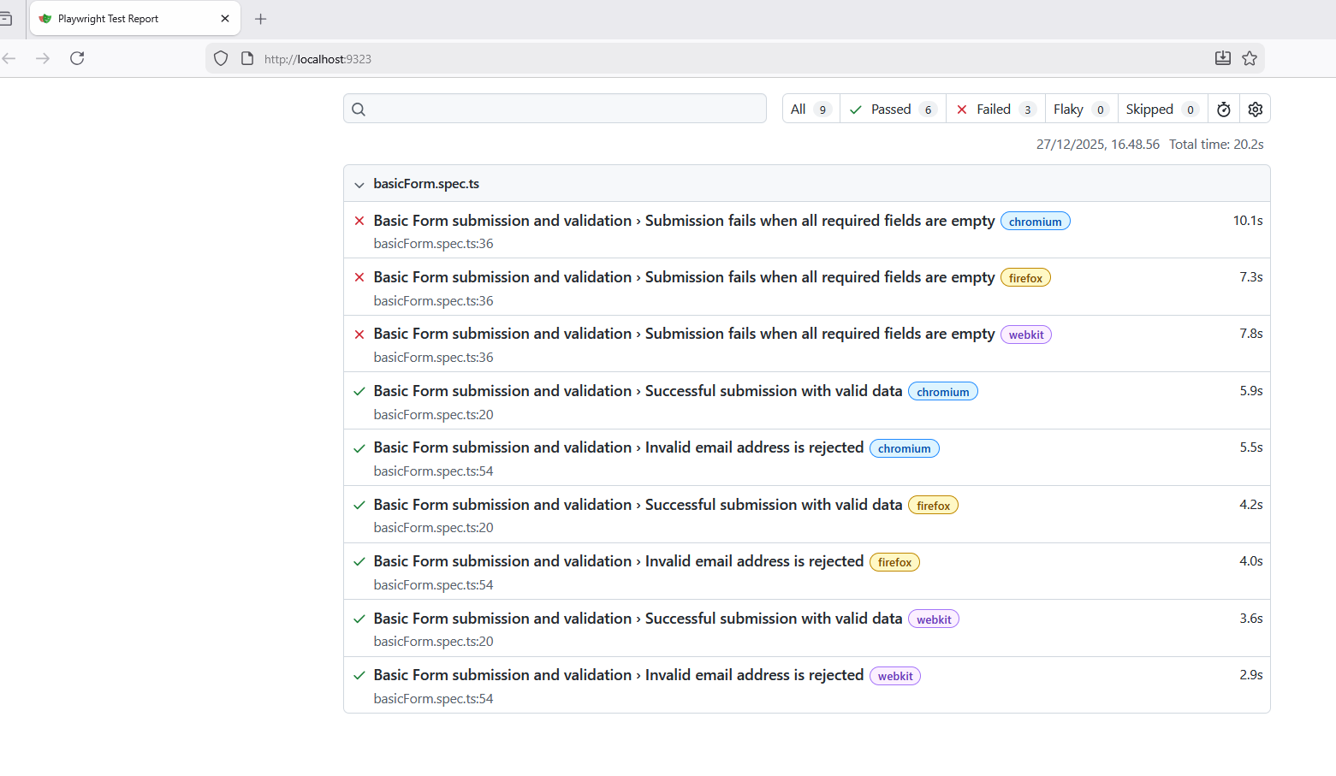
Figure 1. Test report of user story based test cases

How to Run
Click on : https://github.com/spavythra/Playwright_practice
I have two folders
- BasicForm_strict is the user requirement story
- BasicForm_extended is my addition

cd .\BasicForm_strict
npm install
npx playwright test
To open UI mode, run the following command in your terminal:
npx playwright test --ui

Summary
This assignment demonstrates a requirement-driven testing approach with the given test application. The emphasis was on implementing all user stories, using sensible locators, deterministic test, meaningful assertion and consistent code, furthermore extra stories are added in Appendix based on my interest.

Appendix I - Exploratory scenarios

In addition to the assignment required tests, a small set of extended tests is included to express my interest and product understanding. These tests are clearly separated from user-story-driven tests (assignment needs) and derived based on reasonable UI observations (e.g., required fields, radio button behavior). Code is available in GitHub and README also explains the details.
Derived test suite
- Submission is unsuccessful when First Name is missing
- Submission is unsuccessful when Last Name missing
- Submission is unsuccessful when Email is missing
- Submission is successful when all the survey questions are answered
- Survey questions allow only one option to be selected per question
- Submission is unsuccessful when one or more survey questions are left unanswered

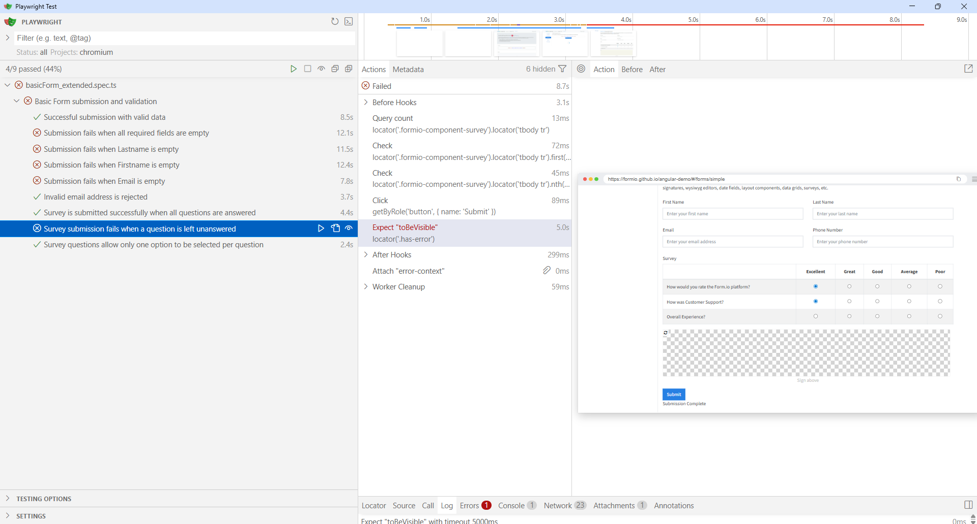
Figure 2. Test execution UI for extended test case showing the results

