Comparative analysis amongst four endemic Coronaviruses for identifying structural similarities:

Four published crystal structures of HCoV 229E, NL63, OC43, and HKU1 strains at ∼1 Å were identified from RCSB PDB with id’s 7e6r, 5zhy, 5gnb, and 4j3k [1]. The structures were superimposed with Smit-Waterman technique to generate figure 1.

Figure 1: A. Superimposed structures of 229E, NL63, OC43, and HKU1 strains for identifying similar domains. B. View of aligned residues C. Sequence alignment.

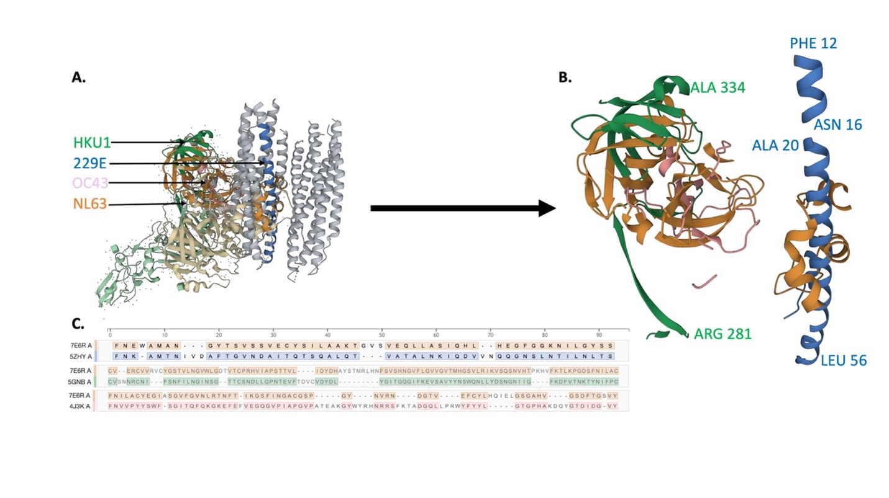

Table 4 summarizes structure identity parameters for aligned residues. We found several interesting and important residues conserved amongst 4 strains (figure 1C). Some like I54, L55, S59 (from 5zhy) have been observed to be conserved amongst HCoV-229E, NL-63, mouse hepatitis virus (MHV), severe acute respiratory syndrome (SARS) and middle east respiratory syndrome coronavirus (MERS) strains [2]. Some of these residues are essential to form an interface of strong hydrophobicity. Overall structures and conserved fusion cores can help with the possibility for broad-spectrum inhibitor design targeting proteins of major HCoV strains.

Table 1: Structure identity parameters for 229E, NL63, OC43, and HKU1 strains.

|  |  |  |  |  |
| --- | --- | --- | --- | --- |
| *Strain PDB ID (Reference: 7e6r)* | *Root Mean Square Deviation (RMSD)* | *Sequence Identity (%)* | *Equivalent Residues* | *Target Coverage (%)* |
| 5zhy | 16.56 | 34 | 50 | 56 |
| 5gnb | 19.57 | 31 | 87 | 24 |
| 4j3k | 11.02 | 42 | 65 | 49 |

Reference:

1. RCSB Protein Data Bank: powerful new tools for exploring 3D structures of biological macromolecules for basic and applied research and education in fundamental biology, biomedicine, biotechnology, bioengineering and energy sciences (2021). Nucleic Acids Research 49(437–D451). doi: 10.1093/nar/gkaa1038
2. Zhang, W., Zheng, Q., Yan, M., Chen, X., Yang, H., Zhou, W., & Rao, Z. (2018). Structural characterization of the HCoV-229E fusion core. Biochemical and biophysical research communications, 497(2), 705–712. https://doi.org/10.1016/j.bbrc.2018.02.136