CMSC 345

Software Design and Development

Fall 2013

System Design Document

[Team name: Cava++ Product name: Coolgles]
System Design Document

Table of Contents

Page

1. Introduction

  - Purpose of This Document 3
  - References 3

- System Architecture

2.1 Architectural Design 3
2.2 Decomposition Description 3

3. Persistent Data Design

3.1 Database Descriptions 19
3.2 File Descriptions 19

- Requirements Matrix 23

Appendix A – 24
Team percent contribution, Team sign-off, Customer acceptance

UML Diagram 26
1. Introduction
1.1 Purpose of This Document

This document provides a comprehensive architectural overview of the application, using a number of different architectural views to depict different aspects of the application. These document present detailed descriptions of an application that will help a traveling salesman determine the shortest distance between groups of locations. This document is intended to be used for the user and the team developing the application.

1.2 References
"Example of Software Design Document(SDD)." Example of Software Design Document(SDD). N.p., n.d. Web. 14 Oct. 2013.

2. System Architecture

2.1 Architectural Design

When the user starts the application, the program starts in the Driver class, which first creates a User Interface (UI) class to display a loading screen. It then starts the central Application (App) class, which itself initializes the rest of the components.

The UI class is the intermediary between the App and the display, and by extension, the user. The User Authentication (UA) class uses text files to authenticate a user's login. The File Manager (FM) class parses and encodes previous searches from files unique to each user. The Search Manager (SM) class performs the graph search algorithm to maximize the efficiency of a search. The KML Creator (KMLC) class creates a KML file to be sent to the Google Earth application. The App class passes information between all of the other classes, as well as stores the currently selected search.

2.2 Decomposition Description

This project has 3 main components that can be broken into subcomponents.
These 3 main components are the functions, files, and classes. We will use these to describe the design for our program.

These subcomponents make up our application to simulate a Google routing program for a user to interact with. These functions in our class will define what any specific class is to accomplish. They will also help to modify our files to the user’s actions. The files for this application are used to store data for previous searches, UID’s, and, our locations. Our classes will represent the objects needed for our program so our user can interact with the Google earth application. With all of these subcomponents we can build our software application that will simulate a Google routing application.
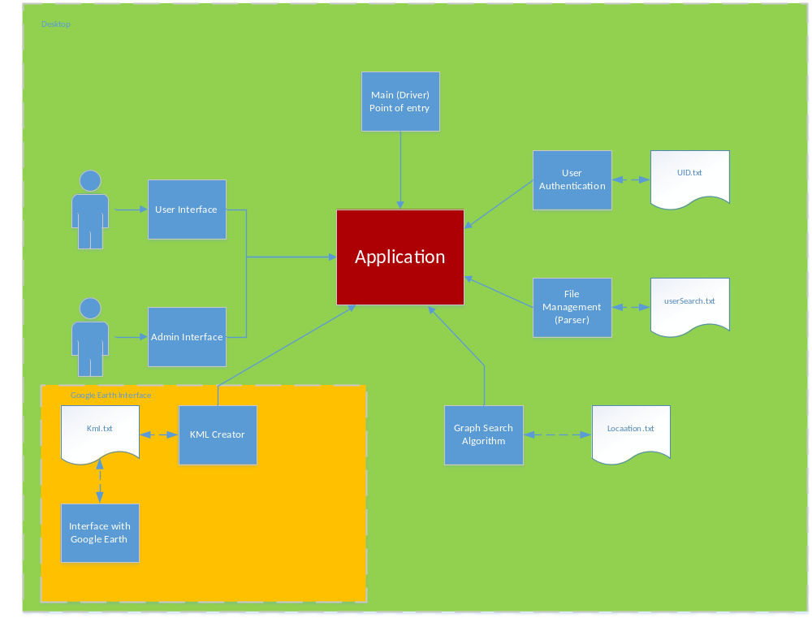

* Patch (V.1.0)

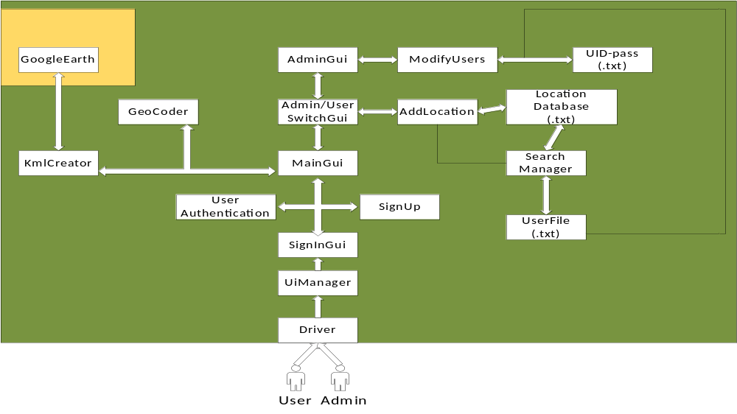
*Patch (V.2.0)
* Patch (V.1.0)

Driver Class (Point of entry) //rename
Data Members:
- UIManager UI
- FileManager FileM
- UserAuthenticationManager UAM
- SearchManager SearchM
- KMLCreationManager KMLCM
- Application CommandCentral (rename)
Member Functions:
main();
Initializes UIManager first (loading screen)
Initializes FileManager
Initializes UserAuthenticationManager
Initializes SearchManager
Initializes KMLCreationManager
Initializes Application (passing managers for construction)

class UIManager (Research UI libraries)
Data Members:
- Application CommandCentral
- Window (where current screen is displayed)
- Screens (containing buttons, dropdowns, etc.)
  - LoadScreen
  - LoginScreen
  - SearchSelectionScreen
  - OutputScreen (?)
Member Functions:

UIManager()
- Initializes Screens
- Sets current screen to Load screen
- Opens new Window
- sets a bit saying CentralCommand has not been Initialized

setApp(Application callback) //perhaps use this to switch out of LoadScreen
- checks to make sure CC has not been initialized
- sets CentralCommand to callback
- flips bit saying CC has been initialized

Accessors:
- currentScreen()
- validToSwitchTo() (?)

Button functions:
- private
- Pass data to CommandCentral, pulling data from textboxes, dropdown lists, etc.

pushPrevSearchList(List searches):
- public
- called by CommandCentral
- searches is a list of strings, formatted to the form to be displayed in dropdown
- UIManager sets the strings in searches as items in dropdown
- flips a switch that says it is now valid to change current screen to SearchSelectionScreen

switchTo(String screenName)
- Checks to make sure it is valid to switch to screenName
- Sets current screen to screen parsed from screenName

class UserAuthenticationManager
Data:
String UNPWFile;
String AdminPWFile;
Functions:
UserAuthenticationManager(Strings filenames)
- Initializes UAM
- Saves strings

authenticateUser(String username, String password)
- Opens UNPW file
- checks validity of password
- Closes UNPW file
- returns a bool

authenticateAdmin(string username, string password)
- Same as authenticateUser, except uses AdminPW file

class FileManager
Data:
const String LocFileName;
File currentUsersFile;
Functions:
(constructor) : Initializes the FileManager

loadLocs(): Loads/parses locations from location file(s)
loadUser(userID): parses userID to a filename, Loads/parses previous searches from file
addSearch(userID, search): parses search to a string, inserts into currentUsersFile
closeUser(userID): closes currentUsersFile

class SearchManager
Data:
None
Functions:
(constructor): does nothing
search(search): modifies search into an ordered search

class KMLCreator
Data:
String filename
Functions:
String makeFile(search); modifies contents of file at filename to form Google Earth can understand

class Application
Data:
UIManager UI;
FileManager FileM
UserAuthenticationManager UAM
SearchManager SearchM
KMLCreator KMLCM
List<location> locations;
String currentUser;
search currentSearch;
List<search> prevSearch;

Functions:
Application(UIManager UI): (constructor) initializes other managers, loads location data, then signals UI that it has finished loading;
boolean login(String username, String password, boolean admin): passes data to UAM; loads searches using FileM and returns true on success, returns false otherwise
functions for manipulating currentSearch
function for setting current search to some specified search in prevSearch
function for enacting a search submit
function for logging out a user

* Patch (V.2.0)

Driver Class (Point of entry) //rename
Data Members:
- UIManager UI

Member Functions:
main()
Initializes UIManager (loading screen)

class UIManager (Research UI libraries)
Data Members:
1. logInPage
Member Functions:
Constructor()
Call displayLogInGui()
displayLogInGui()
Initialize SignInGui logInPage
Set logInPage visible

class UserAuthenticationManager
Data:
String USERFILE
Name of the file that contain user's information
Int MAX_USERS

Functions:
Boolean logUser(String userName, char[] password, type)
- Check validity of password
- Check the user type (user / admin)
- Return true if validate
Boolean addUser(String name, String pass, String email)
- Pass parameter with user type to addUserWithType
- Return validity of addUserWithType
Boolean addUserWithType(String name, String pass, String email, init userType)
- Write user Information to USERFILE, if MAX_USERS not reached
- Create user's data file only if it is not exist
- Return true if successfully added
removeUser(String userName, removeFile)
- Delete user information from USERFILE
- Delete user's data file
String getEmail(String userName)
- Read user's email address from USERFILE
- Return user's email
String getPassword(String userName)
- Read user's password from USERFILE
- Return user's password
String getType(String userName)
- Read user's Type from USERFILE
- Return user's Type
ArrayList<String> getNames()
- Read users' name list from USERFILE
- Return sorted list
updateUser(String oldUserName, String userName, String userPass, String userEmail, int userType)
- Remove older user name information from USERFILE
- Write user's new information into ISERFO:E
Boolean userExists(String userName)
- Call getNames() to get the list of users name
- Check if userName is exist or not
- Return true if userName is exist

class FileManager
Data:
String PATH
Int MAX_PREVIOUS_TRIPS
String SUFFIX
Functions:
Search getPrev(String userName, int SearchIndex)
- Get userName's information from it's file
- Get data when the index of data match to SearchIndex
- Return previous search
Boolean isFull(File file)
- Check the previous Search list reach MAX_PREVIOUS_TRIPS
- Return true if file is full
addSearch(Search search)
- Add search data to user's history
removeUserFile(String userName)
- Remove user's file
Boolean userFileExists(String userName)
- Check if the user's file exist
- Return true if found user's file
addUserFile(String userName)
- Create user's file if not exist

class AddLocationGui
Data:
Int status;
adminGui m_main
javax.swing.JLabel addLocationLabel;
javax.swing.JLabel loAddressLabel;
javax.swing.JLabel loCityLabel;
javax.swing.JLabel loLatLabel;
javax.swing.JLabel loLongLabel;
javax.swing.JLabel loNameLabel;
javax.swing.JLabel loStateLabel;
javax.swing.JTextField loAddressText;
javax.swing.JTextField loCityText;
javax.swing.JTextField loLatText;
javax.swing.JTextField loLongText;
javax.swing.JTextField loNameText;
javax.swing.JTextField loStateText;
javax.swing.JButton saveLocationBtn;
Class AddLocationGui(cont)
Functions:
Constructor(adminGui mainFrame)
- Call setUpGui()
- Add location to file system and gui
Constructor(Location newLocation, adminGui mainFrame)
- Call setUpGui()
- Add newLocation to Gui
Constructor(Location newLocation)
- Add newLocation to file system
setUpGui()
- Set up the gui screen
initComponents()
- Initializing all the components
saveLocationBtnActionPerformed(java.awt.event.ActionEvent evt)
- If status = 1, just save the data
- If status = 0, launch geocoder to confirm the data

class adminGui
Data:
ArrayList<Location> locationList
String user
javax.swing.JList jList1;
javax.swing.JList locationDisplay;
javax.swing.JList userDisplay;
javax.swing.JScrollPane jScrollPane1;
javax.swing.JScrollPane jScrollPane2;
javax.swing.JScrollPane jScrollPane3;
javax.swing.JButton loDelBtn;
javax.swing.JButton loModiSelectBtn;
javax.swing.JButton newLocaBtn;
javax.swing.JButton switchUserBtn;
javax.swing.JButton userDelBtn;
javax.swing.JButton userModifyBtn;
javax.swing.JLabel label1;
javax.swing.JLabel label2;
javax.swing.JLabel loModifyLabel;
javax.swing.JLabel userModifyLabel;
javax.swing.JLabel welcomLabel1;
javax.swing.JLabel welcomLabel2;
Class adminGui (cont)
Functions:
Constructor(String userName)
- Create Gui for admin
newLocaBtnActionPerformed(java.awt.event.ActionEvent evt)
- Initialize AddLocationGui addLoc
- Set addLoc to visible
logOut()
- Initialize SignInGui logout
- Set adminGui to not visible
- Set logout to visible
userModifyBtnActionPerformed(java.awt.event.ActionEvent evt)
- Call modUser()
userDelBtnActionPerformed(java.awt.event.ActionEvent evt)
- Call delUser()
modLocaBtnActionPerformed(java.awt.event.ActionEvent evt)
- Initialize addLocationGui addLoc
  - Modify exist location
- Set addLoc visible
switchUserBtnActionPerformed(java.awt.event.ActionEvent evt)
- Initialize userSwitchGui switchToUser
  - Only if user is not a default admin
- Set userSwitchGui visible
delLocaBtnActionPerformed(java.awt.event.ActionEvent evt)
- Delete selected location
initComponents()
- Initialize all the components
populateUserList()
- Initailize DefaultListModel listModel
- Put all username to listModel
populateLocationList()
- Initailize DefaultListModel listModel
- Put all Location to listModel
editLocation(Location newLoc)
- Edit/replace old location to newLoc
recreatDatabase()
- Update/syncs the locationDatabase.txt file
modUser()
- Initialize modifyUsersGui modUser
- Set modUser visible
delUser()
- Confirm before delete user
- Delete user infromation from database

class adminSwitchGui
Data:
String user
mainGui mainFrame
javax.swing.JLabel label;
javax.swing.JLabel logoLabel;
javax.swing.JLabel pswdLabel;
javax.swing.JPasswordField pswdText;
javax.swing.JButton switchBtn;
Functions:
Constructor(mainGui m_main, String userName)
- set up the Gui
- syncs mainFrame with m_main
initComponents()
- initialize all components
switchBtnActionPerformed(java.awt.event.ActionEvent evt)
- initialize adminGui adminView
- set mainFrame to not visible
- set adminView to visible

class Coord
Data:
Double latitude
Double longitude
Functions:
Constructor()
- initialize longitude, latitude to 0
constructor(double latitude, double longitude)
- initialize longitude, latitude
constructor(String latitude, String longitude)
- change latitude, longitude to double
- initialize longitude and latitude
double getLatitude()
- return latitude
double getLongitude()
- return longitude
setLatitude(double newLat)
- set latitude to newLat
setLongitude(double newLong)
- set longitude to newLong
String toString()
- return the string of longitude and latitude

class Geocoder
Data:
None
Functions:
Location createLocation(String name)
- Initialize Location location
- Use google map to set name's address, city, state, latitude, longitude

class KmlCreator
Data:
String fileName
Final Int SPEED
Functions:
Constructor(String file)
- Syncs the fileName to file
File FillKml(Search search)
- Get locations from search
- Generate kml file with data in search
openKml(File kmlFile)
- Open kmlFile in Google Earth
String printTime(double timeToPrint)
- Generate times in format

class Location
Data:
String name
Coord coord
String address
String city
String state
Functions:
Contstructor()
- Initialize Location's data
Constructor(Location loc)
- Initialize Location's data with loc data
Constructor(String fileInput)
- Get data from fileInput and store it
Constructor(String name, double latitude, double longitude, String city, String state, String address)
- Store data from the parameters
Constructor(Stirng name, String address, String city, String state, Coord coord)
- Store data from the parameters
String getName()
- Return name of location
setName(String name)
- Set location name to name
Coord getCoord()
- Return the coord
setCoord(Coord coord)
- Set location's coord to coord
String getAddress()
- Return address
setAddress(String address)
- Set location's address to address
String getCity()
- Return the location's city
setCity(String city)
- Set the location's city to city
String getState()
- Return the location's state
setState(String state)
- Set the location's state to state
Double getLatitude()
- Return the coord's latitude
Double getLongitude()
- Return the coord's longitude
setLongitude(double newLongitude)
- Set coord's longitude to newLongitude
setLatitude(double newLatitude)
- Set coord's latitude to newLatitude
String toString()
- Return the information of location
String fileToString()
- Return the information of location for database
printToFile(String fileName, boolean allowRepeats)
- If location is not on the database add it
Double distanceTo(Location otherLocation)
- Calculate the distance between two location
Double convertToradians(double degrees)
- Convert degrees to radians
Double convertToDegrees(double radians)
- Covert radians to degrees
Boolean isSame(Location otherLocation)
- Check if the search has two equal location
- Return true if two location equal
Boolean printTofile(String fileName)
- Call printToFile(fileName, true)
- Return what printToFile(String fileName, boolean allowRepeats) returned

class mainGui
Data:
private javax.swing.JList MainLocationDisplay;
javax.swing.JButton addMiddleLocation;
javax.swing.JButton clearSearchBtn;
javax.swing.JLabel containsLabel;
javax.swing.JLabel endLocationDisplay;
javax.swing.JLabel endLocationLabel;
javax.swing.JComboBox filterCategory;
javax.swing.JLabel filterLabel;
javax.swing.JTextField filterText;
javax.swing.JButton helpBtn;
javax.swing.JButton jButton1;
javax.swing.JPanel jPanel1;
javax.swing.JScrollPane jScrollPane1;
javax.swing.JScrollPane jScrollPane2;
javax.swing.JLabel label1;
javax.swing.JLabel label2;
javax.swing.JButton mapItBtn;
javax.swing.JLabel midLocationLabel;
javax.swing.JList midLocationsList;
javax.swing.JLabel orLabel;
javax.swing.JComboBox prevList;
javax.swing.JLabel selectLabel1;
javax.swing.JLabel selectLabel2;
javax.swing.JLabel selectLabel3;
javax.swing.JButton setEndLocation;
javax.swing.JButton setStartLocation;
javax.swing.JLabel startLabel;
javax.swing.JLabel startLabel2;
javax.swing.JLabel startLabel3;
javax.swing.JLabel startLocationDisplay;
javax.swing.JLabel startLocationLabel;
javax.swing.JLabel startTimeLabel;
javax.swing.JButton switchAdminBtn;
javax.swing.JLabel timeDisplay;
javax.swing.JLabel timeLabel;
javax.swing.JComboBox times;
javax.swing.JButton viewInfo;
javax.swing.JLabel welcomeLabel;
javax.swing.JLabel welcomeLabel2;
ArrayList<Location> locationList = new ArrayList<Location>();
Search search;
static String user;
Class mainGui (cont)
Functions:
Constructor(String userName)
- Initialize the gui
- Get userName's data/search from database
helpBtnActionPerformed(java.awt.event.ActionEvent evt)
- Call viewHelp()
filterTextActionPerformed(java.awt.event.ActionEvent evt)
- Call PopulateLocationList(int filterCatergory, String FilterText)
viewInfoActionPerformed(java.awt.event.ActionEvent evt)
- Call viewInformation()
mapItBtnActionPerformed(java.awt.event.ActionEvent evt)
- Call valiateTrip()
clearSearchBtnActionPerformed(java.awt.event.ActionEvent evt)
- Call clearSearch()
removeSelActionPerformed(java.awt.event.ActionEvent evt)
- Call removeSelectedMidTrip()
switchAdminBtnActionPerformed(java.awt.event.ActionEvent evt)
- Call switchToAdminScreen()
selectPrevTrip(java.awt.event.ActionEvent evt)
- Call changeTrip()
logout()
- Initialize signInGui logOut
- Set logOut visible
- Set mainGui to not visible
switchToAdminScree()
- Initialize adminSwitchGui switchToAdmin
- Set switchToAdmin visible
changeTrip()
- Change the search list to previous search data
updateStartingTime()
- Updating starting time
updateStart()
- Updating starting location
updateMid()
- Updating mid locations
removeSelecteMidTrip()
- Remove selected location from midLocationList
updateEnd()
- Update the end location
populateLocationList(int filterCategory, String FilterText)
- populatLocationList by filterCategory and FilterText
validateTrip()
- check if the search is validate to search or not
class mainGui (cont)
- call prepareTrip()
prepareTrip()
- initialize KmlCreator new Kml
- put search data into newKml
viewInformation()
- Initialize AddLocationGui info
- Set info visible
updateVisualDisplay()
- Update the data's into Gui
clearSearch()
- Clear the midLocationList
- Clear times
- Clear search data
viewHelp()
- Pop up help message gui

class modifyUsersGui
Data:
int USER_MAX_LEN
String oldname
adminGui m_main
javax.swing.JLabel Label
javax.swing.JLabel emailLabel
javax.swing.JTextField emailText
javax.swing.JLabel logoLabel
javax.swing.JLabel pswdLabel
javax.swing.JTextField pswdText
javax.swing.JButton submitBtn
javax.swing.JLabel usrLabel
javax.swing.JTextField usrText
javax.swing.JLabel isAdminLabel
javax.swing.JCheckBox isAdminCheck
Functions:
Constructor(adminGui mainFrame, String userName)
- Sync mainFrame with m_main
- Sync oldname with userName
initComponents()
- Initialize the components
submitBtnActionPerformed(java.awt.event.ActionEvent evt)
- Initialize UserAuthetication updateUserAuth
- Check user entered valid information

class Search
Data:
ArrayList<Location> locations
ArrayList<Coord> shortestPath
Location start, end
double distance
boolean optimized
double startTime
String userName
Final int TRIP_LIMIT
Functions:
(constructor): does nothing
search(search): modifies search into an ordered search

class SignInGui
Data:
javax.swing.JLabel accountQuestionLabel;
javax.swing.JCheckBox logAdminCheck;
javax.swing.JLabel pswdLabel;
javax.swing.JPasswordField pswdText;
javax.swing.JButton signInBtn;
javax.swing.JButton signUpBtn;
javax.swing.JLabel signUpUpperImg;
javax.swing.JTextField usernameText;
javax.swing.JLabel usrnameLabel;
Functions:
Constructor()
- Initialize Gui
initComponent()
- Initialize component
signInBtnActionPerformed(java.awt.event.ActionEvent evt)
- Initialize adminGui admin if user is admin
- Initialize mainGui user
usernameTextFocusGained(java.awt.event.ActionEvent evt)
- Set usernameText to blank if no input added to usernameText
usernameTextFocusLost(java.awt.event.ActionEvent evt)
- Set usernameText to "Enter your username" if no input added to usernameText
signUpBtnActionPerformed (java.awt.event.ActionEvent evt)
- Initialize SignUpGui signUp
- Set signUp visible

class SignUpGui
Data:
static int USER_MAX_LEN = 25;
javax.swing.JLabel emailLabel;
javax.swing.JTextField emailText;
javax.swing.JLabel signupLbl;
javax.swing.JLabel coolglesLbl;
javax.swing.JLabel accountLbl;
javax.swing.JLabel logoLabel;
javax.swing.JLabel pswdLabel;
javax.swing.JPasswordField pswdText;
javax.swing.JLabel rePswdLabel;
javax.swing.JPasswordField repswdText;
javax.swing.JButton submitBtn;
javax.swing.JLabel userLabel;
javax.swing.JTextField usrnameText;
Functions:
Constructor()
- Initialize Gui
initComponents()
- Initialize components
submitBtnActionPerformed (java.awt.event.ActionEvent evt)
- Initialize SignInGui signin when user entered valid input
- Set signin visible

class userSwitchGui
Data:
javax.swing.JLabel Label;
javax.swing.JLabel logoLabel;
javax.swing.JLabel pswdLabel;
javax.swing.JPasswordField pwrdText;
javax.swing.JButton switchBtn;
static String user;
adminGui mainFrame;
Functions:
Constructor(adminGui m_main, String userName)
- Initialize gui
- Syncs user with username
- Syncs mainFrame with m_main
initComponents()
- Initialize components
switchBtnActionPerformed (java.awt.event.ActionEvent evt)
- Initialize mainGui userView
Class userSwitchGui (cont)
- Set userView visible
- Set mainFrame to not visible
- Set userSwitchGui to not visible

class SearchManager
Data:
None
Functions:
Constructor()
- Initialize data
Constructor(String un)
- Initialize data
Constructor(String userName, Location start, Location end, ArrayList<Location> locations,)
- Initialize data
Constructor(String startTime, String userName, Location start, Location end, ArrayList<Location> locations, ArrayList<Coord> shortestPath)
- Initialize data
Boolean hasShortest()
- Return true if it is optimized
setOptimized(boolean isOptimized)
- Set optimized to isOptimized
ArrayList<Location> getMidLocations()
- Return locations
setStartTime(double newTime)
- Set startTime to newTime
Double getStartTime()
- Return startTime
Location getStart()
- Return start location
setStart(Location newStart)
- Set start location to newStart
Location getEnd()
- Return end location
setEnd(Location newEnd)
- Set end location to newEnd
String getUserName()
- Return userName
addLocation(Location newLocation)
- Add newLocation to locations
Boolean removeLocation(Location removeLocation)
- If removeLocation found in locations, remove from list
removeAtPosition(int pos)
- Remove locations at locations' index position
Int getNumMidLocation()
- Return locations' size
Boolean isInSearch(Location testLocation)
- Return true if the testLocation is in the locations
clearData()
- Clear the locations / and search data
String toString()
- Return the string of search data information
String fileToStirng()
- Return string that formatted for database txt file
setLocation(ArrayList<Location> locations)
- Set the locations to locations
setShortestPath(ArrayList<Coord> shortestPath)
- Set the shortestPath to shortestPath
setDistance(double distance)
- Set the distance to distance
setUserName(String userName)
- Set userName to userName

3. Persistent Data Design

3.1 Database Descriptions
We will not be using a database for this assignment instead we will be using files to allow the user to look-up locations or previous search.

  - File Descriptions

The software for this project will be a standalone application made in java. This application will contain text files that will hold data for a user’s previous search. Each search will have a specific structure for ease of parsing (shown below). After each current search is completed it will be parsed onto the user’s existing text file. To limit the amount of text placed in a file we will allow a user to have a maximum of 10 searches. We will use a circular queue to maintain the list of the 10 previous searches. In any given search there will be 2-30 locations. In this list of locations there will be a start and an end location clearly labeled. The reason for this is so the Astar algorithm will be able to more easily pick out these specific locations. Here is a diagram of the file structure we will be using for our program:
* Patch (V.1.0)

File Type/Name | Description | Visibility
User object(USER) | This shall contain the user's previous search data | private
Location database text file (LocationDatabase.txt) | This shall contain locations information | private
User text file (UID-Pass.txt) | This shall represent a user’s unique identifier and password | private
Locations (Locations.txt) | This shall contain only the name of locations | private

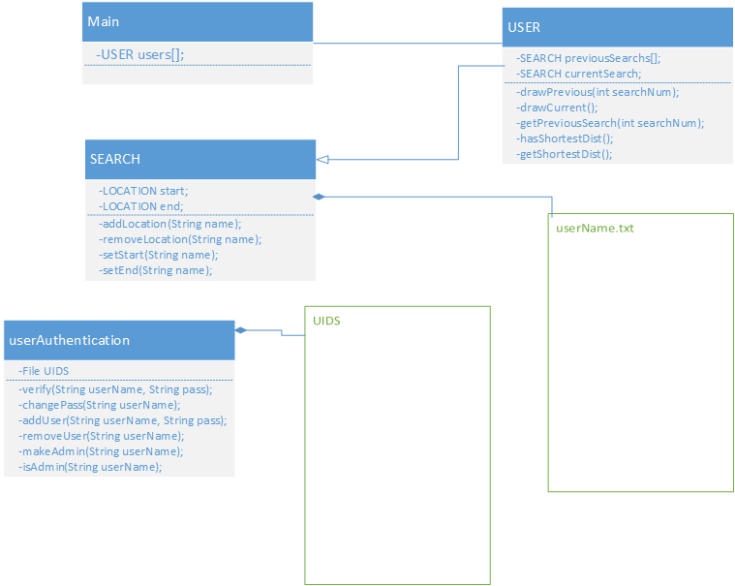
*Here is an example of a search text file structure:
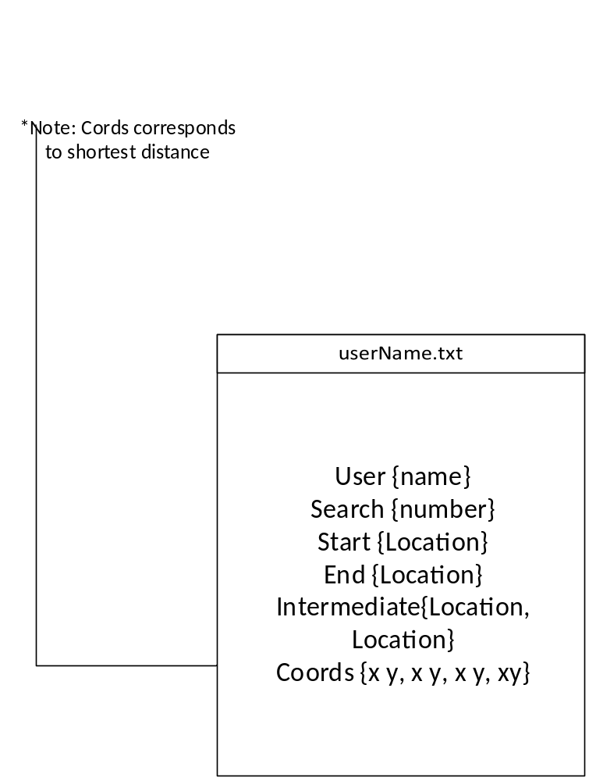

*Here is an example of our user account text file structure:
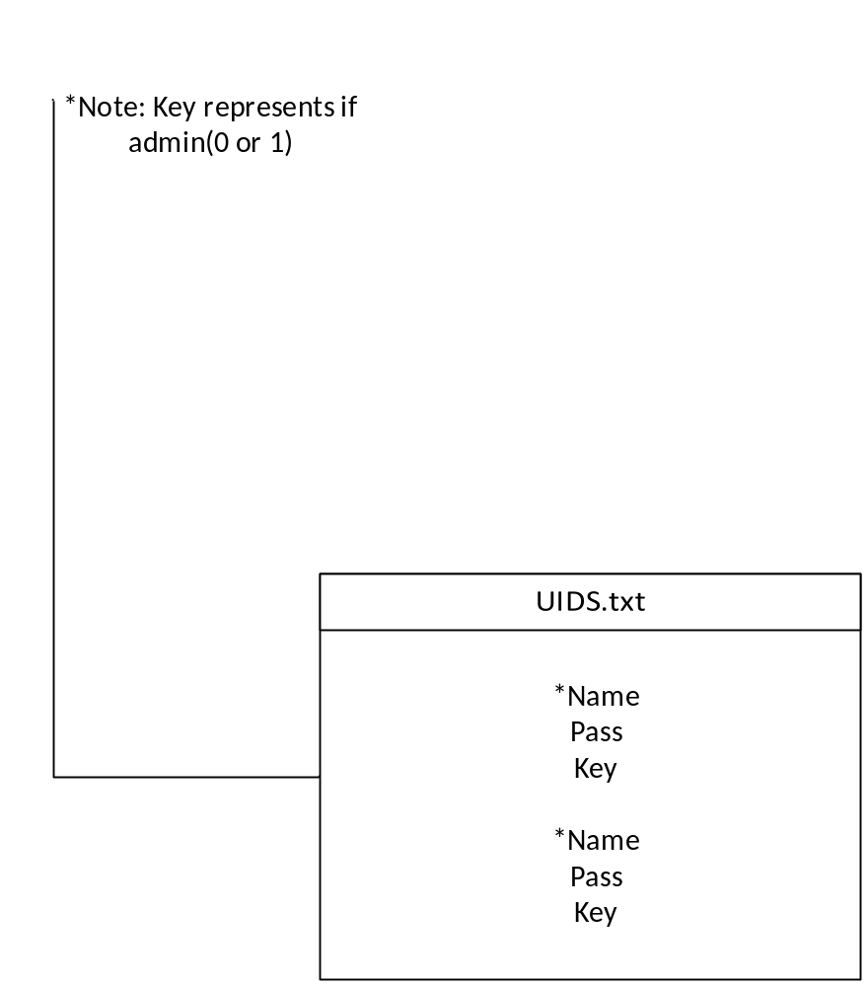

* Patch (V.2.0)

File Type/Name | Description | Visibility
Search Object(SEARCH) | This shall contain all the info on a prev/current search | private
Location database text file (LocationDatabase.txt) | This shall contain locations information | private
User text file (UID-Pass.txt) | This shall represent a user’s unique identifier and password | private
Locations (Locations.txt) | This shall contain only the name of locations | private

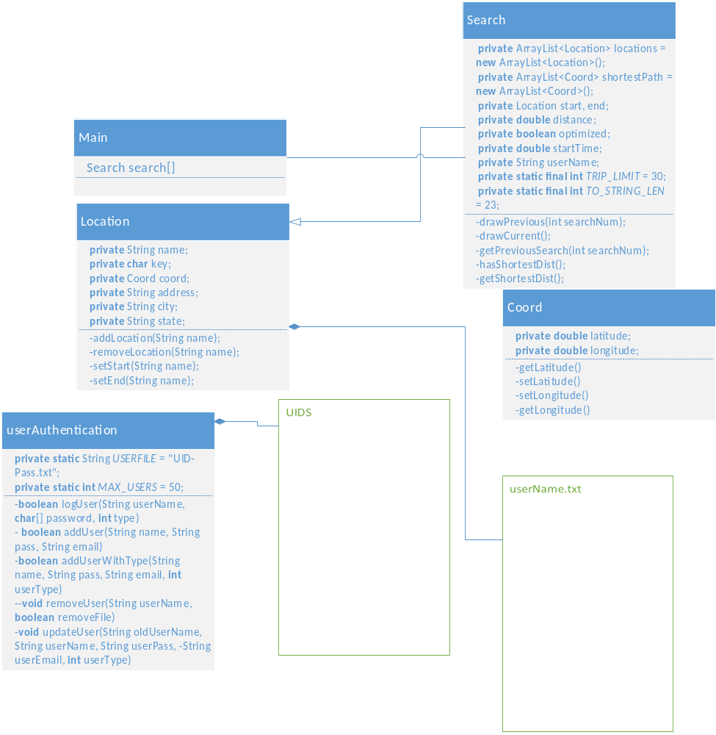
*Here is an example of a search text file structure:
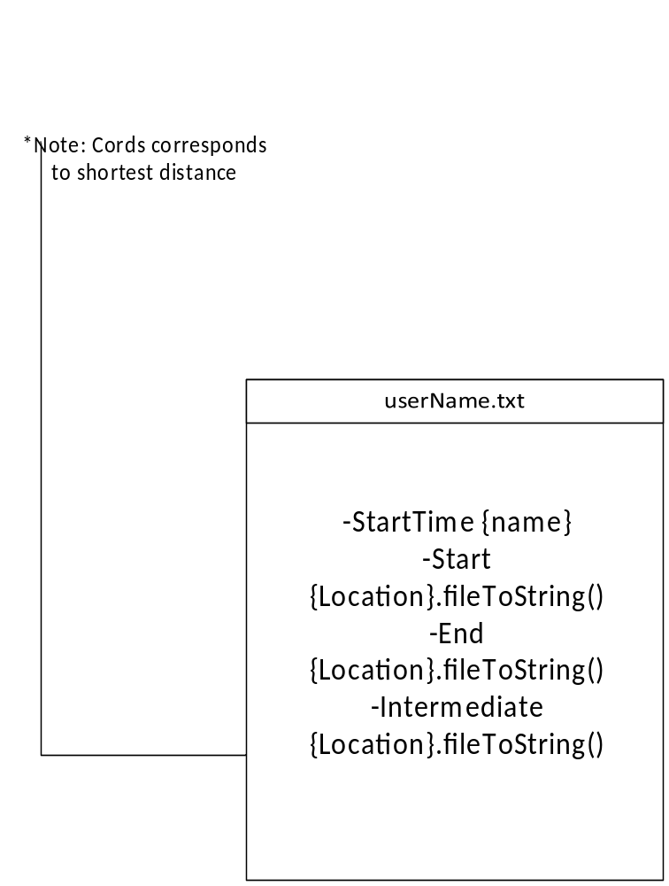

*Here is an example of our user account text file structure:
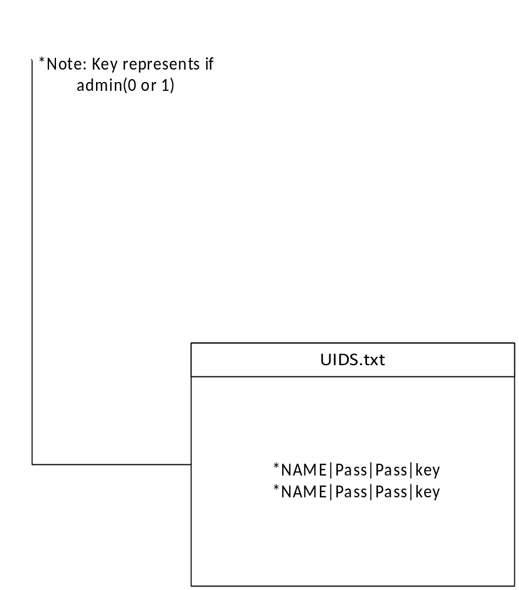

4. Requirements Matrix

Functional Area | ID | DESCRIPTION | PRIORITY | STATUS | TESTED
Layout | 1 | Should be a standalone application, not web based. (NFR) | 5
Layout | 2 | Administrators Shall be able to add a new location in database  (Layout2-4 are grouped on srs) | 5
Layout | 3 | Administrators Shall be able to modify existing locations in the database | 4
Layout | 4 | Administrators Shall be able to delete existing locations from the database | 4
Layout | 5 | Locations shall be stored with a state, city, and exact location attribute | 5
Layout | 6 | Possible first layer location storage should consist of MD / PA / DC | 4
Layout | 7 | Interface shall display a list of all the locations in the database. | 5
Layout | 8 | List of locations shall be able to hold more than 100 locations (110 max) | 5
Layout | 9 | Product should contain useful help files for users | 2
Layout | 10 | Product should contain useful help files for administrators | 2
pre | 1 | Should be able to input a starting time for the trip | 4
pre | 2 | User shall be able to select more than 20 locations from the database of  locations (30) | 5
pre | 3 | User shall be able to search for new locations to add (By entering  state/city/location when need be) | 5
pre | 4 | User must identify which location is the start state | 5
pre | 5 | User Must identify which location is the end state. | 5
post | 1 | Application should interact using Google’s API (NFR) | 5
post | 2 | The system will solve for the shorted straight line distance to visit  all the sites | 5
out | 1 | Display output on Google earth 7 | 5
out | 2 | There shall be a line connecting all the locations in the shortest way. | 5
out | 3 | Output shall display total time the trip will take. Could determine this from  the total length and a static speed. Does not need to take into account  the amount of time you stay at each location | 3
out | 4 | Output should display all information we have about the sites | 2
Account | 1 | Users should be able to log in with a correct username and password  combination | 2
Account | 2 | Users Shall be able to create new user accounts (Will expand later) | 5
Account | 3 | User Accounts shall hold a list of previous searches | 3
Account | 4 | User Accounts shall display a list of previously visited locations | 3
Account | 5 | New accounts should be set as either users or admins (admins can  add-mod-del locations) | 2

Appendix A – Team percent contribution, Team sign-off, Customer acceptance

Sign off Agreement Between Customer and Contractor

The cava++ computer development team and the customer for this project will be agreeing to some points. The cava++ team will be agreeing to do a task of completing this software to the customer’s specifications. The customer will be agreeing to work with the cava++ team by providing requirements for this project to adhere to.

This document is not set in stone for the duration of this project. If any changes happen against this document during the software development cycle they will be noted in the update section and written down.

Team Review Sign-off

Our software team has reviewed this documentation. To show that we have read and understand this document we will provide our names, signatures and dates and comments for each team member. This will show that all members have read and understand this document.

Daniel Brandes; __________________________10/15/13;
Comments:

Patrick Ritchie; __________________________10/15/13;
Comments:

Xiaofei He; __________________________10/15/13;
Comments:

Jim Millican; __________________________10/15/13;
Comments:

Lizset Chavez; __________________________10/15/13;
Comments:

Yo-Han Kim; __________________________10/15/13;
Comments:

Document Contributions

Daniel Brandes;
Contribution: Persistent Data section; Matrix Req.

Patrick Ritchie;
Contribution: Original Matrix Req. outline;

Jim Millican;
Contribution: System Architecture section

Lizset Chavez;
Contribution: Introduction Section

Xiaofei He;
Contribution: Requirement Matrix; UML diagram

Yo-Han Kim;
Contribution: Persistent Data Design

FYI Unified Modeling Language (UML)
Class Diagrams

Reference: UML Distilled, 2nd edition, Martin Fowler and Kendall Scott, 2000

Note: The information below has been modified slightly to meet the purposes of CMSC 345

Symbols:

Class – Represented by a box as follows:

Class Name
Attributes
Operations
Class Name

Navigability – Represented by a solid line with an arrowhead at one or both ends (unidirectional or bidirectional association, respectively). Indicates the direction(s) of an association between classes. (Below, A can navigate to B, but not the reverse.)

A
B

Generalization – Represented by a solid line with a hollow arrowhead at one end. Indicates that one class is a generalization of another. (Below, B is a generalization of A.)
A
B

Composition – Represented by a solid line with a solid diamond at one end. Indicates that an instance of one class is “owned” by a single instance of another. (Below, an instance of B is owned by a single instance of class A. Note: if an instance of A is deallocated, the associated instance(s) of B are also deallocated.)

A
B

Dependency – Represented by a dashed line with an arrowhead at one end. Indicates that one class depends on the interface to another class. (Below, an instance of A is dependent on the interface to an instance of B.)

A
B

Multiplicity – Indicates how many instances of one class type are associated with another class. (Below, 1 to 5 instances of class A are associated with class B.)
A
B
1. . 5

Note: We will not be using any other symbols in our class diagrams.

Format for class attributes:

visibility name : type = defaultValue

where visibility = + for public, # for protected, - for private
name = attribute name
type = data type
defaultValue = default value
Format for class operations:

visibility name (parameter-list) : return-type

where visibility = + for public, # for protected, - for private
name = operation name
parameter-list = comma-separated parameters with the syntax

direction name : type = defaultValue

where direction = in for input
out for output
inout for input/output
name = parameter name
type = parameter type
defaultValue = default value
return-type = return type

