CMSC 345

Software Design and Development

Fall 2013

User Interface Design Document

[Cava / Coolgle]
User Interface Design Document

Table of Contents

Page

1. Introduction 3

  - Purpose of This Document 3
  - References 3

2. User Interface Standards 3

3. User Interface Walkthrough 6

4. Data Validation 11

Appendix A – Team percent contribution, 12
Team sign-off, Customer acceptance

Appendix B – Updates 14

1. Introduction

1.1 Purpose of This Document

This document provides a general overview of the system’s graphical user interface through introducing various design and features. This designs indicated in this document are preliminary at best, which can be changed according to the system requirements or at the customer’s request.

  - References

Documents
System requirements specification
System design document

Design Principles
http://en.wikibooks.org/wiki/GUI_Design_Principles

Design References
Fedora Login Screen
Google Earth GUI Design

Design Tools
Axure RP Pro 6

- User Interface Standards

Give the reader an overview of the design standards that you will use to maintain consistency in the user interface throughout your system. Use illustrations as necessary. Discuss general screen layouts, common components (e.g., buttons, menus), general error handling, and navigation. You do not need to go into details such as colors and fonts. [Length will vary, but I would expect at least one overall screen layout illustration with explanations of the different screen areas, common components that will be used, and how the user will generally navigate through the system.]

Main Component Sizes

Component | Width (pixels) | Length (pixels)
Log in | 400 | 500
New User | 400 | 400
Main GUI | 900 | 800
Add Location | 400 | 500

Buttons

Component | Width (pixels) | Length (pixels)
Big Button | 140 | 30
Small Button | 90 | 30
Special Add | 28 (Round) | 28 (Round)
Delete | 15 | 15
Help | 22 (Round) | 22 (Round)
Window Control | 86 | 15

The buttons will all follow the above sizing requirements and will generally adhere to the below design in figure 1. Other buttons that do not follow the red color rule are also shown below.

Figure 1: The sign-in button


Figure 2: The help roll-over button

Figure 3: Window control buttons

Fields and menus

Component | Width (pixels) | Length (pixels)
Text Field | 180 | 25
Dropdown Menu (Large) | 300 | 22
Dropdown Menu (Small) | 180 | 22
Multi Select Menu | 180 | 140

These fields and menus are standards within GUI design and have not been customized. Some examples are shown below.

Figure 4: Small Dropdown Menu

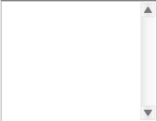

Figure 5: Multi Select Menu

Final List Display

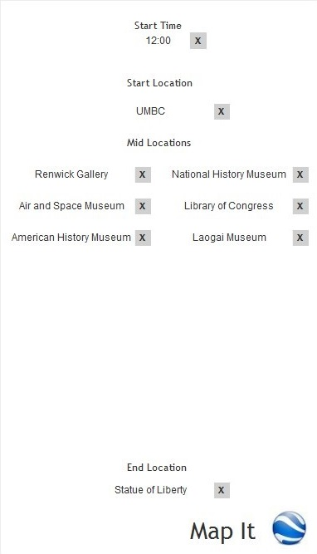
Figure 6: This is a final view of the locations for the users to view before sending the data to Google Earth. The user can of course view and reselect locations and time.

- User Interface Walkthrough

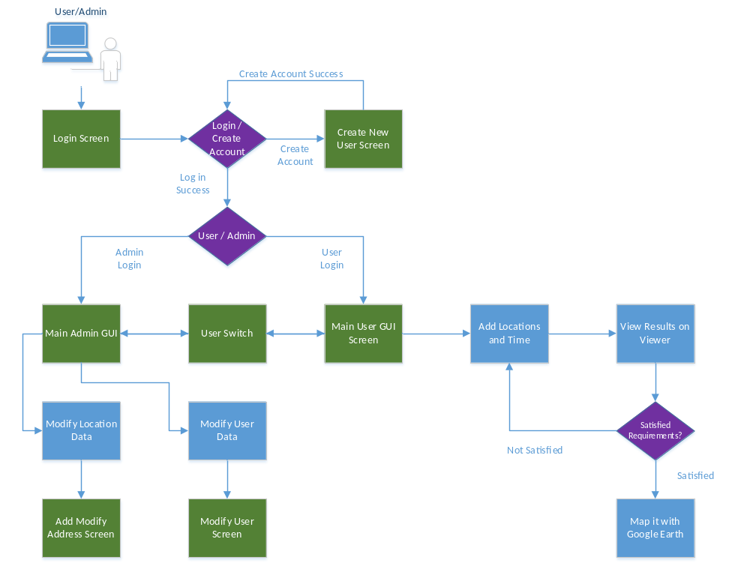

Figure 7: This is a general overview of the flow diagram with a user GUI. The green boxes indicate the currently available GUIs. The purple diamonds indicate a user decision. This user is indicated by the computer/person at the top left corner and is taken through the system by first logging in and then adding locations and time to the results viewer. The admin can modify locations and user data. An admin and user mode can be switch, if and only if the user name is the same on both accounts.

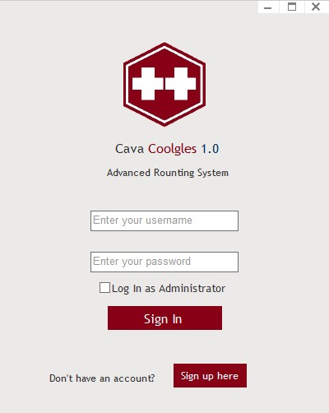

Figure 8: This is the user login screen. As one can see, it has the username/password field. One can also choose to login as administrator, the application will verify that after the user clicks sign in. If on doesn’t have an account, a sign up page is provided, shown in figure 9. If the user logs in successfully, the main GUI is shown in figure 10.

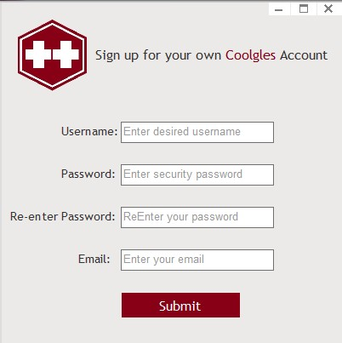

Figure 9: This is a preliminary sign up page for new users. More information may be added later at the customer’s request.
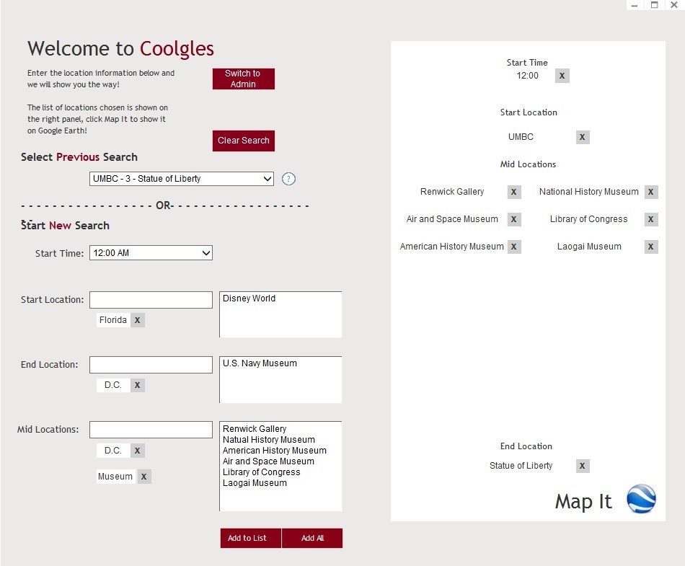

Figure 10: This is a main GUI design for the application. A few noticeable sections are the “Select Previous Search”, “Start New Search”, and the right display page. Here, the user is given the option to select a previous search he or she has done, and to map that out. The user can also start a new search by selecting a start time, start location, end locations, and mid locations. A user can first search for certain “tags” of the locations. Once a tag is entered, the box on the right will be filtered according to the tag content. Users can enter multiple tags. The final “Map It” button will bring up Google Earth and map the distances out. The user can choose to switch to admin mode.

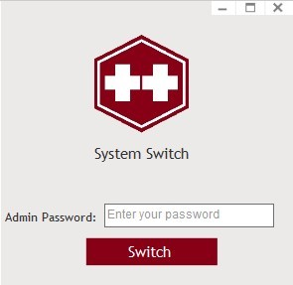

Figure 10: This is the switch to admin interface. The user simply enters the password for the current username (the admin password) and system checks to see if it is valid.

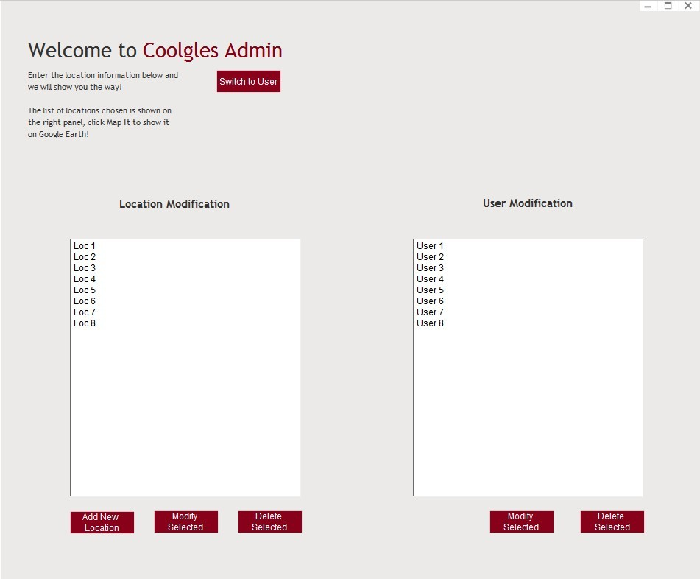

Figure 11: This is the main admin GUI. Once here, one can change location and user data. The list of locations and users are displayed instantly when the admin logs in. Multiple selections for deletion are allowed.
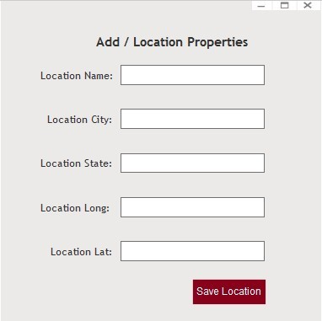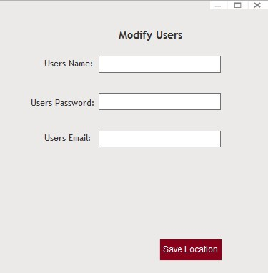

Figure 12 & 13: This is the location / user modification GUI.

- Data Validation

Data ID | Data Type | Limits | Format
username_login | string | 32 char | text (no symbols except underscores, and periods)
password_login | string | 32 char | text (All symbols allowed)
username_signup | string | 32 char | text (no symbols except underscores, and periods)
password_signup | string | 32 char | text (All symbols allowed)
re_pass_signup | string | 32 char | text (All symbols allowed)
email | string | 32 char | text (no symbols except underscores, and periods)
start_loc_tag | string | 32 char | text (No symbols allowed)
end_loc_tag | string | 32 char | text (No symbols allowed)
mid_loc_tag | string | 32 char | text (No symbols allowed)
loc_name | string | 32 char | text (No symbols allowed)
loc_city | string | 32 char | text (No symbols allowed)
loc_state | string | 32 char | text (No symbols allowed)
loc_long | int | 10 char | text, numbers and period only
loc_lat | int | 10 char | text, numbers and period only

Appendix A – Team percent contribution, Team sign-off, Customer acceptance

Sign off Agreement Between Customer and Contractor

The cava++ computer development team and the customer for this project will be agreeing to some points. The cava++ team will be agreeing to design the GUI to the customer’s specifications. The customer will be agreeing to work with the cava++ team by providing requirements for this GUI to adhere to.

This document is not set in stone for the duration of this project. If any changes happen against this document during the software development cycle they will be noted in the update section and written down.

Team Review Sign-off

Our software team has reviewed this documentation. To show that we have read and understand this document we will provide our names, signatures and dates and comments for each team member. This will show that all members have read and understand this document.

Daniel Brandes; __________________________10/15/13;
Comments:

Patrick Ritchie; __________________________10/15/13;
Comments:

Xiaofei He; __________________________10/15/13;
Comments:

Jim Millican; __________________________10/15/13;
Comments:

Lizset Chavez; __________________________10/15/13;
Comments:

Yo-Han Kim; __________________________10/15/13;
Comments:

Document Contributions

Daniel Brandes;
Contribution:

Patrick Ritchie;
Contribution:

Jim Millican;
Contribution:

Lizset Chavez;
Contribution:

Xiaofei He;
Contribution: User Interface Walkthrough, GUI design

Yo-Han Kim;
Contribution:

Appendix B – Updates

October 26, 2013

- Updated GUI according to customer’s new specifications
  - Users can now remove mid locations
  - Users can select multiple mid locations
  - Users can no longer add new locations
  - Users can now filter location results with tags
  - Improved users GUI design
  - Add admin GUI design
  - Admin can now add/modify/delete location data
  - Admin can now modify/delete user data
  - Mode switch between admin / user is now available
- Updated UIDD according to the above changes

