CMSC 345

Software Design and Development

Fall 2013

System Design Document Template

Writing Instructions

Do not have anything the Software Quality Assurance Organization could call a defect.

Be sure that your document is

- Complete - No information is missing
- Clear - Every sentence's meaning must be clear to all parties
- Consistent – The writing style and notation is consistent throughout the document and the document does not contradict itself

Remember that you are required to do a team review of this document.

When you think you are done with the SDD, ask yourself, "Could someone who was not part of the development of this SDD write the corresponding code?"

[Team name: Cava++ Product name: Coolgles]
System Design Document

Table of Contents

Page

1. Introduction

  - Purpose of This Document
  - References

- System Architecture

2.1 Architectural Design
2.2 Decomposition Description

3. Persistent Data Design

5.1 Database Descriptions
5.2 File Descriptions

- Requirements Matrix

Appendix A – Team percent contribution, Team sign-off, Customer acceptance

1. Introduction
1.1 Purpose of This Document

This document provides a comprehensive architectural overview of the application, using a number of different architectural views to depict different aspects of the application. These document present detailed descriptions of an application that will help a traveling salesman determine the shortest distance between groups of locations. This document is intended to be used for the user and the team developing the application.

1.2 References
"Example of Software Design Document(SDD)." Example of Software Design Document(SDD). N.p., n.d. Web. 14 Oct. 2013.

2. System Architecture

2.1 Architectural Design

When the user starts the application, the program starts in the Driver class, which first creates a User Interface (UI) class to display a loading screen. It then starts the central Application (App) class, which itself initializes the rest of the components.

The UI class is the intermediary between the App and the display, and by extension, the user. The User Authentication (UA) class uses text files to authenticate a user's login. The File Manager (FM) class parses and encodes previous searches from files unique to each user. The Search Manager (SM) class performs the graph search algorithm to maximize the efficiency of a search. The KML Creator (KMLC) class creates a KML file to be sent to the Google Earth application. The App class passes information between all of the other classes, as well as stores the currently selected search.
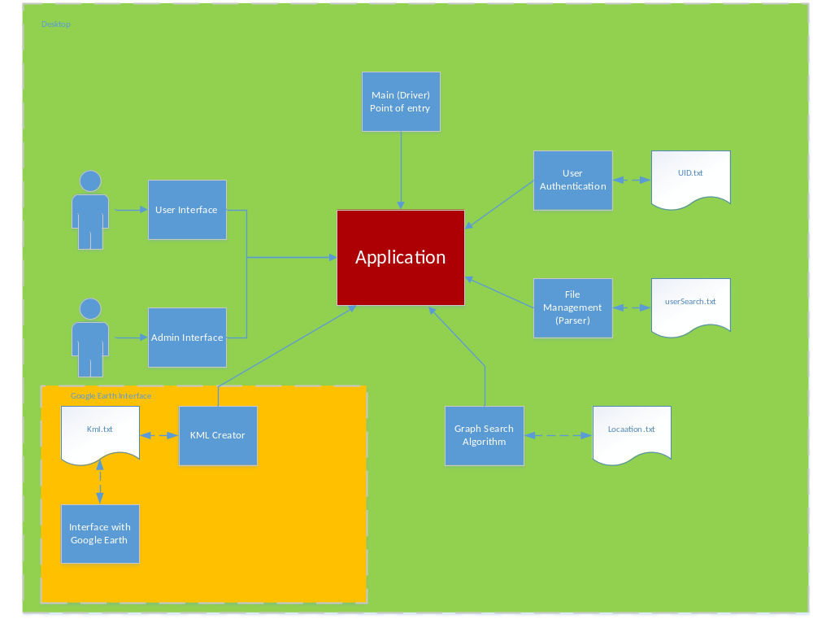

2.2 Decomposition Description

This project has 3 main components that can be broken into subcomponents.
These 3 main components are the functions, files, and classes. We will use these to describe the design for our program.

These subcomponents make up our application to simulate a Google routing program for a user to interact with. These functions in our class will define what any specific class is to accomplish. They will also help to modify our files to the user’s actions. The files for this application are used to store data for previous searches, UID’s, and, our locations. Our classes will represent the objects needed for our program so our user can interact with the Google earth application. With all of these subcomponents we can build our software application that will simulate a Google routing application.

Driver Class (Point of entry) //rename
Data Members:
- UIManager UI
- FileManager FileM
- UserAuthenticationManager UAM
- SearchManager SearchM
- KMLCreationManager KMLCM
- Application CommandCentral (rename)
Member Functions:
main();
Initializes UIManager first (loading screen)
Initializes FileManager
Initializes UserAuthenticationManager
Initializes SearchManager
Initializes KMLCreationManager
Initializes Application (passing managers for construction)

class UIManager (Research UI libraries)
Data Members:
- Application CommandCentral
- Window (where current screen is displayed)
- Screens (containing buttons, dropdowns, etc.)
  - LoadScreen
  - LoginScreen
  - SearchSelectionScreen
  - OutputScreen (?)
Member Functions:

UIManager()
- Initializes Screens
- Sets current screen to Load screen
- Opens new Window
- sets a bit saying CentralCommand has not been Initialized

setApp(Application callback) //perhaps use this to switch out of LoadScreen
- checks to make sure CC has not been initialized
- sets CentralCommand to callback
- flips bit saying CC has been initialized

Accessors:
- currentScreen()
- validToSwitchTo() (?)

Button functions:
- private
- Pass data to CommandCentral, pulling data from textboxes, dropdown lists, etc.

pushPrevSearchList(List searches):
- public
- called by CommandCentral
- searches is a list of strings, formatted to the form to be displayed in dropdown
- UIManager sets the strings in searches as items in dropdown
- flips a switch that says it is now valid to change current screen to SearchSelectionScreen

switchTo(String screenName)
- Checks to make sure it is valid to switch to screenName
- Sets current screen to screen parsed from screenName

class UserAuthenticationManager
Data:
String UNPWFile;
String AdminPWFile;
Functions:
UserAuthenticationManager(Strings filenames)
- Initializes UAM
- Saves strings

authenticateUser(String username, String password)
- Opens UNPW file
- checks validity of password
- Closes UNPW file
- returns a bool

authenticateAdmin(string username, string password)
- Same as authenticateUser, except uses AdminPW file

class FileManager
Data:
const String LocFileName;
File currentUsersFile;
Functions:
(constructor) : Initializes the FileManager

loadLocs(): Loads/parses locations from location file(s)
loadUser(userID): parses userID to a filename, Loads/parses previous searches from file
addSearch(userID, search): parses search to a string, inserts into currentUsersFile
closeUser(userID): closes currentUsersFile

class SearchManager
Data:
None
Functions:
(constructor): does nothing
search(search): modifies search into an ordered search

3. Persistent Data Design

3.1 Database Descriptions
We will not be using a database for this assignment instead we will be using files to allow the user to look-up locations or previous search.

  - File Descriptions

The software for this project will be a standalone application made in java. This application will contain text files that will hold data for a user’s previous search. Each search will have a specific structure for ease of parsing (shown below). After each current search is completed it will be parsed onto the user’s existing text file. To limit the amount of text placed in a file we will allow a user to have a maximum of 10 searches. We will use a circular queue to maintain the list of the 10 previous searches. In any given search there will be 2-30 locations. In this list of locations there will be a start and an end location clearly labeled. The reason for this is so the Astar algorithm will be able to more easily pick out these specific locations. Here is a diagram of the file structure we will be using for our program:
File Type/Name | Description | Visibility
User object(USER) | This shall represent an user in our application | private
Search object(SEARCH) | This shall represent a search in our application | private
Search text file (name.txt) | This shall represent saved data relating  to a user’s previous searches | private
User text file (UID.txt) | This shall represent a user’s unique identifier and password | private

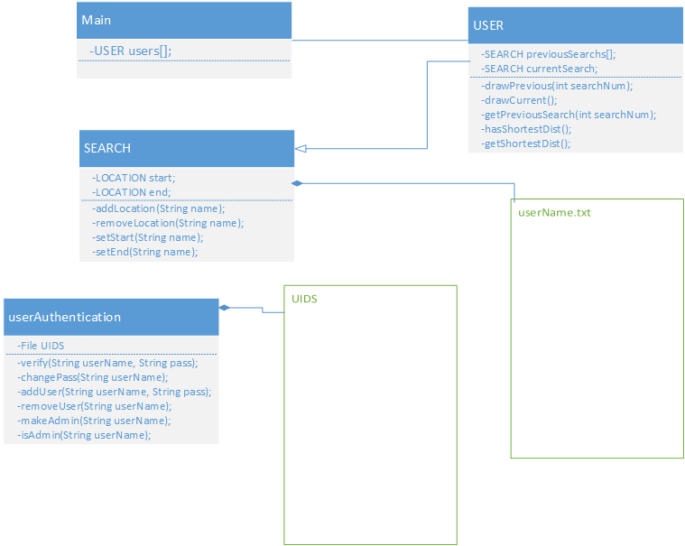
*Here is an example of a search text file structure:
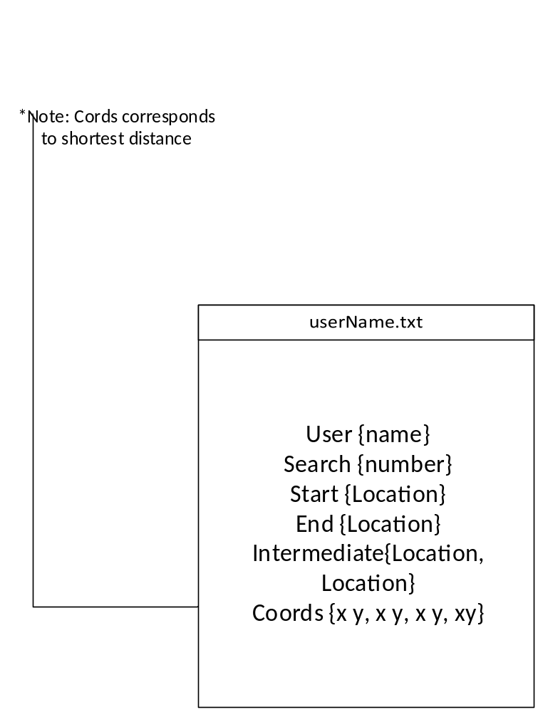

*Here is an example of our user account text file structure:
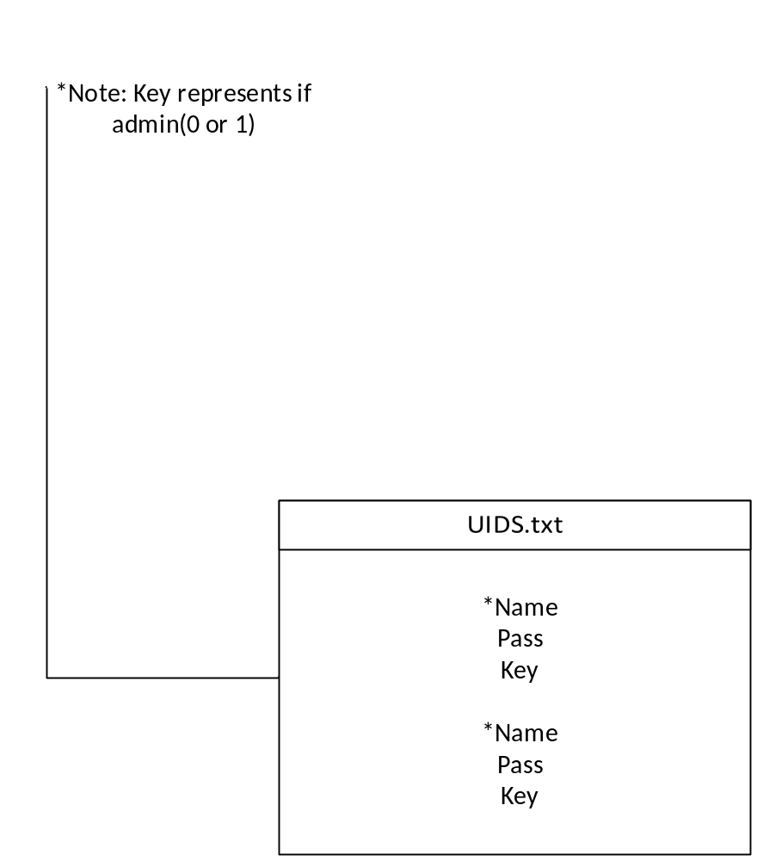

4.Requirements Matrix

Functional Area | ID | DESCRIPTION | PRIORITY | STATUS | TESTED
Layout | 1 | Should be a standalone application, not web based. (NFR) | 5
Layout | 2 | Administrators Shall be able to add a new location in database  (Layout2-4 are grouped on srs) | 5
Layout | 3 | Administrators Shall be able to modify existing locations in the database | 4
Layout | 4 | Administrators Shall be able to delete existing locations from the database | 4
Layout | 5 | Locations shall be stored with a state, city, and exact location attribute | 5
Layout | 6 | Possible first layer location storage should consist of MD / PA / DC | 4
Layout | 7 | Interface shall display a list of all the locations in the database. | 5
Layout | 8 | List of locations shall be able to hold more than 100 locations (110 max) | 5
Layout | 9 | Product should contain useful help files for users | 2
Layout | 10 | Product should contain useful help files for administrators | 2
pre | 1 | Should be able to input a starting time for the trip | 4
pre | 2 | User shall be able to select more than 20 locations from the database of  locations (30) | 5
pre | 3 | User shall be able to search for new locations to add (By entering  state/city/location when need be) | 5
pre | 4 | User must identify which location is the start state | 5
pre | 5 | User Must identify which location is the end state. | 5
post | 1 | Application should interact using Google’s API (NFR) | 5
post | 2 | The system will solve for the shorted straight line distance to visit  all the sites | 5
out | 1 | Display output on Google earth 7 | 5
out | 2 | There shall be a line connecting all the locations in the shortest way. | 5
out | 3 | Output shall display total time the trip will take. Could determine this from  the total length and a static speed. Does not need to take into account  the amount of time you stay at each location | 3
out | 4 | Output should display all information we have about the sites | 2
Account | 1 | Users should be able to log in with a correct username and password  combination | 2
Account | 2 | Users Shall be able to create new user accounts (Will expand later) | 5
Account | 3 | User Accounts shall hold a list of previous searches | 3
Account | 4 | User Accounts shall display a list of previously visited locations | 3
Account | 5 | New accounts should be set as either users or admins (admins can  add-mod-del locations) | 2

Appendix A – Team percent contribution, Team sign-off, Customer acceptance

Sign off Agreement Between Customer and Contractor

The cava++ computer development team and the customer for this project will be agreeing to some points. The cava++ team will be agreeing to do a task of completing this software to the customer’s specifications. The customer will be agreeing to work with the cava++ team by providing requirements for this project to adhere to.

This document is not set in stone for the duration of this project. If any changes happen against this document during the software development cycle they will be noted in the update section and written down.

Team Review Sign-off

Our software team has reviewed this documentation. To show that we have read and understand this document we will provide our names, signatures and dates and comments for each team member. This will show that all members have read and understand this document.

Daniel Brandes; __________________________10/15/13;
Comments:

Patrick Ritchie; __________________________10/15/13;
Comments:

Xiaofei He; __________________________10/15/13;
Comments:

Jim Millican; __________________________10/15/13;
Comments:

Lizset Chavez; __________________________10/15/13;
Comments:

Yo-Han Kim; __________________________10/15/13;
Comments:

Document Contributions

Daniel Brandes;
Contribution: Persistent Data section; help on writing Matrix Req.

Patrick Ritchie;
Contribution: original Matrix Req. outline;

Jim Millican;
Contribution: System Architecture section

Lizset Chavez;
Contribution: Introduction Section

Xiaofei He;
Contribution:

Yo-Han Kim;
Contribution:

FYI Unified Modeling Language (UML)
Class Diagrams

Reference: UML Distilled, 2nd edition, Martin Fowler and Kendall Scott, 2000

Note: The information below has been modified slightly to meet the purposes of CMSC 345

Symbols:

Class – Represented by a box as follows:

Class Name
Attributes
Operations
Class Name

Navigability – Represented by a solid line with an arrowhead at one or both ends (unidirectional or bidirectional association, respectively). Indicates the direction(s) of an association between classes. (Below, A can navigate to B, but not the reverse.)

A
B

Generalization – Represented by a solid line with a hollow arrowhead at one end. Indicates that one class is a generalization of another. (Below, B is a generalization of A.)
A
B

Composition – Represented by a solid line with a solid diamond at one end. Indicates that an instance of one class is “owned” by a single instance of another. (Below, an instance of B is owned by a single instance of class A. Note: if an instance of A is deallocated, the associated instance(s) of B are also deallocated.)

A
B

Dependency – Represented by a dashed line with an arrowhead at one end. Indicates that one class depends on the interface to another class. (Below, an instance of A is dependent on the interface to an instance of B.)

A
B

Multiplicity – Indicates how many instances of one class type are associated with another class. (Below, 1 to 5 instances of class A are associated with class B.)
A
B
1. . 5

Note: We will not be using any other symbols in our class diagrams.

Format for class attributes:

visibility name : type = defaultValue

where visibility = + for public, # for protected, - for private
name = attribute name
type = data type
defaultValue = default value
Format for class operations:

visibility name (parameter-list) : return-type

where visibility = + for public, # for protected, - for private
name = operation name
parameter-list = comma-separated parameters with the syntax

direction name : type = defaultValue

where direction = in for input
out for output
inout for input/output
name = parameter name
type = parameter type
defaultValue = default value
return-type = return type

