CMSC 345

Software Design and Development

Fall 2013

User Interface Design Document

[Cava / Coolgle]
User Interface Design Document

Table of Contents

Page

1. Introduction 3

  - Purpose of This Document 3
  - References 3

2. User Interface Standards 3

3. User Interface Walkthrough 6

4. Data Validation 9

Appendix A – Team percent contribution, 10
Team sign-off, Customer acceptance

1. Introduction

1.1 Purpose of This Document

This document provides a general overview of the system’s graphical user interface through introducing various design and features. This designs indicated in this document are preliminary at best, which can be changed according to the system requirements or at the customer’s request.

  - References

Documents
System requirements specification
System design document

Design Principles
http://en.wikibooks.org/wiki/GUI_Design_Principles

Design References
Fedora Login Screen
Google Earth GUI Design

Design Tools
Axure RP Pro 6

- User Interface Standards

Give the reader an overview of the design standards that you will use to maintain consistency in the user interface throughout your system. Use illustrations as necessary. Discuss general screen layouts, common components (e.g., buttons, menus), general error handling, and navigation. You do not need to go into details such as colors and fonts. [Length will vary, but I would expect at least one overall screen layout illustration with explanations of the different screen areas, common components that will be used, and how the user will generally navigate through the system.]

Main Component Sizes

Component | Width (pixels) | Length (pixels)
Log in | 400 | 500
New User | 400 | 400
Main GUI | 900 | 800
Add Location | 400 | 500

Buttons

Component | Width (pixels) | Length (pixels)
Big Button | 140 | 30
Small Button | 90 | 30
Special Add | 28 (Round) | 28 (Round)
Delete | 15 | 15
Help | 22 (Round) | 22 (Round)
Window Control | 86 | 15

The buttons will all follow the above sizing requirements and will generally adhere to the below design in figure 1. Other button that do not follow the red color rule as also shown below.

Figure 1: The sign-in button


Figure 2: The help roll-over button

Figure 3: Window control buttons

Fields and menus

Component | Width (pixels) | Length (pixels)
Text Field | 180 | 25
Dropdown Menu (Large) | 300 | 22
Dropdown Menu (Small) | 180 | 22
Multi Select Menu | 180 | 140

These fields and menus are standards within GUI design and have not been customized. Some examples are shown below.

Figure 4: Small Dropdown Menu



Figure 5: Multi Select Menu

Final List Display

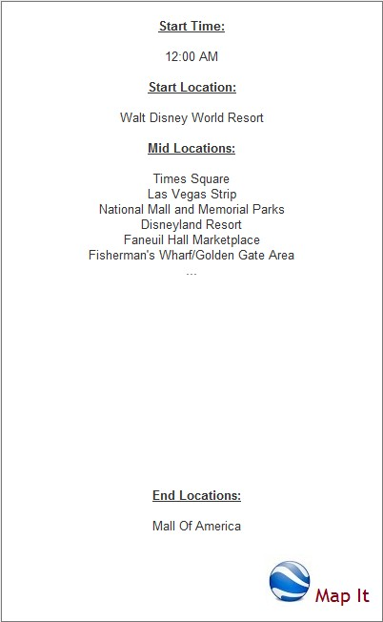
Figure 6: This is a final view of the locations for the users to view before sending the data to Google Earth. The user can of course view and reselect locations and time.

- User Interface Walkthrough

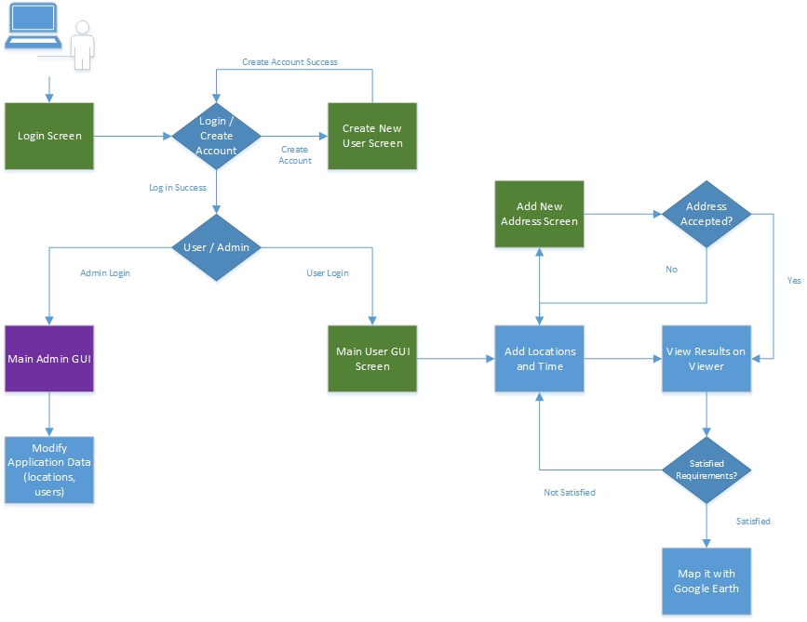
Figure 7: This is a general overview of the flow diagram with a user GUI. The green boxes indicate the currently available GUIs. The purple box indicate a currently under development GUI. This user is indicated by the computer/person at the top left corner and is taken through the system by first logging in and then adding locations and time to the results viewer.

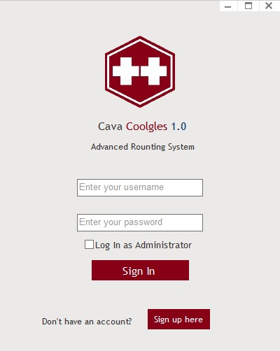

Figure 8: This is the user login screen. As one can see, it has the username/password field. One can also choose to login as administrator, the application will verify that after the user clicks sign in. If on doesn’t have an account, a sign up page is provided, shown in figure 9. If the user logs in successfully, the main GUI is shown in figure 10.

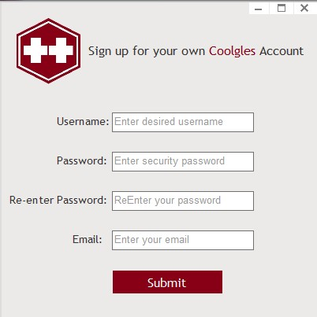

Figure 9: This is a preliminary sign up page for new users. More information may be added later at the customer’s request.
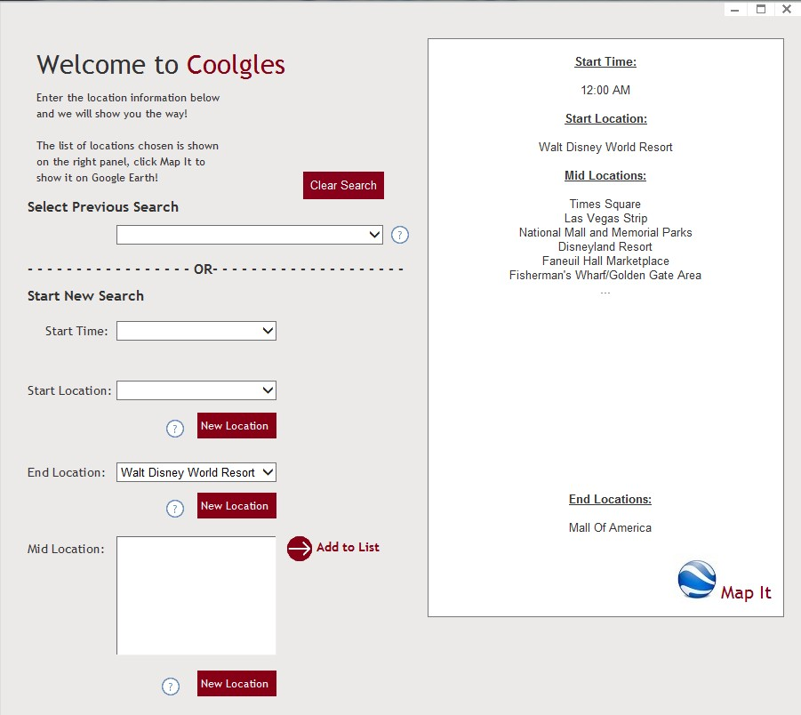

Figure 10: This is a main GUI design for the application. A few noticeable sections are the “Select Previous Search”, “Start New Search”, and the right display page. Here, the user is given the option to select a previous search he or she has done, and to map that out. The user can also start a new search by selecting a start time, start location, end locations, and mid locations. If the locations are not enough, one can add new locations, shown in figure 11. The “?” buttons are there to help the user if there is confusion about how the buttons function. The final “Map It” button will bring up Google Earth and map the distances out.

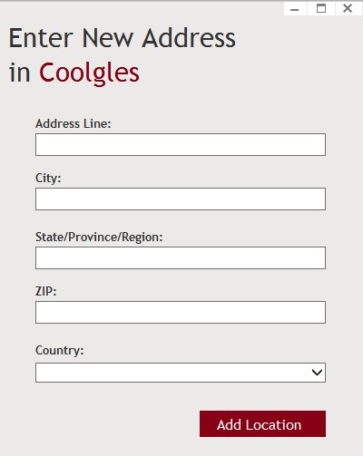

Figure 10: This GUI shows how one can add a new address to the list of locations. When a location is entered, the system checks to see if the address is valid, and if it is, then it’s added to the list.

- Data Validation

Data ID | Data Type | Limits | Format
username_login | string | 32 char | text (no symbols except underscores, and periods)
password_login | string | 32 char | text (All symbols allowed)
username_signup | string | 32 char | text (no symbols except underscores, and periods)
password_signup | string | 32 char | text (All symbols allowed)
re_pass_signup | string | 32 char | text (All symbols allowed)
email | string | 32 char | text (no symbols except underscores, and periods)
address_line | string | 32 char | text (no symbols except periods and hyphens)
city | string | 32 char | text (No symbols allowed)
state | string | 32 char | text (No symbols allowed)
zip | int | 9 char | text, numbers and hyphens only
Appendix A – Team percent contribution, Team sign-off, Customer acceptance

Sign off Agreement Between Customer and Contractor

Describe what the customer and your team are agreeing to when all sign off on this document. [One paragraph] Include a statement that explains the procedure to be used in case there are future changes to the document. [One paragraph]

Team Review Sign-off

Provide a brief paragraph stating that all members of the team have reviewed the document and agree on its content and format. Provide lines for typed names, signatures, dates, and comments for each team member. The comment areas are to be used to state any minor points regarding the document that members may not agree with. Note that there cannot be any major points of contention.

Document Contributions

Remember that each team member must contribute to the writing (includes diagrams) for each document produced.

