1. 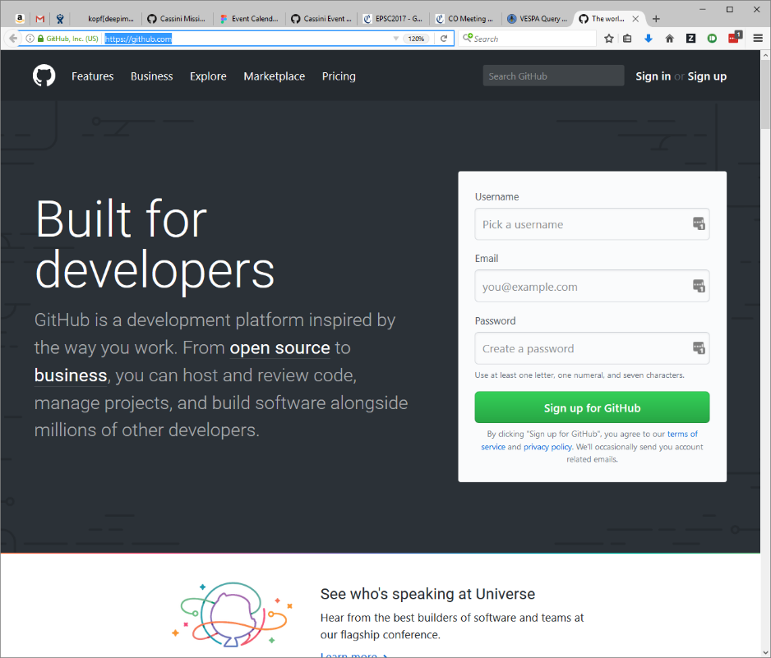Visit <https://github.com>
2. Log in or register for a new account
3. If you already have a GitHub account, use the [Sign in](https://github.com/login) link at the top.
4. If you are new to GitHub, fill in the Username, Email, and Password fields to Sign up.
5. Send your GitHub username to me at [andrea.m.connell@jpl.nasa.gov](mailto:andrea.m.connell@jpl.nasa.gov)

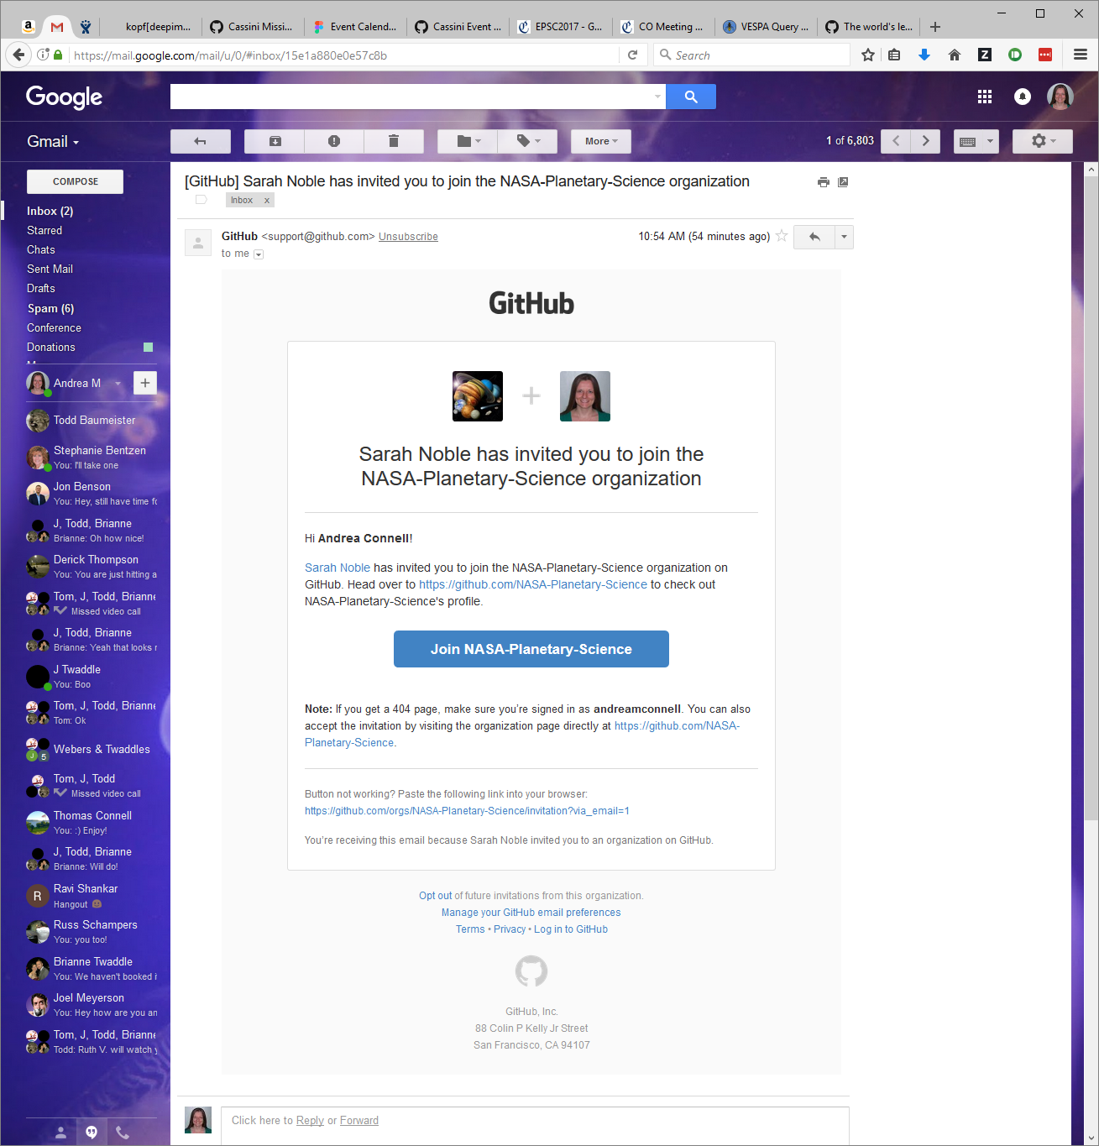

1. You will receive an email from GitHub Support with the title “Sarah Noble has invited you to join the NASA-Planetary-Science organization”
2. Click the button to Join NASA-Planetary-Science
3. View the organization at

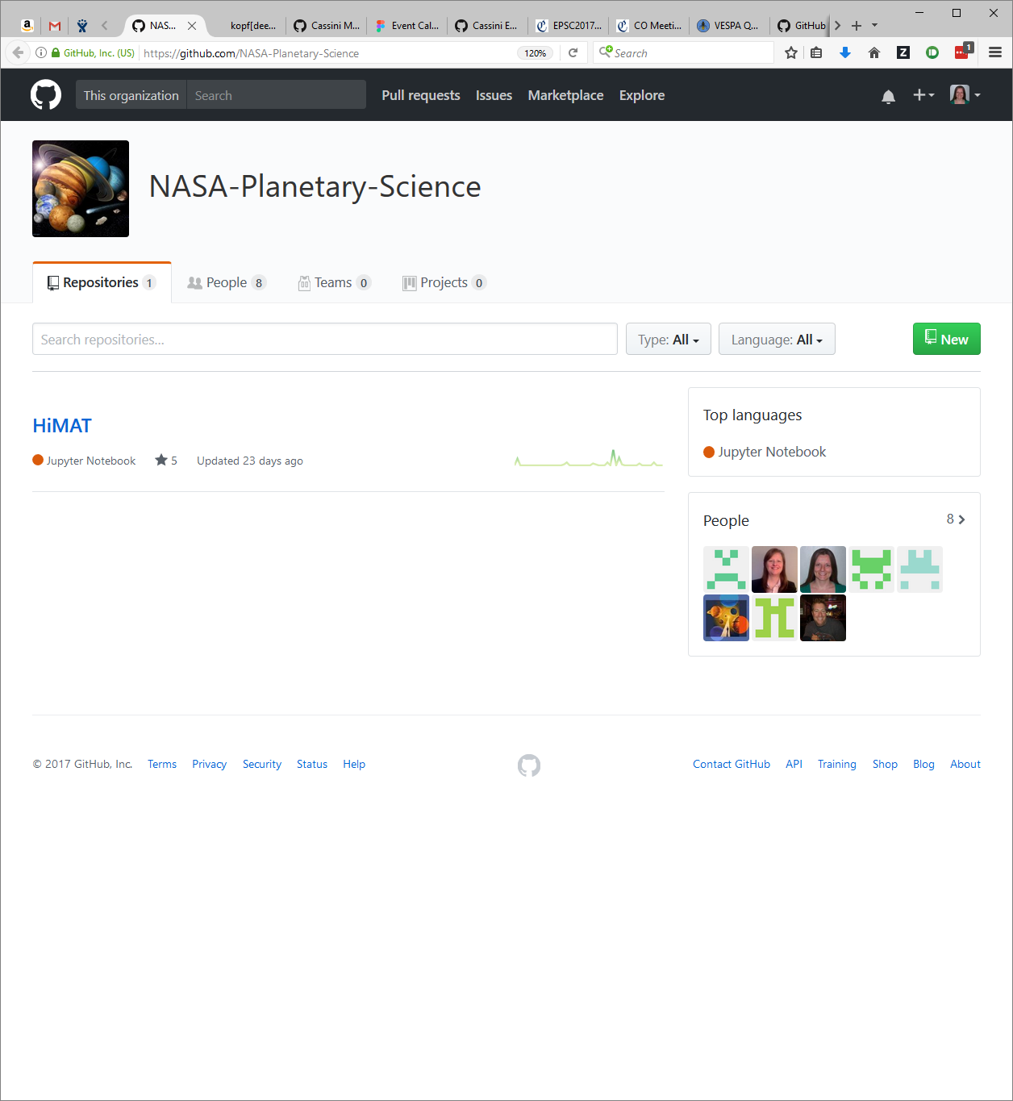<https://github.com/NASA-Planetary-Science>

1. Ensure that you have a git client installed (<https://git-scm.com/downloads>)

**For each piece of software that you would like to archive:**

1. If your code is currently in a GIT, SVN, Mercurial, or TFS repository, follow *a*, *b*,and *c* below. Otherwise (or if you are not sure), skip to Step 9.
   1. Click the “+” button in the upper right corner and select “Import repository”.
   2. Follow the on-screen instructions to import, making sure the owner of the new repository is NASA-Planetary-Science.
   3. Skip to Step 11.
2. If your code is not in another version control system, click the green “New” button to create a new repository for your code.

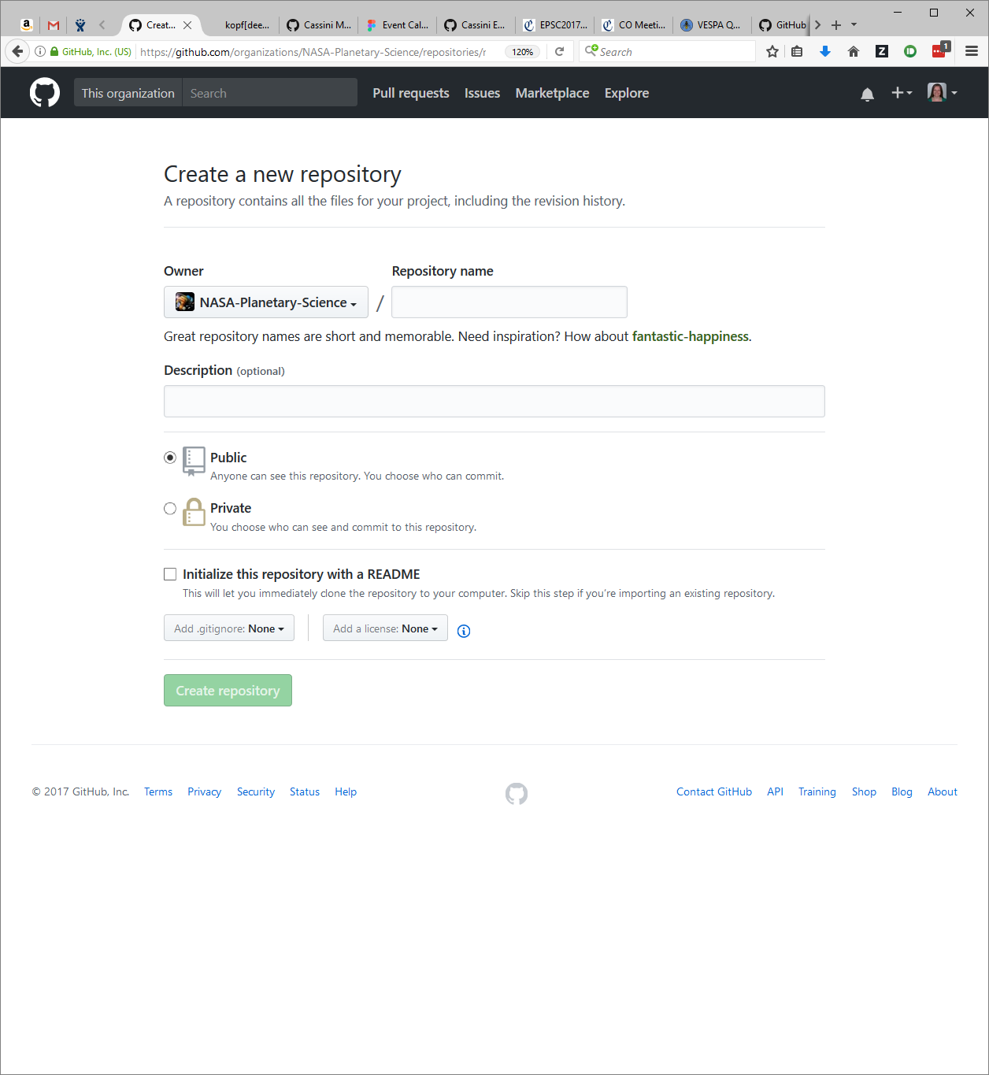

* 1. Make sure the owner is NASA-Planetary-Science.
  2. Note that the name cannot be changed later.
  3. The description will help other users understand what this does. It will probably be useful to include Cassini and your instrument name. The description can be changed at any time.
  4. Make the repository Public so that anybody can view the code. By default, others will not be able to update the code. You can change this later.
  5. Check “Initialize this repository with a README” to create a documentation file
  6. Add a .gitignore template by selecting your main coding language. This will tell Git to exclude specific file types from the repository. (For example, it will ignore .o, .a, and .exe files in a C project)
  7. Select a license from the drop down if applicable for your code

1. Navigate to the root directory of your project’s source code on the command line
   1. git init *(initialize the local Git repository)*
   2. git remote add origin [https://github.com/NASA-Planetary-Sciece/**YourRepoName**.git](https://github.com/NASA-Planetary-Sciece/YourRepoName.git)

*(connect the GitHub repository with this local one)*

* 1. git pull origin master *(pull the GitHub repository to your local machine)*
  2. git add . *(add your existing files to the repository)*
  3. git status *(see files that will be committed to GitHub)*
  4. git commit -m “Import code to GitHub” *(commit the new files)*
  5. git push origin master *(push the commit to the GitHub repository)*

1. See your new repository at https://github.com/NASA-Planetary-Science/**YourRepoName**
2. Click on the Settings tab for your new repository
3. Invite other GitHub users to be Collaborators on your Repository so they can make code changes
4. See <https://services.github.com/on-demand/downloads/github-git-cheat-sheet/> for commonly used Git commands
5. See <https://help.github.com/> for GitHub help
6. Contact me at [andrea.m.connell@jpl.nasa.gov](mailto:andrea.m.connell@jpl.nasa.gov) if you have any questions