Main Content
Synchron 27-10-2026:
What is Authenticate: check the user is genuine or not using their phone / email
Secure Payment Systems in Flutter:
Check the mobile is rooted, prevent screenshot (app protect)
1. Use a trusted payment gateway: Integrate Razorpay,
2. Keep secret keys secure: Store payment gateway secret keys on the backend, never in Flutter code.
3. Use HTTPS: Encrypt communication between the Flutter app and backend. AES - Advance Encryption Standard - Secret key required.
SHA-256 - only for encryption - no decryption - integrity check.
4. Create orders on the backend: Validate the user and amount, then create a payment order on the server.
5. Verify payment signatures: Send payment details to the backend and validate the gateway signature.
6. Verify payment status: Confirm the actual transaction status before marking an order as paid.
7. Prevent duplicate payments: Disable repeated taps and implement backend idempotency.
8. Handle payment failures: Handle success, failure, cancellation, timeout, and pending states.
9. Use webhooks: Reconcile transactions when the app closes or the payment callback is missed. Verify webhook signatures.
10. Secure user authentication: Use secure token storage and validate user permissions on the backend.
11. Protect sensitive data: Never log card details, CVV, passwords, access tokens, or secret keys.
12. Validate payment amounts: Calculate and verify the payable amount on the backend rather than trusting client input.
13. Handle network failures: Query the backend for transaction status before retrying an uncertain payment.
14. Test payment scenarios: Test successful payments, failed payments, invalid signatures, duplicate requests, and network interruptions using sandbox mode.

Difference between == and identical – This is the key difference!
== can be customized to compare values,
identical() checks whether both references same object or not.
class User {
String name;
User(this.name);

@override
bool operator ==(Object other) =>
other is User && other.name == name;
}
void main() {
var user1 = User("Bala");
var user2 = User("Bala");
print(user1 == user2); // true
print(identical(user1, user2)); // false
}
Dart constant can we assign the nullable?
Yes.
const int? a = null;
final int? a;
a = 10;

Stateful widgets: TextField, TextFormField, Checkbox, Radio, RadioListTile, Switch, SwitchListTile, Slider, DropdownButton, TabBar, TabBarView, PageView, ExpansionTile, AnimatedContainer, AnimatedBuilder, Form, PopupMenuButton, Draggable, Dismissible, RefreshIndicator, ReorderableListView, ListWheelScrollView, EditableText, SearchBar, SearchAnchor, Autocomplete, DatePickerDialog, and TimePickerDialog
Stateless widgets: ElevatedButton, Container, and Text
Why should BuildContext not be used after await in Flutter?
Interview answer: After an await, the widget may have been removed from the widget tree. Using its BuildContext could cause errors, such as navigating from a disposed screen. Always check mounted before using the context after an asynchronous gap.
What happens after setState()
setState() updates state synchronously, marks the widget's element dirty, schedules a frame, and causes Flutter to rebuild the widget so the UI can reflect the new state."
In Flutter, “mark the element dirty” means telling Flutter that this widget needs to be rebuilt because its state has changed.
Here, dirty does not mean an error! It means the UI may need updating.

Q1. What is bloc_test?
Interview answer:
bloc_test is a Dart package used to test BLoC and Cubit classes. It allows us to dispatch events, verify emitted states
Q2. Explain the parameters of blocTest.
Parameter | Purpose
build | Creates the BLoC under test
act | Sends events or calls Cubit methods
expect | Defines expected emitted states
seed | Sets the starting state for the test
verify | Checks repository calls or other interactions
wait | Waits for asynchronous operations such as debounce
skip | Skips a number of emitted states
setUp | Prepares test-specific dependencies
tearDown | Performs test-specific cleanup
errors | Checks expected stream errors
// Example of a simple blocTest
blocTest<CounterBloc, CounterState>(
'emits [CounterState(1)] when IncrementEvent is added',
build: () => CounterBloc(),
act: (bloc) => bloc.add(IncrementEvent()),
expect: () => [CounterState(1)],
);

Q5. How do you test API success and failure?
Answer:
I mock the repository response in two separate tests.
- Success: repository completes successfully, so the BLoC emits Loading → Success.
- Failure: repository throws an exception, so the BLoC emits Loading → Failure.
Q8. How do you test a debounce search BLoC?
wait is useful for time-dependent behaviour .
debounce : prevent multiple unnecessary function calls,until the user stops triggering an event for a specified duration
Q12. How would you test BLoC in a Clean Architecture project?
Answer:
I would test each layer independently:
- Data layer: Test API data sources, JSON parsing and repository implementations.
- Domain layer: Test use cases and business rules.
- Presentation layer: Test BLoC events, states and UI-related behaviour.
- Widget layer: Test user interactions and rendered UI.
- Integration layer: Test important end-to-end flows.
For a login flow, I would mock the use case or repository at the BLoC boundary rather than making real API requests.

30% reading
70% practice and recalling/writing code from memory

Turing Mock:
1.What are all the steps needed to follow before release or production?
Run unit test cases, widget test cases, integration testing (full app testing), remove debug codes or print statements, remove unused resources to reduce app size, packages or library in app.
Finally - code obfuscation - safe our code reverse engineering
flutter build apk --release --obfuscate --split-debug-info=misc/mapping/${version}

https://www.youtube.com/watch?v=OBOcSkZk744&t=0s
Unit Testing:
1. Important aspects in programming
2. Test individual code components
3. Verify the working status
4. Fix the bugs
5. Improve the code performance
Example: Add two numbers and get result
1. Providing input and expect or observe the output 2+2 = 4
2. Creating series of test cases 1+1=2, 3+3=6
3. Observing the performance -
When its performed:
1. Before start the code
2. Access the exact requirement
3. Sometime after the code
Uses:
1.Reduce the risks of errors
2.Maintain stability code
3.Easy & quick fix the error
4.Faster testing process

Dio - interceptor - modifying the req, res,
Interceptors
Inspect or modify requests and responses, attach access tokens, log API calls, and handle 401 Unauthorized responses.
Error handling
Catch DioException for connection failures, timeouts, cancelled requests, and HTTP errors.
Timeout configuration
Set connection, send and receive timeouts so requests don't wait indefinitely.
File upload and download
Use FormData and MultipartFile for uploads, and download() for downloading files.
Request cancellation
Use CancelToken to cancel a request, such as when a user leaves a screen or changes a search query.
Progress tracking
Use callbacks to track upload or download progress and update a progress indicator.

class AppInterceptor extends Interceptor{}  dio.options.baseUrl = "https://jsonplaceholder.typicode.com";  dio.options.connectTimeout = const Duration(seconds: 5);  dio.interceptors.add(AppInterceptor(dio)); | final response = await dio.get(  "/posts",  cancelToken: cancelToken,  );  void onError(DioException err, ErrorInterceptorHandler handler) async {  RetryMechanism  }
Upload:  FormData formData = FormData.fromMap({  "files": [  await MultipartFile.fromFile("/path/1.jpg", filename: "1.jpg"),  await MultipartFile.fromFile("/path/2.jpg", filename: "2.jpg"),  ]  });  await dio.post(  "https://example.com/upload",  data: formData,  onSendProgress: (sent, total) {  double progress = (sent / total) * 100;  print("Upload Progress: ${progress.toStringAsFixed(0)}%");  },  ); | Download  await dio.download(  "https://example.com/sample.pdf",  "/storage/emulated/0/Download/sample.pdf",  onReceiveProgress: (received, total) {  if (total != -1) {  double progress = (received / total) * 100;  print("Download Progress: ${progress.toStringAsFixed(0)}%");  }  },  );

Cancel request(Cancel Token), Retry mechanism(retry count & particular interval)
File Uploads and Downloads - provides built-in support for uploading and downloading files, including progress tracking and cancellation capabilities
Difference b/w Object and dynamic:
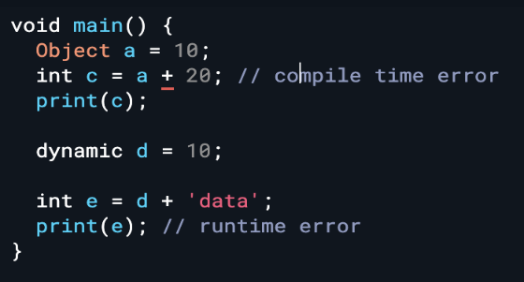
Object: states and behaviour
assign any data type & reassign any data type.But type safety bcz it’s type safety.(Compile Err)
dynamic: assign any data type and reassign any data type. it’s not type safety
Difference b/w : is & as => is data type check, as is Type casting
assert - takes one expression and checks if it is true or false, true means working normally but false means throw assertionError.

Flutter isolation and it’s communication? How to start and End? - set state
Isolation is independent thread execution.
isolate allows code to execute outside the main thread.
Isolate used to Long running task otherwise block the UI.
Isolate run in its own memory space. More than once isolate create

1.Isolate.Spawn() – start the isolate.
2.Isolate.Kill()- stop the isolate.
Another way to create isolate is compute<Q, R>() – Q isolate and R is return type.Once the work is done, isolation kill by itself
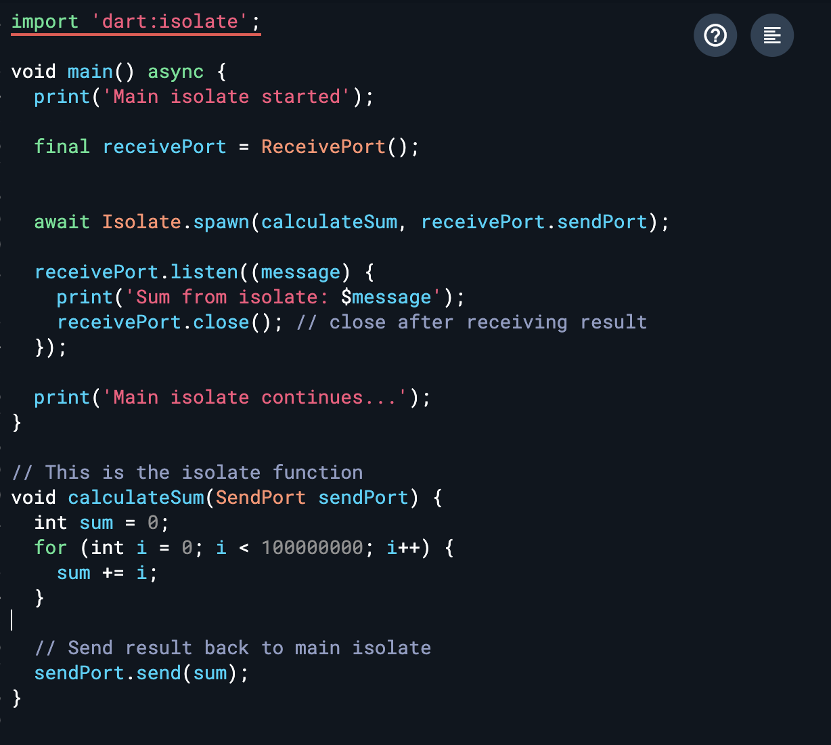

Isolate Communication:
SendPort – Send the data to the Receiver port.
Receive Port – Receive the data from sender port.
These port works normally likes streams, These ports are implements the Streams.

FittedBox:
single-child layout widget
UI’s robustness across different screen sizes,
used to automatically sizing and scaling its child widget by fit property. Ex
Difference between Equatable vs Freezed?
Equatable: compare objects by their values instead of their references
Freezed: it’s a package and reduce the code like fromJson, toJson, toString, copyWith (Clone the object), it will generate all of its method’s - json serialize package needed for fromJson and toJson. Pass the param in factory constructor. Code generation
constants - value that is known at compile time. cannot be changed.
Constant variables must be initialized. Error const int? A;
const means the value must be known at compile time and must be initialized immediately.
What are Dart Constants? Final - runtime, const - compile time
Final -values assigned at runtime & immutable - final currentTime = DateTime.now();
final int? a;
a = 10;
print(a); // 10

Const - value known at compile time. cannot be changed- const String appTitle = "Flutter Constants";
Why is the build() method on State and not StatefulWidgets?
Stateful widget class is immutable(non editable), State class is mutable(Editable) when setState is called the widget tree is updated in the state class
What is State?: A widget’s “state” is the information or data that it holds over time.
Double.infinity: as big as parent allows & Media query as big as the screen
Layout Builder:
It is a widget in Flutter that helps in building widgets based on the parent widget’s constraints. It is particularly useful for making responsive designs.
Event Loop:
executing asynchronous tasks on a single thread without blocking the UI.
Microtask Queue -higher priority - Ex: Future operations
Event Queue - Low priority - Ex: User taps, Network responses
manages tasks and events
such as UI rendering, user interactions, and asynchronous operations
continuously monitors and processes a queue of tasks or events
Dart is Single thread, it is used to make it multi thread,
event loop is a crucial part of flutter, manages the execution of asynchronous operations and UI updates.
manage System events (thread isolate) and touch events (click event)
Ex: Futures, isolates,
Sealed Class:
restricts the extend or implement of a class. Ex: sealed class test{}
Only classes defined in the same library/file can extend a sealed class
Helps Dart know all possible subclasses at compile time - ex: switch needs to add all of its sub classes
sealed class Calculation{}
class Addition extends Calculation {}
class Subtraction extends Calculation {}
class Multiplicaion extends Calculation {}

Dependency Injection:
Dependency Injection is a design pattern where objects or dependency receive from outside the class, instead of a creating them itself.

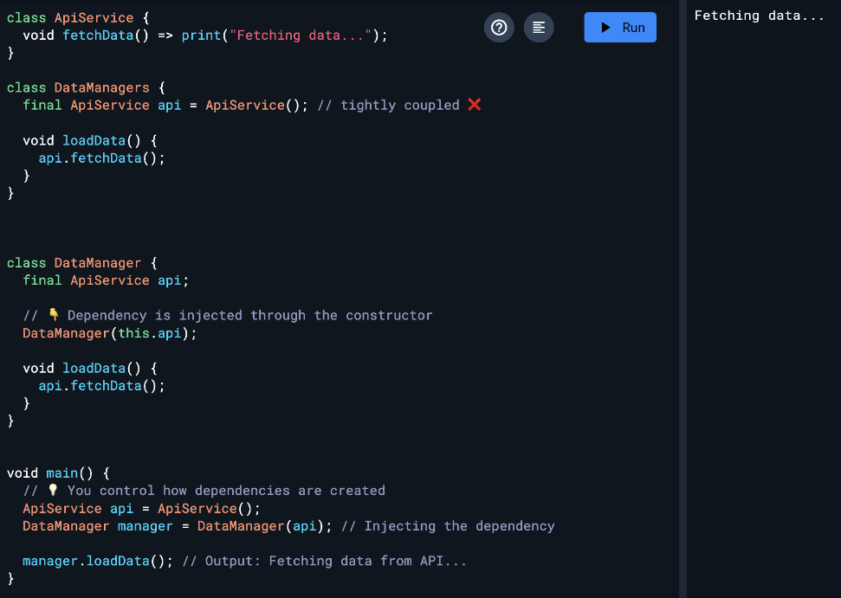
Constructor

Type | Definition | Simple Code Example | Preferred?
Constructor Injection | Dependency is passed through constructor | class HomeController {  final ApiService apiService;  HomeController(this.apiService);  void load() {  apiService.fetchData();  }  } | ✅ Most Preferred
Setter Injection | Dependency is set after object creation | class HomeController {  late ApiService apiService;  void setApiService(ApiService service) {  apiService = service;  }  void load() {  apiService.fetchData();  }  } | ⚠️ Not Recommended
Method Injection | Dependency passed directly into method | class HomeController {  void load(ApiService apiService) {  apiService.fetchData(); } } | ⚠️ Limited Usage

AppLication Life Cycle:
inactive — not receiving user input. when a phone call is received
paused — The application is not currently visible to the user, not responding to user input, and running in the background.
resumed — The application comes to the foreground and visible to the user .responding to user input.
suspending (deprecated)— Long time in the pause state will be suspended momentarily

What is an "is-a" Relationship?
An "is-a" relationship means that a child class is a type of its parent class.
this is represented using inheritance (extends).

6. What is Mixin: - A mixin is a way to reuse code in multiple class hierarchies without using inheritance.
- Reuse code in multiple classes without using inheritance

- Allows reusing a class’s code in multiple class hierarchies.
- A class can use more than one mixin.
- Defined using the mixin keyword.
- Applied using the with keyword.
- Cannot have a constructor.
- Mainly used to achieve multiple inheritance behavior in Dart.

Ex: Student class -> with PhyscialStatus (Height,Weight,Bgroup), MarksDetails(Tamil, Eng,Maths, Science, Total, Rank)

What is the difference between WidgetsApp and MaterialApp?
WidgetsApp
WidgetsApp is the foundational application widget in Flutter that provides core services like navigation, routing, localization, and text direction,
WidgetsApp provides the core Flutter app infrastructure
MaterialApp
MaterialApp extends WidgetsApp and adds Material Design-specific features such as themes, Material navigation, dialogs, snackbars, and Scaffold support
How to run a flutter app on the web?

1.To run a Flutter app on the web, first ensure web support is enabled using flutter config --enable-web,
2.Then execute flutter run -d chrome.
3.For production deployment, use flutter build web,
4.Which generates optimized web assets in the build/web directory

Stateful Widget life cycle
1.CreateState – Creating a stateful widget.
2.InitState – initializing the state and data, used to initialization.
3.didChangeDependency - Here we can get context to perform an action based on needs.(Like mediaQuery- screen size,)
4.Build – This method is called often used in setState , It must be return widget.
5.didUpdateWidget - Called when the parent widget rebuilds and passes new configuration.
Used to compare old and new values.

6. Deactivate - state is removed temporarily from the tree. Before dispose, we will call this function.
7.Dispose – The state is remove permanently, Here we can do dispose controller’s like stream controller, animation controller etc…

IOS APPS STORE BUILD PROCESS:
Step 1: Register App (Bundle Identifier)
1.Create App ID
Login to Apple Developer portal - Reg app using - identifier com.company.appname - Bundle ID match in Xcode proj.
2: Create Certificate Signing Request (CSR)
Generate CSR - Open Keychain Access - Apple developer email - Generate CSR file - Upload Apple Developer portal.
Download - Development & distribution certificate
3. X - code
Automatically manage signing - Manually select
4. App store - Archive file - distribute app - upload build - test flight / production
5. Submit & Review - new version - description - screen shots - privacy policy - submit (2 to 3) days for review
X-Code runner file
General : Change app version, build no., IOS Deployment version, Signing & Cap: select automatic signing to distribute the app in appstore
command - Flutter build ipa - Archives- Distribute the app
+ 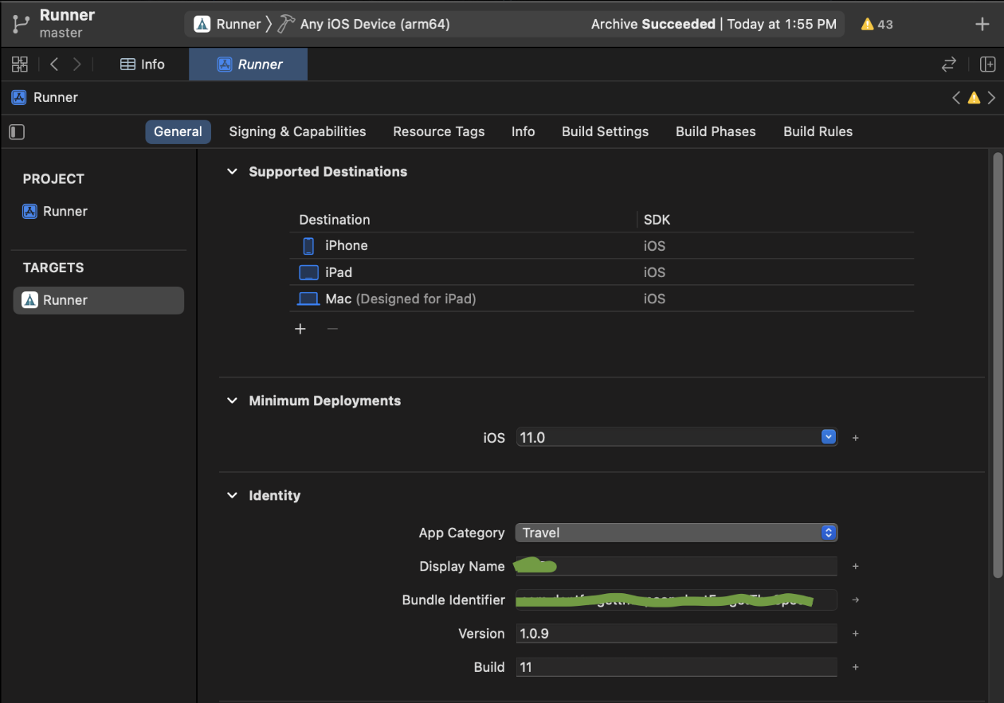
Android Build Process
- Change the default app icon (ic_launcher)
- Generate the Keystore - keytool -genkey -v -keystore
In android studio - Build tab - Generate signed apk - u will get the new keystore dialogue
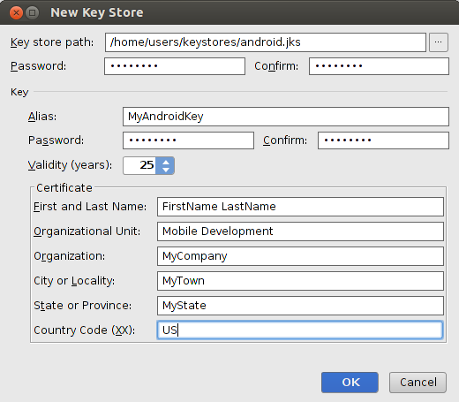
we have to choose keystore path and enter user name, password, validity years, first name last name, organization, city, state country code
- details about the app and company
- create the user name, alias name and password,
- Config the keystore file and password details in the gradle file
- update the version number and build number in the gradle file
- Enable multidex in gradle - for large app or large no of plugin used - 64k method supports
- Generate the release build
- flutter build apk --no-tree-shake-icons

Difference between apk and aab
APK - Android application Package | AAB - Android App Bundle
all assets, resources, and compiled code in a single package | Only required assets and resources are downloaded for the specific user’s device
same APK - all device types | device-specific APKs
Directly install | not directly installable (via google play)
Larger size | Smaller download size (Fast download)

Navigation? Navigation push, Navigation pop?
Navigator.of(context).push(MaterialPageRoute(builder: (context) => NewScreen()));
Navigator.Push - Navigate new screen and added to the route in stack,
Navigator.PushNamed - Navigate the new screen and added named stack route,
Navigator.pop - removed last item of the route stack,
Navigator.PushReplaced - replace the route item in the stack,
Navigator.PushRemoveUntill - Removed all route except the current item in the stack

Ticker: refresh rate of our animation. It is a class that sends a signal at a regular interval, i.e., around 60 times per second.
Singletickerproviderstatemixin: -> Single Animation controller.

TickerProviderStateMixin -> More than one animation controller.
Vsync -> keeps track of the screen, so that Flutter does not renders the animation when the screen is not being displayed.
Build Context – Current reference of widget tree or location of the widget tree.
widget's are attached in the Build Context , so every widget has its own BuildContext.
interact with the environment, access resources, screen information and more.
What is Identical – Check the two object reference same or not
mounted is a boolean property of a State object that tells whether the widget is currently attached to the widget tree.
- mounted == true → The widget is still on the screen (or part of the widget tree).
- mounted == false → The widget has been removed (disposed).

Material Vs Cupertino Widget?
Cupertino widgets are used to build an iOS-like app and MaterialApp is used to build an Android (Material) app.
Material widgets implement the Material design language for iOS, Android, web, and desktop.

Channels: (Async)
MethodChannel is used for asynchronous, single method communication between Flutter and native platforms.
Channel | Type | Use Case
MethodChannel | Single call (one-time method) | Battery, encryption
EventChannel | Stream (continues streams of data) | Location, sensors
BasicMessageChannel | Two-way messaging | Continues bi-directional communication

Tween Animation: Type of animation,
value of a property smoothly transitions between a start and an end
over a specified duration
Form, TextField, and TextFormField
Form: performs to save, reset, or validate operations- use TextFormField.
GlobalKey<FormState>
TextField: basic text input field, no validation
TextFormField: mainly used in form validation support through the validator.
Difference between StreamBuilder and FutureBuilder?
Future Builder: used for one-time response, like taking an image from the Camera, api call,
StreamBuilder: used for fetching data more than once, like listening for a location update, playing music, stopwatch, etc.
What is the Difference between synchronous operation and synchronous function also Difference between asynchronous operation and asynchronous function? synchronous operatil̥on: Line by line execution, synchronous function: only performs synchronous operations.
asynchronous operation: (parallel execution)
asynchronous function: An asynchronous function performs at least one asynchronous operation and can also perform synchronous operations.

Responsive Apps | Adaptive Apps
Adjust layouts & different screens dynamically | Adjust layouts & screens based platforms
MediaQuery, Layout Builder | Cupertino iOS - Material for Android

When to use mixins and when to use interfaces in Dart
Mixin -
1. Reusable behavior to multiple classes without inheriting parent class.
2. Seperate the function into reusable components

Interface in Dart
In Dart, every class acts as an interface.
An interface is used to force other classes to implement specific methods.

How many ways can you pass the parameters in Dart?
Required positional parameters — old/common style
Optional positional parameters — [ ]
Named parameters — { }

How to access property or method conditionally in Dart?
1.1. Null-Aware Access (?.)
access to a property or method of an object that might be null
1.2 Default Value (??)
Use the ?? operator to provide a default value if the object is null.( name ?? ‘Bala’)
1.3 Null-Aware Assignment (??=)
Use the ??= operator to assign a value only if the variable is null.( name ??= ‘Bala’)

Explain the spread operator - (...) => inserting multiple elements
var a = [0,1,2,3,4];
var b = [6,7,8,9];
var c = [...a,5,...b];
print(c); // prints: [0, 1, 2, 3, 4, 5, 6, 7, 8, 9]

Explain singleton class in flutter?
singleton class is a class that allows only a single instance of itself to be created, to access the instance globally.

How to Secure your Flutter Application?
1.Code obfuscation, 2.Stay up-to-date with your Flutter version, 3.Use Flushing in-memory cache, 4.Use local authentication, 5.Use Secure Storage, 6.Restrict network traffic

How would you execute code only in debug mode?
import 'package:flutter/foundation.dart' as Foundation;
Foundation.kDebugMode

What is Iterable collections in Dart?
collection of elements that can be accessed sequentially

What is Concurrency in Dart? (Parallel Programming)
execution of several instructions at the same time.

Deeplink: opens specific screen inside your app
User clicks a URL - OS checks -app registered for this URL - If yes → OS launches app- Flutter receives the link - You parse the URL - Navigate to the required screen

What is Deep Linking?
- Opens a specific screen inside the app directly from a URL.
- Useful for product pages, news articles, password reset, email verification, and promotional links.
Why use go_router?
- Simplifies navigation with declarative routing.
- Supports deep linking out of the box.
- Makes route management cleaner and easier to maintain.
Implementation Steps
- Create a Flutter project.
- Add the go_router dependency.
- Create application screens.
- Configure routes using GoRouter.
- Replace MaterialApp with MaterialApp.router().
- Configure Android (AndroidManifest.xml) -
android.intent.action.VIEW -Allows the activity to open a URL
DEFAULT -Allows normal implicit intent resolution
BROWSABLE -Allows links opened from browsers and other apps
iOS (Info.plist) for deep linking - <key>FlutterDeepLinkingEnabled</key>

- Test deep links using Android Emulator (adb) and iOS Simulator (xcrun)

Reg the app : Android - Android Manifest file, iOS - Runner file

What is Typedef in Dart?
In Dart, Typedef is used to create an alias (another name) for a type.

What is Generics in Dart? (List<int>) - Similar to dart collections it work with any data types
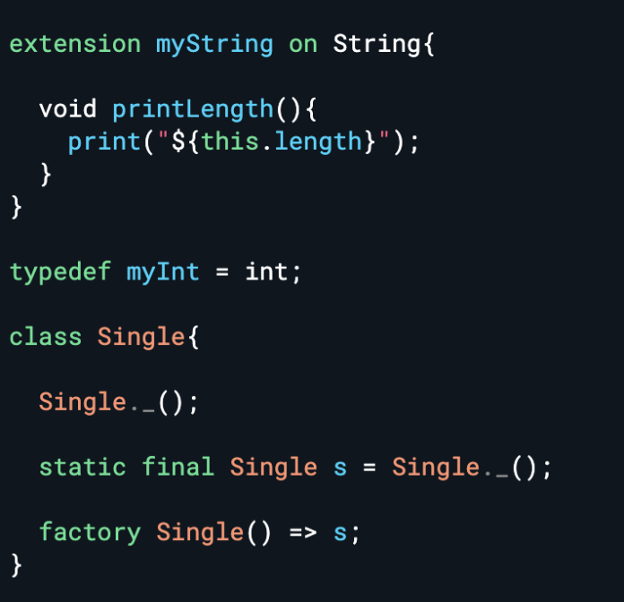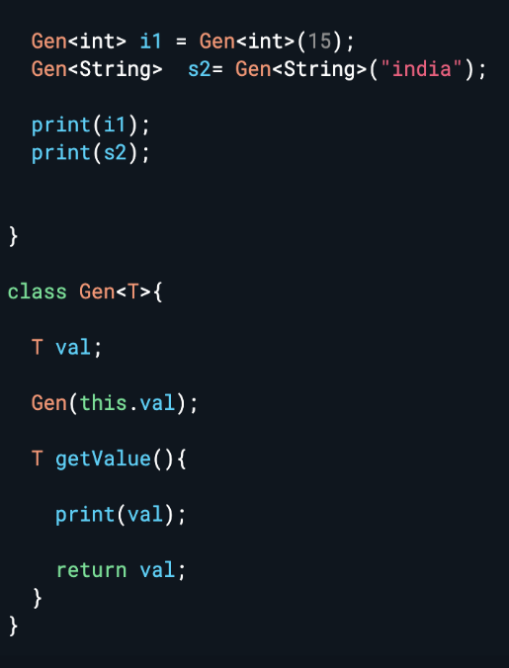

What is HTML DOM in Dart?
The HTML DOM (Document Object Model) - interact with and manipulate HTML programmatically.
This is particularly useful for web applications built with Dart. Dart provides a library called dart:html to interact with the DOM.

What is Symbol in Dart?
name of a Dart identifier (like a variable, method, or class name)
Symbol in Dart: Represents an identifier at runtime
Creation: Use the Symbol constructor or the # shorthand.
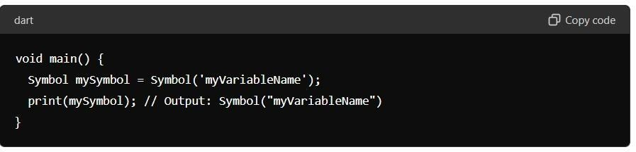

What are Dart Callable Classes?
special call method,
Creating instances like regular function
use: Managing the state, normal function not manage the state
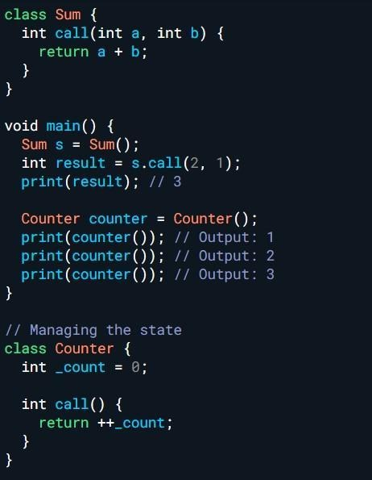
What is a Super Constructor in Dart?
Subclass is called the parent class constructor using the super keyword.
Implicit constructor - Default constructor
Explicit constructor - user created constructor

What is Anonymous Function (Function Expression) in Dart?
doesn't have a name.
Assign function to variable
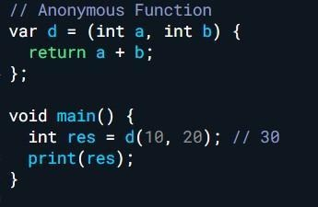

What is FFI in Dart?
FFI stands for Foreign Function Interface.
FFI allows Dart code to communicate to native C functions in shared libraries (DLLs on Windows, shared objects on Linux, and dylibs on macOS).
enables Dart developers to interoperate with existing native code,

1.Rabbit MQ:
Open-source message queuing protocol between the devices.
We have to config the MQ server.
Listen the message topic wise,
The MQ gives the stream of data. We must listen to the data.
If the connection is failing it has a retry mechanism to connect the server.
Why – Intercommunication within the network.
Local Notifications - Flutter awesome Notification plugin
We are showing notifications within the application, example file download success, timer etc...
Firebase Configuration (Very very Important)
1.Create the project in the firebase console.
2.Given package name.
3.Download google Json file and paste in app folder (Details about the firebase).
4. Config the Gradle file and add dependency fire base core.
5. Initialised fire base in main method.
IOS – Download Google service info.plist and move ios/ runner folder of your project.
Firebase Notifications (Push notification):
Login to firebase console.
Create a project.
Add dependencies in flutter project. (Firebase messaging, firebase core).
Initialise firebase in the main method.
Notification permission.
FirebaseMessaging token identification of device,
Setup Notification like channel id, title, icon, sound, vibration, get message from Json.
Config the required dependencies in the gradle file in android similarly config the pod file in the IOS.
FCM token uniquely identifies device - Android requires notification channel

WebRTC – (Web Real Time Communication)
Which is used to communicate video call, audio call and message through the streams,
Calls make through the streams of data. It’s free of cost.
We have to configure the webRTC server.
Firebase OTP Authentication:
Create and setup the project in the firebase console.
Configure the Firebase in your project.
Open Firebase Console - > Go to Authentication -> Sign in method -> Choose phone -> Enable and save.
Add dependency firebase authentication, firebase core.
Init in main method. Get the mobile number from app and the firebase generated the otp. Once you get the otp verify the otp from the app through firebase. Success means you can able to login.
Forking GitHub Repository:
The library was presented in the github repository and take a copy of the repository. Change the branch as for our logic and commit in the github itself.
The committed repository address should be specified in the pubspec yaml file.
Google Map Integration steps:
Add google map dependency.
Login to google cloud and create a project.
Enable API key for both IOS, Android and Get API credential.
Config the API key in Manifest in android, IOS AppDelegate.swift file.
get location permission from Manifest file and info.plist file in ios
You can play with the maps.
AppDelegate File in IOS: Entry point of IOS, App Launch appdelegate first called
Razorpay Payment Gateway
Create the razor pay account.
Login to razor pay account and generate the API key in test mode.
Add razor pay dependency in flutter project.
It has different methods: Payment success, Payment fail, external wallet like g-pay, phone-pay, paytm.
pass the api key, amount,name, contact num, email in the api
Test mode API key used for development Once it’s done you can integrate the Live Mode API Key.
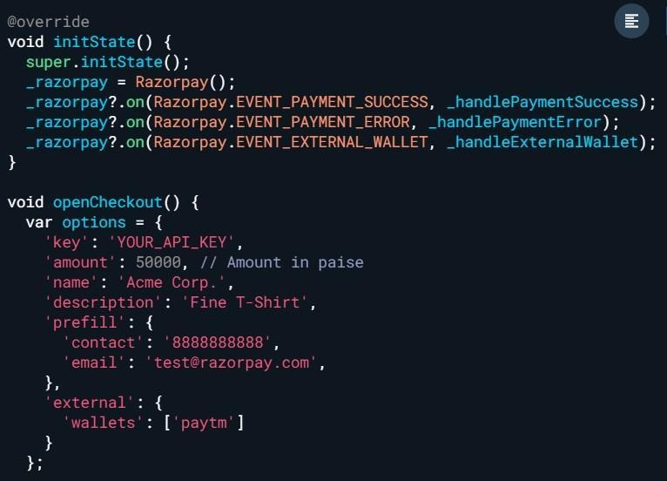

FireBase Crashlytics:
Which is used to report the crash error from the users with the stack trace.
Add dependency for the crahlytics
Catch the error and report the error in the firebase instance.

UB TECHNOLOGY:
- Flutter isolation
  - Flutter thread communication like START and END
- Custom widget.
- API or Network call.
- Inherited widget.
- Notifier in flutter and update notifier. (Value Notifier, change notifier)
- Mixin.
- Pagination.
- S3 Bucket Integration steps
- Explain about your project.
- Clipper, painting, chips.(Clipper is a custom widget that is used to clip the content within its bounds)- chips holding an icon and text - circle avatar widget, elevation,padding, labels style, background color
- Why we are going BLOC pattern.
- Subversion used like SVN, GIT, ASANA, REDMINE.
Nova Tech:
1.Isolates.
2.Inherited Widget.
3.Explain about your project.
4.Google Map Integration steps.
5.How to update lat lang in server background.
6.How do you get Flutter debug build and release build command and explain.
7.Lazy in flutter.
8. How to run flutter app on the web.
9.Screen orientation.
10.what is App state. data needs to manage and share across widgets or screens.

Emphasis:
1.How do you get the release build.
flutter clean
flutter pub get
flutter build apk --release
flutter build appbundle --release

2. Types of widget.
3. Bloc pattern.
4. What is the difference between the current flutter version and existing version.
Previous - 3.44 and Current -Flutter 3.47.0
-

Sweken
1.Streams.
2.What is Null aware and what is null aware operator
Null - Variable is not init that variable holds the null value,
Null-aware operator (?.) - variable hold the value or null value,
Null-coalescing operator (??) - (name ?? 'Guest')
Null-aware assignment (??=) - name ??= 'Guest';
Null assertion operator (!) - nullable variable but it should not be a null otherwise throw error
3.API calls.
4.Future Builder. -snapshot (success, error, processing)
5.Scope model in flutter. () - ScopedModel is a state-management approach in Flutter that allows you to share data and business logic between multiple widgets without passing values manually through every constructor.
6.How do you find the platform in flutter. (platform.isAndroid or ios - foundation)
7. Flutter isolates.
8.Call back function.
9.What is Json. (Key - value)
10. update the data post,put,delete.
11. what is key and it types explain.
12.MediaQuery
13. Difference between the current and previous version of the flutter.

Value Labs:
1.what is bloc – Bloc builder and it types explain.
2.How to protect your app?.
3. Difference between current flutter version and previous version

Alex Interview Company:
1.Isolates.
2. Flutter multi thread or single thread.
3.What is AOT and JIT
4.BLOC.
5.Mixin
6. What is Future.micro task in flutter? - immediate asynchronous execution.
If there is a list of future tasks, The Future.micro tasks is going to execute first.
7. What is identical in flutter?.
Compare the object reference, Primitive data types same value has same object reference, but array has different
two objects are the exact same instance in memory — not just equal in value
8. What is schedularMicroTask?
(way to run small tasks immediately after the current code finishes)
- print 0 : print
- print 1 : schedularMicroTask
- print 2 : Future.microTask
- print 3 : Future function
9.What is Future.wait? - Wait for the all future function executed
10. Unwait - Ignore the future (don’t wait the future function complete)
No company name (Perungudi)
1.What is the difference between Android and flutter.
2. Why you switch the Android to flutter.
3.State management. - State management is the process of storing, updating, and sharing data in an application
4.why don’t use GET X.
5.Explain about bloc.
6.Flutter advantages. - Single code base, platform independent, Fast development, High native performance (skia graphic engine used, it fast and smooth ui rendering), Strong developer community, Easy to learn, Open source, support web, desktop application, It was used zerodha, gPay, google ads

Wepril Technologies:
1.Stream builder. - Firebase realtime database
2.what is dio.
3.what is bloc.
4. What is builContext.

CGI
1.SharedPreference name in ios ans : (user default).
2.What is stream? Explain about single subscription stream and broadcast streams?
3.Hot reload and Hot restart?
Hot Reload - Just update the current state,
Hot restart - Restart the application & lose the current state.
4.Explain about your project?
5.Method channel? - Native platform communication
6.Statefull widget and stateless widget?
7.Bloc pattern?
8. What is context or Build Context in flutter?
reference to the location of a widget
interact with the environment, access resources, screen information and more.

Take Leap Tech
- What is context?
- How to send a context to other’s (Constructor)
- Stateful widget life cycle?
- Notification Explain about the notification? - group notification -> channelGroup
- How to protect our application?
- Dart is synchronous or Asynchronous. - both synchronous and asynchronous
Bank Genie
- What is Statefull widget and Stateless widget?
- Git & Subversion (Explain git commands like git merge and rebase)?
- Difference between cubit and bloc?
- Optional parameter and positional parameter?

Type | Syntax | Can Skip? | Use Order?
Positional | String name | ❌ No | ✅ Yes
Optional Positional | [String? name] | ✅ Yes | ✅ Yes
Named | {String name} | ✅ (unless required) | ❌ No
Named (required) | {required String name} | ❌ No | ❌ No

Option parameter - Square bracket []
Position parameter - Old format,
named parameter - using braces{}

- Different running mode like Debug mode, profile mode and release mode?
- Stream Single subscription stream and broadcast streams?
- What is animation controller?
- Explain about bloc?
- Scaffold and Container?
- Navigation? Navigation push, Navigation pop?

Navigator.Push - Navigate new screen and added to the route in stack,
Navigator.PushNamed - Navigate the new screen and added named stack route,
Navigator.pop - removed last item of the route stack,
Navigator.PushReplaced - replace the route item in the stack,
Navigator.PushRemoveUntill - Removed all route except the current item in the stack

- Different types of key? Global key, local key, unique key?
- What is media query? - gets information about the device screen — like its size, orientation, pixel density, and padding

Keys: keys are used to preserve the state of widgets or identify the widget
Use Case | Key Type
You want to uniquely identify widgets with a value (like id, name) | ValueKey
You want to use an object instance as a key | ObjectKey
You want to force uniqueness | UniqueKey
You need to access a widget’s state or context globally | GlobalKey

PWC
1.What is Dalvik?
2.
– 7 thread
3.How many states in a activity?
4.How to take release build?
5.Lamda function or Arrow function? => short block of code return value
6.What is ticker? -refresh rate of our animation.
7.What is Mixin?

No company name
- How do you find UI is rendered? -WidgetBindingInstaceOf.PostFrameCallBack
- Mixin and with keyword need clear example?
- Stream, Single subscription stream and broadcast stream?

- What is memory leak? Example?
Memory is allocated and it is not properly released
Ex : Stream controller, animation controller

- What is mount in setstate? -
mounted is a boolean property of a State object that tells whether the widget is currently attached to the widget tree.
- mounted == true → The widget is still on the screen (or part of the widget tree).
- mounted == false → The widget has been removed (disposed).

- How to add flutter page in android?
1. Include the flutter module in settings.gradle
2. build.gradle - add flutter module as dependency,
3.Initalise the flutter in your android project in mainActivity using flutter engine

- How to add flutter page in IOS?
1.create a flutter module in the ios root folder,
2. Add a flutter module as a dependency in pod file
3.Initialize the flutter in your android project in appdelegate file using flutter engine

- What is the callback function ? Example?
- Futures and it different functions?
- Futures with await and without await?
- How futures
Call Back function Example
Is a function that is passed to another function and gets executed later.
Real Time Exam[ple: After you finish your work, call me back
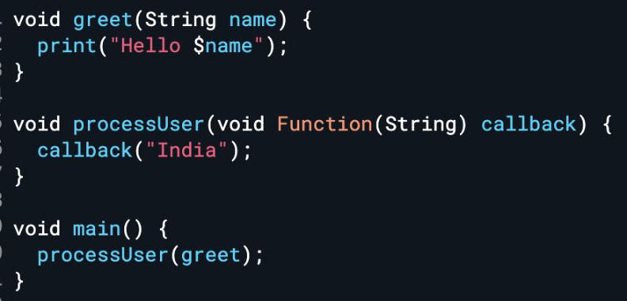

Difference b/w Bloc and Cubit:
- Cubit is subset of Bloc,
- Cubit don’t have event’s
- Cubit only have methods to emit the state.
- Cubit for simple project and Bloc for big projects.
Lamda function: Short block code and returns a value.
How do you find UI is rendered - WidgetsBinding.instance
.addPostFrameCallback((_) => afterFirstLayout(context));

Dalvik : virtual machine (VM) in the Android operating system that executes applications written for Android.

Media Query: access information about the screen.

UB TECHNOLOGY:
1.Flutter isolation and it’s communication? How to start and End?
2.Custom Widget:
Customised as per our requirements like Rounded Shape, color , size, etc.
3.Network or API:
1. Http provides the basic functionality.
2. Dio provide the extra functionality like log cache, encoding and speed.
4.Inherited Widget: - share data down the widget tree efficiently

This is particularly useful for the same data object needs to be accessed by multiple widgets
updateShouldNotify - true means rebuilt or else not
Can we update an InheritedWidget directly - NO - immutable(Non editable) - use stateful widget - setState to update the value
5.Notifier’s:
5.1.Value Notifier – managing a single state and notifies listeners when its value changes
ValueNotifier<int> counter = ValueNotifier<int>(0); counter.value = 1;
5.2.ChangeNotifier: managing complex state and notifies all subscribed listeners notifyListeners() called.
Route Guard in flutter: allow you to control navigation based on certain conditions, such as authentication status or permissions -

6. What is Mixin:
Abstrsct class – provide partial abstraction - Method declarations (without body), Method definitions (with body)
Without including the background details, ( tv switch on ),
Not able to create a object,
Partially abstract - method definition, method decleration
We can extend only one abstract class in a class,
Used extends keyword

Interface: - Every class can act as an interface. - Must override all methods
it’s a blueprint of a class
Fully abstract - Only method declaration, no definition
No object creation,
More than one interface can use in a class
used implements keyword

7.Pagination
Offset – Starting position of the record. offset = (page - 1) × limit
Limit – Number of records (total count of record). Ex => limit = 20.

Page | Offset Calculation | Records Fetched
1 | (1-1) × 20 = 0 | 0 – 19
2 | (2-1) × 20 = 20 | 20 – 39
3 | (3-1) × 20 = 40 | 40 – 59

8. Clipper – Custom shape the child widget.
8.1 Painting - To draw the shape to the widget.
9. Why we are using the BLOC
Separate the logic from UI and easy to understand the code.
Used to manage state.

Nova Tech:
10.Isolates – Refer S. No 1.
11.Inherited Widget – Refer S.No 4.
12. Google Map Integration steps:
add the google_maps_flutter dependency - create a project in Google Cloud - enable Maps SDK APIs - configure API keys in Android Manifest and iOS AppDelegate
13. How to update lat lang in server background?
Through the isolate. Location.lat lang.
14.Flutter Builds:
14.1 Debug – flutter build apk --debug.
14.2 Release – flutter build apk --release.
14.3 Profile – flutter build apk --profile.
15.Lazy in flutter - By default, object is created only when it is first accessed. To override this behavior, set lazy to false.
16. How to run flutter app on the web?
Flutter run -d chrome.
Build / Release Build – flutter build web.
17.Screen orientation (AltiMatrix)
Orientaion Builder gives orientation whether portrait or landsape.
Also detect orientation via Media query.
18. What is Ephemeral state and App state?
Ephemeral State - state variables are inside of the Stateful widget.
App State – variables are Outside declared stateful widget State that is shared across multiple parts of the app and persists for a longer duration. It includes data like user preferences, authentication status, and data fetched from a backend service.
Ex : User preference, Login info (Offical flutter doc)

Emphasis:
19. How do you get the release build?
20.Types of Widget:
20.1 StateFull Widget:
The statefull widget has a state to update the widget tree. It have lifecycle. Set state method to update the widget.
20.2 Stateless Widget:
The state less widget don’t have state. Once the value is set, we can’t update. Don’t have a life cycle.

21. Bloc Pattern (Business Logic Components):
1. Used to manage the state and separate the business logic from the UI.
2.Event & State – Event used to do an action and State used carry the out the result value and update the UI.
3. Types:
3.1 Bloc Builder – Build the ui respective states.
3.2 Bloc Consumer – Which is update the UI and do an action based on the state.
3.3 Bloc Listener – Used to listen the States and perform action like, dialogue, snack bar, Navigation. It doesn’t update the state.
3.4 Bloc Provider – Which is used to provide the bloc for its children. Children can access the bloc through the Bloc Provider of context.
BlocSelector - Select a specific part of the state and rebuild only when that selected value changes.
3.5 The Bloc Builder, Bloc Consumer, Bloc Listener has Build when, The Build When Which is used to When the bloc builder should build and similarly When the consumer or Bloc listener listen the states.
3.6 Multi Bloc Provider – Which used to initialize the multiple bloc.
3.6 on<Event> (event, state) is call back function which returns the event and state.
22. What is the difference between the current flutter version and existing version?
Previous - 3.44. and Current - 3.47 (Material Design 2 to 3, colors, themes, font, fab, dialog, performance enhancement, memory management)
Tab Bar, Date Picker, Time Picker
Sweken Technology:
23. What is Stream and it types:
Stream – Asynchronous sequence of events.
Sink – input of our stream or add the data, Example - StreamController.sink.add(“Data String”),
Stream.Listen – used to listend the data.
23.1 Single Subsription Stream - Which is used listen to the stream only one time. Otherwise, it will throw error. (file download progress shown to notification and inside the app screens).
23.2 – BroadCast Stream – Which is used to listen multiple time. Example (Stock price changes & portfolio screen update using socket).
24. What is Null aware and what is null aware operator?
Null Aware : The variable is not initialized, which means it holds the null value .
Null Aware operator’s: ! – Shuold not be a null, ?? variable is null we can assign some value.
25. Future Builder.
Used to execute the asynchronous functions and based on the function outcome UI Will update. Example API calls, Future functions.
26. How do you find the platform in flutter? - Platform.isAndroid.
27. Flutter isolates?
28. Call back function.
29. What is Json – Key value pair.
30. What is Key and it’s Types?
Identify the widget, Stores the widget states.
Value Key – Stores the Alpha numeric values.
( Object Key - It stores the complex object ex custom classes like model.)
Unique Key – Used store every widget is unique.
Global Key - it is a key that is unique across the entire app.
31.Media Query
32.Difference between the current and previous version of the flutter.

Value Labs:
33.what is bloc – Bloc builder and it types explain.
34.How to protect your app:
35.Difference between current flutter version and previous version.

Alex Interview Company:
36.Isolates.
37. Flutter multi thread or single thread. Single threaded.
38.What is AOT and JIT
JIT - Just In Time – Development Mode , Hot reload and Hot restart. Less time, Debug Mode
AOT – Ahead Of Time – Release Mode, Native build, Optimization, Release mode
39.BLOC.
40.Mixin
41. What is Future.micro task in flutter?.
The future micro Task which is used to execute first asynchronous task as soon as possible.
Ex:void main() {
Future(() => print('future 1'));
Future(() => print('future 2'));
// Microtasks will be executed before futures.
Future.microtask(() => print('microtask 1'));
Future.microtask(() => print('microtask 2'));
}

42. What is identical in flutter?. - identical() in Dart checks whether two objects refer to the same memory instance
43. What is schedularMicroTask? - immediate Run function asynchronously
44.What is Future.wait?
It will wait the all future function is completed and return the result, - All future function started at the same time.
45.Flutter advantages.
All platform, Fast development hot reload, Access Native features, Example Zerodha Kite, Google Ads, Pairing

Wepril Technologies:
46.Stream builder.
Stream builder is a widget, the widget can be update based on the snapshot.
47.what is dio.
Network call, decode the response data, resume and cancel request. interceptor(modify the input request & output response)
48.what is bloc.
49. What is builContext.
CGI
50.SharedPreference name in ios ans : (user default).
51.What is stream? Explain about single subscription stream and broadcast streams?
52.Hot reload and Hot restart?
Hot Reload – The code changes reload the current widget tree, preserve the app state.
Hot Restart – Restart the flutter app, losing the app state.
53.Explain about your project?
54.Method channel? - Native platform communication
Event channel – Used in native platform stream communication,
55.Statefull widget and stateless widget?
56.Bloc pattern?
Take Leap Tech
57.What is context? – a locator. Locate the position of the widget tree.
58.How to send a context to other’s (Constructor)
59.Stateful widget life cycle?

60.Notification Explain about the notification?
61.How to protect our application?
62.Dart is synchronous or Asynchronous? - Both.
Bank Genie
63.What is a Stateful widget and Stateless widget?
64.Git & Subversion (Explain git commands like git merge and rebase)?
Git Merge – Merge the branch with the commit history.
Git Rebase – Merge the branch without commit history like a fresh branch.
65.Difference between cubit and bloc?
66.Optional parameter and positional parameter? - Ref Previous Answer
67.Different running mode like Debug mode, profile mode and release mode?
Debug mode – Debugging the code, Profile – Performance, Release Mode – Deployment.
68.Stream Single subscription stream and broadcast streams?
69.What is animation controller?
70.Explain about bloc?
71.Scaffold and Container?
72.Navigation? Navigation push, Navigation pop?
Navigation – Route the page one to another page.
Navigation.push() – Used to navigate new page and it was added in the stack.
Navigator.push(context, MaterialPageRouter(builder: (context) => Page());
Navigation.pop() -> remove the last item of the route stack
73.Different types of key? Global key, local key, unique key?
74.What is media query?
—-----------------------------------------------------------------------------
Solid Principle:
S - Single-responsibility principle.
A class should have one, and only one, reason to change..
Ex: I separate validation, get the user details,
O - Open-closed principle.
Objects open for extension, but closed for modification.
Ex: initially supports email login. Later, the business asks for Google login.
L - Liskov substitution principle
Subtypes must be substitutable for their base types.(Parent base type suitable for its child class) EX: Farmer base class Suitable for Farmer child class and not suitable for shopkeeper child
I - Interface segregation principle.
A class should not be forced to implement methods it doesn't need.

I keep interfaces small and feature-specific. Login, logout, and password reset can have separate contracts, avoiding unnecessary dependencies.

abstract class LoginRepository {
Future<String> login(String email, String password);
}

abstract class LogoutRepository {
Future<void> logout();
}

D - Dependency Inversion Principle.
High-level modules should not depend on low-level modules.
Teacher - student class, The teacher class not dependent on the student class but student class depend on the teacher class

dependencies- development stage and build stage.
dev_dependencies - only used during development stage not in the build stage.
---------------------------------------------------------------------------------------------------------------------------
OOPS Concept:
Object - States & Behaviour.
Class - Group of objects called Class.
Inheritance – The child get behavior’s and properties from the parent. It’s used to achieve runtime polymorphism.
Polymorphism – More than one form is called polymorphism,
compile-time polymorphism(Not in Dart - type safe) – Method overloading is compile time polymorphism. Add params to the methods - we can achieve through optional parameter. Why not support means we can’t create two methods in the same name
Runtime -Polymorphism – Override method is called Runtime polymorphism.
Single Inheritance – Class Inherits another class.
Multilevel Inheritance – Chain of inheritance is called multi-level inheritance.
Hierarchical Inheritance – Two or More classes Inherit the single class.
Multiple Inheritance – Dart -Not Support – Because – Class A has test()and Class B also has test() so it could be problem when extending. Ex Class Test extends A,B
Abstract class - Without including the background details like fan switch.
- It has abstract methods and non-abstract methods.
- It cannot be initiated. 3. It can have constructors and static methods also.
Interface: It is a blueprint of a class. It has only had abstract methods and constants.
Encapsulation
Both combining data and function is called encapsulation. Example – Model class.
Async – Parallel execution.
Sync – Only one execution at a time.c
Future – The function is execute and returns the value after some time in the future .
Await – wait until the function is complete.

Altimatrix
1. List<int> list =<int>[23, 1, 90, 3, 56, 23, 0, 6, 12] – Array Sorting Logic & reverse a list
2. Flutter Application life cycle,
INACTIVE (IOS Only)– App is not active, not receive user i/p, only works on IOS, no eq method in android.
PAUSED – App is not visible to the user, running in the background and not responds to the user.
RESMED – App is visible to the user, responds to the user.
SUSPENDS(Android only) – App is suspended.
3. Build Context, Media query, Layout builder, Widget life cycle.
4.What is flex widget? - We can change its childs to row or column - axis direction
5.Equilent of onResume in Flutter -> Widget.bindingInstance.PostFrameCallBack

TCS:
1.Dependency Injection, mixin, polymorphism, isolates, method channel, future, async, await,

Altimatrix(Samsung):
Async, await, Future, Method channel, Event channel,shrinkwrap,bloc,streams,

Photon Flutter:
- What is Callback hell? How to resolve using future?
Nested callback function is called callback hell, You can use await and then function to resolve this
- What is Local variable and instance variable?
Variables declared within a method are local variables, Instance variable is declared inside a class.
- Difference between statefull widget and stateless widget?
- Communication b/w Parent to child and Child to Parent – Bloc pattern
- Difference b/w Scaffold and container
- Screen navigation in flutter
Navigator.push() – New screen and added the page navigator stack
Navigator.pop() – Whick helps to remove the last added navigator in the stack,
Navigator.pushNamed(context, '/second'); - which helps to push the named navigator
Direct Navigation with MaterialPage Route
Navigator.push(
context,
MaterialPageRoute(
builder: (BuildContext context) => LobbyScreen(),
),
);

Static Navigation with Route Map
return MaterialApp(
title: 'Flutter Demo',
theme: ThemeData.light(),
initialRoute: LoginScreen.route,
routes: {
LobbyScreen.route: (context) => LobbyScreen(),
LoginScreen.route: (context) => LoginScreen(),
GameScreen.route: (context) => GameScreen(),
},
);

- how to manage dependency management in flutter - Using pubspec.yaml file,
- how to store data or persist data in flutter – Shared preference or Session service class instance using singleton class.
- how to implement styling in flutter?
TextStyle(
fontFamily: 'Montserrat',
color: ThemeColor.bodyText,
fontSize: 40,
height: 0.5,
fontWeight: FontWeight.w600)

- Unit testing -
- security implementation in flutter – VPN network, ssl certification, api authendication SSL - secure sockets layer ,
- Pro-guard rules, - ProGuard is a tool used to shrink, optimize, and obfuscate Android application code.
- How to optimize flutter app performance? Minimize Widget Rebuilds, Use Stateless Widgets, use const keyword which return the same instance for same value object, Minimize resources imported from libraries, Reduce the Size of the App, Use Asynchronous Operations, Listviewbuilder,

Photon 2:
1.Multi- Thread - Isolates - How to update the ui from isolate -Future builder single data, Stream builder for continues data,
2. What is abstract class, Difference between abstract and normal class,
Abstract class - Can’t create objects, Partially abstraction have method declaration and definition . Normal class: Create object.
3.Stateful widget lifecycle- DidupdateWidget ?
@override
void didUpdateWidget(Foo oldWidget)
super.didUpdateWidget(oldWidget);
_controller.duration = widget.duration;
setState

4.Why are we using a stateful widget inside bloc or whether right or wrong?- wrong, use stateless widget
5.Secure storage - flutter_secure_storage - encrypts data before storing
6.Local DB name- SQFLite
7. PGM - [1,1,1,2,2,3] k =2 ans : [1,2] we can solve in single loop;

Password validation
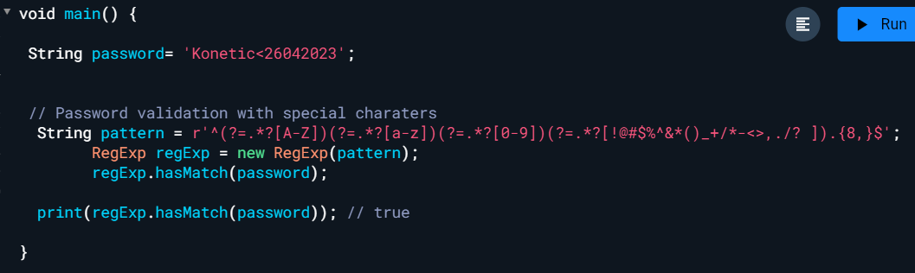

INTERVIEW PROGRAMS:
- How do you find the missing number in a given integer array of 1 to 100? (solution)
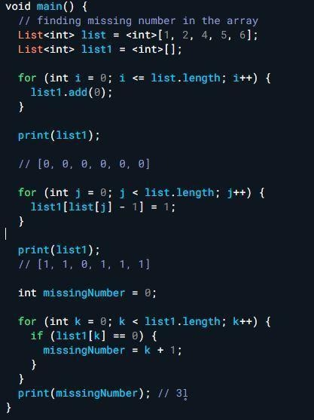
- How do you find the largest and smallest number in an unsorted integer array? (solution)
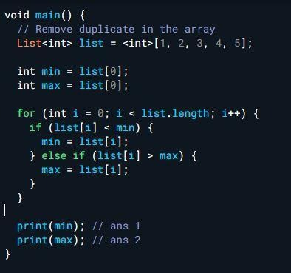

- Reverse a String and check it is palindrome?
- Check the integer value count in a String?
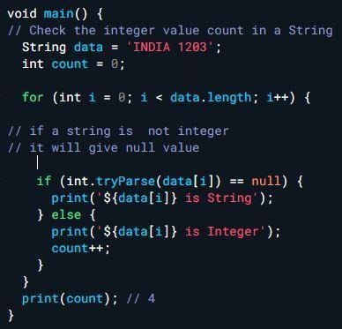

Mphasis:
- What is compiler, (High level lan - Low level lang)
- What is then function,
GroundFos:
- Statefull widget and stateless widget
- Statefull widget life cycle
- How do you update the state less widget - Value notifier
- encapsulation - getter setter
- scaffold widget
- inheritance,
- object , class
- mixin
- difference between abstrFact class and interface,
- String operations
- Streams - single subscription and broadcast stream,
- How do find user is logged in redirect to home page - shared preference
- futurebuilder, streambuilder, Buildcontext, interface,
- factory constructor,
- Bloc can update stateless widget - yes - using Bloc builder

Use StatelessWidget with BLoC for most UI screens, and use StatefulWidget when you need to manage local UI state or widget lifecycle.

Accenture company Interview:
1.Singleton class - create - example - types
2.Inherited widget - creation - example
3.Provider - How to use
4. Unit test - bloc test - golden test(Widget testing)
5.Routing - Navigation - types
6. Difference Didchange dependency and DidUpdate widget
7. Bloc - Brief Details
8.Inheritance - Types
9.Error handling.
10. Difference between https and dio packages
11. D/w abstract class and interface
Sing X:
1.What is stateful widget and State less widget?
2.Stateful widget life cycle?
3.Start point of Dart i.e void main and Run App?
void main - entry point dart program, RunApp - start point of widget
4.IOS Notification extension - modify the content, Encrypt or decrypt, download attchement
5.Notification Plugin and QR code plugin - notification awesome notification,
6. What is Info.plist - config file, version, bundle name, permission, meta data
7.Push Notification
8.How do you get the crash details from the user? - crashlytics
9.What is shrink wrap? -
Usually a ListView tries to fill all the available space given by the parent element, even when the list items would require less space.
With shrinkWrap: true, Adjust size based on content.
What does the shrinkWrap property do in Flutter? - Stack Overflow
10. What is const and final
11.What is future?
12.What is var and dynamic?
var - Once the data type is assigned. We can’t change the data type.
dynamic - We can the data type any time
13.What is tree shake?
- Remove unused codes during the building time
14.What is deeplink? - specific screen inside your Flutter app directly using a URL
15.Network image? -
16.Difference b/w Flexible and Expanded
17.Method channel?
18.What is access token and Refresh token?
Access Token - authenticate API requests.
Refresh Token - If the current access token expires, get the new access token.

Accenture Interview (Ashan Kumar)
- Bloc - Bloc Listener, Bloc Consumer, Bloc Builder, Bloc Selector
- Bloc Provider access - Code Bloc Provider.of(context)<BlocName>, Bloc provider passing next page
- Difference b/w bloc provider and multi bloc provider.
- Different b/w Bloc and Cubit
- High order class
- Call back.
- Sealed class
- Inherit widget - Inside method
- Life cycle of widget
- Abstract class and interface
- Generic class

Flutter Architecture:
- Frame Work (Dart)
- Engine ( C / C++)
- Embedder (Platform specific)
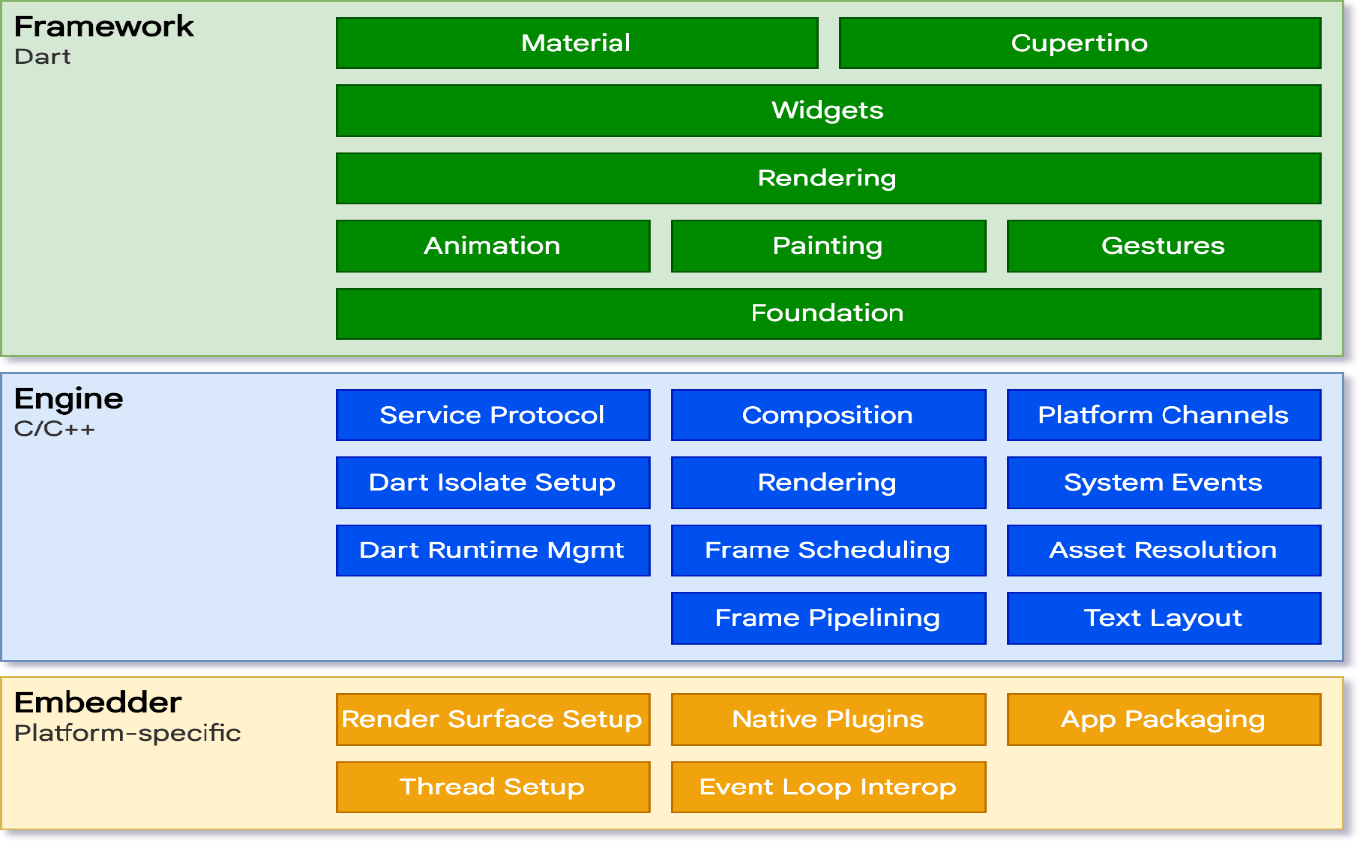
1.Frame work:
1.1 Material - ( using Material 3 - Cards, Floating action button, Text fields, color, elevation, animation, Theme customization, motion and transition)
consists of widgets, containers, gesture detectors, cards, fab button and etc…
1.2 Cupertino - Which used ios Styling like chips, icons .. etc
1.3 Widgets - Everything is widgets like container, text, gesture detectors, animations stateful widget and stateless widgets
1.4 Rendering - Different phases
Build phase - creating elements
Layout Phase - Size and position
Paint Phase - Visual representation
1.5 - Animation - Handling the animation
1.6 - Painting - Visual representation of widgets
1.7 - Gestures - handling the taping functionality like gesture detector , ink well (ripple effect)
1.8 - Foundation - handling the flutter core things like keys, typedef… etc
2. Engine ( C / C++):
2.1 - Service protocol - Dart virtual Machine (Low level lang to High level lang)
2.2 - Dart isolate - Separate thread, Own memory space, Communicate through ports
2.3 - Platform Channel - Communicate native platforms
2.4 - Dart Runtime management - JIT -Just In Time (Development) - AOT - Ahead Of Time (Release Mode)

3. Embadder (Platform Specific):
3.1 - Render surface setup - Setup specific platform to run the code
3.2 - Native Plugins - Handle the platform specific plugin
3.3 - App Packaging - Platform specific application like android , ios

Just-in-Time (JIT) Compilation
- Development: During development, Dart uses JIT compilation, allowing features like hot reload. This means the Dart code is compiled to machine code on-the-fly during execution.
- Advantages: JIT enables quick iterations and fast feedback cycles, which are essential during development.
Ahead-of-Time (AOT) Compilation
- Production: For production, Dart uses AOT compilation. The Dart code is compiled to native machine code before execution.
- Advantages: AOT compilation provides better performance, faster startup times, and smaller memory footprint, making it suitable for production deployments.
Recursive Function:
A function called itself directly or indirectly, It is called recursive function.
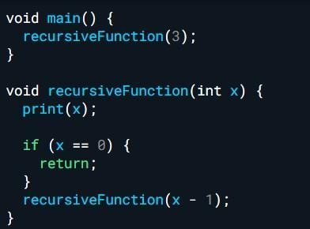
Generic Class: the same as the Dart collections, store homogenous data.
generic class allows you to create classes, methods that work with any data types
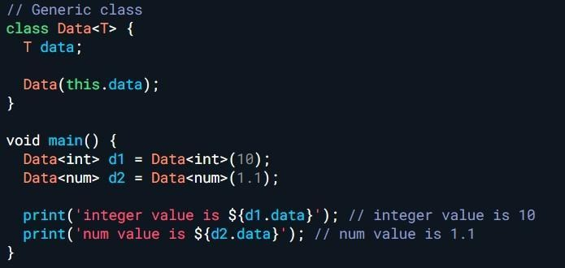

Difference between async and async*
async: used in future and return future value,
async*: used in stream and return a stream
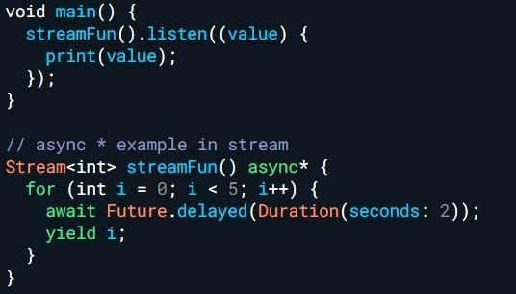
Extension in dart: - Add new functionality to existing library .
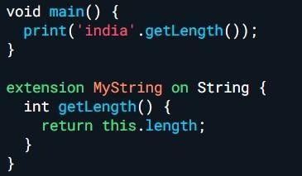
Count the vowels in the string?
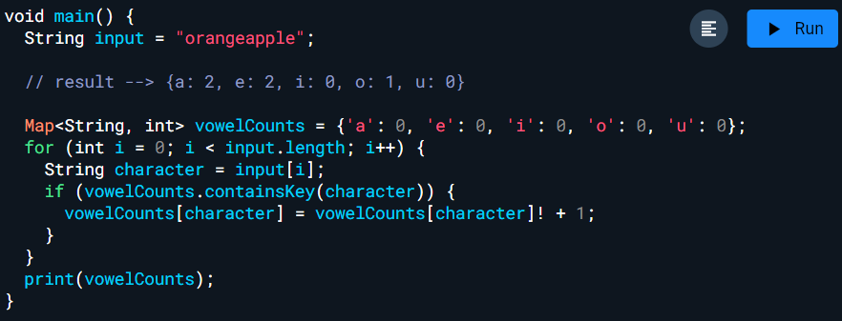
Find the each letter count in a string
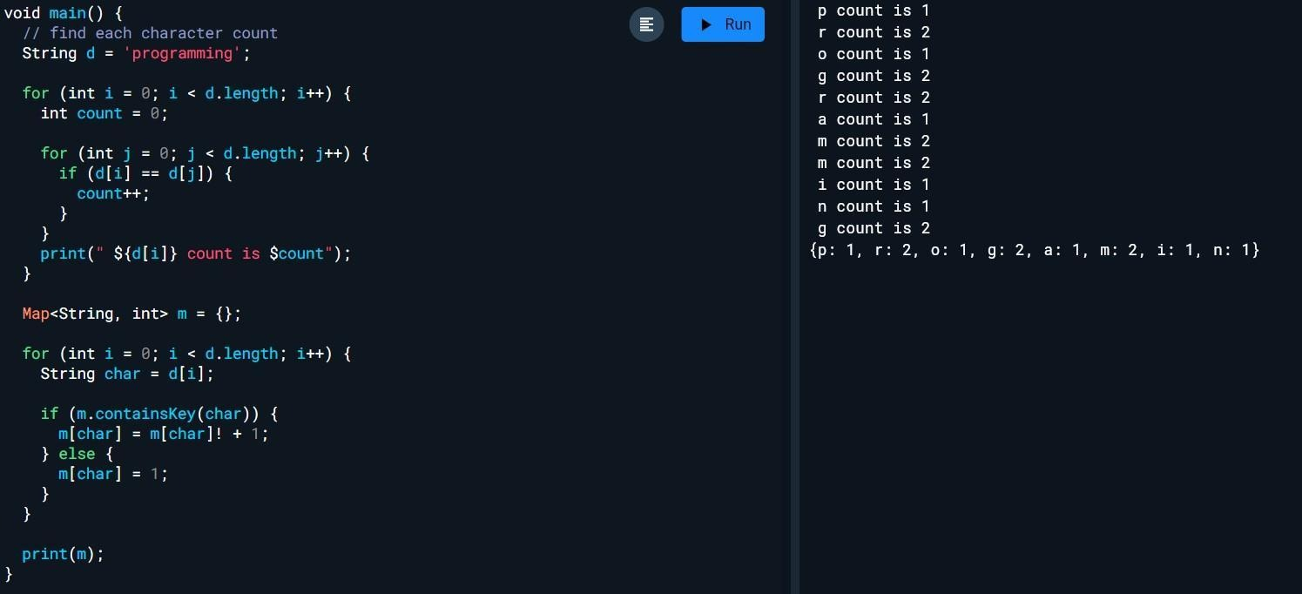
Capgemini

1. State management - BLOC
2. Clean Architecture - MVC
Data Layer - Handles API calls, local DB, Firebase, Shared Preferences, JSON Parsing, Repository Implementation
Domain Layer - entity - core business logic , use case - handling of exception, error handling
Presentation Layer - UI Layer (Widgets, Screens, BLoC),Responsible for user interaction
3. Safe Area - find separate ios and android - Platform.ios
Sealed Class : Sealed class
4. Android camera is working and ios Camera not working -(Before used you can see the popularity and continuous update) Looks for another plugin, library defect
Higher order Function - Takes another function as a parameter.
Higher-order function = accepts or returns another function.
Callback function = the function passed to another function.

void greet() {
print('Hello, Bala!');
}

void executeFunction(Function callback) {
callback();
}

void main() {
executeFunction(greet);
}

5. freezing model class
6. ios camera -
7. what is info.plist -
It is configuration file, it is declared key value pair, bundle identifier, camera permission,
8. what is permission given in ios (info.plist) and android (Manifest file - XML - Extensible Markup Language) - camera permission, file permission, storage permission
9. How to generate android release, ios release build - certificates
10.What is the text size of the push notification - 4 KB
11.What do you do the package is deprecated?
1. Read deprecated notice,
2. Checkout the latest version of the plugin
3. Looking for alternative plugin,
4. Example: FlatButton is deprecated and latest button TextButton
12.Stream 1.Single 2. Broadcast stream
13.await and async
14. ble
15.Application life cycle
16.State ful widget and state less widget
17.Flutter flow Explain - visual development tool,build Flutter apps without writing code, drag-and-drop
18.Firebase database - No SQL Database, json- Set(Add), update
19.Flutter is single threaded language,
20.Pubspec yaml file (Yet Another Markup Language - easy to read,write, complex data structure, widely used config file - docker, )
21.Type of api integration - post, put(whole resource update), delete, get, patch - partial update(lightweight update)
Json to Model(List);
List<Notes>? notes;
if (json['notes'] != null) {
List<Notes> notes = <Notes>[];
for (final dynamic v in json['notes'] as List<dynamic>) {
notes!.add(Notes.fromJson(v as Map<String, dynamic>));
}
}

Model to JsonArray:
Map<String, dynamic> toJson() {
final Map<String, dynamic> data = <String, dynamic>{};
if (notes != null) {
data['notes'] = notes!.map((Notes v) => v.toJson()).toList();
}
return data;
}
Pubspec yaml file:
Project Metadata: The name, description, and version fields provide basic information about your project.
Environment: Ensures that your project uses the correct versions of the Dart and Flutter SDKs.
Dependencies and DevDependencies: Manage the packages your project requires for both production and development.
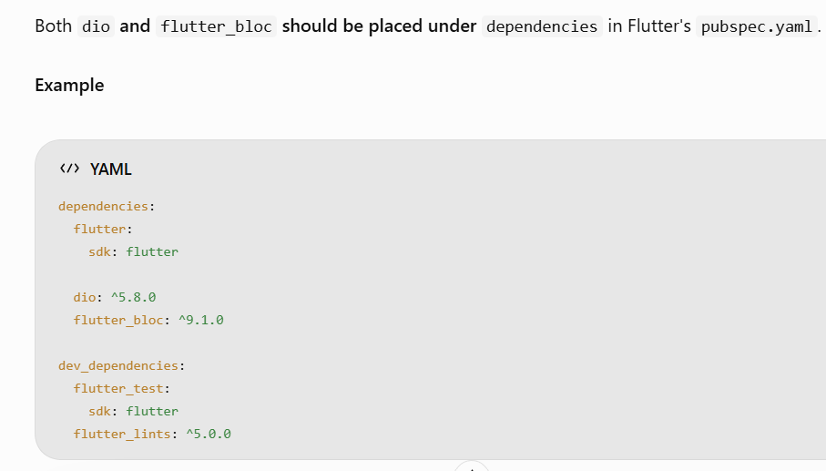

Dependencies: - Required to develop and build the project.
Dev dependency : - required during the development ex: flutter test.
Assets and Fonts: Define any assets or custom fonts that your project uses.

Dependency / Library:
Android : gradle file, IOS: pod file

Named Constructor:
class Test {
String? data;
Test.myConst(String data) {
this.data = data;
}
}

Capgemini (Bala) - Gopal:
1. Screen A to Screen B - what is the life cycle is called for Screen A and Screen B?
Screen A Before Navigate to Screen B
Screen A: initState
Screen A: didChangeDependencies
Screen A: build
After Navigation: (No change in the Screen A life cycle)
Screen B: initState
Screen B: didChangeDependencies
Screen B: build
Again Back to the Screen A:
Screen B: deactivate
Screen B: dispose
2. mount?
3.Basic message channel
4.Event channel
5.mimic in flutter - simulate specific behaviors and states in Flutter, you typically use mock data unit testing or integration test
6.what is Constructor and it's types named constructor ex?
7.How to pass a value one bloc to another bloc (Create a variable to pass)
9.Webview is work on webview ? not worked
10.Adaptive and responsive screen ?
11.Method channel
12.Inherited widget?c
13.Flutter fire -
FlutterFire is a set of Flutter plugins that enable Firebase services (like : Firebase authentication, Firebase Firestore, Firebase Messaging, Firebase crashlytics, Firebase real time database)
14.Flutter firebase push notification architecture?
15.Flutter latest version and previous version, Difference
16.Print letter count in a string Ex: "apple" Res: a:1,p:2,p:2,l:1,e:1
17.Named constructor example code
18.What is the problem faced in flutter web development? Hot reload.
19.Difference between the package and plugin?

BetaFront: (02-8-2024)
1.What is types of widget tree?
Widget Tree - root of the widget hierarchy ,Describes the UI, created by the runApp()
Element Tree- bridge between widgets and the render objects, manage the lifecycle of the widgets, It is created by the Flutter framework
Render Object Tree- rendering of the visual elements painting, layouts, it constructs the element tree.
Why container take full screen EX h-100,w-100? - A Container will expand as much as its parent allows. If it's placed inside a widget that gives it unconstrained space, like the root of the app (e.g., Scaffold or MaterialApp), then it will take the full screen.
Did update widget code -
Blocbuilder & blocListener- BB - Render the ui respect to state & BL- Only action respect to the state
Bloc consumer and Block Provider code
Inherited widget - code need

Anubhavam Technology(08-08-2024)
1.Stream - Single subscription, BroadCast Stream
2.Appstore & Playstore steps and release builds
3.Image.Networks & NetworkImage diff-
Image.Networks - Displays images from a URL - (Widget)
NetworkImage - create an image from a URL using ImageProvider(Decoration image)
Image.asset - Displays images from the assets.
Image.file - Displays images from the local file system
Image.memory - Displays images from raw bytes(Uint8List) in memory.
4.Firebase authentication-
5.spread operator - inserting multiple elements
6.Google map location - can share 2nd floor location- through the elevation
7. What do you do if the download is stopped due to the networks disconnected after sometime network is back and resume the download how to work ?
I preserve the partially downloaded file and calculate its current size. When connectivity returns, I send an HTTP Range request starting at that byte offset
8. Difference between key and Global key
9. Expanded and Flexible
10. Null aware operator
11. Flutter architecture
12. How to solve merge conflict
13. Push notification and Local notification
14. Deeplink
Nagarro (09-08-2024)
1. Differe

Animation controller- forward, reverse, stop, repeat, addListener, dispose
animation builder - widget, animating the children

Flyersoft:
- How do you animate widget - AnimatedContainer, AnimatedPositioned, AnimatedOpacity,
- Difference b/w Stateful widget and inherited widget
- How to update inherited widget - wrap - stateful widget - rebuild(setState)
- Isolate - isolate.spawn, isolate.kill
- BLOC-
- BuildContext
- FCM Push Notification - (IOS need certificate p.12)
- What is the difference between value notifier and change notifier
- Global key and local key
- Diff Future builder and StreamBuilder
- Nullable operation
- Diff Flexible, Aspect - maintains a fixed width-to-height ratio for its child
- Custom widget - bloc, api call
Core Dart Questions
- What is the difference between == and identical()?
- How many types of parameters are there in Dart?
- Difference between abstract class and interface?
- Difference between extends, implements, and with?
- What is lazy initialization in Dart?
- What is the use of const vs final?
- What is mixin in Dart?
- What is the difference between static and instance members?
Flutter Architecture Questions
- What is BuildContext?
- Why can't we use context inside initState()?
- What is widget lifecycle?
- Difference between StatelessWidget and StatefulWidget?
- What happens during Flutter rebuild?
- What is the difference between hot reload and hot restart?
State Management (Very Important for You)
- What is BLoC pattern?
- Difference between Bloc and Cubit?
- What is BlocBuilder?
- What is BlocListener?
- What is BlocConsumer?
- What is BlocSelector?
- Difference between BlocBuilder and BlocSelector?
- What is buildWhen and listenWhen?

buildWhen is a condition in BlocBuilder. builder should rebuild when a new state is emitted.

listenWhen is a condition in BlocListener. listener listener the callback when a new state is emitted.
- How does BLoC prevent unnecessary rebuilds?
- Difference between ValueNotifier and ChangeNotifier?
- ValueNotifier vs setState?
Navigation & Routing
- What is Route Guard?
- How to implement authentication-based navigation? - If the user is not logged in → show the Login screen.
- Difference between Navigator 1.0 and 2.0?
- GoRouter vs AutoRoute?
- How to handle deep linking in Flutter?
Platform Integration
- What is MethodChannel?
- Difference between MethodChannel, EventChannel, BasicMessageChannel?
- Is Platform Channel synchronous or asynchronous? - asynchronous.
- How to integrate Google Maps in Flutter?
- How to restrict Google Maps API key? - (Android package name + SHA-1, iOS bundle ID)
Performance Optimization
- What is lazy loading? objects are created - when they needed
- What is const constructor and how it improves performance?
- What causes unnecessary rebuilds?
- How to optimize large list performance? - ListViewBuilder
- When to use RepaintBoundary?
- How do you structure large Flutter projects?
1️⃣ Presentation Layer
- UI
- Screens
- Widgets
- BLoC / Cubit
2️⃣ Domain Layer
- Business logic
- Use cases
- Abstract repositories
- Entities
3️⃣ Data Layer
- API calls
- Models
- Repository implementations

- How do you handle API cancellation in BLoC?
- How do you handle memory leaks in Flutter? -
properly disposing controllers, streams, and subscriptions, avoiding retaining BuildContext unnecessarily
- How do you manage global state? -
Global state is data that needs to be accessed across multiple screens.
Logged-in user data, Authentication status
- What is Clean Architecture in Flutter?
- How do you test BLoC?

Topic's
Week 1: Dart Fundamentals (Strong Foundation)
Master these topics:
- Variables (var, final, const)
- Data types
- Functions
- Optional parameters
- Named parameters
- Collections
  - List
  - Set
  - Map
- Null Safety
- Extensions
- Generics
- Async Programming
  - Future
  - async/await
  - Stream
- Exception Handling
- Mixins
- Abstract Classes
- Interfaces
- Sealed Classes
- Factory constructors
- Cascade operator (..)
- Spread operator (...)
- Pattern Matching
Coding Practice
- Reverse String
- Palindrome
- Fibonacci
- Prime Number
- Remove duplicates
- Frequency count
- Sorting
- Binary Search

Week 2: Flutter Core
Study every widget deeply.
StatelessWidget
Know
- lifecycle
- when to use
- immutable
StatefulWidget
Know
- createState()
- State object
- Widget lifecycle
Important lifecycle methods
initState()

didChangeDependencies()

build()

didUpdateWidget()

deactivate()

dispose()
Interview Questions
- Why build() is called multiple times?
- Why initState cannot use BuildContext? - widget has not completed its dependency setup
- Difference between initState and didChangeDependencies?
- BuildContext
Very Important
Know
- ancestor lookup
- Provider
- Navigator
- Theme
Questions
- What is BuildContext?
- Why context from initState fails?
- Builder widget purpose?

Layout Widgets
Master
Center

LayoutBuilder

FittedBox

FractionallySizedBox

CustomMultiChildLayout

Scroll Widgets
ListView

GridView

SingleChildScrollView

CustomScrollView

Slivers

NestedScrollView

State Management
You MUST know multiple approaches.
Provider
- ChangeNotifier
- Consumer
- Selector
- MultiProvider
Riverpod
- Provider
- StateProvider
- FutureProvider
- StreamProvider
- StateNotifierProvider
- Notifier
Bloc
Know
Bloc

Cubit

Event

State

BlocBuilder

BlocListener
Interview
Why Bloc?
Why Riverpod?
Difference between Provider and Riverpod?

Week 3: Advanced Flutter
Navigation
Navigator 1
Navigator 2
GoRouter
Deep Linking
Named Routes

Networking
Know
http

dio

Retrofit
Topics
- GET
- POST
- Multipart
- Timeout
- Retry
- Token Refresh
- Interceptors

Local Storage
SharedPreferences

Hive

SQLite

Secure Storage
Interview
When to use each?

Architecture
Very Important
Clean Architecture

Dependency Injection
Know
injectable
Questions
Why DI?
Benefits?

Performance
Interviewers love this.
Know
const widgets

RepaintBoundary

Keys

Selector

AutomaticKeepAlive

Image cache

Lazy loading

Pagination
Questions
How do you improve app performance?

Animation
Know
Implicit Animation

AnimatedContainer

AnimatedOpacity

Hero

AnimationController

TweenAnimationBuilder

Week 4: Senior Topics
Firebase
Know
Authentication

Firestore

Crashlytics

Analytics

Remote Config

Push Notification

Platform Channels
Know
MethodChannel

EventChannel

BasicMessageChannel
Interview
When native code is required?

Flutter Internals
Question

Memory Management
Know
dispose()

Memory leak

TickerProvider

Controller disposal

Testing
Know
Unit Test

Widget Test

Integration Test

Mockito

CI/CD
Know
GitHub Actions

Fastlane

Codemagic

Firebase App Distribution

App Release
Know
Android
APK

AAB

Signing

ProGuard

Play Store
iOS
IPA

Provisioning

Certificates

TestFlight

App Store

Flutter Interview Coding Questions
Practice these
- Login Form
- Todo App
- Infinite List
- Pagination
- Search with debounce
- OTP Screen
- Shopping Cart
- Theme Switch
- API Integration
- File Upload
- Image Picker
- Pull to Refresh
- Infinite Scroll
- Timer
- Stopwatch
- Chat Screen
- Bottom Navigation
- TabBar
- Custom Painter

Flutter Debugging Questions
Know how to solve
- Widget rebuild issue
- Memory leak
- FutureBuilder rebuilding
- Nested ListView issue
- RenderFlex overflow
- Null Safety issue
- State lost after navigation
- Hero animation issue
- BuildContext issue

iOS & Android Knowledge
Since Flutter developers are often expected to work across platforms:
Android
- Activity lifecycle
- Fragment basics
- Intents
- Permissions
- Deep Links
iOS
- App lifecycle
- Swift basics
- SwiftUI basics
- Info.plist
- Universal Links

System Design (Senior-Level)
Be ready to explain:
- How would you design a scalable e-commerce app?
- How would you implement offline-first synchronization?
- How would you support multiple environments (Dev/UAT/Prod)?
- How would you secure API communication and token storage?
- How would you organize a large Flutter project with multiple teams?
- How would you optimize startup time and reduce app size?

Mock Interview Questions
Expect questions such as:
- Explain the Flutter rendering pipeline.
- What happens internally when setState() is called?
- Provider vs Riverpod vs Bloc—which would you choose and why?
- How do you optimize Flutter performance?
- How do you prevent unnecessary widget rebuilds?
- What is the difference between Future and Stream?
- Explain isolate usage and when you'd use one.
- How do you handle API errors and token refresh?
- Explain Clean Architecture with a real project example.
- Describe the most challenging bug you've solved and how you approached it.
Daily Study Plan (3 Hours)
- 45 minutes: Dart concepts and coding problems.
- 60 minutes: Flutter concepts (widgets, state management, architecture, performance).
- 45 minutes: Build or enhance a small feature (API integration, pagination, authentication, etc.).
- 30 minutes: Mock interview practice—answer questions aloud and review common interview topics.
Given your experience, also prepare project-based answers. Be ready to discuss:
- The architecture you used.
- State management choices and why.
- Performance optimizations you implemented.
- CI/CD pipeline and release process.
- A difficult production issue you resolved.
- How you collaborated with backend, QA, and product teams.
These practical discussions often carry more weight than theoretical questions in senior Flutter interviews.
Keys
What is a Key in Flutter?
A Key tells Flutter how to identify a widget across rebuilds.
Normally, Flutter matches widgets by:
- Widget Type
- Widget Position (Index)
If these change, Flutter may destroy the old widget and create a new one.
A Key gives Flutter a stable identity.

Interview Definition
A Key is an identifier that helps Flutter preserve a widget's state and correctly match widgets when the widget tree changes due to rebuilds, reordering, insertion, or deletion.

1. ValueKey
Interview Question
When do you use ValueKey?
Answer:
Use ValueKey when each widget has a unique value like an ID, email, or username.

Example
import 'package:flutter/material.dart';

void main() {
runApp(const MaterialApp(home: ValueKeyExample()));
}

class ValueKeyExample extends StatefulWidget {
const ValueKeyExample({super.key});

@override
State<ValueKeyExample> createState() => _ValueKeyExampleState();
}

class _ValueKeyExampleState extends State<ValueKeyExample> {
List<String> names = ["John", "Alice", "David"];

@override
Widget build(BuildContext context) {
return Scaffold(
appBar: AppBar(title: const Text("ValueKey Example")),
body: Column(
children: [
ElevatedButton(
onPressed: () {
setState(() {
names.shuffle();
});
},
child: const Text("Shuffle"),
),
Expanded(
child: ListView(
children: names.map((name) {
return ListTile(
key: ValueKey(name),
title: Text(name),
);
}).toList(),
),
)
],
),
);
}
}
Why ValueKey?
Suppose
John
Alice
David
After shuffle
David
John
Alice
Without keys Flutter matches by index.
With
ValueKey(name)
Flutter knows
"This is still John, just moved."
It preserves state correctly.

Real Project Use Cases
- Chat messages
- Product list
- Employee list
- User list
- Email list

Interview Tip
ValueKey should be used whenever each item has a unique identifier.

2. ObjectKey
Interview Question
What is ObjectKey?
Answer
ObjectKey uses the object instance itself instead of a primitive value.

Example
import 'package:flutter/material.dart';

void main() {
runApp(const MaterialApp(home: ObjectKeyExample()));
}

class Person {
final String name;

Person(this.name);
}

class ObjectKeyExample extends StatefulWidget {
const ObjectKeyExample({super.key});

@override
State<ObjectKeyExample> createState() => _ObjectKeyExampleState();
}

class _ObjectKeyExampleState extends State<ObjectKeyExample> {
List<Person> people = [
Person("John"),
Person("Alice"),
Person("David"),
];

@override
Widget build(BuildContext context) {
return Scaffold(
appBar: AppBar(title: const Text("ObjectKey Example")),
body: Column(
children: [
ElevatedButton(
onPressed: () {
setState(() {
people.shuffle();
});
},
child: const Text("Shuffle"),
),
Expanded(
child: ListView(
children: people.map((person) {
return ListTile(
key: ObjectKey(person),
title: Text(person.name),
);
}).toList(),
),
)
],
),
);
}
}

Why ObjectKey?
Imagine
Person(
id,
name,
salary,
department
)
Instead of
ValueKey(person.id)
you can simply use
ObjectKey(person)
Flutter identifies that object instance.

Real Use Cases
- Product Model
- Employee Model
- Cart Item
- Chat Message Model

Interview Tip
ObjectKey is useful when the object instance itself represents the identity.

3. UniqueKey
Interview Question
When should we use UniqueKey?
Answer
Every time you create a UniqueKey, it is different from every other key, even if the widget data is the same.

Example
import 'package:flutter/material.dart';

void main() {
runApp(const MaterialApp(home: UniqueKeyExample()));
}

class UniqueKeyExample extends StatefulWidget {
const UniqueKeyExample({super.key});

@override
State<UniqueKeyExample> createState() => _UniqueKeyExampleState();
}

class _UniqueKeyExampleState extends State<UniqueKeyExample> {
Key key = UniqueKey();

@override
Widget build(BuildContext context) {
return Scaffold(
appBar: AppBar(title: const Text("UniqueKey Example")),
body: Center(
child: Column(
mainAxisAlignment: MainAxisAlignment.center,
children: [
Container(
key: key,
width: 150,
height: 150,
color: Colors.blue,
),
ElevatedButton(
onPressed: () {
setState(() {
key = UniqueKey();
});
},
child: const Text("New Key"),
)
],
),
),
);
}
}

What happens?
Every button click
Old Widget

↓

Destroy

↓

New Widget
Flutter treats it as a completely new widget.

Real Use Cases
- Restart animation
- Reset form
- Restart timer
- Reload widget from scratch

Interview Tip
UniqueKey forces Flutter to recreate the widget instead of reusing the existing one.

4. GlobalKey
The most important key for interviews.

Interview Question
What is GlobalKey?
Answer
A GlobalKey uniquely identifies a widget across the entire app and lets you access its State, BuildContext, or methods from outside the widget.

Example
import 'package:flutter/material.dart';

void main() {
runApp(const MaterialApp(home: GlobalKeyExample()));
}

class GlobalKeyExample extends StatelessWidget {
GlobalKey<FormState> formKey = GlobalKey<FormState>();

GlobalKeyExample({super.key});

@override
Widget build(BuildContext context) {
return Scaffold(
appBar: AppBar(title: const Text("GlobalKey Example")),
body: Padding(
padding: const EdgeInsets.all(20),
child: Form(
key: formKey,
child: Column(
children: [
TextFormField(
validator: (value) {
if (value!.isEmpty) {
return "Required";
}
return null;
},
),
ElevatedButton(
onPressed: () {
if (formKey.currentState!.validate()) {
print("Valid");
}
},
child: const Text("Submit"),
)
],
),
),
),
);
}
}

Why GlobalKey?
Normally
Parent
↓
Child
↓
State
Parent cannot directly access the child's state.
With
GlobalKey<FormState>
the parent can call
formKey.currentState!.validate();

Another Example
GlobalKey<ScaffoldState> scaffoldKey =
GlobalKey<ScaffoldState>();

Scaffold(
key: scaffoldKey,
);
Open Drawer
scaffoldKey.currentState!.openDrawer();

Real Project Use Cases
- Form validation
- Open Drawer
- Access child methods
- Show Overlay
- Capture widget for screenshots (RepaintBoundary)

Interview Tip
Use GlobalKey only when necessary because Flutter must keep track of it globally, making it more expensive than local keys.

Common Interview Questions
1. Why do we need Keys?
Without keys, Flutter matches widgets by type and position, which can cause state to move to the wrong widget after reordering. Keys provide a stable identity so the correct state stays with the correct widget.

2. Difference between ValueKey and ObjectKey?
ValueKey | ObjectKey
Uses a primitive or immutable value (ID, name, email) | Uses the object instance itself
ValueKey(user.id) | ObjectKey(user)
Best when a unique property exists | Useful when the object itself represents identity

3. Difference between LocalKey and GlobalKey?
LocalKey | GlobalKey
Unique among siblings | Unique across the entire app
Cannot access widget state directly | Can access State, BuildContext, and widget methods
Includes ValueKey, ObjectKey, and UniqueKey | More expensive; use only when needed

4. Which key is used most in real projects?
- ✅ ValueKey (most common)
- ✅ GlobalKey (mainly for forms and scaffold interactions)
- ✅ ObjectKey (when working with model objects)
- ⚠️ UniqueKey (specific scenarios like forcing recreation)

Senior-Level Interview Answer
If asked "Explain all Flutter keys.", you could answer:
"Flutter provides both LocalKey and GlobalKey. LocalKey identifies widgets among siblings and includes ValueKey, ObjectKey, and UniqueKey. I use ValueKey most often for list items with stable IDs, ObjectKey when the model object itself is the identity, and UniqueKey when I intentionally want Flutter to discard the old widget and create a new one, such as restarting an animation. GlobalKey is different because it uniquely identifies a widget across the entire application and allows access to its State or BuildContext. I typically use it for form validation, controlling a Scaffold, or interacting with a child widget from outside its own build context. Since GlobalKey has additional overhead, I avoid using it unless it's the right tool for the job."
A GlobalKey uniquely identifies a widget across the entire app and lets you access its State, BuildContext, or methods from outside the widget. i don't understand, explain me with the program
Great question. This is one of the concepts that many developers memorize but don't fully understand. Let's build it step by step.

Without GlobalKey
Imagine you have two widgets:
Parent Widget
|
|
Child Widget
The child has a method:
class ChildWidget extends StatefulWidget {
const ChildWidget({super.key});

@override
State<ChildWidget> createState() => ChildWidgetState();
}

class ChildWidgetState extends State<ChildWidget> {
int counter = 0;

void increment() {
setState(() {
counter++;
});
}

@override
Widget build(BuildContext context) {
return Text("Counter: $counter");
}
}
Now suppose the parent wants to call
increment();
Can it?
No.
Why?
Because the parent only knows
ChildWidget()
It does NOT know
ChildWidgetState
So this is impossible:
ChildWidget().increment(); // ❌ Error
The parent has no reference to the child's state.

Solution: GlobalKey
A GlobalKey acts like a remote control.
Think of it like this:
TV ---------------- Remote

Child Widget ------ GlobalKey
The key stores a reference to the child's State.

Example 1 – Access Child State
Step 1: Child Widget
import 'package:flutter/material.dart';

class ChildWidget extends StatefulWidget {
const ChildWidget({super.key});

@override
ChildWidgetState createState() => ChildWidgetState();
}

class ChildWidgetState extends State<ChildWidget> {
int counter = 0;

void increment() {
setState(() {
counter++;
});
}

@override
Widget build(BuildContext context) {
return Text(
"Counter : $counter",
style: const TextStyle(fontSize: 28),
);
}
}

Step 2: Parent Widget
import 'package:flutter/material.dart';
import 'child_widget.dart';

void main() {
runApp(
const MaterialApp(
home: ParentWidget(),
),
);
}

class ParentWidget extends StatelessWidget {
const ParentWidget({super.key});

final GlobalKey<ChildWidgetState> childKey =
GlobalKey<ChildWidgetState>();

@override
Widget build(BuildContext context) {
return Scaffold(
appBar: AppBar(title: const Text("GlobalKey Demo")),
body: Column(
mainAxisAlignment: MainAxisAlignment.center,
children: [

ChildWidget(
key: childKey,
),

const SizedBox(height: 20),

ElevatedButton(
onPressed: () {
childKey.currentState?.increment();
},
child: const Text("Increment"),
),
],
),
);
}
}

What happens?
Initially
Counter : 0
Click
Increment
Now
Counter : 1
Again
Counter : 2
Again
Counter : 3
Notice something interesting.
The button is in the Parent, but it updates the Child.
Normally this isn't possible.
Because of
childKey.currentState
the parent gets access to
ChildWidgetState
and can call
increment();

What does currentState mean?
This line
childKey.currentState
returns
ChildWidgetState
which means you can call
childKey.currentState?.increment();
or
childKey.currentState?.setState(() {});
or any public method you created.

Visual Diagram
Without GlobalKey
Parent
|
|
Child

Parent ❌ cannot access ChildState
With GlobalKey
Parent

|
GlobalKey
|
ChildState

Parent ✔ can call Child methods

Example 2 – Form Validation (Most Common Interview Example)
final formKey = GlobalKey<FormState>();
Attach it to the form:
Form(
key: formKey,
child: Column(
children: [
TextFormField(
validator: (value) {
if (value!.isEmpty) {
return "Enter your name";
}
return null;
},
),
],
),
)
Validate from a button:
ElevatedButton(
onPressed: () {
if (formKey.currentState!.validate()) {
print("Valid Form");
}
},
child: const Text("Submit"),
)
What is happening?
The button is outside the Form's internal state, but because the Form has a GlobalKey, Flutter lets you access its FormState:
Button
|
GlobalKey
|
FormState
|
validate()
Without a GlobalKey, you couldn't directly call validate() on the form's state.

Example 3 – Open Drawer
final scaffoldKey = GlobalKey<ScaffoldState>();
Assign it:
Scaffold(
key: scaffoldKey,
)
Open the drawer:
scaffoldKey.currentState?.openDrawer();
Again, you're accessing the ScaffoldState through the key.

Interview Explanation
If the interviewer asks:
"Why do we use GlobalKey?"
You can answer:
"Normally, a parent widget cannot directly access the State object of a child StatefulWidget. A GlobalKey provides a unique reference to that widget's state, allowing the parent to call public methods, access the BuildContext, or interact with built-in widgets like Form and Scaffold. Common use cases include form validation, opening a drawer, and invoking methods on a child widget."
Firebase Notification
Firebase Push Notifications (Flutter) - Complete Explanation
1. What is GoogleService-Info.plist in iOS?
Answer:
GoogleService-Info.plist is the Firebase configuration file for iOS.
It contains
- Firebase Project ID
- App ID
- API Key
- Sender ID
- Storage Bucket
- Other Firebase configuration values
Steps
- Open Firebase Console.
- Create or select a project.
- Register the iOS application using the Bundle ID.
- Download GoogleService-Info.plist.
- Copy it into
ios/Runner/
- In Xcode
- Right Click Runner
- Add Files to Runner
- Select GoogleService-Info.plist
- Ensure "Copy items if needed" is checked.
Without this file, Firebase cannot communicate with the iOS application.

2. How do you configure Firebase Push Notifications?
Step 1
Login to Firebase Console
https://console.firebase.google.com

Step 2
Create a Firebase Project
Example
My Banking App

Step 3
Register Android App
Provide
Package Name

com.company.bank
Download
google-services.json
Move to
android/app/

Step 4
Register iOS App
Provide
Bundle Identifier

com.company.bank
Download
GoogleService-Info.plist
Move to
ios/Runner/

3. Add Required Flutter Dependencies
dependencies:
firebase_core: ^latest
firebase_messaging: ^latest
flutter_local_notifications: ^latest
Run
flutter pub get

4. Initialize Firebase
Inside main()
void main() async {
WidgetsFlutterBinding.ensureInitialized();

await Firebase.initializeApp();

runApp(MyApp());
}
Always initialize Firebase before using any Firebase service.

5. Notification Permission
Android
Android 13+
await FirebaseMessaging.instance.requestPermission();
Earlier Android versions grant permission automatically.

iOS
Need explicit permission
NotificationSettings settings =
await FirebaseMessaging.instance.requestPermission(
alert: true,
badge: true,
sound: true,
);

6. FCM Token
Every installed application gets a unique FCM Token.
Example
String? token =
await FirebaseMessaging.instance.getToken();

print(token);
Example Output
dKJL8293kdlJ2938kdf...
This token is sent to the backend server.
The backend stores it and uses it to send push notifications to that specific device.

7. What is an FCM Token?
Interview Answer
The FCM Token uniquely identifies an application instance on a specific device. Whenever the backend wants to send a notification to a user, it uses the stored FCM token. If the app is reinstalled or the token is refreshed, we send the updated token to the backend.
Also listen for token refresh:
FirebaseMessaging.instance.onTokenRefresh.listen((token) {
// Update backend
});

8. Notification Message Flow
Backend

↓

Firebase Cloud Messaging (FCM)

↓

Android / iOS Device

↓

Flutter App

↓

Display Notification

9. Receiving Notifications
App in Foreground
FirebaseMessaging.onMessage.listen((RemoteMessage message) {
print(message.notification?.title);
});

App in Background
FirebaseMessaging.onBackgroundMessage(
firebaseMessagingBackgroundHandler);

Future<void> firebaseMessagingBackgroundHandler(
RemoteMessage message) async {

await Firebase.initializeApp();

}

App Terminated
FirebaseMessaging.instance.getInitialMessage();

10. Notification Payload (JSON)
Example
{
"notification":{
"title":"Payment Success",
"body":"₹5000 Credited"
},
"data":{
"screen":"transaction",
"transactionId":"12345"
}
}
Notification contains
- title
- body
Data contains
- custom values
- navigation data
- ids
- deep links

11. Display Local Notification
Usually we use
flutter_local_notifications
Example
flutterLocalNotificationsPlugin.show(
0,
message.notification?.title,
message.notification?.body,
notificationDetails,
);

12. Android Notification Channel
Android 8+ requires Notification Channels.
Example
AndroidNotificationChannel channel =
AndroidNotificationChannel(
'high_importance_channel',
'High Importance Notifications',
description:
'Used for important notifications.',
importance: Importance.high,
);
Then create it
flutterLocalNotificationsPlugin
.resolvePlatformSpecificImplementation<
AndroidFlutterLocalNotificationsPlugin>()
?.createNotificationChannel(channel);
Without a notification channel, notifications may not appear properly on Android 8.0 (API level 26) and above.

13. Notification Customization
Configure
- Channel ID
- Channel Name
- Title
- Body
- Icon
- Sound
- Badge
- Priority
- Vibration
- Large Icon
- Color
Example
AndroidNotificationDetails(
'high_importance_channel',
'Notifications',
importance: Importance.max,
priority: Priority.high,
playSound: true,
enableVibration: true,
);

14. Android Gradle Configuration
Project-level (android/build.gradle or settings.gradle depending on your Gradle setup)
classpath 'com.google.gms:google-services:4.4.2'
App-level (android/app/build.gradle)
plugins {
id 'com.google.gms.google-services'
}
Minimum SDK
minSdkVersion 21
Place
google-services.json
inside
android/app/

15. iOS Configuration
Enable
Push Notifications
and
Background Modes

✔ Remote notifications
Inside Xcode
Signing & Capabilities
Push Notifications

Background Modes
Also upload the APNs Authentication Key or Certificates in the Firebase Console for iOS push delivery.
APNs Authentication Key (.p8) ✅ (Recommended)
APNs Certificates (.p12) (Older method)
How do you create an APNs Authentication Key?
- Log in to the Apple Developer portal.
- Go to Certificates, Identifiers & Profiles.
- Select Keys.
- Click the + button to create a new key.
- Enter a name (e.g., "Firebase Push Notifications").
- Enable Apple Push Notifications service (APNs).
- Create the key.
- Download the .p8 file (it can only be downloaded once).
- Note the Key ID and your Apple Team ID.
Run
cd ios
pod install

16. Foreground vs Background vs Terminated
App State | Callback
Foreground | FirebaseMessaging.onMessage
Background | FirebaseMessaging.onBackgroundMessage
Notification Tap | FirebaseMessaging.onMessageOpenedApp
Terminated | FirebaseMessaging.instance.getInitialMessage()

17. Real-Time Flow in a Banking App
Suppose a user transfers ₹10,000.
- Backend completes the transaction.
- Backend retrieves the user's stored FCM token.
- Backend sends a push notification through Firebase Cloud Messaging.
- FCM delivers the notification to the device.
- If the app is in the foreground, onMessage receives it and you can show a local notification.
- If the app is in the background or terminated, the system displays the notification.
- When the user taps the notification, onMessageOpenedApp or getInitialMessage() is triggered, allowing the app to navigate directly to the transaction details screen.

Common Interview Questions & Answers
Why do we use Firebase Core?
firebase_core initializes Firebase in the Flutter application. It loads the Firebase configuration from google-services.json (Android) and GoogleService-Info.plist (iOS) and establishes the connection to the Firebase project

Why do we use Firebase Messaging?
firebase_messaging integrates Firebase Cloud Messaging (FCM) to receive push notifications and data messages on Android and iOS.

Why do we use flutter_local_notifications?
FCM delivers the message, but on Android and iOS, foreground notifications are not automatically shown by the operating system. flutter_local_notifications is used to display a local notification while the app is active and to customize its appearance (icon, sound, channel, etc.).

Why is an FCM token important?
The FCM token uniquely identifies an app instance on a device. The backend stores this token and targets it when sending notifications to that specific user or device.

Why are Notification Channels required on Android?
Starting with Android 8.0 (API 26), every notification must belong to a notification channel. Channels define user-visible behavior such as importance, sound, vibration, and visibility. Without a channel, notifications may not be displayed correctly.

What is the difference between Notification Payload and Data Payload?
Notification Payload | Data Payload
Contains predefined keys like title and body. | Contains custom key-value pairs defined by your app.
The operating system can display it automatically when the app is in the background. | Always delivered to the app for custom processing.
Used for standard alerts. | Used for navigation, deep links, IDs, or custom business logic.

Chat GPT Ques & Ans
Q3 What happens internally when runApp() is called?
Most people cannot answer this.
main() — Dart starts executing your application.
runApp() — attaches the supplied root widget to the Flutter view and schedules the initial frame.
Widget tree — Flutter creates the initial element tree and calls build() as needed.
Element tree — Elements manage the widget instances' positions in the tree and their lifecycle.
Render tree — Render objects handle layout, painting, and hit testing.
Rendering pipeline — Flutter produces the frame, which is presented on the screen.

Interviewer Follow-up
Why is Flutter faster?
Answer
- Skia/Impeller rendering
- No WebView
- No JavaScript Bridge
- AOT Compilation

Q5 Difference between initState() and didChangeDependencies()
Interviewers ask this frequently.
initState()
- Called once
- API call
- Controller initialization
didChangeDependencies()
- Called after initState
- Called whenever inherited widgets change

Q6 Why should BuildConte5trfce zxt not be used after await?
Example
Wrong
Future login() async {

await api();

Navigator.push(context,...);

}
Correct
if(!mounted) return;

Navigator.push(...);
This is a common senior-level question.

SECTION 4 State Management
Q7 Why Bloc?
Expected answer
Large Application

↓

Business Logic Separation

↓

Easy Testing

↓

Scalable

↓

Predictable State

Q8 Cubit vs Bloc
Cubit
LoginCubit

↓

emit(LoginLoading())

↓

emit(LoginSuccess())
Bloc
LoginButtonPressed

↓

Event

↓

State
Bloc
Pros
- Better for large applications
Cubit
Pros
- Less Boilerplate

Q9 BlocBuilder vs BlocListener vs BlocConsumer
This is asked almost every interview.
BlocBuilder
UI rebuild
BlocListener
One-time actions
SnackBar

Dialog

Navigation
BlocConsumer
Builder + Listener together

Q10 BlocSelector
Expected answer
Rebuild only selected value.
Example
Cart

↓

100 products

↓

Only price changed

↓

Only total price rebuild
Not entire screen.

SECTION 5 Dart Advanced
Very important.

Q11 Explain Event Loop
main()

↓

Microtask Queue

↓

Event Queue
Microtasks execute first.
Interview follow-up
Difference between
Future()

Future.microtask()

scheduleMicrotask()

Q12 Future vs Stream
Future
One value
Login API
Stream
Multiple values
Chat

Stock Price

Location

Firebase

Q13 What is an Isolate?
Expected answer
Flutter UI thread cannot be blocked.
Heavy work
↓
Separate Isolate
↓
Background processing
Example
100MB JSON Parsing

Image Compression

Encryption

SECTION 6 Performance
Favorite area.

Q14 Why is ListView slow?
Reasons
- Large widget rebuilds
- No pagination
- Heavy images
- Nested ListViews
- Missing const
Solutions
ListView.builder()

Pagination

CachedNetworkImage

RepaintBoundary

Q15 const widget importance
Without const
Widget rebuilds
With const
Reuse existing widget
Less CPU
Less Memory

Q16 Keys
Difference
Key

ValueKey

UniqueKey

GlobalKey
Favorite follow-up
Why GlobalKey is expensive?
Answer
Entire widget tree lookup.

SECTION 8 API
Expected questions
Difference
http

vs

Dio
Why Dio?
Interceptors

Retry

Logging

Multipart

Timeout

Better Error Handling

Q How Token Refresh works?
Diagram
API Request

↓

401

↓

Refresh Token

↓

New Access Token

↓

Retry API

SECTION 9 Firebase
Questions
Firebase Messaging
Crashlytics
Analytics
Remote Config
Dynamic Links
Background Notification
Foreground Notification
APNs
FCM Token
You've recently worked on Firebase Push Notifications, so be prepared to explain APNs setup, FCM token generation, background handlers, notification channels, and iOS permissions in detail.

SECTION 10 Real Project Questions
These decide selection.
Examples
Explain your architecture.
Why Bloc?
Biggest production issue?
Performance optimization?
Offline mode?
API retry?
Crash debugging?
CI/CD?
Code Review?

SECTION 11 Leadership
Since 7+ years
Expected
How do you mentor?
How do you estimate?
Sprint Planning?
Handling production issues?
How do you review code?
How do you improve code quality?
Conflict handling?

SECTION 12 Coding Questions
Frequently asked
✅ Reverse String
✅ Remove Duplicate
✅ LRU Cache
✅ Debounce
✅ Singleton
✅ Factory Pattern
✅ Repository Pattern
✅ Pagination
✅ Infinite Scroll
✅ Search with Debounce

SECTION 13 Flutter Practical Questions
These are very common.
- Why does setState() rebuild only one widget?
- Difference between Expanded, Flexible, and Spacer.
- Why does BuildContext change?
- Why use const constructors?
- What happens if dispose() isn't called?
- Why avoid nested ListViews?
- How does Hero animation work?
- How does AutomaticKeepAliveClientMixin work?
- Difference between FutureBuilder and StreamBuilder.
- Difference between InheritedWidget and Provider.
- What is the purpose of WidgetsBindingObserver?
- How do you handle app lifecycle changes?
- How do you implement offline support?

Final Interview Preparation Roadmap
If I were preparing specifically for an Accenture Senior Flutter interview, I'd study in this order:
- Dart internals (Event Loop, Isolates, async/await).
- Flutter rendering pipeline (Widget → Element → RenderObject).
- Widget lifecycle.
- State management (especially BLoC/Cubit).
- Clean Architecture and SOLID.
- REST APIs with Dio (interceptors, token refresh).
- Firebase (FCM, Crashlytics, Analytics).
- Performance optimization.
- Testing (Unit, Widget, Integration).
- Real project stories with architecture, production issues, and leadership examples
1. Why does setState() rebuild only one widget?
Interview Answer
Short Answer
setState() does not rebuild the entire application. It marks only the StatefulWidget where it is called as dirty, and during the next frame Flutter rebuilds that widget's subtree.

Detailed Answer
Internally, when setState() is called:
setState()

↓

Element.markNeedsBuild()

↓

Widget becomes Dirty

↓

Next Frame

↓

Only that subtree rebuilds
Flutter has three trees:
Widget Tree

↓

Element Tree

↓

Render Tree
When setState() executes:
- Flutter marks the Element as dirty.
- During the next frame, Flutter rebuilds only that Element and its descendants.
- Parent widgets and unrelated widgets are not rebuilt.

Example
class CounterPage extends StatefulWidget {
@override
State<CounterPage> createState() => _CounterPageState();
}

class _CounterPageState extends State<CounterPage> {
int counter = 0;

@override
Widget build(BuildContext context) {
print("CounterPage Build");

return Column(
children: [
Text("$counter"),
ElevatedButton(
onPressed: () {
setState(() {
counter++;
});
},
child: const Text("Increment"),
),
],
);
}
}
Only CounterPage rebuilds.

Real Project Example
Suppose you have:
Home Screen

↓

Header

↓

Banner

↓

Product List

↓

Bottom Navigation
If the user likes a product:
setState(() {});
Only the Product List subtree rebuilds.
Header doesn't.
Banner doesn't.
Bottom Navigation doesn't.

Interview Follow-up
Q: Does setState() repaint the entire screen?
Answer:
No.
It rebuilds the widget subtree.
Flutter compares old and new widgets.
Only changed RenderObjects are repainted.

2. Difference between Expanded, Flexible and Spacer
This is asked in almost every Flutter interview.
Expanded | Flexible | Spacer
Takes remaining space | Takes only needed space unless flex forces expansion | Creates empty space

Expanded
Expanded(
child: Container(color: Colors.red),
)
Uses all remaining space.

Flexible
Flexible(
child: Text("Hello")
)
Allows the child to use available space without forcing it to fill everything.

Spacer
Row(
children: [
Text("Left"),
Spacer(),
Text("Right"),
],
)
It is essentially:
const Spacer() == Expanded(child: SizedBox.shrink())

Interview Answer
Expanded forces the child to occupy all available space.
Flexible allows the child to decide its size within constraints.
Spacer is used only to create flexible empty space.

3. Why does BuildContext change?
This is a favorite senior-level question.
Short Answer
BuildContext is actually an Element.
Whenever Flutter rebuilds the widget tree, Elements may be updated, moved, or replaced, so the associated BuildContext can change.

Detailed Answer
Many developers think:
BuildContext = Widget
Wrong.
Actually:
BuildContext

↓

Element
Widgets are immutable.
Elements are mutable.
BuildContext references an Element.

Real Example
Suppose:
Page

↓

Container

↓

Text
Later:
Page

↓

Column

↓

Container

↓

Text
Flutter creates new Elements.
Therefore BuildContext changes.

Interview Follow-up
Why shouldn't we store BuildContext?
Because after rebuilding:
Old Context

↓

Disposed
Using it later may throw:
Looking up a deactivated widget's ancestor is unsafe.

4. Why use const constructors?
Interviewers ask this constantly.

Answer
const tells Flutter:
This widget never changes.
Flutter can reuse the same instance instead of creating a new one.

Example
Without const
Text("Hello")
Every build:
New Widget

New Memory

New Comparison
With const
const Text("Hello")
Flutter reuses the existing object.

Benefits
✅ Less Memory
✅ Less CPU
✅ Faster rebuild

Follow-up
Does const stop rebuilding?
No.
It avoids creating new Widget objects.

5. What happens if dispose() isn't called?

Answer
Resources remain allocated.
Memory leaks occur.

Examples
AnimationController

TextEditingController

ScrollController

FocusNode

StreamSubscription

Timer

TabController
All should be disposed.

Example
late final controller = TextEditingController();

@override
void dispose() {
controller.dispose();
super.dispose();
}

Real Project Example
Suppose a chat screen.
Every visit creates:
Socket

↓

Stream

↓

Controller
Without dispose:
Old socket still listens.
Memory grows.
Battery drains.

6. Why avoid nested ListViews?
Because
ListView

↓

Scrollable
Nested ListViews compete for scroll events.
Problems:
- Infinite height
- Poor performance
- Janky scrolling

Solution
Use
CustomScrollView

↓

Slivers
or
ListView(
shrinkWrap: true,
physics: NeverScrollableScrollPhysics(),
)

7. How does Hero animation work?
Hero matches widgets with the same tag.
Screen A

Hero(tag:"image")
↓
Push
↓
Screen B
Hero(tag:"image")

Flutter:

- Takes widget snapshot
- Creates overlay
- Animates position and size
- Inserts destination widget

---

Real Example

Instagram image opening.

---

# 8. How does AutomaticKeepAliveClientMixin work?

Normally

```text
Tab 1

↓

Scroll

↓

Switch Tab

↓

Destroyed
Using
AutomaticKeepAliveClientMixin
Flutter keeps the State alive.
Example
@override
bool get wantKeepAlive => true;
Used in:
- BottomNavigationBar
- TabBarView
- PageView

9. FutureBuilder vs StreamBuilder
FutureBuilder
One value.
Example
Login API
Runs once.

StreamBuilder
Many values.
Example
Stock Market

Chat

Firebase

Location
Updates continuously.

10. InheritedWidget vs Provider
InheritedWidget
Low-level Flutter mechanism.
Must implement manually.
Provider
Built on top of InheritedWidget.
Simpler.
Less boilerplate.
Recommended for most apps.

11. Purpose of WidgetsBindingObserver
It listens to app lifecycle events.
Example
class HomeState extends State<Home>
with WidgetsBindingObserver
Events
resumed

inactive

paused

detached
Use cases
- Pause video
- Stop location
- Refresh token
- Lock app

12. How do you handle app lifecycle changes?
Using
WidgetsBindingObserver
Example
@override
void didChangeAppLifecycleState(AppLifecycleState state) {

if(state==AppLifecycleState.paused){

saveDraft();

}

}
Real Project
Banking app
User minimizes app.
Lock app after 30 seconds.

13. How do you implement offline support?
Senior-level answer:
Architecture
UI

↓

Bloc

↓

Repository

↓

Local DB

↓

API
Repository decides
Internet available?
↓
Yes
↓
API
↓
Save Local
↓
Return
↓
No
↓
Read Local
↓
Return Cached Data
Use:
- Hive
- Isar
- SQLite
- SharedPreferences (small preferences only)
Also:
- Queue failed writes and retry when connectivity returns.
- Use timestamps or versioning for conflict resolution if users can edit data offline.
- Keep the UI informed of sync status.

1. Why did you choose BLoC?
Interview Answer
I chose BLoC because it provides a clear separation between the UI and business logic, making the application easier to maintain, test, and scale. Since business logic is centralized in BLoCs, multiple developers can work independently without tightly coupling UI and logic.
Keywords
- Separation of Concerns
- Scalable
- Testable
- Predictable State
- Reusable Business Logic
Real Example
In our Mutual Fund application, multiple screens shared portfolio data. Instead of calling APIs from each screen, we managed the state in a single BLoC, ensuring consistent data and reducing duplicate logic.

2. Why not Provider?
Interview Answer
Provider is simple and works well for small to medium-sized applications. However, for large enterprise applications with complex business logic, I prefer BLoC because it follows an event-driven architecture, offers better separation of concerns, and is easier to test and maintain.
Keywords
- Simple
- Lightweight
- Small applications
- Less boilerplate
- Not ideal for complex workflows
Real Example
For a settings screen, Provider is sufficient. For a banking app with authentication, payments, and portfolio management, BLoC is a better choice.

3. Why Hive instead of SQLite?
Interview Answer
I use Hive when I need fast key-value storage without complex relational queries. Hive is lightweight, pure Dart, and performs very well for caching and offline data. If the application requires relational data with joins and complex queries, I would choose SQLite instead.
Keywords
- Key-value database
- Pure Dart
- Fast
- Lightweight
- Offline cache
Real Example
In our application, we cached portfolio data and user preferences in Hive because we didn't require SQL joins.

4. How will you support offline mode?
Interview Answer
I follow an offline-first approach. The Repository acts as the single source of truth. When online, data is fetched from the API, saved locally, and shown to the user. When offline, the Repository serves cached data from the local database. Any changes made offline are stored with a pending status and synchronized once connectivity is restored.
Keywords
- Offline-first
- Repository Pattern
- Local Database
- Pending Queue
- Background Sync

5. How will you optimize performance?
Interview Answer
I optimize performance by reducing unnecessary widget rebuilds, using const constructors, pagination, lazy loading, image caching, and efficient state management. I also profile the application using Flutter DevTools to identify CPU, memory, and rendering bottlenecks.
Keywords
- const widgets
- Pagination
- Lazy Loading
- Image Cache
- DevTools
- Widget Rebuild Optimization

6. How will you handle 1 million users?
Interview Answer
From the Flutter application's perspective, I ensure the app is efficient by implementing pagination, caching, debounced search, and minimizing API calls. On the backend, the system should use load balancers, horizontal scaling, caching layers, and databases optimized for high traffic. Flutter itself doesn't handle server scalability, but it should interact efficiently with scalable backend services.
Keywords
- Pagination
- API Optimization
- Caching
- Load Balancer
- Horizontal Scaling
- CDN
Note
Mentioning backend concepts shows you understand end-to-end system design.

7. How will you implement push notifications?
Interview Answer
I would use Firebase Cloud Messaging (FCM). On app startup, I request notification permission, retrieve the FCM token, and send it to the backend. The server uses this token to send notifications. I also handle foreground, background, and terminated states separately, and configure notification channels for Android and APNs for iOS.
Keywords
- FCM
- Token Registration
- Notification Permission
- Background Handler
- APNs
- Notification Channels

8. How will you secure the app?
Interview Answer
I secure the application using HTTPS, JWT authentication, secure token storage, SSL pinning, biometric authentication when required, and input validation. Sensitive information is never stored in plain text, and I avoid exposing secrets inside the application.
Keywords
- HTTPS
- JWT
- Secure Storage
- SSL Pinning
- Biometrics
- Encryption

9. How will you reduce API calls?
Interview Answer
I reduce API calls by caching frequently used data locally, implementing pagination, debouncing search requests, avoiding duplicate requests, and refreshing data only when necessary.
Keywords
- Cache
- Debounce
- Pagination
- Repository Cache
- Request Deduplication
Real Example
Search APIs are called only after the user stops typing for around 300–500 milliseconds.

10. How will you implement pagination?
Interview Answer
I use lazy loading with page-based or cursor-based pagination. Initially, the app loads a limited number of records. As the user scrolls near the end of the list, the next page is requested and appended to the existing list.
Flow
Load Page 1
│
User Scrolls
│
Load Page 2
│
Append Results
Keywords
- Lazy Loading
- Infinite Scroll
- Page Number
- Cursor
- Loading Indicator

11. How will you cache data?
Interview Answer
Frequently used data is stored in a local database such as Hive or Isar. The Repository checks the local cache first and refreshes it from the API when necessary. This improves performance and enables offline access.
Keywords
- Hive
- Isar
- Repository
- Cache Expiry
- Offline Access

12. How will you handle token refresh?
Interview Answer
I use Dio interceptors to detect HTTP 401 responses. When the access token expires, I call the refresh token API, securely store the new access token, and retry the original request automatically. If the refresh token is also invalid, I redirect the user to the login screen.
Flow
API Request
│
401 Unauthorized
│
Refresh Token API
│
New Access Token
│
Retry Original Request
Keywords
- Dio Interceptor
- Refresh Token
- Retry Request
- Secure Storage
- Authentication

How will you synchronize offline data?
Flow
Offline
│
Save to Local DB
│
Status = Pending
│
Internet Restored
│
Sync Pending Records
│
API Success
│
Status = Synced

Offline / Online Sync

User Action
│
▼
Is Internet Available?
│
┌────────────┴────────────┐
│ │
YES NO
│ │
▼ ▼
Send Data to API Save Data to Local DB
│ Mark Status = Pending
│ │
▼ ▼
API Success Show Success to User
│ (Saved Offline)
└────────────┬────────────┘
│
▼
Internet Connection Restored
│
▼
Read Pending Data from Local DB
│
▼
Send Pending Data to Server API
│
┌────────┴────────┐
│ │
Success Failed
│ │
▼ ▼
Mark Status = Synced Keep Status = Pending
│ │
└────────┬────────┘
▼
Sync Completed

Interview Explanation (1 Minute)
"In my Flutter application, when the user performs an action like creating or updating data, I first check the internet connection. If the internet is available, I immediately send the data to the server through the API. If there is no internet, I save the data in the local database (Hive/Isar/SQLite) with a Pending status and show a success message to the user so they can continue using the app. I continuously monitor connectivity using connectivity_plus. Once the internet is restored, a background synchronization service reads all pending records from the local database, sends them to the server one by one, and if the API call succeeds, I mark those records as Synced or remove them from the pending queue. If any API call fails, I keep the record in the pending state and retry later. This ensures no user data is lost and keeps the local database and server synchronized."
Keywords that impress interviewers
- ✅ Offline-first architecture
- ✅ Local Database (Hive/Isar/SQLite)
- ✅ Pending Status
- ✅ Connectivity Listener (connectivity_plus)
- ✅ Background Sync
- ✅ Retry Mechanism
- ✅ Sync Success → Mark as Synced
- ✅ Sync Failure → Retry Later
Leadership / Mentor
Leadership / Manager Round – Questions with Keywords
1. How do you mentor junior developers?
Keywords:
- Project onboarding
- Architecture explanation
- Code standards
- Pair programming
- Knowledge sharing
- Code review
- Best practices
- Documentation
- Encourage independent problem-solving
- Continuous learning

2. How do you estimate a task?
Keywords:
- Requirement analysis
- Break into small tasks
- UI
- API
- Business logic
- Testing
- Dependencies
- Risk assessment
- Buffer time
- Team discussion

3. How do you participate in Sprint Planning?
Keywords:
- User story understanding
- Requirement clarification
- Task breakdown
- Story points
- Dependencies
- Risk identification
- Team collaboration
- Sprint goal
- Capacity planning
- Technical feasibility

4. How do you handle production issues?
Keywords:
- Incident analysis
- Crashlytics
- Logs
- Root Cause Analysis (RCA)
- Reproduce issue
- Hotfix
- Testing
- Deployment
- Monitoring
- Preventive measures

5. How do you review code?
Keywords:
- Readability
- Clean Code
- SOLID Principles
- Flutter Best Practices
- Performance
- Security
- Error Handling
- Null Safety
- Maintainability
- Constructive feedback

6. How do you improve code quality?
Keywords:
- Coding standards
- Code reviews
- Flutter lints
- Static analysis
- Unit testing
- Widget testing
- Reusable components
- Documentation
- CI/CD validation
- Refactoring

7. How do you handle conflicts within the team?
Keywords:
- Active listening
- Stay neutral
- Understand root cause
- Open communication
- Technical discussion
- Data-driven decisions
- Team consensus
- Respect opinions
- Win-win solution
- Professionalism

8. How do you motivate your team?
Keywords:
- Appreciation
- Recognition
- Ownership
- Career growth
- Learning opportunities
- Mentoring
- Positive environment
- Trust
- Team collaboration
- Regular feedback

9. How do you prioritize tasks?
Keywords:
- Business impact
- Customer priority
- Production issues
- Deadlines
- Dependencies
- Risk
- Urgency vs Importance
- Sprint commitment
- Stakeholder discussion
- Backlog refinement

10. How do you manage tight deadlines?
Keywords:
- Planning
- Prioritization
- Task breakdown
- Team collaboration
- Daily tracking
- Risk communication
- Avoid shortcuts
- Quality assurance
- Time management
- Stakeholder updates

11. How do you ensure on-time delivery?
Keywords:
- Sprint planning
- Milestones
- Progress tracking
- Daily stand-up
- Early risk identification
- Code review
- Testing
- Continuous integration
- Communication
- Buffer planning

12. How do you deal with changing requirements?
Keywords:
- Requirement analysis
- Impact assessment
- Stakeholder discussion
- Flexible design
- Re-estimation
- Sprint planning
- Communication
- Documentation
- Change management
- Agile mindset

13. How do you communicate with clients?
Keywords:
- Requirement clarification
- Regular updates
- Transparent communication
- Technical explanation
- Expectation management
- Status reports
- Issue escalation
- Demo
- Feedback
- Professional communication

14. How do you make architectural decisions?
Keywords:
- Scalability
- Maintainability
- Performance
- Security
- Reusability
- Team expertise
- Business requirements
- Future enhancements
- Trade-offs
- Best practices

15. How do you handle a low-performing team member?
Keywords:
- One-on-one discussion
- Identify root cause
- Coaching
- Mentoring
- Training
- Clear expectations
- Regular feedback
- Improvement plan
- Support
- Progress monitoring

16. How do you ensure application performance?
Keywords:
- Flutter DevTools
- Widget rebuild optimization
- const widgets
- Lazy loading - List view Builder
- Pagination
- Image optimization
- Memory profiling
- Isolates
- Caching
- Performance monitoring

17. How do you manage technical debt?
Keywords:
- Refactoring
- Code review
- Prioritization
- Documentation
- Automated testing
- Incremental improvements
- Architecture review
- Coding standards
- Backlog
- Continuous improvement

18. How do you manage risks in a project?
Keywords:
- Risk identification
- Risk analysis
- Mitigation plan
- Dependencies
- Buffer time
- Communication
- Contingency plan
- Monitoring
- Escalation
- Regular review

19. How do you handle release management?
Keywords:
- Release checklist
- Versioning
- Regression testing
- CI/CD
- Feature flags
- Rollback plan
- Monitoring
- Production validation
- TestFlight
- Play Store rollout

20. Why should we hire you as a Senior Flutter Developer?
Keywords:
- 7+ years experience
- Flutter expertise
- Clean Architecture
- BLoC
- Leadership
- Mentoring
- Performance optimization
- Problem solving
- Production support
- Ownership
- Delivery focus
These 20 manager-round questions are among the most common for Senior Flutter Developer, Technical Lead, and Mobile Lead interviews. They cover the areas interviewers typically assess beyond technical coding skills.
CI / CD github action
CI/CD Interview Questions & Answers (Flutter + GitHub Actions)

1. What is CI/CD?
Interview Answer
CI (Continuous Integration) is the practice of automatically building, testing, and validating code whenever developers push changes to the repository.
CD (Continuous Delivery/Deployment) automates the release process by generating app builds and deploying them to testing or production environments.
Keywords
- Continuous Integration
- Continuous Delivery
- Automation
- Build
- Test
- Deploy

2. What is GitHub Actions?
Interview Answer
GitHub Actions is GitHub's built-in CI/CD platform. It allows us to automate tasks like building Flutter apps, running tests, analyzing code, generating APK/AAB/IPA files, and deploying to Firebase App Distribution, TestFlight, or the Play Store whenever code is pushed or a pull request is created.
Keywords
- Workflow
- Automation
- YAML
- Event Trigger
- Runner

3. Explain the CI/CD workflow for a Flutter project.
Interview Answer
Developer Pushes Code
│
▼
GitHub Repository
│
▼
GitHub Actions Triggered
│
▼
Checkout Code
│
▼
Install Flutter SDK
│
▼
flutter pub get
│
▼
flutter analyze
│
▼
flutter test
│
▼
Build APK / AAB / IPA
│
▼
Deploy to TestFlight /
Firebase App Distribution /
Play Store

4. What are the main components of GitHub Actions?
Interview Answer
- Workflow → Automation process (.github/workflows/*.yml)
- Event → Trigger (push, pull_request, release)
- Job → Group of related steps
- Step → Individual command
- Runner → Machine that executes the workflow
- Action → Reusable automation task
Keywords
- Workflow
- Job
- Step
- Runner
- Trigger
- Action

5. When does the workflow start?
Interview Answer
Common triggers are:
- Push to develop
- Push to main
- Pull Request
- Release creation
- Manual trigger (workflow_dispatch)
- Scheduled execution (cron)

6. What happens after you push code?
Interview Answer
When I push code to GitHub, GitHub Actions automatically starts the workflow. It checks out the repository, installs Flutter, downloads dependencies, runs static analysis and tests, builds the application, and optionally deploys the build to the configured environment.

7. Why run flutter analyze in CI?
Interview Answer
flutter analyze checks the code for syntax issues, lint violations, unused variables, null-safety issues, and coding standard violations before the code is merged.
Keywords
- Static Analysis
- Lint Rules
- Code Quality

8. Why run tests in CI?
Interview Answer
Running tests automatically ensures that new changes don't break existing functionality. It catches regressions before the code reaches production.
Keywords
- Unit Tests
- Widget Tests
- Regression Prevention

9. What is a Runner?
Interview Answer
A Runner is the machine that executes the GitHub Actions workflow. GitHub provides hosted runners such as Ubuntu, Windows, and macOS. For Flutter Android builds, Ubuntu is commonly used, while iOS builds require macOS.
Keywords
- Ubuntu
- macOS
- Windows
- Hosted Runner

10. Why is macOS required for iOS builds?
Interview Answer
iOS applications must be compiled using Xcode, which is available only on macOS. Therefore, GitHub Actions uses a macOS runner to generate IPA files.

11. How do you deploy Android builds?
Interview Answer
Common deployment targets:
- Firebase App Distribution
- Google Play Internal Testing
- Google Play Production
Flow:
Build AAB
│
▼
Firebase App Distribution
│
▼
QA Testing

12. How do you deploy iOS builds?
Interview Answer
Build IPA
│
▼
TestFlight
│
▼
App Store Review

13. Where do you store secrets?
Interview Answer
Sensitive information such as API keys, signing passwords, keystore passwords, and Apple credentials should never be stored in the repository. Instead, they are stored securely in GitHub Secrets.
Keywords
- GitHub Secrets
- Secure Storage
- Environment Variables

14. What are GitHub Secrets?
Interview Answer
GitHub Secrets are encrypted values used during CI/CD. They securely store credentials like keystore passwords, API keys, Firebase tokens, and signing certificates.
Examples:
- KEYSTORE_PASSWORD
- KEY_ALIAS
- FIREBASE_TOKEN

15. Why use CI/CD?
Interview Answer
Benefits:
- Faster builds
- Consistent releases
- Automated testing
- Early bug detection
- Better code quality
- Reduced manual work
- Reliable deployments

16. What if the build fails?
Interview Answer
I review the workflow logs to identify the failing step, such as dependency issues, test failures, signing problems, or compilation errors. After fixing the issue locally, I push the changes, and the workflow runs again automatically.

17. What is the difference between Continuous Delivery and Continuous Deployment?
Continuous Delivery | Continuous Deployment
Manual approval before release | Automatically released
Safer | Faster
Common in enterprise apps | Common in startups

18. What checks do you include before deployment?
Interview Answer
- flutter analyze
- Unit tests
- Widget tests
- Build verification
- Code review approval
- Security checks

19. What are the advantages of GitHub Actions over manual builds?
Interview Answer
- Automated builds
- Consistent environment
- No manual mistakes
- Faster feedback
- Easy rollback
- Integration with GitHub
- Build history
- Team collaboration

20. Describe your CI/CD experience.
Interview Answer
In my previous Flutter project, we used GitHub Actions to automate the build pipeline. Whenever code was merged into the develop branch, the workflow automatically checked out the code, installed Flutter, fetched dependencies, ran static analysis and unit tests, generated Android AAB and iOS IPA builds, and distributed them to Firebase App Distribution and TestFlight for QA. Before production releases, the workflow used GitHub Secrets for secure signing and ensured all quality checks passed.

Most Asked Follow-up Questions
Question | Short Answer
What is YAML? | Configuration file used to define GitHub Actions workflows.
What is workflow_dispatch? | Manually trigger a workflow.
What is pull_request trigger? | Runs the workflow when a PR is opened or updated.
Why use GitHub Secrets? | Securely store passwords, keys, and tokens.
Can CI run without CD? | Yes. You can automate builds and tests without deployment.
What is artifact upload? | Saving build outputs (APK, AAB, IPA) from the workflow.
Why run flutter pub get? | Download project dependencies before building.
What happens if tests fail? | The workflow stops, preventing deployment.
Why use separate workflows? | Different pipelines for development, QA, and production.
Why automate releases? | Faster, reliable, and consistent deployments.

2-Minute Interview Answer
"We use GitHub Actions as our CI/CD platform. Whenever code is pushed or a pull request is created, GitHub Actions automatically starts the workflow. It checks out the code, installs Flutter, downloads dependencies, runs flutter analyze and automated tests, then generates Android AAB and iOS IPA builds. Sensitive information like signing keys and API tokens is stored securely in GitHub Secrets. After a successful build, the application is distributed to Firebase App Distribution or TestFlight for QA. This automation improves code quality, reduces manual effort, ensures consistent releases, and helps us catch issues before they reach production."

