**Free cutting software Cutting Free**

Cutting Free is a free non-commercial open source program for linear cutting .   
Free forever and without any licenses and restrictions.

The program is designed to build a nesting map of a set of profiles of different articles.

(There is a more complex version, with colors, engineering positions and processing rules, but I did not put it on the Internet for less simplicity for the user).

If you need to improve the program, you can knock to me in telegram dvimT Or write to [spbdvm@gmail.com](mailto:spbdvm@gmail.com) .

The program has an interface in Russian and English, for the possibility of its use in different countries.

The program does not require installation. To run it, download and unpack the archive into a folder.

Then in it you need to run the program - 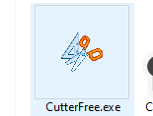

At startup, if you have Russian language installed, the program will start in it.

You can change the interface language in the "about program" window.

The program consists of several grids and buttons.

The Load button allows you to load a file with data

The program understands only Excel files of the specified format. An example is attached.

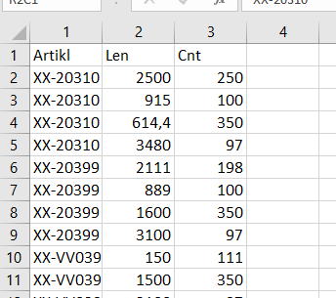

To load in 1 column the article number of the profile that we cut.

In 2 columns the length of the workpiece, in 3 - the number of blanks.

The first line is for the header.

The left grid is the specification we loaded.   
you can make sure that the system has loaded it correctly.  
The right grid is the article summary.

The second step is to set the length of the profile from which the cut is made.  
This can be done in the grid for each article, you can select a number on the form and click the button.

If several lines are selected - the length will be set for them, if nothing is selected - the length will be set for all of them.

**About** - button displays the menu about the program, including the libraries used in it.

After filling in the data, you must click on the red Cut button .

The system will cut the job and the second tab will open on the left - cutting results.

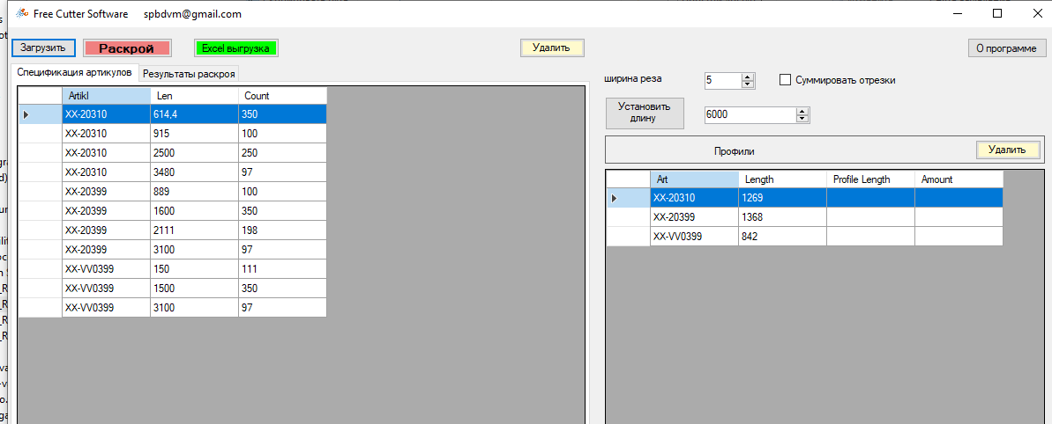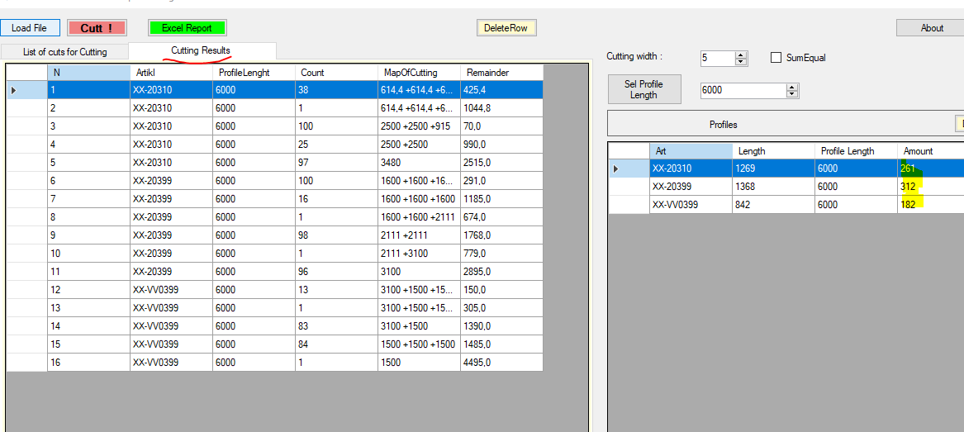

You can see how the system cut these profiles.

How many cutting schemes we have and how many profiles should be cut for each scheme.

The right grid shows for each profile and the total number of blanks.

By pressing the export button, the nesting report is uploaded to Excel.