Name: Daniel Franks Mark _____________________/50

Brief introduction __/3
I will be designing the shop system, which will allow players to “purchase” items from a variety of shopkeepers to improve their character in different ways.

Use case diagram with scenario __14
[Use the lecture notes in class.
Ensure you have at least one exception case, and that the <<extend>> matches up with the Exceptions in your scenario, and the Exception step matches your Basic Sequence step.
Also include an <<include>> that is a suitable candidate for dynamic binding]
Example:

Use Case Diagrams
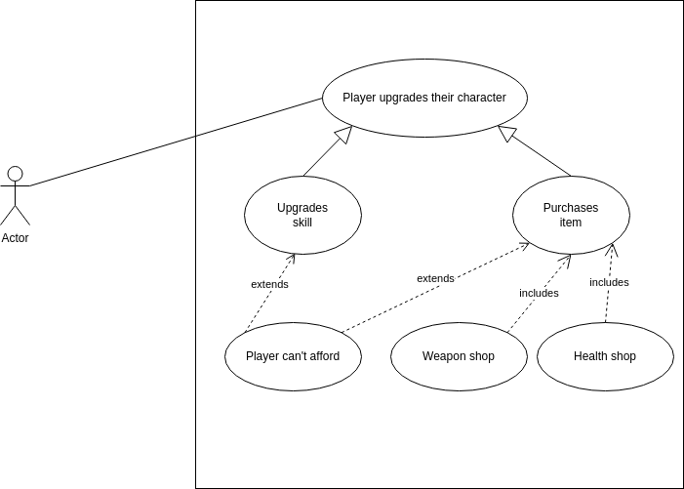

Scenarios
Name: Purchase Item
Summary: The player buys an item from one of the in game shopkeepers.
Actors: Player
Preconditions: Player is in a game session (ie, not in the home)
Basic sequence:
Step 1: Player initiates interaction with shopkeeper.
Step 2: Shopkeeper UI comes up (game is paused? TBD)
Step 3: Player selects their preferred item
Step 4: Item is applied to player (the exact meaning of this varies depending on the item) and value of item is deducted from player’s cash.
Step 5: Player exits the shopkeeper UI.
Exceptions:
Step 3: User exits without purchasing anything: don’t apply anything to them
Step 4.1: Item cannot be applied to player: display a message to that effect, refund them.
Step 4.2: Player cannot afford item: display a message to that effect, do not apply item to player, do not charge player.
Post conditions: Player has item applied to them.
Priority: 2*
ID: C01

Name: Obtain Skill
Summary: The player obtains a skill in the at-home skill tree.
Actors: Player
Preconditions: Player is at home
Basic sequence:
Step 1: Player initiates interaction with skill tree
Step 2: Skill tree UI comes up (game is paused? TBD)
Step 3: Player selects their preferred skill
Step 4: Skill is applied to player and skill points are deducted from player.
Step 5: Player exits the skill tree UI.
Exceptions:
Step 3: User exits without selecting skill: don’t apply anything to them
Step 4.1: Skill cannot be applied to player: display a message to that effect, refund them.
Step 4.2: Player does not have enough skill points: display a message to that effect, do not apply skill to player, do not charge player.
Post conditions: Player has skill applied to them.
Priority: 3*
ID: C02
*The priorities are 1 = must have, 2 = essential, 3 = nice to have.

Data Flow diagram(s) from Level 0 to process description for your feature _______14
[Get the Level 0 from your team. Highlight the path to your feature]
Example:

Data Flow Diagrams
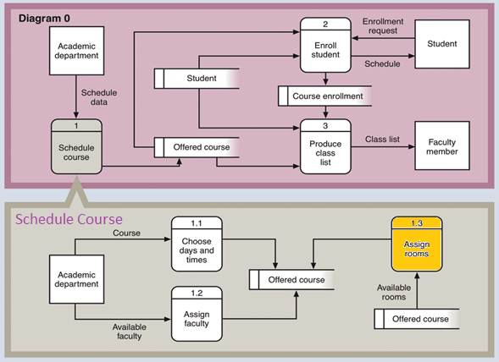

Process Descriptions
Assign rooms*:
WHILE teacher in two places at once OR two classes in the same room
Randomly redistribute classes
END WHILE
*Notes: Yours should be much longer. You could use a decision tree or decision table instead if it is more appropriate.

Acceptance Tests ________9
Shop
Open Shop UI
Press Down arrow 99 times to attempt to navigate past the end
Give the player enough money to buy a basic item 5 times
Attempt to buy it 10 times
Player should have that perk only 5 times
Verify that perk works as expected (ie: stacks)
Skill Tree
Open Skill Tree UI
Press Down arrow 99 times to try to navigate past the end
Try to obtain a skill the player already has
verify that it didn’t work and didn’t use skill points
Try to obtain a locked skill
verify that it didn’t work and didn’t use skill points
Obtain a new skill
verify that it worked and used skill points

Timeline _________/10
[Figure out the tasks required to complete your feature]
Example:

Work items
Task | Duration (PWks) | Predecessor Task(s)
1. Determine items | 1 | -
2. Determine skills | 1 | -
3. Construct shared underlying menu structure | 3 | -
4. Construct item menu | 2 | 1, 3
5. Construct skill menu | 2 | 2, 3
6. Testing | 2 | 4.5
7. Integration | 1 | 6

Pert diagram
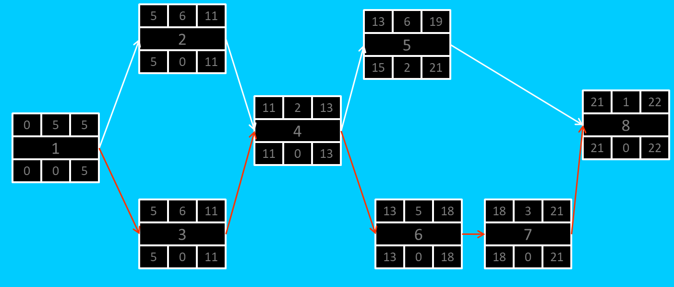

Gantt timeline
1
2 |  |  |  |  |  | 1
3 |  |  |  |  |  | 1
4 |  |  |  |  |  |  |  |  |  |  |  | 3
5 |  |  |  |  |  |  |  |  |  |  |  |  |  |  |  | 4
6 |  |  |  |  |  |  |  |  |  |  |  |  |  |  |  | 4
7 |  |  |  |  |  |  |  |  |  |  |  |  |  |  |  |  |  |  |  |  | 6
8 |  |  |  |  |  |  |  |  |  |  |  |  |  |  |  |  |  |  |  |  |  |  |  | 7
 | 1 | 2 | 3 | 4 | 5 | 6 | 7 | 8 | 9 | 10 | 11 | 12 | 13 | 14 | 15 | 16 | 17 | 18 | 19 | 20 | 21 | 22 | 23 | 24

