**Министерство науки и высшего образования Российской Федерации**

Федеральное государственное автономное образовательное учреждение высшего образования «Национальный исследовательский университет ИТМО»

**Дисциплина:** WEB Programming

**Explanatory note**

**«Chatex»**

Выполнил:

Го Цзыхань

Группа:

P3221

Проверил:

Ефимчик Е. А.

Санкт-Петербург

2021г.

* Catalog

● Introduction 2

● 1 Analytical rationale 2

● 1.1 Domain Research 2

● 1.2 Description of the project services 2

● 1.3 Goals and objectives 2

● 2 Content 3

● 2.1 Analyze similar websites 3

● 2.2 Functional model (Use Case) development 3

● 2.3 Database model development 4

● 2.4 UI model development 4

● 3 Practical part 5

● 3.1 Software selection 5

● 3.1.1 IntelliJ IDEA 5

● 3.1.2 Spring Framework 5

● 3.1.3 Mysql 5

● 3.2 Host applications on the internet 5

● 3.2.1 Buy a domain name 5

● 3.2.2 Build server 5

● 3.3 User manual 6

● Conclusion 11

● List of sources 12

* Introduction

Chatex social application website based on clustering algorithm. The website calculates and pushes people who match with you based on the personal information, hobbies and other information filled in by the user during registration, helping users to meet new friends who have a good impression of each other.

* 1 Analytical rationale
* 1.1 Domain Research

As the pace of life accelerates, people spend less time socializing. The emergence of chatex website helps people to socialize more efficiently, and helps people find like-minded friends through quantitative methods.

* 1.2 Description of the project services

chatex provides users with the following services.

- Find like-minded people based on your hobbies.

- Leave contact information for others to find you.

- Like or dislike the person found.

* 1.3 Goals and objectives

The main goal of this project is to make an online social networking site chatex, to achieve this goal, the following tasks need to be solved:

- Learn how to create web applications.

- Analyze similar websites.

- Functional model (Use Case) development.

- Database model development.

- UI model development.

- Complete the code.

- Host a website on the Internet.

The objective of the project is to make the website run smoothly on the Internet.

* 2 Content
* 2.1 [Analyze similar websites](https://github.com/spbgzh/chatex/blob/main/docs/HLO%20%2B%20Analogues/Analogs.md)

Similar websites:

1.VK: A social networking site that provides functions such as chatting with friends, adding people you know as friends, sharing text, videos and pictures, understanding news, watching videos, etc.

2.Tinder: A social networking site, add strangers as friends, share photos, chat with friends, find friends of the opposite sex, etc.

3.Badoo: A social networking site, looking for potential dates, chatting with friends, sharing photos and videos, etc.

The website is a social application website, to meet people's needs for finding dates or new friends. To achieve this goal, our website needs to provide users with the function of finding new friends, and at the same time, it needs to enable users to upload their own photos, share posts, and obtain the contact information of friends. At the same time, we will try our best to realize the function of chatting with friends.

* 2.2 [Functional model (Use Case) development](https://github.com/spbgzh/chatex/blob/main/docs/UseCases/UseCases.md)

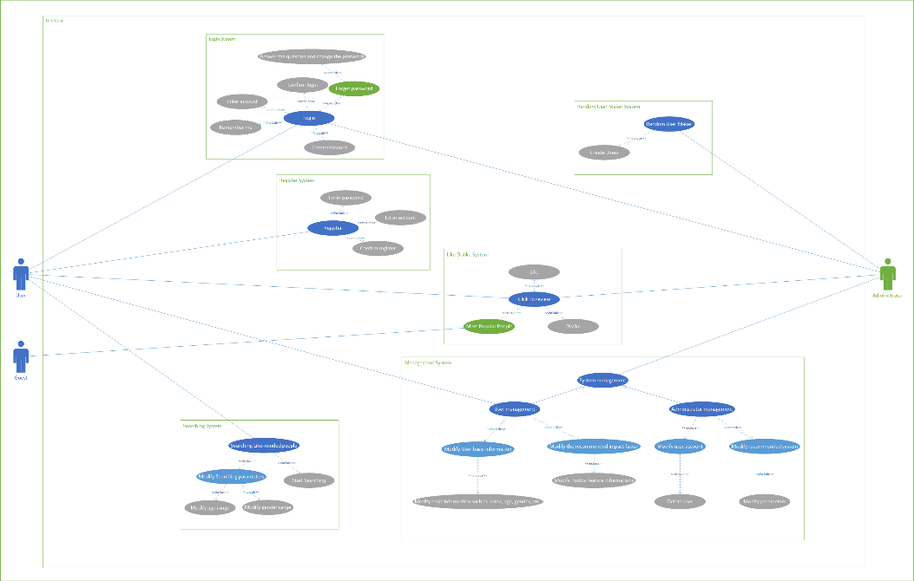Before starting application development, developers and customers must have a good understanding of what they want to see at the end of development and what they want to get from their work. They want to see which functions inside the system and which functions can be implemented in development. To do this, you need to create a "use case diagram". It clearly describes the purpose of the entire system.

* 2.3 [Database model development](https://github.com/spbgzh/chatex/blob/main/docs/Database/EER_and_ER_model_and_description_of_database.md)

A database model is needed to indicate objects and relationships, constraints, rules, and operations to indicate the data semantics of a specific subject area. Generally, the database model establishes relationships between certain objects.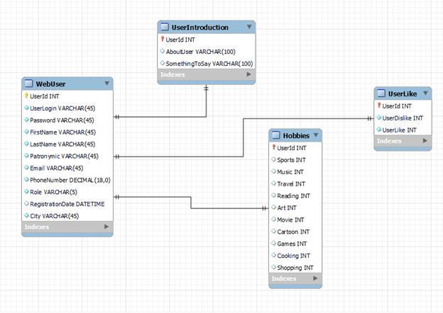

* 2.4 [UI model development](https://github.com/spbgzh/chatex/blob/main/docs/UI/UI.md)

UI interface design:

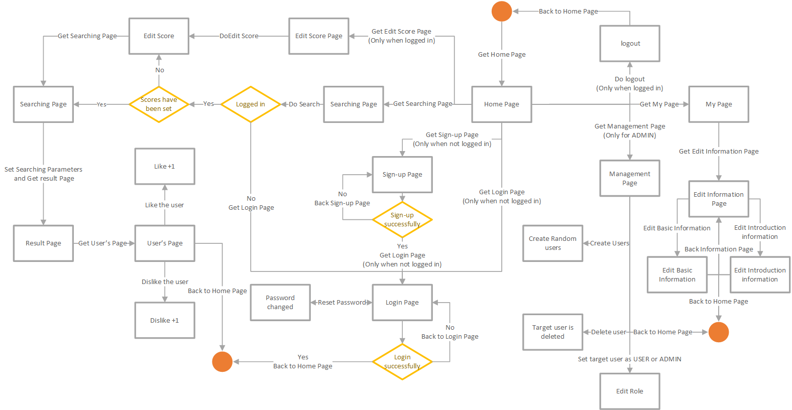

UI appearance design: [link](http://chatex.bar/)

* 3 Practical part
* 3.1 Software selection
* 3.1.1 IntelliJ IDEA

IntelliJ IDEA is an integrated development environment (IDE) written in Java for developing computer software. It is developed by JetBrains (formerly known as IntelliJ), and is available as an Apache 2 Licensed community edition, and in a proprietary commercial edition. Both can be used for commercial development.

* 3.1.2 Spring Framework

The Spring Framework is an application framework and inversion of control container for the Java platform. The framework's core features can be used by any Java application, but there are extensions for building web applications on top of the Java EE (Enterprise Edition) platform. The Spring Framework is open source.

* 3.1.3 Mysql

MySQL is an open-source relational database management system (RDBMS). A relational database organizes data into one or more data tables in which data types may be related to each other; these relations help structure the data. SQL is a language programmers use to create, modify, and extract data from the relational database, as well as control user access to the database. In addition to relational databases and SQL, an RDBMS like MySQL works with an operating system to implement a relational database in a computer's storage system, manages users, allows for network access, and facilitates testing database integrity and creation of backups.

* 3.2 Host applications on the internet
* 3.2.1 Buy a domain name

Before hosting a website on the Internet, you need to choose a domain name and purchase it. Domain name: The personal unique name of your website. In order to obtain your own domain name, you need to register with a licensed domain name registrar. The name of the website should be simple, memorable, and even better connect with everyday things.

* 3.2.2 Build server

Build a ubuntu virtual machine with suitable performance on the cloud service platform, open port 80 in the security group, install the corresponding versions of java and mysql in the virtual machine, and run the jar package

* 3.3 User manual

When the website "Chatex" is opened, the home page appears in front of the user.

There are five buttons on the homepage that can be clicked without logging in, the login and registration in the upper right corner, the search and "medals" in the middle, and the “GitHub” icon in the lower right corner.

Login and registration in the upper right corner, you can jump to the login page and registration page respectively.

When not logged in, the search button will jump to the login page.

The medal icon will show you the most popular users.

The GitHub icon redirects you to the GitHub repository page.

图形用户界面

After logging in, the login and registration in the upper right corner will become logout and my page, which will realize logout and jump to my page respectively.

If you are an administrator, you will have an additional button with a gear icon to jump to the user management interface.

Next displayed is the login and registration page.

You can log in to the website by entering your username and password, and optionally tick remember me.

You can click the infinity icon to return to the homepage, and click forgot password to jump to the password modification page.

You can register a website account by entering your username, password, and basic information.

Similarly, click the infinity icon to return to the homepage.

By entering the account name, basic information, and new password, you can change the password on the password change page.

And you can click the infinity icon to return to the login page.

Let's go back to the home page and assume that you are already logged in.

When you click the search button on the homepage, if you have never set a score, you will be redirected to the score setting page, if you have set a score, you will be redirected to the search parameters page.

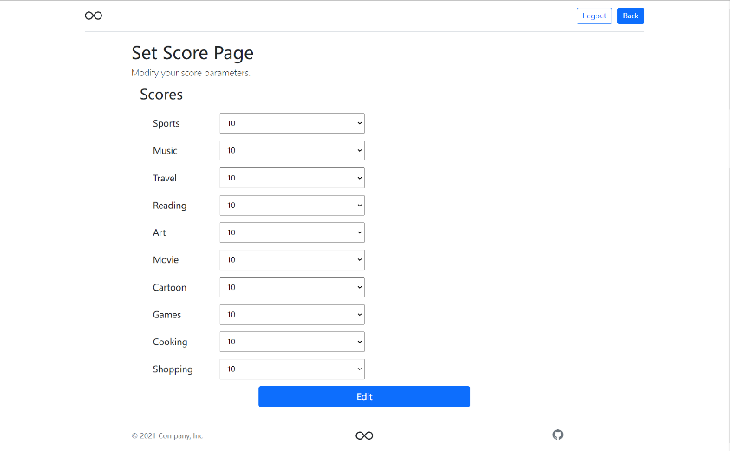

When you set the parameters and search, you will get the search results.

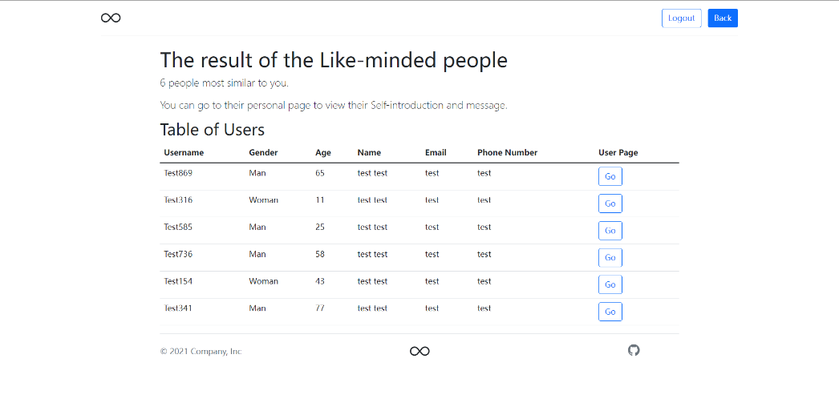

Click go, you will be able to see the personal information of the user.

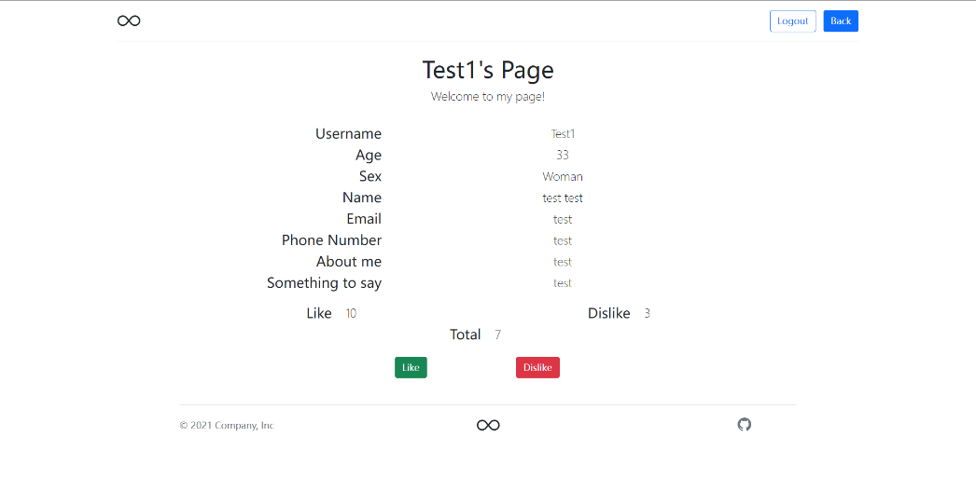

Here, you can like or dislike the user.

Back to homepage. When you click on my page, you will be redirected to my page, which looks like this.

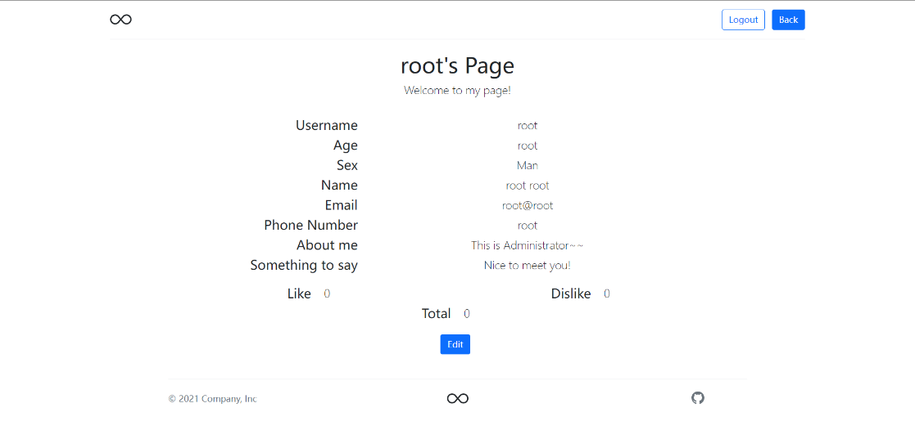

You can click edit to enter the edit information page.

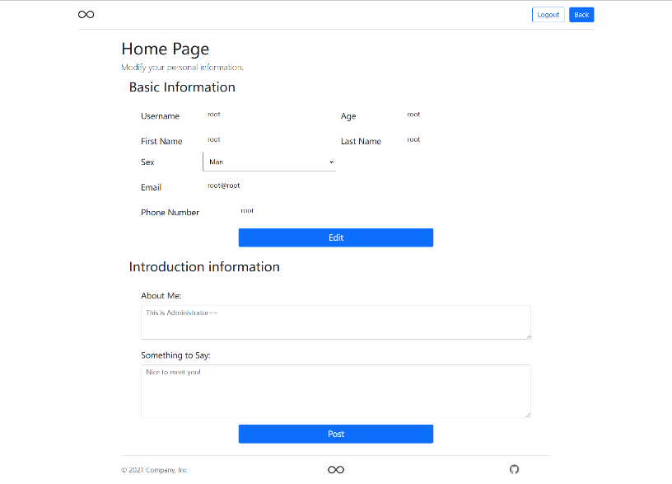

For the most popular users, you can see their likes and dislikes.

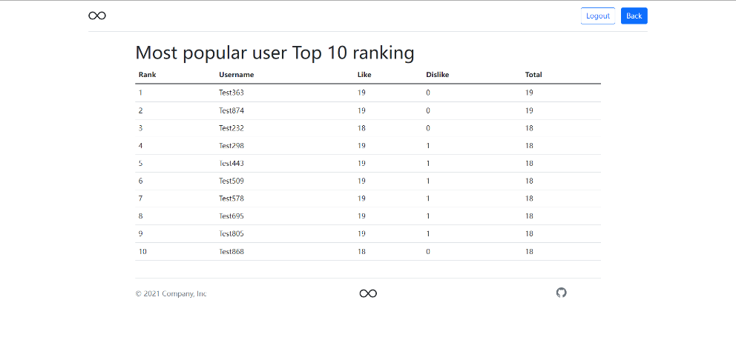

For the administrator, you can modify the role of the specified user and delete the specified user on the management page.

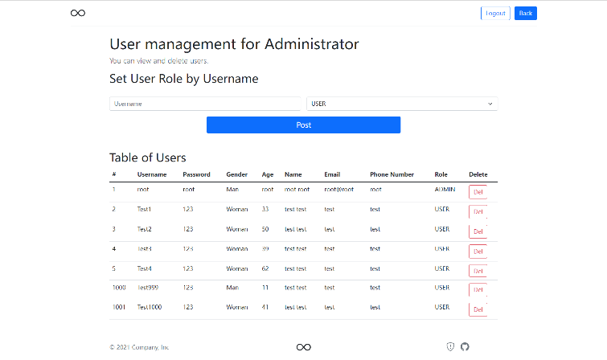

If you want to test the website, click the shield icon with an exclamation mark in the lower right corner, you can generate random users to test the website.

* Conclusion

Nowadays, the number of web applications is increasing every day. People browse the web, for work, for leisure, obtaining information through the website has gradually become a way of life.

By building the “Chatex” website, the following tasks have been completed:

-Critical and necessary models have been created during the design phase of the application.

-Selected software tools for developing web applications.

-On the basis of the construction model, developed the "Chatex" website.

* List of sources

Chatex Website: <http://chatex.bar/>

Wikipedia MySQL: <https://en.wikipedia.org/wiki/MySQL>

Wikipedia Java: <https://en.wikipedia.org/wiki/java>

Wikipedia Spring Framework: <https://en.wikipedia.org/wiki/Spring_Framework>