A Northside Train Control System Extension for Port Authority of Allegheny County (PAAC)

Tricky Trainz

Table of Contents
1. Overview 2
1.1. Scope 2
1.2. Purpose 3
1.3. Intended Audience 3
1.4. Conformance??? 3
2. Definitions 3
3. Design Viewpoints 3
3.1. Introduction 3
3.2. Train Control System 4
3.2.1. Context Viewpoint 4
3.2.2. Deployment Diagram 4
3.2.3. Logical Viewpoint 4
3.2.4. Interaction Viewpoint 4
4. Design Considerations 16
4.1. Assumptions and Dependencies 16
4.2. General Constraints 16
4.3. Goals and Guidelines 16
4.4. Development Methods 16
5. Architectural Strategies 16
6. System Architecture 17
6.1. Subsystem Architecture 18
7. Policies and Tactics 18
8. Detailed System Design 18
8.1. Classification 18
8.2. Definition 18
8.3. Responsibilities 18
8.4. Constraints 19
8.5. Composition 19
8.6. Uses/Interactions 19
8.7. Resources 19
8.8. Processing 19
8.9. Interface/Exports 19
8.10. Detailed Subsystem Design 20
9. Glossary 20
10. Bibliography 20

Overview

Scope

The following is a specification document for the design of the Tricky Trainz Control System. The proposed system has five modules: CTC Office, Track Controller, Track Model, Train Model, and Train Controller. The Track and Train Controllers are vital modules.

The Tricky Trainz System Software will give the Pittsburgh Port Authority the ability to control trains and deliver passengers in a manner that they see timely and efficient.

The system is designed to run on Windows operating system. The users will perform tasks specific to them on each individual module and the system will act accordingly.

Purpose
This document serves the purpose of establishing the complete design for the Tricky Trainz System Software. This includes architectural details of the system down to the individual details each system will perform. It also goes into how each use case will be implemented into the system.

Intended Audience
This design document is intended for anyone who wants to understand the Tricky Trainz System Software architecture and its uses. More specifically it targets the following groups:
- Operators: To understand the layout of the system and how it runs to improve efficiency.
- Maintenance: To understand how the system was built to find and fix problems in an efficient manner.
- Software Developers: To understand the architecture to build and add features to the software.

Definitions
Vital systems – systems that are safety critical in nature
Authority – a block number that the train is targeted to go to
Block – a section of track with its own track circuit (lowest location of train)
Track – made up of contiguous blocks
PLC – Programmable Logic Controller
CTC – Centralized Traffic Control

Design Viewpoints

Introduction
The Tricky Trainz System Software can be described in 6 major viewpoints: the 5 sub-systems (modules) and the overall system. This document will describe the architecture and the and design from these viewpoints.

Train Control System

Context Viewpoint
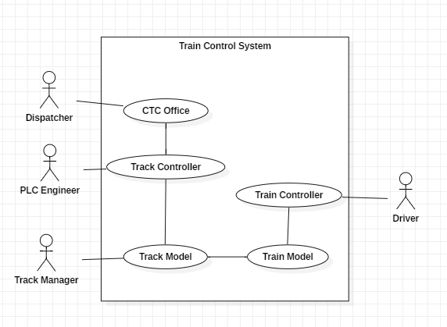

Deployment Diagram
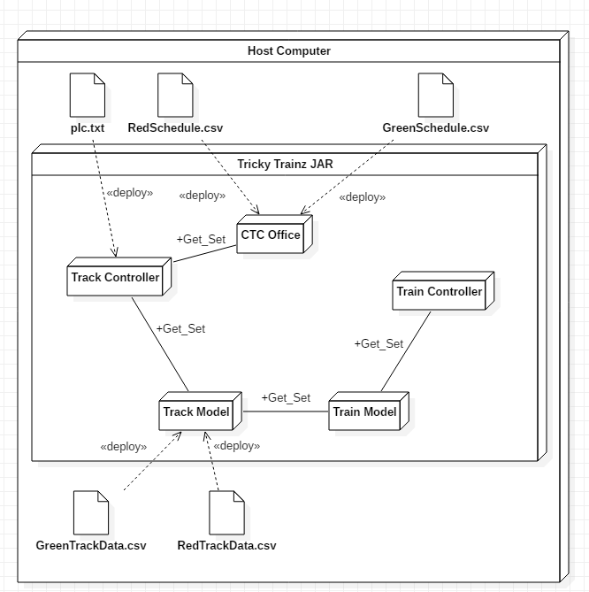

Logical Viewpoint

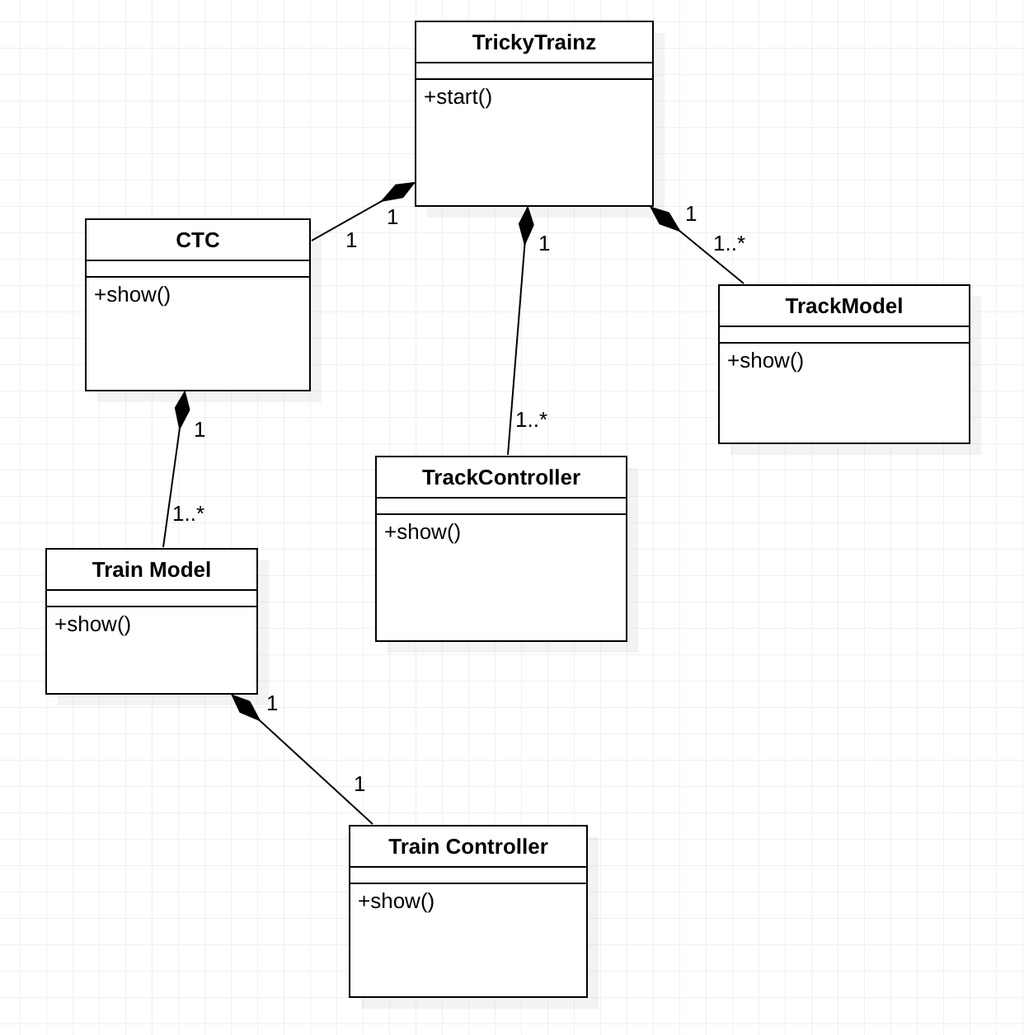

Interaction Viewpoint
      - Dispatch new train
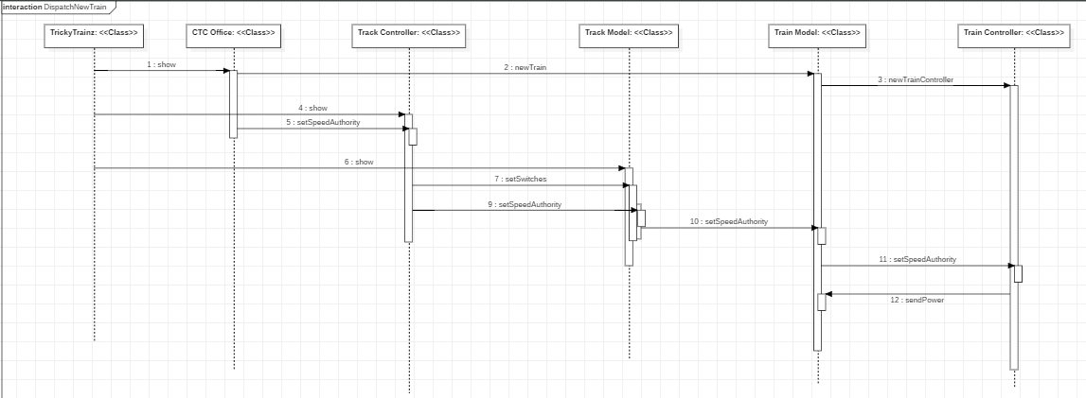

CTC Office

Context Viewpoint
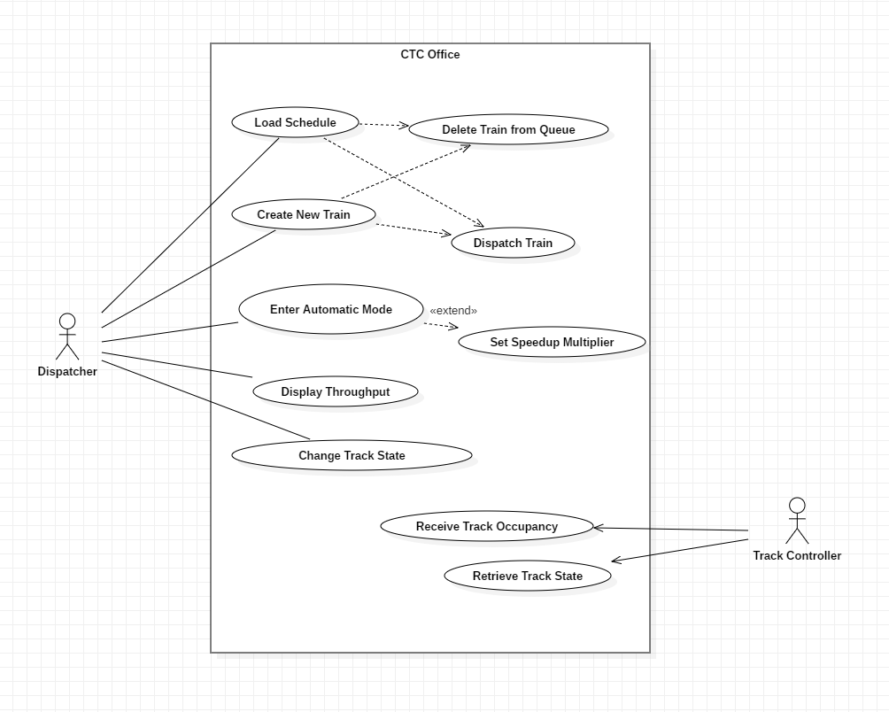

Logical Viewpoint
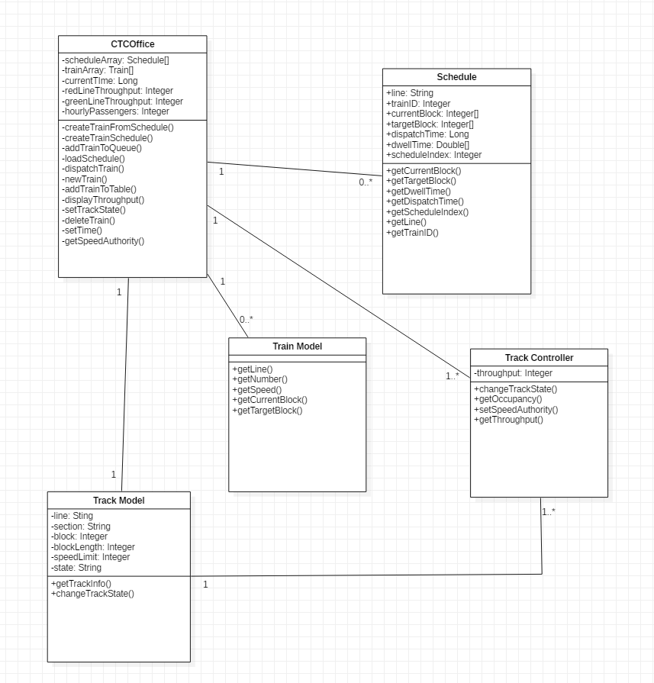

Interaction Viewpoint
      - Dispatch Train via New Train

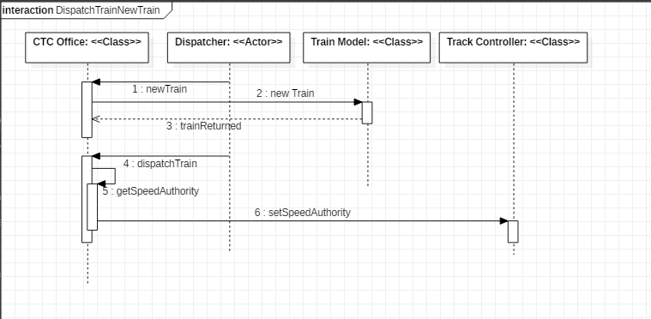
Use Case | Dispatch Train via New Train
Actor | Dispatcher
Precondition | Train is in queue through manual creation, and train is selected
Postcondition | Train is dispatched: suggested speed and authority are sent to the track controller
Trigger | Dispatcher presses the dispatch train button
Main Path | - Dispatcher presses submit button on new train creation  - Train is created via train class  - Train is returned and placed in queue  - Dispatcher selects train and presses dispatch button  5-6. CTC office gets the speed and authority of the train and sends it to the track controller

      - Dispatch Train via Schedule
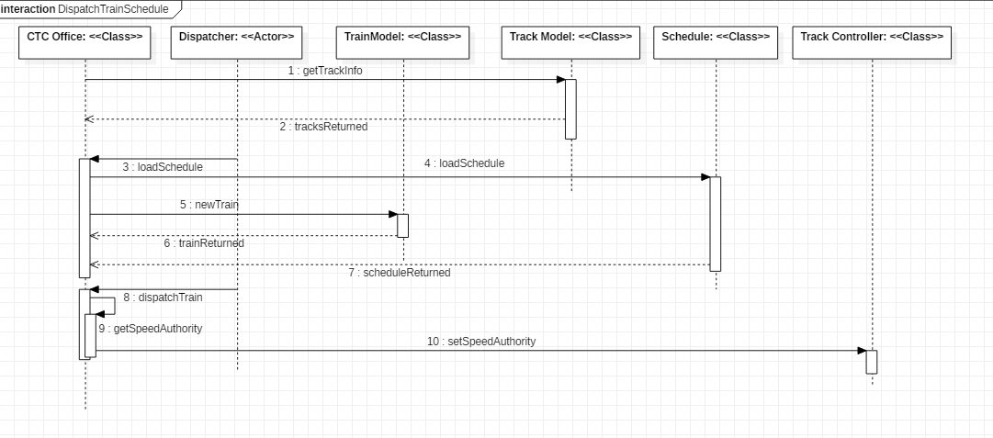
Use Case | Dispatch Train Via Schedule
Actor | Dispatcher
Precondition | Train is in queue through loading in a csv schedule file, and train is selected
Postcondition | Train is dispatched: suggested speed and authority are sent to the track controller
Trigger | Dispatcher presses the dispatch train button
Main Path | - CTC gets track information from the track model  - Track model returns track information to the CTC Office  - Dispatcher loads in a csv schedule through browsing the file system  - Schedule is created based on csv info  - A new train is created based on the schedule information  6-7. Train and schedule objects are returned  - Dispatcher selects train and presses dispatch button  9-10. CTC office gets the speed and authority of the train and sends it to the track controller | Main Path | - PLC Programmer selects Import PLC button and selects a PLC file from a file explorer.  - Track Controller sets imported PLC as active PLC by initializing a new PLC object.

      - Delete Train via Schedule
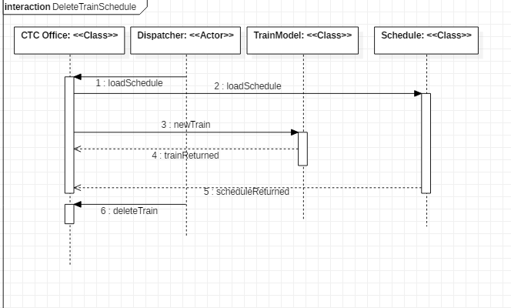
Use Case | Delete Train via Schedule
Actor | CTC Office, Track Model
Precondition | Train is in queue through loading in a csv schedule file, and train is selected
Postcondition | Train is removed from queue
Trigger | Dispatcher presses the delete train button
Main Path | - Dispatcher loads in a csv schedule through browsing the file system  - Schedule is created based on csv info  - A new train is created based on the schedule information  4-5. Train and schedule objects are returned  - Dispatcher selects train and presses delete button

      - Delete Train via New Train
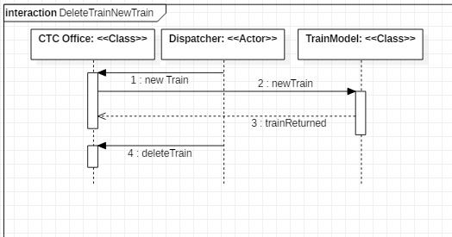
Use Case | Delete Train via New Train
Actor | CTC Office, Track Model
Precondition | Train is in queue through manual creation, and train is selected
Postcondition | Train is removed from queue
Trigger | Dispatcher presses the delete train button
Main Path | - Dispatcher presses submit button on new train creation  - Train is created via Train class  - Train is returned and placed in queue  - Dispatcher selects train and presses delete train button

      - Change Track State
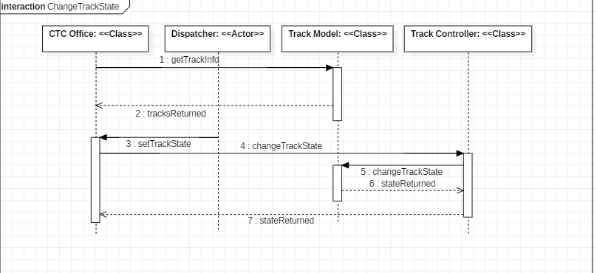
Use Case | Change Track State
Actor | Dispatcher
Precondition | Track information has been received from track model
Postcondition | Track State is changed.
Trigger | Dispatcher presses change state button on selected track
Main Path | - CTC gets track information from the track model  - Track model returns track information to the CTC Office  - Dispatcher presses change state button on selected track  - CTC calls on the track controller to change the track state  5-6. Track controller works with the track model to change and return the state  7. New track state is returned from the track controller to the CTC Office
      - Display Throughput
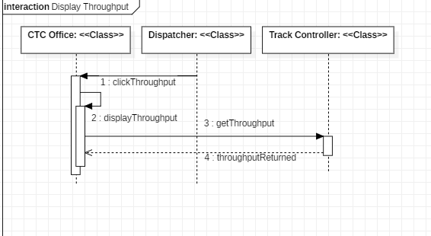
Use Case | Display Throughput
Actor | Dispatcher
Precondition | None
Postcondition | A notice is displayed with the throughput on the red and green lines
Trigger | Dispatcher presses display throughput button
Main Path | - Dispatcher presses display throughput button  - CTC Office calls a display throughput function  - Display throughput function reaches out to get the throughput from the track controller  - Track controller returns throughput
      - Automatic Mode
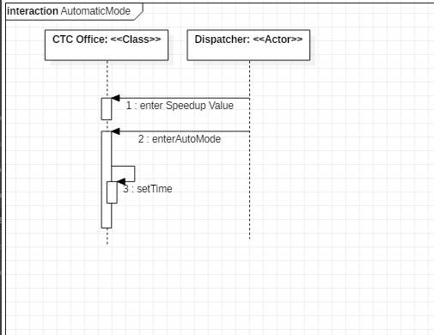
Use Case | Automatic Mode
Actor | Dispatcher
Precondition | None.
Postcondition | System begins automatic operation
Trigger | Dispatcher presses automatic mode button
Main Path | - Dispatcher enters a multiplier in the speedup field  - Dispatcher presses automatic mode button  - CTC Office adjusts the system time to operate based on the multiplier

Track Controller

Context Viewpoint
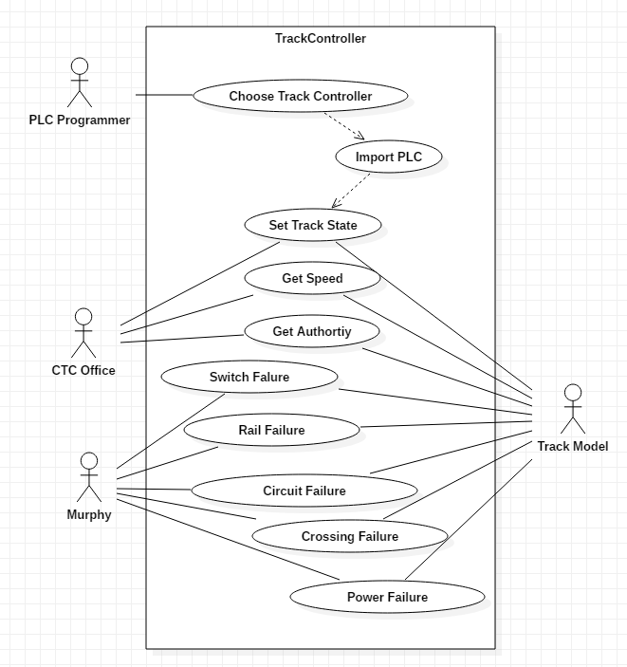

Logical Viewpoint
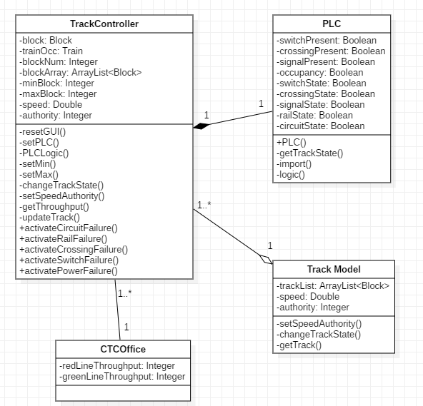

Interaction Viewpoint
      - Choose Track Controller

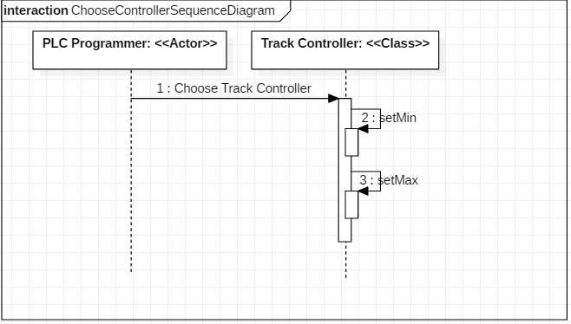
Use Case | Choose Track Controller
Actor | PLC Programmer
Precondition | None.
Postcondition | Track Controller has been selected and configured.
Trigger | PLC Programmer selects a Track Controller from a dropdown menu.
Main Path | - PLC Programmer selects a Track Controller.  - System gets Track Controller and sets available blocks within the scope of the Track Controller by setting min and max blocks.

      - Import PLC
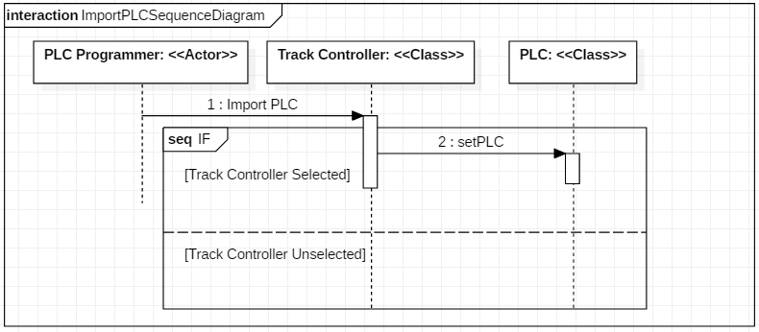
Use Case | Import PLC
Actor | PLC Programmer
Precondition | Track Controller has been selected and configured.
Postcondition | Track Controller contains PLC program to set Track state.
Trigger | PLC Programmer selects import PLC button.
Main Path | - PLC Programmer selects Import PLC button and selects a PLC file from a file explorer.  - Track Controller sets imported PLC as active PLC by initializing a new PLC object. | Main Path | - PLC Programmer selects Import PLC button and selects a PLC file from a file explorer.  - Track Controller sets imported PLC as active PLC by initializing a new PLC object.
Alternate Path | 2b. Track Controller sets imported PLC as active PLC by initializing a new PLC object.

      - Pass Speed and Authority
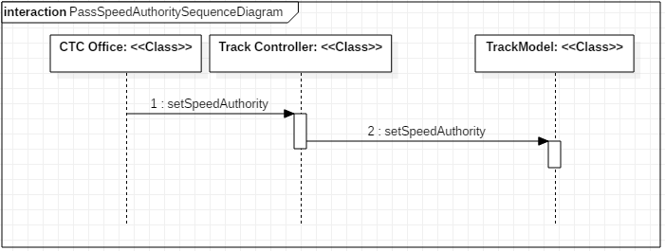
Use Case | Pass Speed and Authority
Actor | CTC Office, Track Model
Precondition | None.
Postcondition | Track Model receives speed and authority.
Trigger | Track Controller is created.
Main Path | - CTC Office calls setSpeedAuthority in Track Controller to send speed and authority to Track Controller.  - Track Controller calls setSpeedAuthority in Track Model to send speed and authority to Track Model.

      - Set Track State
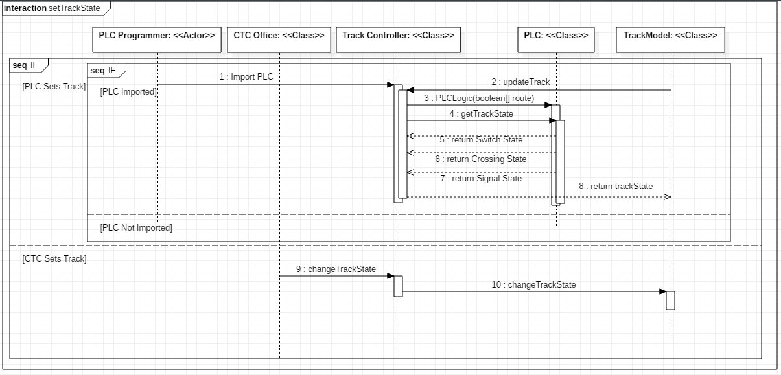
Use Case | Set Track State
Actor | PLC Programmer, CTC Office, Track Model
Precondition | None.
Postcondition | Track State is changed.
Trigger | Train enters scope of Track Controller or CTC changes track state
Main Path | - PLC Programmer imports PLC into Track Controller.  - Track Model calls updateTrack from the Track Controller.  - Track Controller calls PLCLogic with the train route. PLC generates new Boolean values for switch, crossing, and signal state.  - Track Controller calls getTrackState in PLC.  - PLC returns new switch, crossing, and signal states to the Track Controller.  8. Track Controller sends new Track State to Track Model.
Alternate Path 1 | 1a. PLC is not imported and Track State is not changed.
Alternate Path 2 | 1b. CTC Office calls changeTrackState in Track Controller to set a block for maintenance.  2b. Track Controller calls changeTrackState in Track Model.

      - Murphy Cases
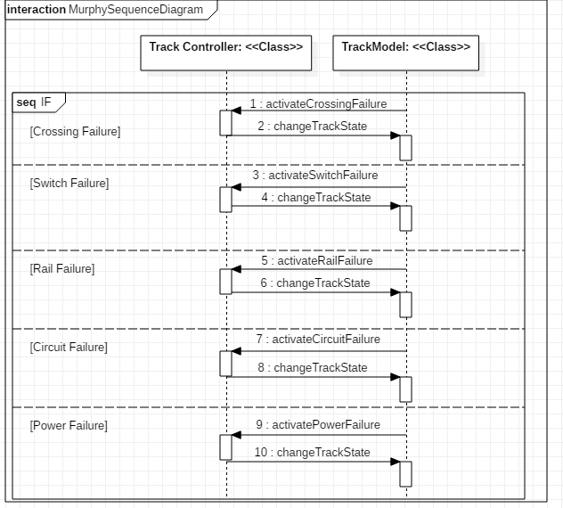
Use Case | Murphy Cases
Actor | Track Model
Precondition | Track Controller and block selected.
Postcondition | Track Model receives new Track State
Trigger | Track Model selects a Murphy button
Main Path | - Track Model presses Crossing Failure button  - Crossing is broken and current fail state is returned to Track Model.
Alternate Path 1 | 1a. Track Model presses Switch Failure button  2a. Switch is broken and current fail state is returned to Track Model.
Alternate Path 2 | 1b. Track Model presses Rail Failure button  2b. Rail is broken and current fail state is returned to Track Model.
Alternate Path 3 | 1c. Track Model presses Circuit Failure button  2c. Circuit is broken and current fail state is returned to Track Model.
Alternate Path 4 | 1d. Track Model presses Power Failure button  2d. Power heating is broken and current fail state is returned to Track Model.

Track Model

Context Viewpoint
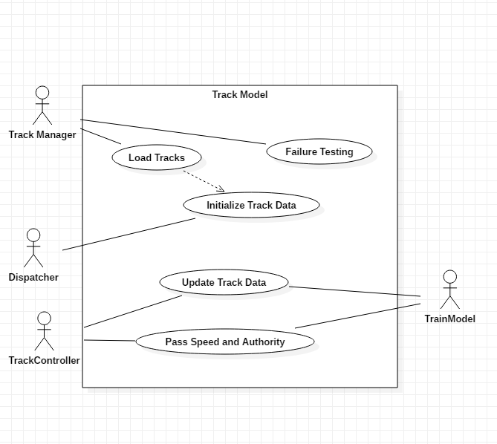

Logical Viewpoint
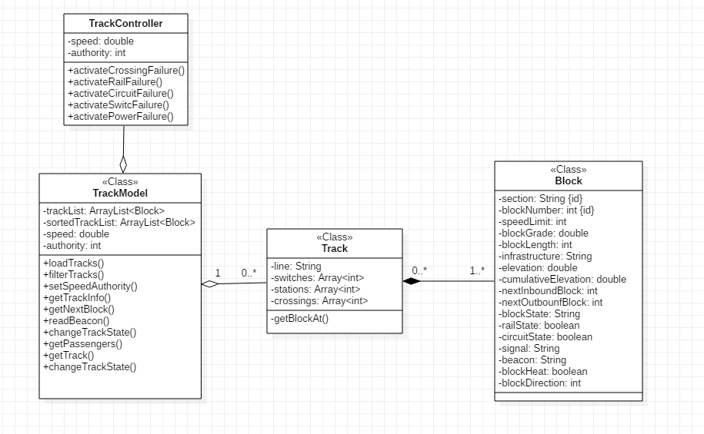

Interaction Viewpoint
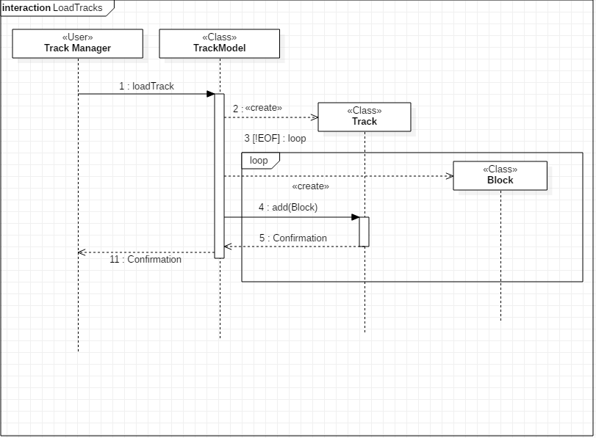
Use Case | Load Tracks
Actor | Track Manager
Precondition | Track CSV file stored locally
Postcondition | Track Model updated with new track line
Trigger | Track Manager selects ‘Load Track’ button
Main Path | - Track Manager selects ‘Load Button’  - Track Model is updated with new track line

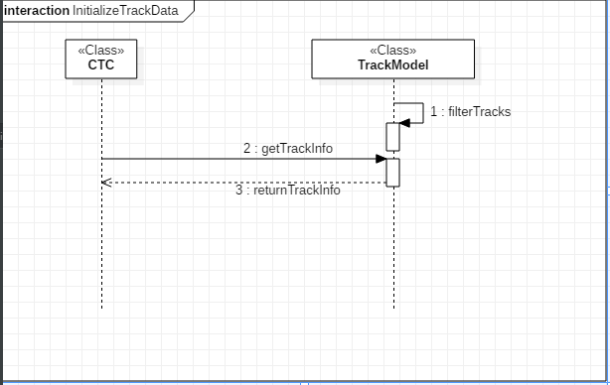
Use Case | Initialize Track Data
Actor | Dispatcher
Precondition | Track is loaded into the Track Model
Postcondition | CTC receives track info and track state
Trigger | Dispatcher opens CTC
Main Path | - Dispatcher opens CTC  - Track info is displayed in CTC GUI

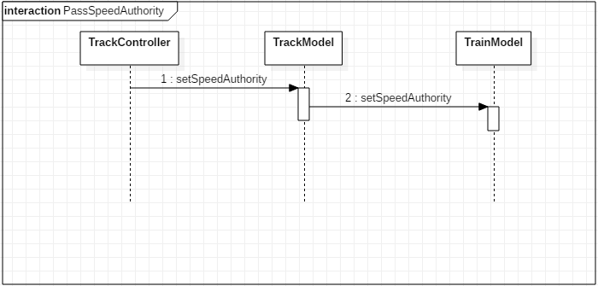
Use Case | Pass Speed and Authority
Actor | Track Controller, Train Model
Precondition | Track is loaded
Postcondition | Speed and Authority is passed to the Train Model
Trigger | Speed and Authority is set in the Track Controller
Main Path | - Speed and authority is set in the Track Controller  - Speed and authority is set in the Track Model  - Speed and authority is set in the Train Model

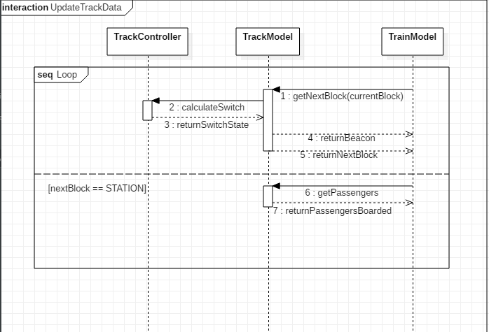
Use Case | Update Track Data
Actor | Train Model, Track Controller
Precondition | Train is dispatched and moving
Postcondition | - Track Controller sets any upcoming switches  - Train Model receives the beacon, the next block and the number of passengers if the upcoming block has a station
Trigger | Train enters a new block
Main Path | - Train Model requests next block from the Track Model based on current block and direction  - Track Model tells the Track Controller to set any upcoming switches based on train occupancy  - Track Model returns beacon and next block to Train Model based on new switch states
Alternate Path 1 | 3a. Train Model also returns number of passengers that will board the train based on train occupancy and station occupancy

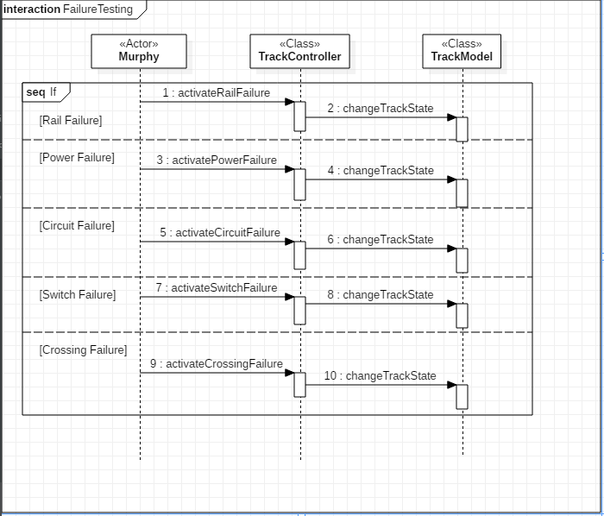
Use Case | Murphy Cases
Actor | Murphy
Precondition | Track block selected
Postcondition | Track Model updates with new state
Trigger | Murphy selects a failure button
Main Path | - Murphy selects Toggle Crossing button.  - Crossing is raised or lowered based on current crossing position.
Alternate Path 1 | 1a. Murphy selects Toggle Switch button.  2a. Switch is opened or closed based on current switch position.
Alternate Path 2 | 1b. Murphy selects Toggle Rail State button.  2b. Rail state is set to faulty or functional based on current rail state.
Alternate Path 3 | 1c. Murphy selects Toggle Circuit button.  2c. Track Circuit is set to faulty or functional based on current track circuit state.
Alternate Path 4 | 1d. Murphy selects Toggle power button.  2d. Track power is set to off

Train Model

Context Viewpoint
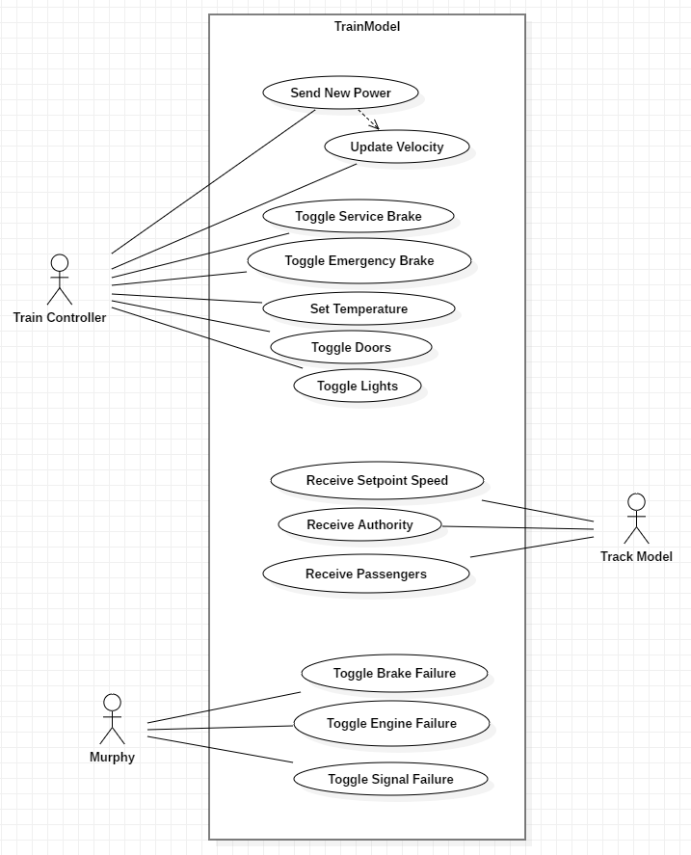

Logical Viewpoint
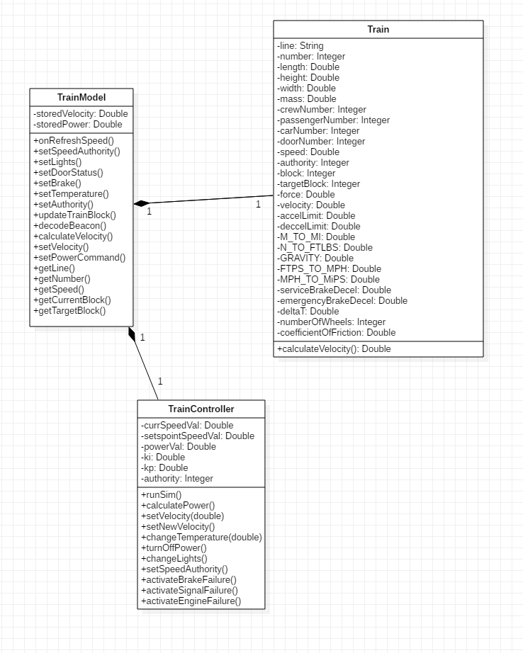

Interaction Viewpoint
      - Set Speed and Authority
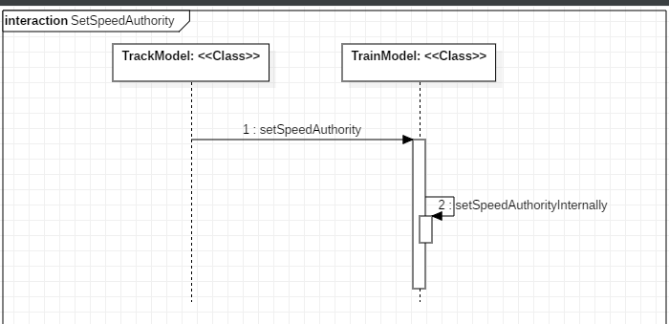
Use Case | Set Speed and Authority
Actor | Track Model
Precondition | None.
Postcondition | Train model has recorded speed and authority and updated the GUI.
Trigger | Train model receives speed and authority from the track model
Main Path | - Track model calls the receive speed and authority method  - Train model sets and displays the speed and authority on the GUI

      - Set Passengers

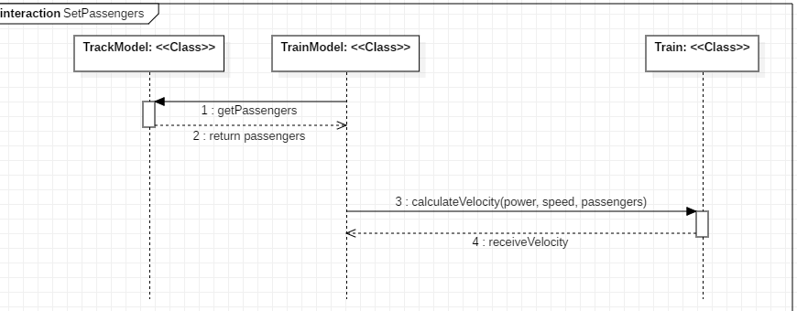

Use Case | Set passengers
Actor | Track Model
Precondition | None.
Postcondition | Train model has recorded passenger count on board and updated the GUI.
Trigger | Track model calls the method to set passenger count on the train model
Main Path | - Track model calls the receive passengers method  - Train model sets and displays the passenger count on the GUI

      - Set Brake
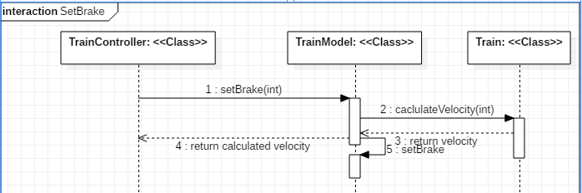
Use Case | Set Brake
Actor | Train Controller
Precondition | None.
Postcondition | Train model has recorded brake status and updated the GUI.
Trigger | Train controller calls the method to set the brake on the train model
Main Path | - Train controller calls the receive brake method  - Train model sets and displays the brake status on the GUI

      - Set Light Status
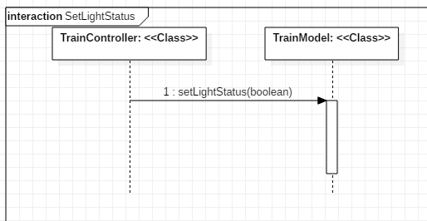
Use Case | Set Light Status
Actor | Train Controller
Precondition | None.
Postcondition | Train model has recorded light status and updated the GUI.
Trigger | Train controller calls the method to set the lights on the train model
Main Path | - Train controller calls the receive lights method  - Train model sets and displays the light status on the GUI

      - Set Door Status
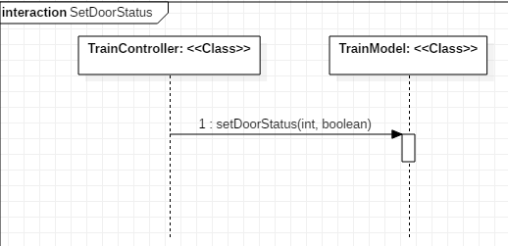
Use Case | Set Door Status
Actor | Train Controller
Precondition | None.
Postcondition | Train model has recorded door status and updated the GUI.
Trigger | Train controller calls the method to set the door status on the train model
Main Path | - Train controller calls the receive door status method  - Train model sets and displays the door status on the GUI

      - Set Temperature
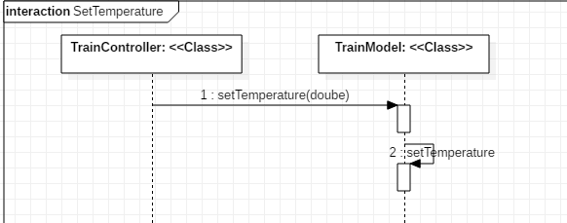
Use Case | Set Temperature
Actor | Train Controller
Precondition | None.
Postcondition | Train model has recorded temperature and updated the GUI.
Trigger | Train controller calls the method to set the temperature on the train model
Main Path | - Train controller calls the receive temperature method  - Train model sets and displays the temperature on the GUI

      - Receive Power Command
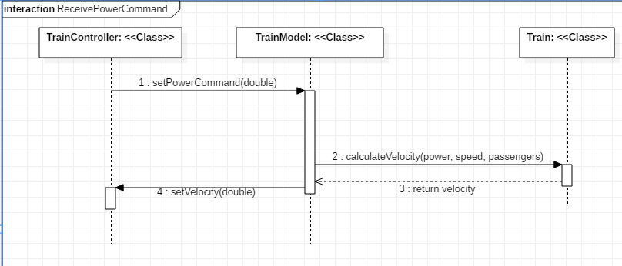
Use Case | Receive Power Command
Actor | Train Controller
Precondition | None.
Postcondition | Train model has recorded the power command and updated the GUI.
Trigger | Train controller calls the method to set the power command on the train model
Main Path | - Train controller calls the receive power command method  - Train model sets and displays the power command on the GUI  - Train model sends the power command the Train class to cacluateVelocity  - Train class calculates velocity and returns it to the Train model to send back to the Train controller

      - Murphy Commands
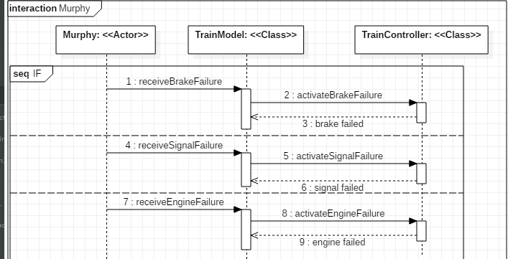
Use Case | Murphy Commands
Actor | Murphy
Precondition | None.
Postcondition | Train model has executed the murphy command and updated the GUI.
Trigger | Murphy calls the methods to trigger the failures on the train model
Main Path | - Murphy calls the murphy command methods. These commands are mutually exclusive but shown as above for simplicity.  - Train model sets and displays failures on the GUI

Train Controller

Context Viewpoint
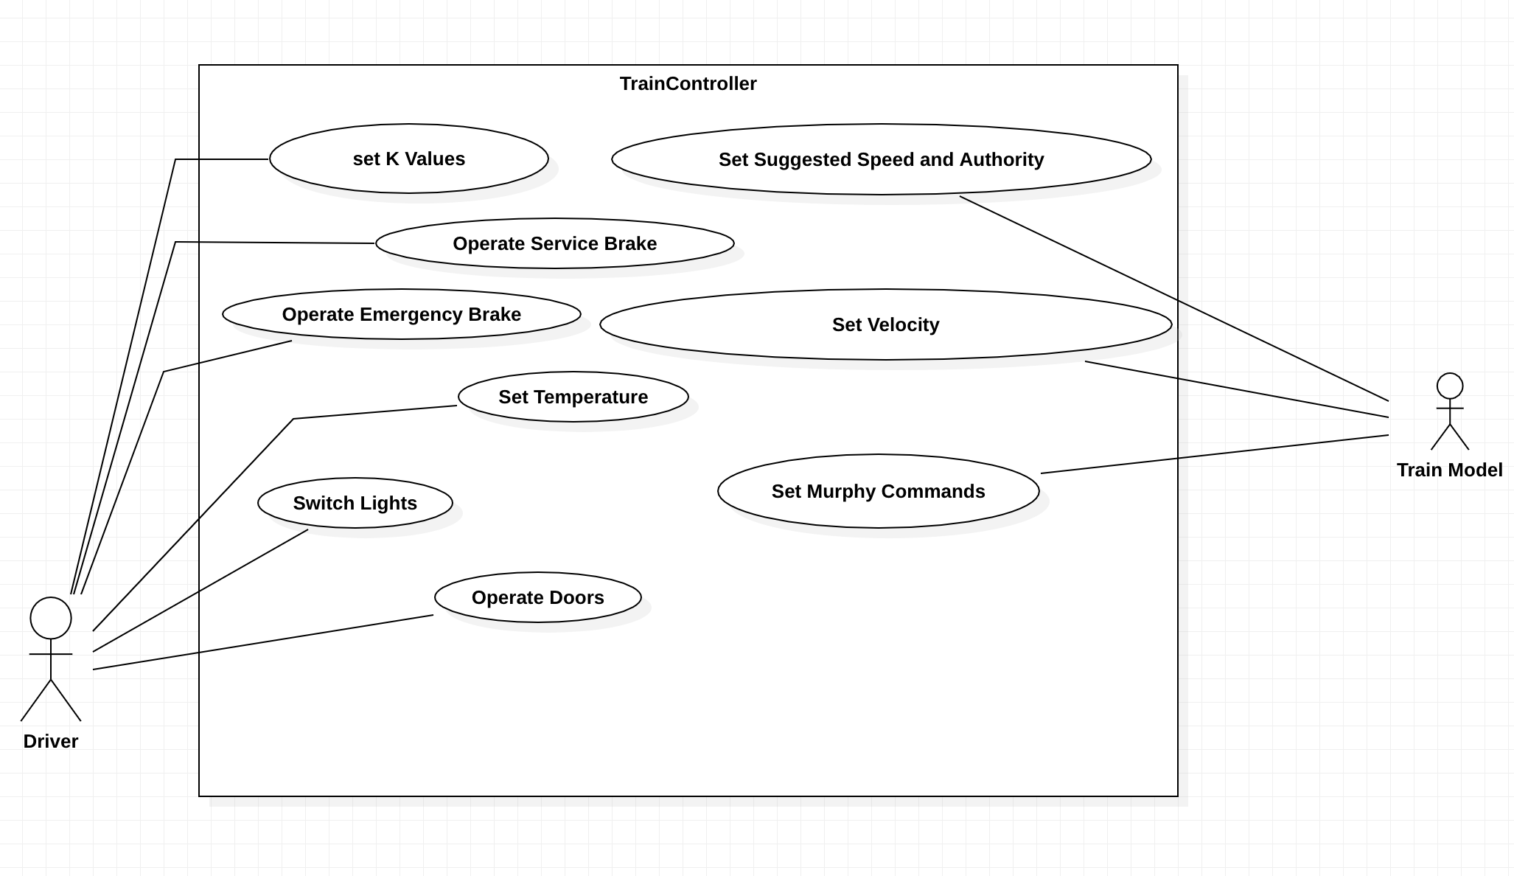

Logical Viewpoint
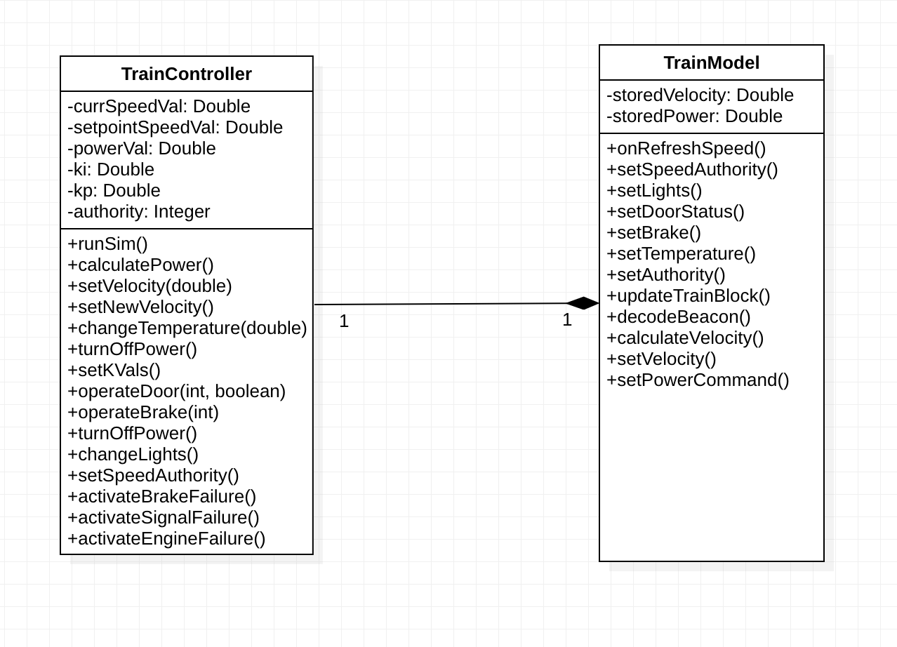

Interaction Viewpoint
      - Set Speed and Authority
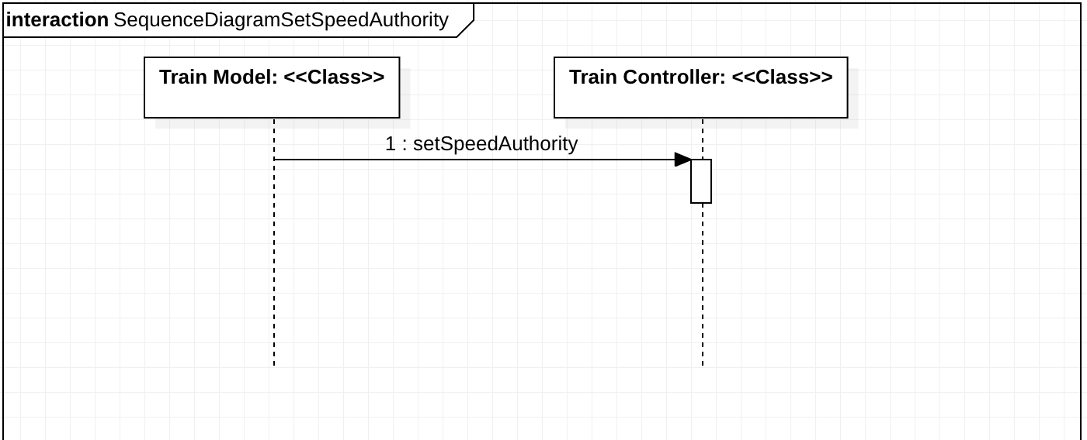
Use Case | Set Speed and Authority
Actor | Train Model
Precondition | None
Postcondition | Train Controller has received speed and authority from Train Model and updated the GUI.
Trigger | Train Model and Train Controller are created
Main Path | - Train Model sends speed and authority to Train Controller and Train Controller sets internal variables and updates GUI

      - Power Loop
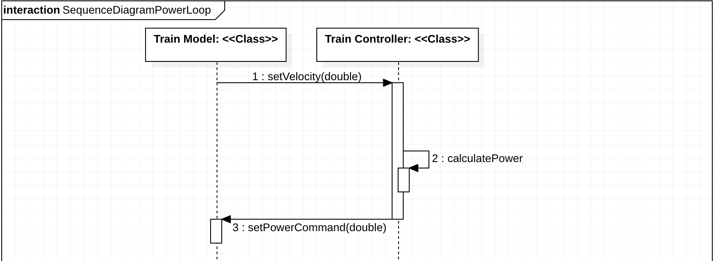
Use Case | Power Loop
Actor | Driver
Precondition | - Train Controller and Train Model have been created  - Ki and Kp have been set
Postcondition | Train speeds up until reaching suggested speed
Trigger | Driver presses ‘Run’ on Train Controller
Main Path | - Train Controller receives current velocity from Train Model and updates Train Controller GUI  - Train Controller calculates power command  - Train Controller sends power command to Train Model

      - Set K Values

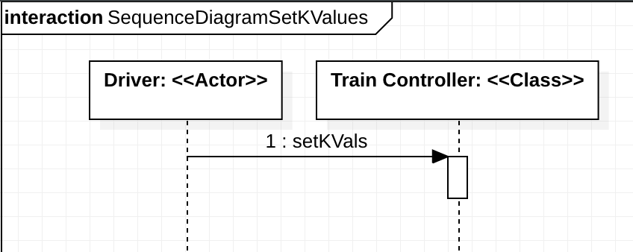
Use Case | Set K Values
Actor | Driver
Precondition | Train Controller and Train Model have been created
Postcondition | Kp and Ki are set to desired values and GUI reflects changed values
Trigger | Driver enters Kp and Ki values or presses ‘DEFAULT’ and after presses ‘Set’ on Train Controller
Main Path | - Driver sets Kp and Ki values which updates Train Controller GUI

      - Set Temperature
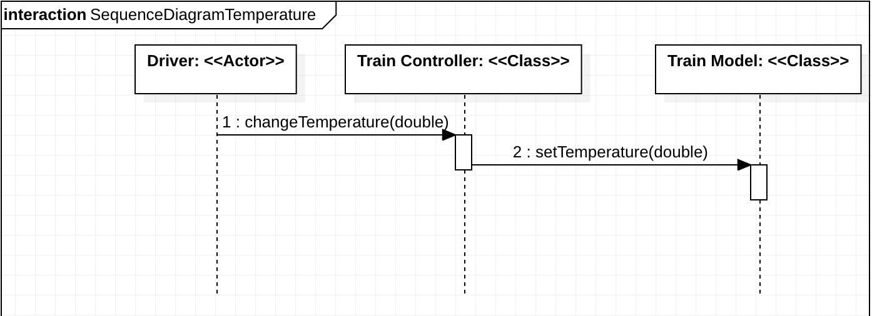
Use Case | Set Temperature
Actor | Driver
Precondition | Train Controller and Train Model have been created
Postcondition | Temperature is changed to desired value and GUI is updated
Trigger | Driver enters temperature value and presses ‘Set’ on Train Controller
Main Path | - Driver sets temperature value which sets the temperature variable in the Train Controller and updates GUI  - Train Controller sends temperature to Train Model

      - Operate Doors
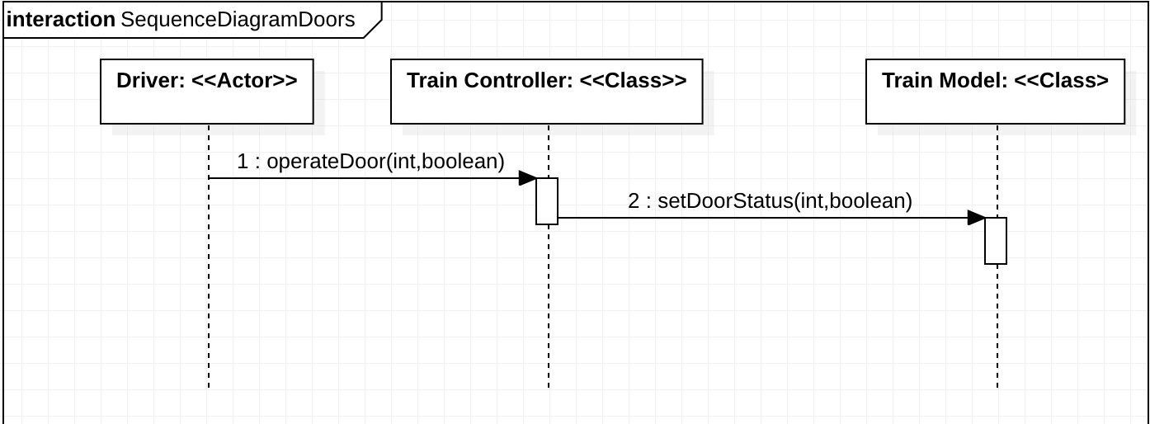
Use Case | Operate Doors
Actor | Driver
Precondition | Train Controller and Train Model have been created
Postcondition | Selected Door is either opened or closed depending on desired status and GUI updates accordingly
Trigger | Driver clicks ‘Open’ or ‘Close’ on desired door
Main Path | - Driver clicks on desired door and action which updates GUI  - Train Controller sends door status to Train Model

      - Operate Brakes
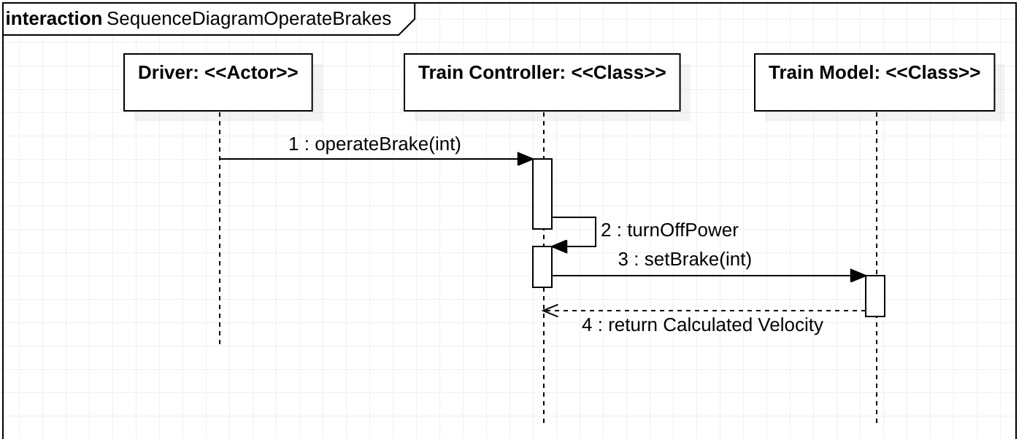
Use Case | Operate Brakes
Actor | Driver
Precondition | Train Controller and Train Model have been created
Postcondition | Selected brake is activated or deactivated depending on brake selected and brake status and GUI is updated
Trigger | Driver clicks ‘Service Brake’ or ‘Emergency Brake’
Main Path | - Driver clicks on desired brake which updates GUI  - Train Controller turns off Train Power  - Train Controller sends brake command to Train Model  - Train Model sends back calculated speed to Train Controller

      - Change Lights
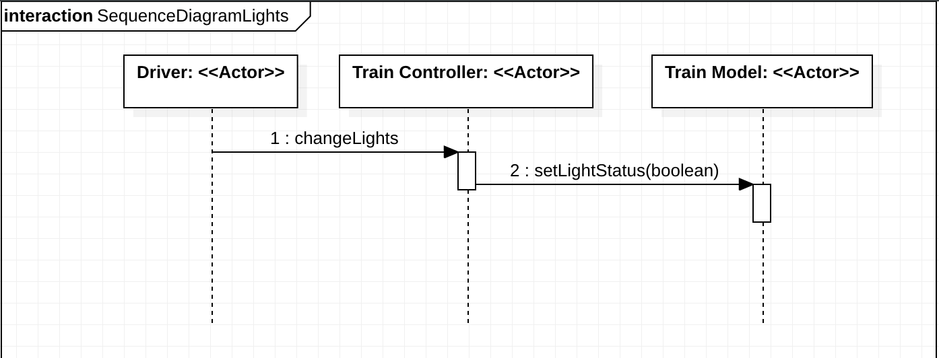
Use Case | Change Lights
Actor | Driver
Precondition | Train Controller and Train Model have been created
Postcondition | Lights are changed to desired status and GUI reflects light status
Trigger | Driver clicks ‘On’ or ‘Off’ in Lights panel on Train Controller
Main Path | - Driver clicks on desired light status which updates GUI  - Train Controller sends light status to Train Model

      - Murphy Commands
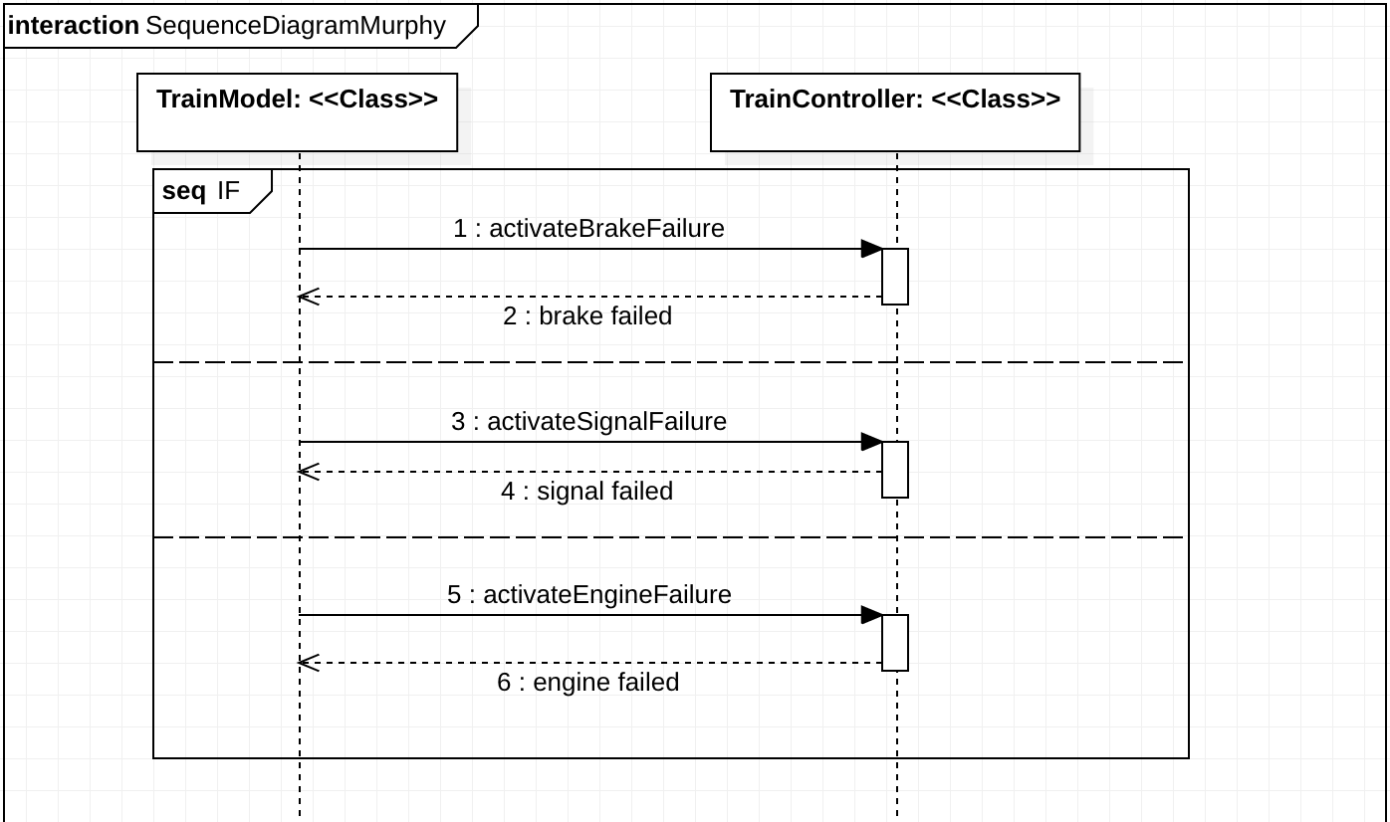
Use Case | Murphy Commands
Actor | Train Model
Precondition | - Train Controller and Train Model have been created  - Train Controller and Train Model are running
Postcondition | Murphy Failure activated, and GUI reflects Murphy Failure status
Trigger | Train Model sends Failure activation to Train Controller
Main Path | - Train Model sends Murphy failure signal  - Train Controller activates Murphy failure which updates GUI and returns resulting failure

