Optimal control strategies to prevent the hospital beds collapse during Covid-19 outbreak

*Leonardo Pio Lo Porto*

*Simone Rotondi*

**Abstract:** In 2020 the world has faced a serious challenge since the breakout of corona-virus started in Wuhan, China. The deathly disease has killed about 1.770.000 and infected more than 80 million humans around the globe since December 2019 to 27 of December 2020.

The paper presents a new mathematical model for the SARS-CoV-2 virus propagation, designed to include all the possible actions to prevent the spread and to help in the healing of infected people, including the new inoculation to the SARS-CoV-2. The objective of this project is to propose the possibility of optimal controls over the susceptible and the infected subjects considering different cost functions in order to see the effects of different optimised control actions on the evolution of the epidemic spread and in particular how these controls should be tuned in order to avoid the hospital beds collapse. The optimal control analysis was carried out using the Pontryagin’s maximum principle to figure out the optimal strategy necessary to curtail the disease and the existence of the optimal solution is assessed. Numerical evaluations are developed for a more intuitive and immediate presentation, showing the consequences on the classes of interest.

Indices

1. Introduction 2

2. Methods 4

2.1 Mathematical Model 4

2.2 Model Fitting 10

2.3 Optimal Control strategy 11

3. Results and discussion (Numerical Simulations and Discussion) 20

4. Conclusions 30

References 31

# 1. Introduction

Coronavirus disease 2019 (COVID-19) is a disease caused by severe acute respiratory syndrome coronavirus 2 (SARS CoV-2).

Italy has been severely affected. After the first indigenous case on 21 February 2020 in Lodi province, several suspect cases (initially epidemiologically linked) began to emerge in the south and southwest territory of Lombardy [1]. A ‘red zone’, encompassing 11 municipalities where SARS-CoV-2 infection was endemic, was instituted on 22 February 2020, and put on lockdown to contain the emerging threat [2]. A campaign to identify and screen all close contacts with confirmed cases of COVID-19 resulted in taking 691,461 nasal swabs as of 5 April 2020 . Of the 128,948 detected cases, 91,246 were currently infected (28,949 hospitalized, 3,977 admitted to intensive care units (ICUs) and 58,320 quarantined at home), 21,815 had been discharged due to recovery and 15,887 had died [3]. In the early days of the epidemic in Italy, both symptomatic and asymptomatic people underwent screening. A government regulation dated 26 February 2020 limited screening to symptomatic subjects only [4]. On 8 March 2020, to further contain the spread of SARS-CoV-2, the red zone was extended to the entire area of Lombardy and 14 more northern Italian provinces. On 9 March 2020, lockdown was declared for the

entire country [5] and progressively stricter restrictions were adopted. COVID-19 displays peculiar epidemiological traits when compared with previous coronavirus outbreaks of SARS-CoV and MERS-CoV. According to Chinese data [6], a large number of transmissions, both in nosocomial and community settings, occurred through human-to-human contact with individuals showing no or mild symptoms. The estimated basic reproduction number (*R*0) for

SARS-CoV-2 ranges from 2.0 to 3.5[7–9], which seems comparable, or possibly higher, than for SARS-CoV and MERS-CoV. High viral loads of SARS-CoV-2 were found in upper respiratory specimens of patients showing little or no symptoms, with a viral shedding pattern akin to that of influenza viruses [10]. Hence, inapparent transmission may play a major and underestimated role in sustaining the outbreak.

Until the end of December the disease had neither approved medicine nor vaccine and has made governments and scholars search for drastic measures in combating the pandemic. The 27th of December the first 9.750 doses of vaccine have been delivered in Italy [11].

Predictive mathematical models for epidemics [12–14] are fundamental to understand the course of the epidemic and to plan effective control strategies. One commonly used model is the SIR model [15] for human-to-human transmission, which describes the flow of individuals through three mutually exclusive stages of infection: susceptible, infected and recovered. More complex models can accurately portray the dynamic spread of specific epidemics. For the COVID-19 pandemic, several models have been developed for specific classes of infections, to better describe their propagation and to particularize the specific control actions against its spread.

In this paper a quite rich model is proposed, composed by 8 different classes and the model parameters are identified on the basis of the available data. To have a more detailed model all the known preventive and active actions that can be put in place are considered, at an organizational and decisional level as well as from a medical point of view, to contain the virus spread. For the aim of our work, the model explains in a better way the compartments of infected people drawing a distinction between different type of infectious and paying attention to those that are in the hospitals.

Regrettably, the spread of the virus and mortality due to COVID-19 has continued to increase daily. Hence, it is imperative to control the spread of the disease particularly using different strategies applied on the different compartments.

This work studied the effect of these different control strategies using mathematical modeling and optimal control approach to ascertain their contributions in the dynamic transmission of COVID-19.

In the following paragraph the model is presented and described.

# 2. Methods

## 2.1 Mathematical Model

The mathematical model here adopted is an enrichment of a classical SEQIR one, usually adopted to describe the dynamic of epidemic spreads in presence of a virus incubation phase (E) in which the quarantine compartment (Q) is considered. To the standard SEQIR model more classes are added, the possible ways of intervention are modelled in order to make available some numerical evaluations about the potential epidemic diffusion depending on the different strategies. We have considered the *SEIaQI1I2RV* epidemic model for Covid-19 transmission*,* where each class is defined as follow:

* Susceptible (S): people who are not yet infected but they are potentially plagued by the virus.
* Expose (E): people who have been infected but they still can not spread the virus because of the incubation period.
* Infected undetected (I­a): fraction of population that can infect the susceptible class because they are not yet detected and so they could have contacts with susceptible people.
* Quarantined (Q): fraction of population detected with or without symptoms quarantined and due to this fact they can not have contact with susceptible.
* Hospitalized infected non-ICu (I­1): fraction of population detected, with symptoms and hospitalized not in Intensive Care (IC).
* Hospitalized infected in ICu (I­2): fraction of population detected that due to the heavy symptoms has been hospitalized in Intensive Care (IC).
* Recovered (R): fraction of population healed from the virus and temporarily immune.
* Vaccinated (V): fraction of population vaccinated and immune.

The mathematical model proposed is the following one[1]:

*(1)*

With initial conditions:

*(2)*

And with the control bounds:

*(3a)*

*(3b)*

(*3c)*

*(3d)*

Where **.**

The model in Equation (1) subdivides human population into eight mutually exclusive compartments defined previously. The uppercase letters are the state variables and they represent the fraction of population in each stage; the considered parameters, denoted by lowercase Greek and Latin letters, are positive numbers. The interactions among different stages of infection are visually represented in the block diagram in Fig.1. Now we will describe the variation of each compartment to understand how the different terms flow through the system and how the different compartments interact among them:

1. *Modelling of susceptible population ():* By the number of births per day in Italy *b* and by the fraction of population that was recovered but no longer immune by the virus ()*,* the susceptible population is augmented. The susceptible population decreases through natural death (), the interaction between a susceptible individual and infected but not detected by testing individual (); the latter term is mitigated by a preventive control (): it means that if the control effort in prevention, such as correctly using the mask in a public place or during interaction with people, washing hands accurately, is strongly applied the fraction of population infected during a contact is quite lower. Thanks to the vaccine campaign that in the last few months are carried on by the government this compartment could decrease also thanks the vaccine control ().
2. *Modelling of Infected but not contagious due to the incubation period ():* the fraction of population in this compartment increases due to the contact between a susceptible and an infected but not yet detected individual influenced by the preventive control (). In this compartment, people cannot infect a susceptible individual because of the incubation period (period in which people are infected but not ye infectious). After this period, exposed individuals flow out ( ) and they are led in the next compartment .
3. *Modelling of Infected but not detected by testing population ():* The income population comes from the previous compartment (E) at the end of the incubation period (. Now those individuals are infected and infectious but not detected; they can decrease either through the natural death or due to detection at a rate after a time that represents the inverse of the mean time to swab () or, moreover, thanks to a spontaneous recovery rate .
4. *Modelling of quarantine population ():* on one hand the growth of quarantine population depends on the detected individuals that are subjected by a parameter *p* that represents the percentage of detected people solitary confinement (). On the other hand, its decreasing is affected by the natural death (), an healing factor that is the spontaneous recovery rate () or the complication of the disease that brings those people in hospital ().
5. *Modelling of symptomatic hospitalized Infected but not in Intensive Care population ():* in this compartment two different terms converge: one from the quarantine compartment due to disease complications, the other comes from the remaining part of detected people (). The reasons that are the causes of a decreasing evolution are pointed out by the following reasons: natural death (), disease complication that bring the individuals from this compartment to the infected in intensive care class () affected by the hospital treatments (the more is the effort the lower is the fraction of hospitalized population that flows in intensive care), spontaneous recovery () and “controlled” recovery thanks to the drugs and the medical staff looks after the patients () depending on the effectiveness and the care control .
6. *Modelling of symptomatic hospitalized Infected in Intensive Care population ():* this compartment is nurtured by those people that because of a complication of the diseases are obliged to go in IC (). In this compartment the only way to be recovered () is using ventilator, oxygen, specific equipment and machineries that are translated in a control parameter and it is affected by its effectiveness . Otherwise, natural death () and death due to the disease () are the other causes of the decreasing.
7. *Modelling of recovered population ():* infected not yet detected, quarantined individuals, hospitalized infected not in IC recover spontaneously from the disease (at rates respectively. For hospitalized infected not in IC and in IC it is possible to recover through a control action , respectively and they are represented by the terms (with effectiveness of the two controls , ).
8. *Modelling of vaccinated population ():* the inflow and outflow of this compartment depend on the vaccinated fraction of susceptible population () through a control action representing the investment cost on vaccine and the natural death respectively ().

**Figure 1: The model.** Graphical scheme representing the interactions among different stages of infection in the mathematical model *SEIaQI1I2RV.* Each stage has a natural death rate(d) output

The parameters of the considered model are presented in **Table 1.**

*Discussion on modelling choices:* In the model, we omit the control referring to the swabs considering just the percentage of the positive people. This choice is given by the fact that we are interested in the study of the infected people, so we assume that all the people that are infected not yet detected are positive with a precise percentage given by estimations on real data.

In the model, in compartment we have decided to consider a parameter that has the purpose to mitigate the effectiveness of the control in the case in which the control effort is maximum. As a matter of fact, we have supposed that, even if the effort on hospitalised control with respect to non IC units and IC units, is maximum, it is not certain that the outcome of this choice has its maximum effectiveness. About the recoveries we have assumed that it is possible to heal without external control effort only if the infected people are not yet detected and without symptoms (in Ia), quarantined (in Q) or hospitalized but not in IC. In the latter case we have considered those infected people that go to the hospital just for a check or would have recovered also without any treatments. On the other side, to be more realistic, the infected people in IC can be healed just through treatments and the usage of ventilator and oxygen, so in this class the only way to be recovered is with a control effort.

**Table** **1:** parameters of the model

|  |  |
| --- | --- |
| Symbol | Interpretation |
|  | **Prior control (social distancing, masks, information campaigns)** |
|  | **Hospital treatments control over non-IC patients (availability of beds, medical staff, use of drugs)** |
|  | **Hospital treatments control over IC patients (availability of beds in IC units, ventilator, oxygen, medial staff)** |
|  | **Control over vaccine inoculation and production.** |
|  | **Number of births.** |
|  | **Death rate in Italy** |
|  | **Contact rate** |
|  | **Incubation period** |
|  | **Percentage of positive** |
|  | **Percentage of quarantined people. *(1-p):* percentage of hospitalized patients not in IC** |
|  | **Percentage of people that from quarantine move to Covid units after complications.** |
|  | **Percentage of people that from Covid units move to IC units after complications.** |
|  | **Recovery rate without external control effort in Ia(*i=1*), Q (*i*=2), I1 (*i*=3)** |
|  | **Death rate** |
|  | **Control effectiveness ( *with respect to u1 and with respect to u2)*** |
|  | **Inverse of the mean time to swab (both referring to the onset of symptoms and the time spent to know about the contact with a positive person)** |
|  | **Inverse of the mean time to be again susceptible** |

## 2.2 Model Fitting

*2.2.1 Motivations*

In this subsection we briefly discuss the main reasons on why before the optimal control we have decided to fit some parameters of the model.

Before we could get to the optimization of the model the fitting problem was considered. The aim of this additional step before optimization is to check that the proposed model should follow the real data. To accomplish this task, we have had to find the parameters that would reproduce the real behaviour. Some of those parameters was inferred based on the official data and statistics (source: Protezione Civile, Ministero della Salute, Istat) like death rate (,), number of births (), the delays ,; the remaining ones ( plus the base control applied by the government ) has been estimated due to the lack of information and the uncertainties on the data.

The fitting has been performed to start the control optimization from a more solid and realistic base so that the data source could be more easily visualized and compared.

*2.2.1 Fitting strategy and objective function definition*

We have decided to fit the parameters based on data given by italian “Protezione Civile”[18] on the Hospedalized non IC, Hospedalized IC, and Quarantined people because we are mostly interested to follow in as accurate as possible way the behaviour of those individuals that are hospitalized in Intensive Care and not due to our initial optimal control purpose.

To achieve this objective the fitting strategy was to reduce the error between the real behaviour and the estimated one by minimizing the difference between real and our model. This objective can be translated in a mathematical way as a cost function of this type:

*(4)*

Where the subscript *r* represents the reference data and *e* the estimated state variables. M is a matrix non-singular, symmetric, diagonal and semi definite positive that weights the different components of the cost function; and are column vectors.

## 2.3 Optimal Control strategy

*2.3.1 Motivations on the use of optimal control strategies*

In the past few months Italy has been affected by the second wave of the Covid-19. During this period, a lot of infected people are carried to the hospital because of complications. This situation has caused on the whole Italian territory hospitals overcrowding and a collapse of the IC beds’ hospital with very hard consequences in the number of deaths. Due to this the government has taken very heavy decisions at the expense of the economy but most of all the life of many people. The growth of infected in IC has led to the requirement of new IC units that it is translated in economic terms in an outlay by the government.

So, the purpose is to find an optimal control strategy through the optimal control theory and the use of different objective function to avoid as much as possible the overcrowding of the hospital minimising the number of infected people and simultaneously minimising also the economic costs due to the control applied on infected people and on susceptible population, in such a way that there are mild consequences on the daily life of the Italian people.

*2.3.2 Optimal control strategies and objective function definitions*

In this paper we have considered different strategies using different objective function in order to achieve our goal: minimise the number of infected hospitalized patient in IC and not in IC in order to avoid death and simultaneously minimise the control effort that the government must face. Most precisely we have selected four different strategies to study:

1. Maximize susceptible class (*S*);
2. Minimize hospitalized patients in IC (*I2*) and hospitalized with symptoms not in IC (*I1*);
3. Maximize susceptible (*S*) and minimize hospitalized individuals in IC (*I2*) and hospitalized with symptoms not in IC (*I1*);
4. Maximize the number of vaccinated individuals (*V);*

These four strategies result in the following four cost functions:

1) *(5a)*

2) *(5b)*

3) *(5c)*

4) *(5d)*

Where representing the weights in the cost index, with = diag([]) , is the fixed initial time and is the fixed final time of the control interval, the corresponding state variables considered for each cost function and . All control efforts *u(t)* are assumed to be bounded. The control effort set is possible to be defined as

*(6)*

Based on the literature for the optimal control of epidemics, the cost of the controls is assumed to be nonlinear and quadratic. [16]**.**

If then 100% effort is applied in prevention, treatments for hospitalized non-IC patients, treatments for hospitalized IC patients and vaccines. Conversely, if , then no effort in prevention, treatments for hospitalized non-IC patients, treatments for hospitalized IC patients and vaccines is applied.

In the following subsection we will describe with the use of the optimal control theory the optimal control problem and its solutions.

*2.3.3 Optimal control problem and solutions (Pontryagin)*

The optimal control problem is stated below.

**Problem:** Given the model *(1)* with initial condition *(2),* determine the state *x°* and the controls *u°* satisfying the system *(1),* the conditions *(3)* and that minimize the considered cost index among the four different ones.

The aim is to determine the best strategy that minimizes the infected hospitalized non in IC and in IC and the control resources in the fixed control interval.

From the optimal control theory[17], the necessary conditions that an optimal solution must satisfy are obtained by applying the Pontryagin’s Maximum Principle to the COVID-19 model of equation *(1).* This principle converts system *(1)* and the selected cost function in *(5)* into a problem of minimizing pointwise the Hamiltonian, *H,* given as:

*(7)*

Where are the Lagrange multipliers and the Lagrange function depending on which cost function we are considering.

The general optimal solution is given by the following theorem.

**Theorem:** Let consider an admissible solution *(x*, U*)* satisfies the dynamic control systems *(1)*, the initial condition *(2)* and the constraint *(6).* It is an optimal solution (global minimum) if there exist a constant, functions not simultaneous equal to zero such that:

*(8)*

*(9)*

*(10)*

*(11)*

*(8)* are necessary and sufficient condition for optimality of the solution *(x*, U*)*.

The notation denotes all the function piecewise continuously differentiable. Note that the singular case is not possible; in fact, in this case, considering the last condition in *(8),* the existence and uniqueness theorem for differential equations implies which is impossible because as stated by the theorem, the Lagrange multipliers cannot be simultaneously equal to zero.

Let particularize the necessary condition of optimality assuming and consider the four different case:

**Case 1 (first strategy).** In the first strategy we recall we want to maximize susceptible. Using *(5a),* the Hamiltonian becomes

*(12)*

Then there exist such that the first order necessary conditions for the existence of optimal control are given by the equations:

*(13)*

Exploiting the minimum condition *(13)* it follows:

And therefore, considering the box constraints on the controls, we obtain:

Where is the first day from the day we start the simulation in which has been done the first vaccine (28th December 2020).

**Case 2 (second strategy).** In the second strategy we recall we want to minimize hospitalized patients in IC and hospitalized with symptoms not in IC. Using *(5b),* the Hamiltonian becomes

Performing computations as before:

Exploiting the minimum condition *(13)* it follows:

And therefore, taking into account the box constraints on the controls, we obtain:

**Case 3 (third strategy).** In the third strategy we recall we want to maximize susceptible class and minimize hospitalized individuals in IC and hospitalized with symptoms not in IC.Using *(5c),* the Hamiltonian becomes

Computing the necessary condition of optimality:

Exploiting the minimum condition *(13)* it follows:

And therefore, considering the box constraints on the controls, we obtain:

**Case 4 (fourth strategy).** In the fourth strategy we recall we want to maximize the number of vaccinated individuals. Using *(5d),* the Hamiltonian becomes

The necessary condition of optimality is particularized for this last case in this following way:

Exploiting the minimum condition *(13)* it follows:

And therefore, taking into account the box constraints on the controls, we obtain:

# 3. Results and discussion (Numerical Simulations and Discussion)

In this section the necessary conditions *(8)-(11)* are studied from a numerical point of view; they are solved by using the © Matlab Optimization Toolbox and the function *fmincon.* It allows the finding of a constrained minimum of a function of several variables in an iterative way by solving a sequence of approximate minimization problems.

To discuss the effects of the control strategy over the number of infected subjects in IC and not, we have considered the following initial states:

Where the initial time was set at 23rd June 2020 in order to be more accurate during the fitting and also because in the first months of monitoring the collected data were affected by bias. All the simulations are performed from 23rd June 2020 to 22nd February 2021 (245 days). Data about quarantined, infected hospitalized not in IC and in IC are taken by Protezione Civile daily monitoring [18]. Data about infected subjects not detected are not available, for this reason we have done a suitable and realistic estimation that works properly for our task.

Some parameter values were taken from the literature and set for the entire simulation to the following value:

Note that, even if was considered as a reinfection parameter, it was set equal to zero because there are not a statistically significant number of reinfected cases in Italy.

All the other parameter values, because of the lack of information, were estimated by fitting the simulated curve with the real on by the function *fmincon.*

*Fitting numerical results and simulations*

The parameters that we have estimated are and the controls where their definition is explained in **Table 1**. Each parameter varies on a monthly base, whereas the controls on a weekly base despite for the vaccination control that was fixed by us.

We have assumed small variations of the control during the fitting to be more loyal with the real scenario, after the march 2020 lockdown we have not faced something that could be considered as a maximum control also, in considering the bounds of the other 2 controls we thought that the hospitals had lack of tools and beds cannot be considered as a maximum control u=1 .Therefore the lower bounds and the upper bounds of the controls are set in different way in order to satisfy this intuition:

with first day of vaccine and the day in which the number of daily administered vaccine are augmented thanks to the contribution of different pharmaceutical companies.

The parameters upper and lower bound have more flexibility to accommodate the differences between the real behaviour and the modelled one.

The fitting has been performed by using the cost index *(4)* and setting the following weights:

Where we have decided to give more importance to the fitting of the hospitalized not in IC and IC over the Quarantined () because of the more certain values given by ( classes.

Figure 1 shows the simulated evolution and the real evolution after the fitting for the compartments . For a complete view of the evolution was also plotted the evolution of the other classes. 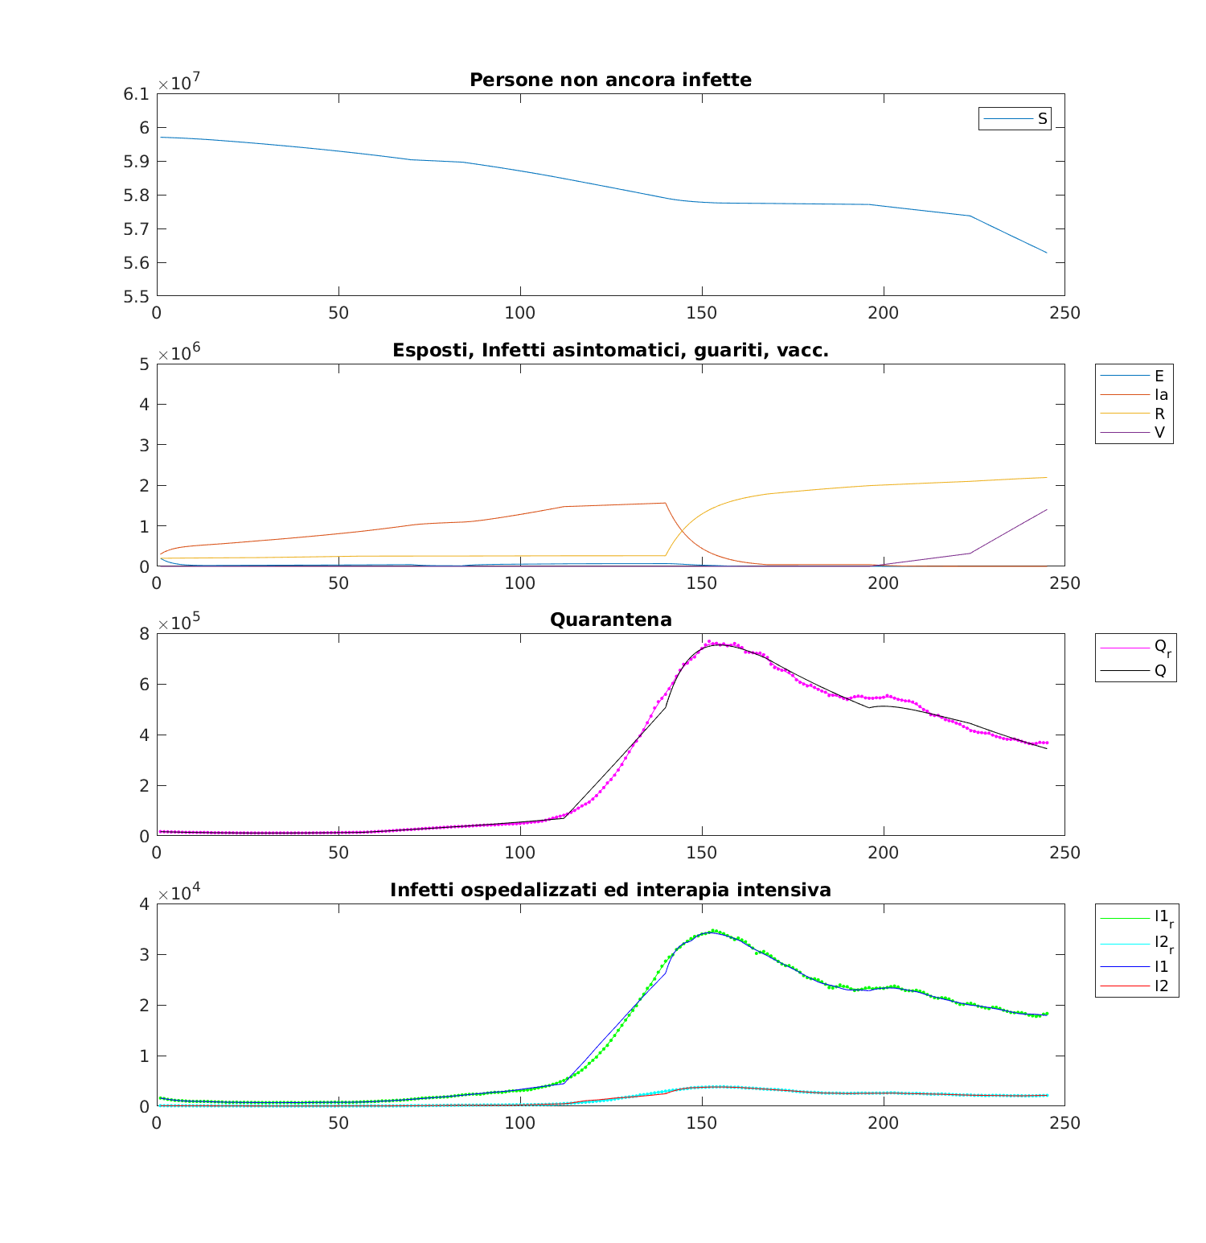

**Figure 1**: comparison between real evolution and the simulated one from 23rd June 2020 (t=0) to 22nd February 2021 (t=245)

The control values are changing each 7 days, while other parameters change each 28 days (each month) so for 245 days we will have 35 values and 9 for the other parameters.

Values assigned at the end of the fitting are presented in **Table 2**

**Table 2:** values of the fitted parameters

|  |  |
| --- | --- |
| Parameter | Value |
|  | [0.82438 ,0.94192 ,0.95159 ,0.97146 ,0.95922 ,0.95485 ,0.95231 ,0.94923 ,0.94699 ,0.94547 ,0.94392 ,0.94240 ,0.94019 ,0.93849 ,0.93561 ,0.93437 ,0.92285 ,0.89904 ,0.87546 ,0.85775 ,0.72154 ,0.56562 ,0.49534 ,0.47672 ,0.46369 ,0.46515 ,0.45858 ,0.49596 ,0.39689 ,0.45576 ,0.47108 ,0.41408 ,0.59015 ,0.36111 ,0.44229] |
|  | [0.00262 ,0.32444 ,0.30206 ,0.20534 ,0.73298 ,0.29215 ,0.29229 ,0.29311 ,0.29389 ,0.29290 ,0.29142 ,0.29441 ,0.29300 ,0.28945 ,0.29042 ,0.28366 ,0.29488 ,0.29383 ,0.29297 ,0.28918 ,0.30490 ,0.29188 ,0.29188 ,0.29188 ,0.29188 ,0.29188 ,0.29188 ,0.29188 ,0.29188 ,0.29188 ,0.29188 ,0.29188 ,0.29188 ,0.29188 ,0.29188] |
|  | [0.54289 ,0.54155 ,0.54063 ,0.54245 ,0.91058 ,0.54424 ,0.54424 ,0.54424 ,0.54424 ,0.54424 ,0.54424 ,0.54424 ,0.54424 ,0.54424 ,0.54424 ,0.54424 ,0.54469 ,0.54518 ,0.54492 ,0.54529 ,0.61193 ,0.54424 ,0.54424 ,0.54424 ,0.54424 ,0.54424 ,0.54424 ,0.54424 ,0.54424 ,0.54424 ,0.54424 ,0.54424 ,0.54424 ,0.54424 ,0.54424] |
|  | [0.00000 ,0.00000 ,0.00000 ,0.00000 ,0.00000 ,0.00000 ,0.00000 ,0.00000 ,0.00000 ,0.00000 ,0.00000 ,0.00000 ,0.00000 ,0.00000 ,0.00000 ,0.00000 ,0.00000 ,0.00000 ,0.00000 ,0.00000 ,0.00000 ,0.00000 ,0.00000 ,0.00000 ,0.00000 ,0.00000 ,0.15777 ,0.18240 ,0.18144 ,0.18149 ,0.95292 ,0.95235 ,0.95007 ,0.95044 ,0.99732] |
|  | [0.00375 ,0.00935 ,0.00509 ,0.00565 ,0.05495 ,0.18701 ,0.05719 ,0.90000 ,0.05940] |
|  | [0.86752 ,0.96000 ,0.96000 ,0.86000 ,0.94155 ,0.92146 ,0.96000 ,0.96000 ,0.95999] |
|  | [0.00308, 0.04430, 0.00396, 0.00190, 0.00010, 0.01109, 0.00503, 0.00779, 0.00474] |
|  | [0.01237 ,0.09741 ,0.02719 ,0.02969 ,0.05747 ,0.16732 ,0.02984 ,0.02636 ,0.03717] |
|  | [0.00002 ,0.00001 ,0.00001 ,0.00001 ,0.00001 ,0.10647 ,0.00001 ,0.00001 ,0.00001] |
|  | [0.03763 ,0.05748 ,0.00034 ,0.00010 ,0.00010 ,0.00010 ,0.00734 ,0.00020 ,0.00729] |
|  | [0.00021 ,0.27868 ,0.00010 ,0.00010 ,0.00010 ,0.00010 ,0.00010 ,0.00240 ,0.00010] |
|  | [0.00375 ,0.00935 ,0.00509 ,0.00565 ,0.05495 ,0.18701 ,0.05719 ,0.90000 ,0.05940] |
|  | [0.00375 ,0.00935 ,0.00509 ,0.00565 ,0.05495 ,0.18701 ,0.05719 ,0.90000 ,0.05940] |

From the parameters’ value in **Table 2** it is possible to notice some interesting aspects. We could feel satisfied in the way the optimiser assigned the value to fit the simulated curve in order to minimise the error with respect the real curve of infected hospitalised and quarantined people. Because of the increasing number of swab, the number of infected people (also aymptomatic) positive (lambda) due to the swab increase and as a consequence, also the percentage of infected quarantined. It seems to be faithful to the real situation the values given to the parameters ; the control effectiveness of the treatments in the hospital for not IT subjects and IT subjects grew during the time interval from a value of 0.00375 in the first month to a value if 0.059 in the last month. This is given by the fact that the number of ICu and beds in the hospitals was improved but, how we can see, even though this improvement in the following months, the value of the effectiveness of treatments control in hospital is kept low due to the deficiency of healthy facilities.

*Optimal control numerical results and simulations*

In this paragraph we are going to show the numerical results of the optimal control given by the four different strategies.

For all the four optimal control strategies we have set the control guess for the optimization as follow:

Because of the absence of a vaccine on 23rd June, was set to 0 for the initial time instant with an upper and lower bound equal to 0 and just after 189 days (it corresponds to the first vaccine day executed on 28th December 2020) its upper bound has been varied.

The upper and lower control bounds wont the fixed to the behaviour they had in fitting period. We can consider a new lockdown () or no restrictions (), and for similar reason also the other 2 controls have different bounds. So this are bounds are set for the optimisation:

The optimization has been performed considering weekly variations of the control in order to be more accurate during the computations and to be more realistic because of the different restrictions and measures taken by the government.

Also, to keep lower the value of the controls we have decided to perform an optimal resources allocation setting the following inequality constraint:

**Strategy 1:** to compute the optimal control we have used the cost index *(5a)* and the upper and the lower bounds are defined by *(3a).*

The weights in the cost index were chosen in order to privilege the maximization of the susceptible with respect to the control terms that are also weighted in such a way to give the proper level of importance:

The number of susceptible was normalized with respect to the total population.

In **Figure 3** the obtained controls and the evolution of different classes are presented.

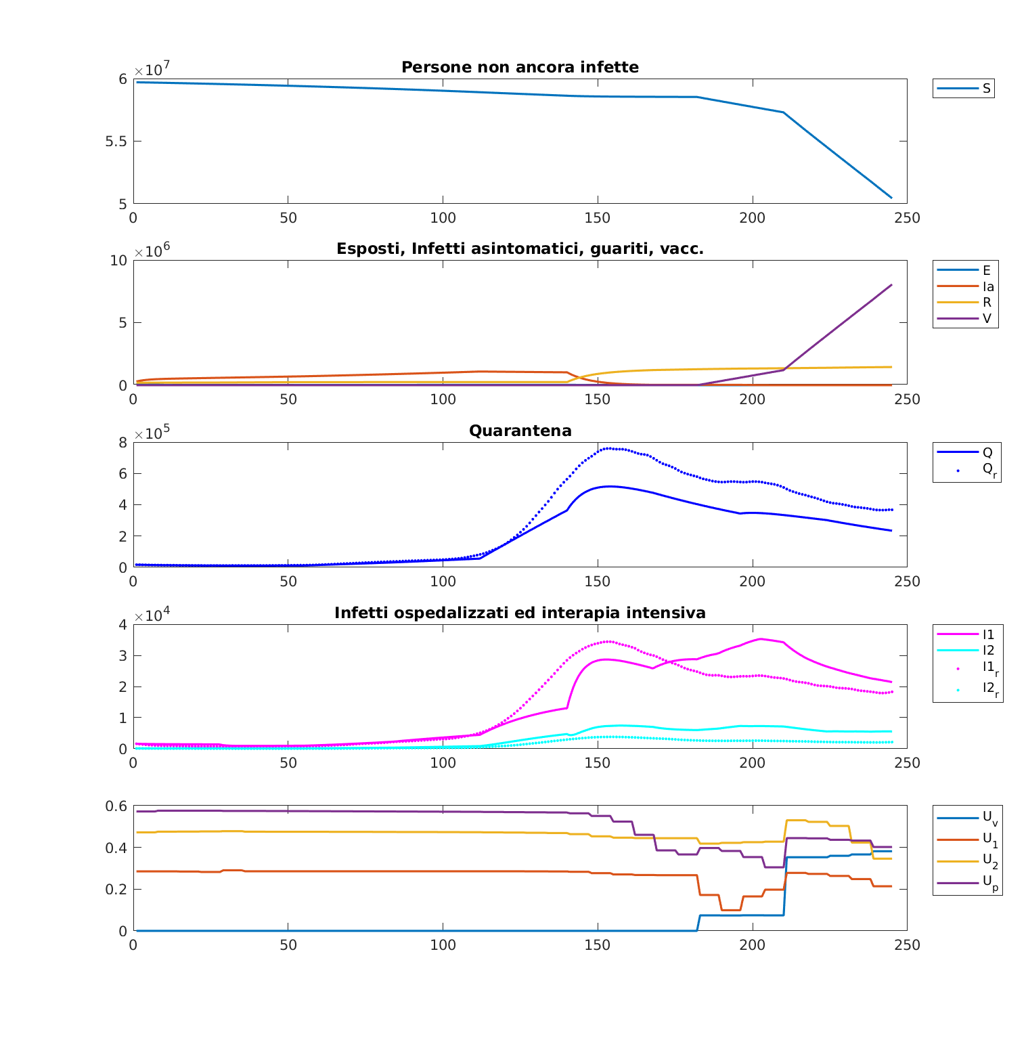

**Figure 2**: evolution of the dynamic system with the first optimisation strategy applied, considering the comparison of real and simulated evolution between the compartments of interest (Q, I1, I2) and showing the control changes along the time interval.

**Strategy 2:** to compute the optimal control we have used the cost index *(5b)* and the upper and the lower bounds are defined by *(3b).*

The weights in the cost index were chosen in order to privilege the minimization of the infected in IC with respect to the control terms and the infected hospitalized not in IC. The weights are set in the following way:

The number of infected hospitalized not in IC and in IC are normalized to 1.

In Figure 3 the obtained controls and the evolution of different classes are presented

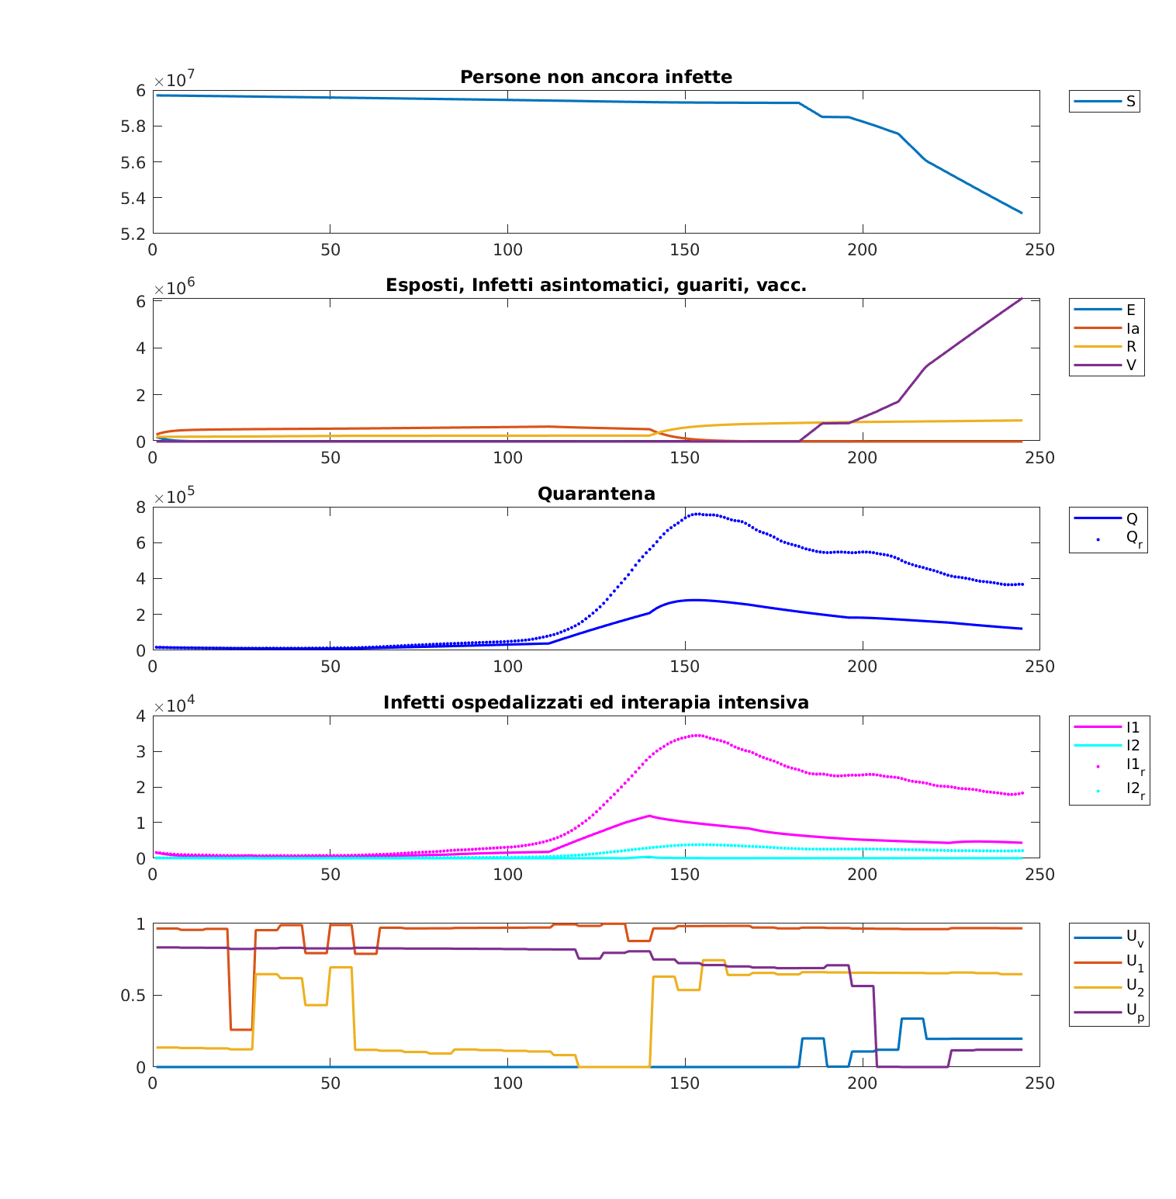

**Figure 3**: evolution of the dynamic system with the second optimisation strategy applied, considering the comparison of real and simulated evolution between the compartments of interest (Q, I1, I2) and showing the control changes along the time interval.

**Strategy 3:** to compute the optimal control we have used the cost index *(5c)* and the upper and the lower bounds are defined by *(3c).*

The weights in the cost index were chosen in order to privilege the minimization of the infected in IC with respect to the control terms and the infected hospitalized not in IC but giving also importance to the susceptible maximisation. The weights are set in the following way:

The number of susceptible, infected hospitalized not in IC and in IC are normalized to 1.

In Figure 4 the obtained controls and the evolution of different classes are presented

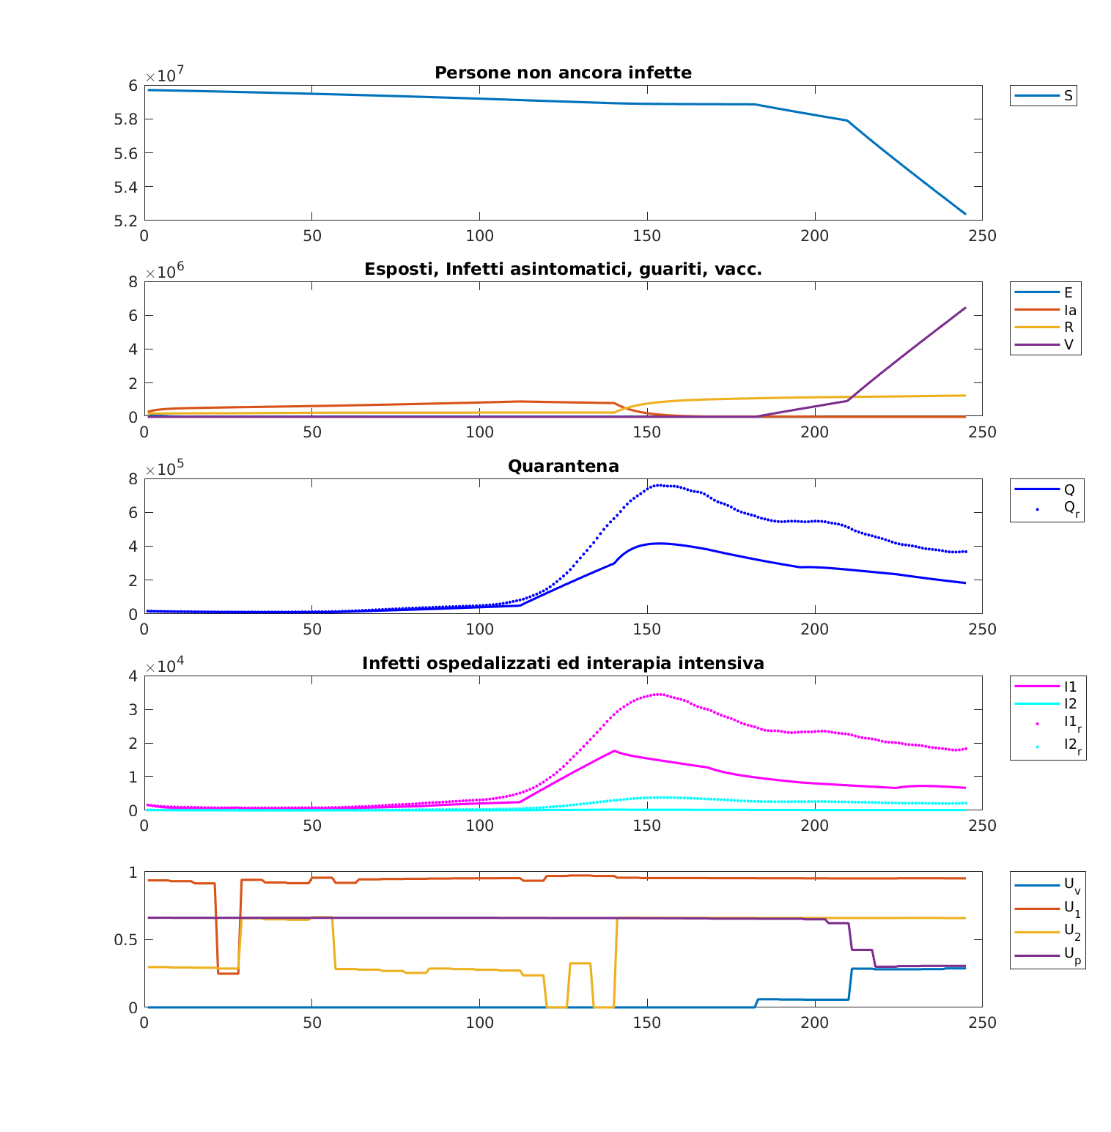

**Figure 4**: evolution of the dynamic system with the third optimisation strategy applied, considering the comparison of real and simulated evolution between the compartments of interest (Q, I1, I2) and showing the control changes along the time interval.

**Strategy 4:** to compute the optimal control we have used the cost index *(5d)* and the upper and the lower bounds are defined by *(3d).*

The weights in the cost index were chosen in order to privilege the minimization of the infected in IC with respect to the control terms. The weights are set in the following way:

The number of vaccinated people is normalized to 1.

In Figure 5 the obtained controls and the evolution of different classes are presented

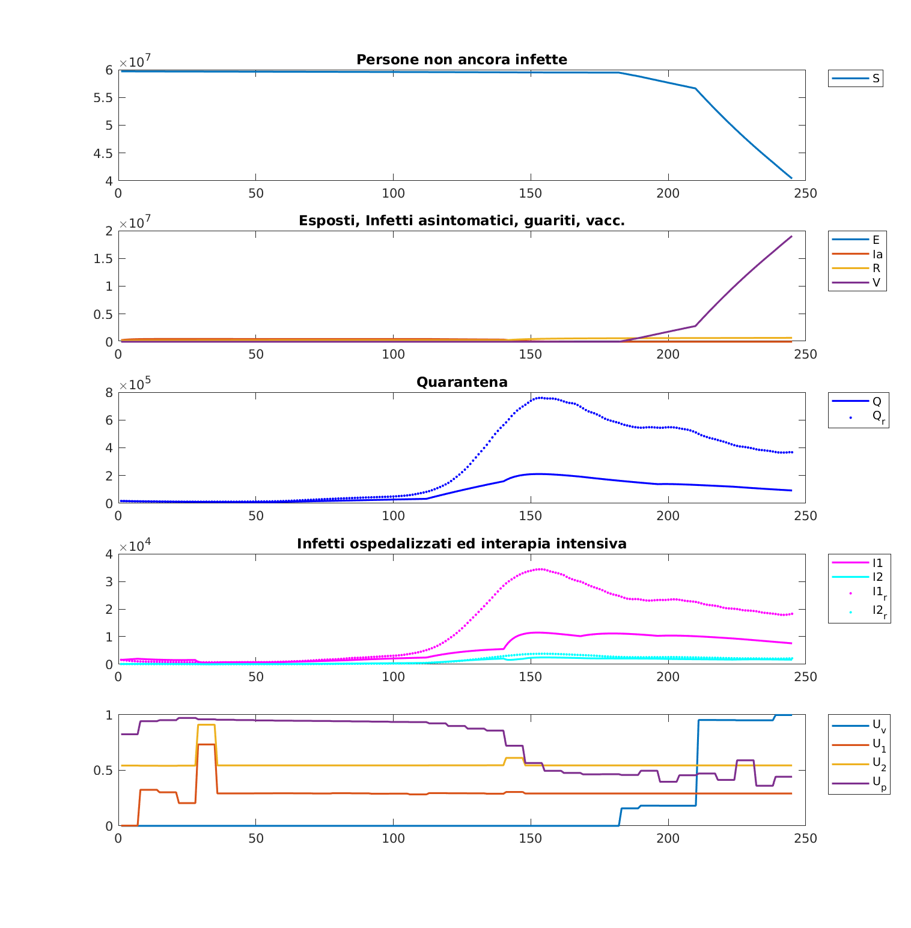

**Figure 5**: evolution of the dynamic system with the fourth optimisation strategy applied, considering the comparison of real and simulated evolution between the compartments of interest (Q, I1, I2) and showing the control changes along the time interval.

To discuss the results obtained we present the comparison between four different strategies and the fitting evolution of the infected not in IC ( the infected in IC ( (Figure 6) and the controls (Figure 7).

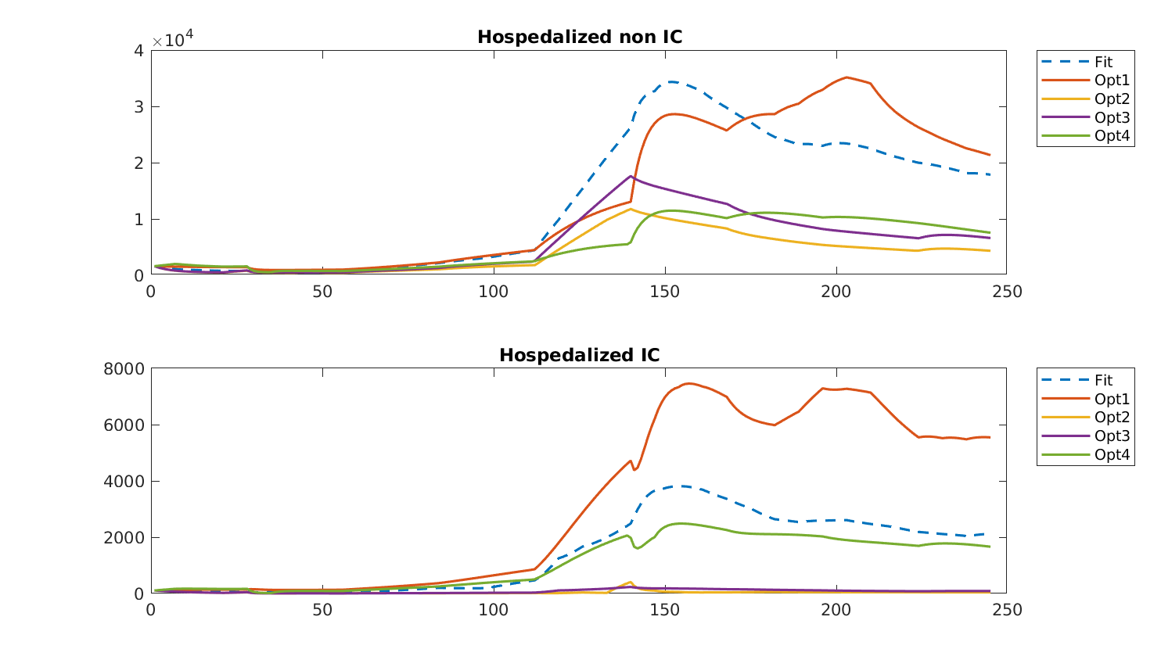

**Figure 6:** Comparison of the incidence of the infected not in IC and infected in IC subjects in the five situations: fitting evolution, first optimisation strategy (maximising the number of susceptible), second strategy (minimising the number of infected not in IC and in IC), third strategy (maximising the number of susceptible and simultaneously minimising the number of infected not in IC and in IC), fourth strategy (maximising the number of vaccinated people).

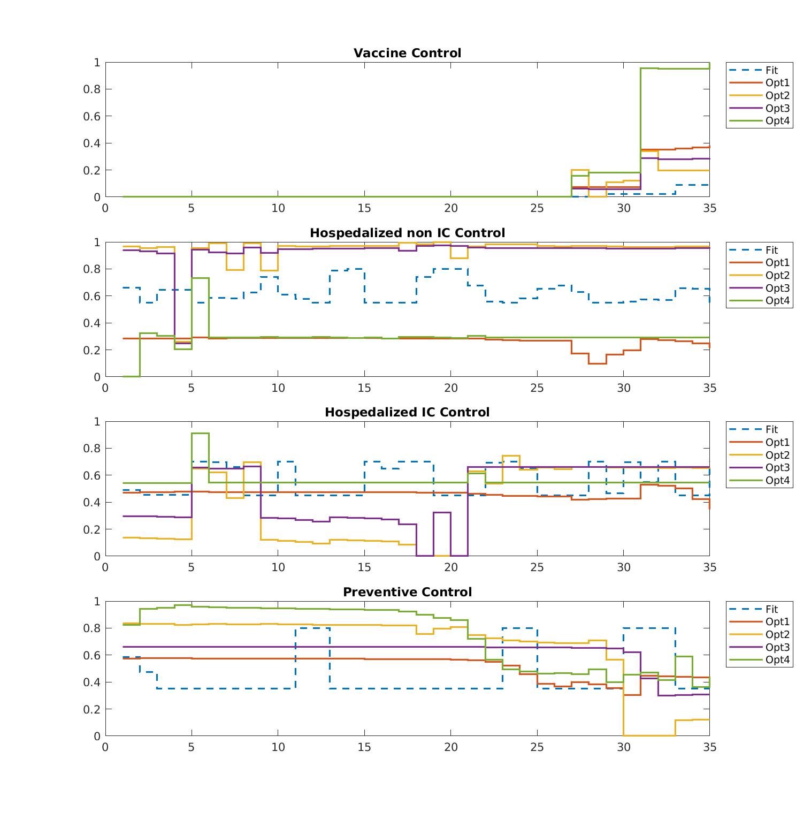

**Figure 7:** optimal controls up(t), u1(t),u2(t),uv(t) and fitting controls comparison on a time interval of 35 weeks (245 days).

Using the dashed blue curve as our reference of the evolution of the infected hospitalized not in ICand in IC and as the reference of the control during the time interval, It is possible to assert from the above figures that the infected not in IC in all the optimisation are better than the reference evolution despite for the first strategy in which we try to maximise the susceptible; in this case the peak of infected hospitalised is just delayed from day 150 to day 200 but it assume the same value with respect the reference graph (fitted curve). Even if all the controls are just below the reference ones, comparing the infected in IC evolution, it is quite evident how this first strategy is not suitable for our objective, namely minimise the number of people hospitalized and moreover those in IC. Looking on the other evolutions, all the three other strategies are always below with respect to the fitted curve, so it is possible to say that they are all good candidates to choose. But focusing on their evolution and the value of the control assumed it is possible to see how, from one side, optimisation 2 and optimisation 3 (minimisation of the infected hospitalized not in IC an in IC, maximisation of susceptible and minimisation of both kind of infected hospitalized respectively) keep very low the curve of infected in IC with a peak of 500 people (respect to the reference with 4000 people hospitalized in IC), on the other side, the resources for the control, especially for treatments in IC are very high (80-90%), despite for the fourth strategy in which the number of infected in IC is higher than the previous two strategies, characterised by a peak of 2200 people in ICu but with a positive outcome in the allocation of resources in the controls. Infact, in the last strategy, in which we want to maximise the number of vaccinated people, the controls on infected hospitalized not in IC is lower (30%) than that used by the second and third strategy (80-90%). As a trade-off, the preventive control (all those restrictions taken by the governments to keep the spread of the epidemic down) is higher in the first weeks (80%) and then decrease stabilizing at 40% of the control effort. The control that gives a huge contribute is the vaccine; in the last weeks the control effort on vaccine has a growth from 0.2 to 0.95, this means that the government has to rely in the vaccination campaign to keep low the infected people that have complications.

Overall, the decision of which strategy is better among the last three, depends on what we want to keep low. If we want to keep the number of infected in IC and not in IC as low as possible despite for a greater effort for the controls of these two compartments, then we want to prioritize the second and the third strategies. Otherwise, if we want to keep the control effort related to the subjects hospitalized not in IC at the expense of an higher number of infected in IC (but still lower than the real situation), therefore we decide to keep in consideration the fourth strategy.

In conclusion, since our objective is to prevent the bed collapse and the overcrowding in the hospital by minimise the number of hospitalized infected, we think that the second and the third strategies are the most suitable.

# 4. Conclusions

The COVID-19 pandemic represents a dilemma for public health policies, which are faced with either mitigating the epidemic wave to rely on natural immunisation or suppressing the wave long enough to develop and implement a vaccine (as Italy has done since the disease spread in the country) and trying to avoid the bed collapse and overcrowding in the hospital that the country was affected during the second wave in the last months of 2020. We focused on the latter case to address the following question: in a context where resources are finite, hot to best allocate the control effort of the epidemic over the time period necessary to mitigate the number of infected hospitalised in Intensive Care and not?

For our aim we have decided to try different optimisation strategies to understand which strategy was the best in terms of numbers of infected hospitalised and in terms of control efforts. Using optimal control theory, we have shown that, assuming a quadratic cost for the control effort at a given time, the second and the third optimal control strategies significantly reduce the number of infected not in IC and in IC hospitalized preventing the lack of beds in the hospitals and in particular the machineries for the Intensive Care Units but as a trade-off the control effort is higher in the first months. The other strategies, even if the curves are lower than the real one, make the use of higher control efforts or even though are lower than the second and the third strategies, the result in the number in infected hospitalised is not satisfactory.

One of the limitations of our study is the vaccine control that was set in a particular way in order to accomplish to our task.

Our results offer new perspectives and research avenues to control the COVID-19 epidemics. In particular, we find that alleviate epidemic controls and moreover the preventive control too early all tend to only delay the epidemic wave and cause an overcrowding of the hospitals. An open topic could be to predict the dynamic system evolution by an Model Predictive Control (MPC(?)) method and therefore act on the controls in time in order to prevent new epidemic waves and saturations of sanitary facilities.

# References

1. [1] “Coronavius, primi casi in Italia: 16 in Lombardia”, da Tgcom24, <https://www.tgcom24.mediaset.it/cronaca/lombardia/coronavirus-un-contagiato-in-lombardia-ricoverato-nel-milanese_15091444-202002a.shtml>
2. [2] “Decreto coronavirus, ecco tutte le misure del governo”, da La Repubblica <https://www.repubblica.it/politica/2020/03/01/news/coronavirus_misure_governo-249980561/>
3. [3] Ministero della Salute, (Italian Ministry of Health) <http://www.salute.gov.it/imgs/C_17_notizie_4403_0_file.pdf>
4. [4] Dati e notizie dal portale della Protezione Civile. Situazione Italia al 5 marzo. http://www.salute.gov.it/portale/nuovocoronavirus/dettaglioNotizieNuovoCoronavirus.jsp?lingua=italiano&menu=notizie&p=dalministero&id=4157 (5 March 2020).
5. [5] Chronology of main steps and legal acts taken by the Italian Government for the containment of the COVID-19 epidemiological emergency. http://www.protezionecivile.gov.it/documents/20182/1227694/Summary+of+measures+ta
6. ken+against+the+spread+of+C-19/c16459ad-4e52-4e90-90f3-c6a2b30c17eb
7. [6] Wang, Y., Wang, Y., Chen, Y. & Quin, Q. Unique epidemiological and clinical features of the emerging 2019 novel coronavirus pneumonia (COVID-19) implicate special control measures. *J. Med. Virol.* **92**, 568–576 (2020).
8. [7] Fisman, D., Rivers, C., Lofgren, E. & Majumder, M. S. Estimation of MERS-Coronavirus reproductive number and case fatality rate for the Spring 2014 Saudi Arabia outbreak: insights from publicly available data. *PLoS Curr.*
9. <https://doi.org/10.1371/currents.outbreaks.98d2f8f3382d84f390736cd5f5fe133c> (2014).
10. [8] Zhao, S. et al. Preliminary estimation of the basic reproduction number of novel coronavirus (2019-nCoV) in China, from 2019 to 2020: a data-driven analysis in the early phase of the outbreak. *Int. J. Inf. Dis.* **92**, 214–217 (2020).
11. [9] Read, J., Bridgen, J. R., Cummings, D. A. T., Ho, A. & Jewell, C. P. Novel coronavirus 2019-nCoV: early estimation of epidemiological parameters and epidemic predictions. Preprint at *medRxiv* https://doi.org/10.1101/2020.01.23.20018549 (2020).
12. [10] Zou, L. et al. SARS-CoV-2 viral load in upper respiratory specimens of infected patients. *N. Engl. J. Med.* **382**, 1177–1179 (2020).
13. [11] Ansa, “il 27 dicembre le prime 9.750 dosi di vaccino in tutta italia”, <https://www.ansa.it/canale_saluteebenessere/notizie/sanita/2020/12/18/il-27-dicembre-le-prime-9.750-dosi-vaccino-in-tutta-italia_1f66d610-5800-4224-9c0f-992a34b19100.html>
14. [12] C. E. Madubueze, S. Dachollom, I.O. Onwubuya. Controlling the spread of COVID-19: Optimal Control Analysis. *Hindawi, Computational and Mathematica Methods in Medicine, Vol.2020,* <https://doi.org/10.1155/2020/6862516>
15. [13] D.Pal, D. Ghosh, P.K. Santra, G.s. Mahapatra. Mathematical analysis of a COVID-19 Epidemic Model by using data driven epidemiological parameters of diseases spread in India, April 29, 2020, https://doi.org/10.1101/2020.04.25.20079111
16. [14] D. Iacoviello, N.Stastio, Optimal control for SIRC epidemic outbreak, *Elsevier,* January 11, 2013
17. [15] Kermack, W. O. & McKendrick, A. G. A contribution to the mathematical theory of epidemics. *Proc. R. Soc. Lond.* **115**, 700–721 (1927).
18. [16] S.A.Araz. Analysis of a Covid-19 model: Optimal control, stability and simulations *Elsevier,* pg. 4, September 29, 2020.
19. [17] D.Liberzon, Calculus of Variations and Optimal Control Theory: A Concise Introduction, Princeton University Press, 2012
20. [18] Protezione Civile, github repository: <https://github.com/pcm-dpc/COVID-19/tree/master/dati-andamento-nazionale>

1. Note that for a better view of the system we have omitted the time dependences of the state variables and parameters in the system that are intrinsically in.