Правительство Российской Федерации

Федеральное государственное бюджетное образовательное учреждение

Высшего профессионального образования

«Санкт-Петербургский государственный университет»

Математико-механический факультет

Шайхетдинова Алиса

Мультимодальная биометрическая система

аутентификации по рисунку вен и отпечатку пальца

Научные руководители:

Доцент, к.ф.-м.н. Михайлова Елена Георгиевна,

RNDr. Игорь Чермак, CSc

Санкт-Петербург

2017

Saint-Petersburg State University

Mathematics and Mechanics Faculty

Sub-Department of Analytical Information Systems

Shaykhetdinova Alisa

Finger-based Multimodal Biometric Recognition

Scientific advisers:

Assoc. Prof. Mikhailova Elena Georgievna

RNDr. Igor Čermák, CSc

Saint-Petersburg

2017

**Abstract:** Most biometric systems from real world applications use a single source of biometric modality which is known as uni-modal biometrics. Multi-modal biometric recognition requires several biometric features for recognition of a person to eliminate some drawbacks of uni-modal biometrics and, thereby, raise the level of security. The physiological biometrics such as fingerprint (which is now the most popular trait for recognition) and the pattern of blood veins of human’s body (which cannot be easily faked or cracked) in conjunction can produce high performance biometric system. In this paper a novel approach for biometric authentication is suggested which employs these two traits: fingerprint and finger vein. Proposed method uses both the Minutiae Extraction to extract features from the images of fingerprints and the Scale-Invariant Feature Transform for images of finger vein. The extracted features in the form of coefficients are stored in the data base. Then the matching is done between the coefficients of the input test images and the features stored in the data base using distance measure and finally the fusion is carried out. This approach was tested on standard data bases of fingerprint and finger vein images of hands. The proposed method provides a maximum accuracy of 97%, with a reduction in false acceptance and false rejection rates.

**Keywords**: fingerprint; finger vein; scale-invariant feature transform; minutiae extraction; multi-modal biometric recognition

I. Introduction

Biometrics is automatic personal recognition. Biometrics enables to establish an identity based on who you are, rather than by what you possess, such as an ID card, or what you remember, such as a password. Nowadays, biometric recognition is a familiar and reliable way to authenticate the identity of a person utilizing human characteristics or behavior. Since many various characteristics are unique to an individual, biometrics provides a more reliable system of authentication than ID cards (which can be stolen) or passwords (which can be forgotten).

Unfortunately, even biometrics has several vulnerabilities, such as not sufficient recognition accuracy or fake biometric attacks. There are two ways for addressing threats:

* by appending hardware and software mechanisms for vitality detection into the biometric recognition system (fingerprint devices can incorporate vitality detection by measuring, for example, thermal properties of the human skin or other biomedical characteristics.)
* by designing multimodal-biometric systems that combine several different biometric characteristics (or other multi-biometric techniques)

In this paper the second approach for system’s improvement will be discussed.

II. Issues in designing multibiometric system

Some of the factors that impact the design and structure of multibiometric system considered in this paper are described below:

1. Determining sources of biometric information:

The multi-modal biometric system considered in this work is implemented combining the evidence presented by fingerprint and finger vein.

A *fingerprint* is the pattern of ridges and valleys on the surface of a fingertip. The matching accuracy using this modality is very high, cost – very low.

The field of *vein pattern* technology uses the subcutaneous vascular network of the finger to verify the identity. This feature is a highly distinctive and does not depend on the skin condition.

1. Cost benefits:

The modalities used in the proposed approach are selected for increasing accuracy without extra costs for several sensors and the raise of time taken to acquire the biometric data: fetching both biometrics can be made by *one sensor* simultaneously.

1. Acquisition and processing sequence:

Typically, the evidence is gathered sequentially, but in case of chosen modalities it would be possible and convenient to *gather it* *simultaneously* using the same unit (fingerprint sensor combined with infrared camera for vein-based trait).

The information acquired is *processed in parallel mode* too. This approach utilizes more evidence about the user and, thus, entails higher accuracy and lower error rates.

1. Type of information:

In the context of a biometric system the various levels of fusion are possible: sensor level, feature level, match score level, decision level. In the proposed method *fusion* is implemented *at the match score level*. The match scores output by biometric matchers contain the richest information about the input pattern. Also, it is relatively easy to access and combine the scores generated by the different matchers.

1. Fusion methodology:

Score level fusion techniques can be divided into three categories: Transformation-based, Classifier-based and Density-based. It this paper *transformation-based score level fusion* is implemented.

Scores of the individual matchers must be comparable. Hence, score normalization is applied to transform the match scores into a common domain.

There are several *normalization techniques* (*min-max, z-score, MAD*), which are implemented and compared. Then the sum, max and min classifier combination rules applied to obtain the fused match scores from the normalized match scores.

The full block diagram of the proposed technique is given in Figure 2.1.

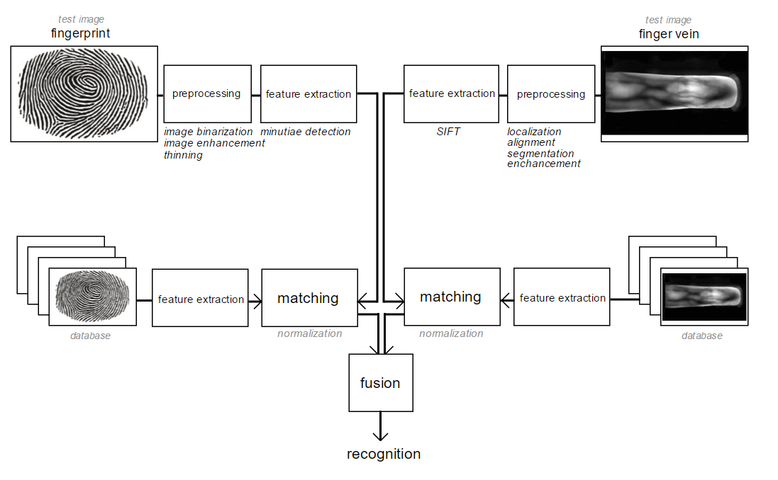

*Figure 2.1.* Flow of information in a match score level fusion scheme.

**III. Related Works.**

A multimodal biometric recognition based on hand images was discussed in [3] **.** The Shearlet transform and Scale-invariant feature transform were used for extraction features from finger vein and palm vein images. Finally, fusion on the matching results from those biometrics was performed on the score level. In [4], a multimodal biometric system utilized iris and facial images was considered. Contourlet transform and two dimensional principal component analyses were used there to extract the iris features and the facial features respectively, and a new fusion feature vector was formed by the combination of the iris and facial features.

The detailed survey of uni- and multi- modal biometric systems was done in [5] and the drawbacks of using only one modality in the recognition system was presented. The positive impact of the fusion such biometrics as fingerprint and face was discussed in [6].

Recently, biometric recognition based on veins has achieved more attention from researches. A review on vein biometric recognition using geometric pattern matching techniques was presented in [7]. A well defined classification has also been provided for vein pattern extraction strategies. Palm vein recognition has been deliberated in [8], based on the implementation of Local Derivative Pattern (LDP) as feature extraction algorithm and Histogram Intersection matching algorithm in a palm vein-based biometric identification system. In [9], Palm-dorsal vein recognition method, based on histogram of local Gabor phase XOR Pattern (HLGPXP) has been suggested.

From these examples, it is clear that the biometrics based on veins ensures improved security and it cannot be easily spoofed or falsified. Hence, in our proposed system, we have used finger vein biometrics in addition to traditional fingerprint biometric.

**IV. Used programs and databases**

Experiments have been conducted on three different databases. The first two databases are:

* Finger Vein Database
* Multi-Sensor Fingerprint Database

from a public-domain database (SDUMLA-HMT). These image sets have been used in several studies of multimodal biometrics, such as [10]. In order to produce the system, considered in this paper, fingerprint score of one person and finger vein score of another person were merged, thus virtual user was created.

MATLAB code is utilized here for the biometric system simulation, excluding acquisition phase, including feature extraction, template matching and decision.

# V. Overview of the algorithms deployed in the proposed method.

## *Feature extraction.*

**Scale-invariant feature transform (SIFT)** algorithm [4]shows its tolerance to scale, rotation, and view-point variations in the image processing.

|  |  |
| --- | --- |
| Detector | 1. Find Scale-Space Extrema 2. Key point localization and filtering   Improve key points and throw out bad ones |
| Descriptor | 1. Orientation Assignment   Remove effects of rotation and scale   1. Create descriptor   Using histograms of orientations |

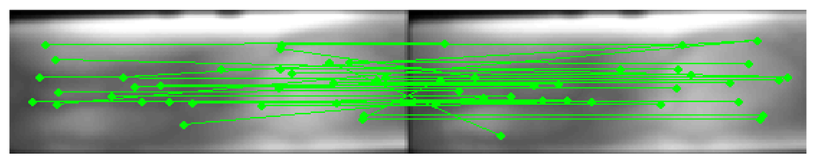

*Figure 5.1.* Matching results of SIFT features for finger-vein images from a same person.

|  |  |
| --- | --- |
| **Minutiae extraction.**  The set of minutiae points is considered to be the most distinctive feature for fingerprint representation and is widely used in fingerprint matching. | types of minutiae.PNG |

The traditional method for the minutiae extraction consists of the binarization (converting the gray scale image in binary image), thinning (find the ridges of one pixel width) and minutiae detection (from the binary thinned image the minutiae are detected by using 3x3 pattern masks).

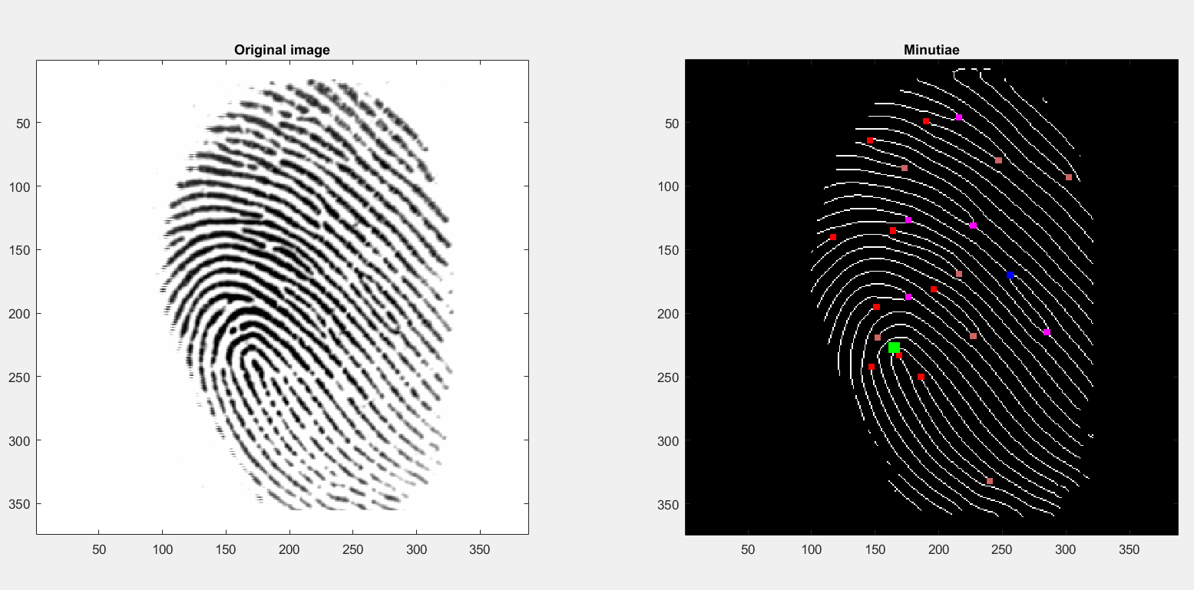

*Figure 5.2.* Termination and bifurcation minutiae in a sample finger-print.

## *Fusion.*

Denotation:

X – *input pattern*;

xj – *feature vector (derived from the input pattern X) provided by j classifier*;

{w1, w2, … , wM} – *M possible classes (enrolled users)*

According to the Bayesian decision theory:

*Assign* X wr *if* P(wr|x1,x2) P(wk|x1,x2), *where* k = 1, …, M.

Transform this formula into other representations:

**Sum Rule:**

*Assign* X wr *if* P(wr|x1) + P(wr|x2) P(wk|x1) + P(wk|x2), *k = 1, …, M.*

**Max Rule:**

*Assign* X wr *if* max (P(wr|x1),P(wr|x2)) max (P(wk|x1),P(wk|x2)), *k = 1, …, M.*

**Min Rule:**

*Assign* X wr *if* min (P(wr|x1),P(wr|x2)) min (P(wk|x1),P(wk|x2)), *k = 1, …, M.*

## *Normalization.*

Denotation:

R – *number of matchers;*

N – *number of scores;*

$s_{j}^{i}$– *i-th match score output by the j-th matcher, where i = 1,2,…,N, j = 1,2,…,R;*

${ns}_{j}^{i}$– *normalized score;*

Scaling:

**Min-Max: ${ns}_{j}^{t}$** = $\frac{s_{j}^{t}- \min_{i=1}^{N}s_{j}^{i}}{\max_{i=1}^{N}s_{j}^{i}- \min_{i=1}^{N}s_{j}^{i}}$

**Z-score**: ${ns}_{j}^{t}$ = $\frac{s_{j}^{t}- μ_{j}}{σ_{j}}$, $μ_{j}$- *arithmetic mean*, $σ_{j}$- *the stand. deviation for the j-th matcher*

**Median**: ${ns}_{j}^{t}$ = $\frac{s_{j}^{t}- {med}_{j}}{{MAD}_{j}}$, ${med}_{j}$ = ${median}_{i=1}^{N}s_{j}^{i}$, ${MAD}_{j}$ = ${median}_{i=1}^{N}{|s}_{j}^{i}-{med}_{j}|$

# VI. Experimental results

The evaluation metrics employed here are FAR (False Acceptance Rate) and FRR (False Rejection Rate).

FAR (FMR) is the measure of the likelihood that a biometric security system will incorrectly accept an access attempt by an unauthorized user. FAR typically is stated as the ratio of the number of false acceptances divided by the number of identification attempts.

FRR (FNMR) is the measure of the likelihood that the biometric security system will incorrectly reject an access attempt by an authorized user. FRR typically is stated as the ratio of the number of false rejections divided by the number of identification attempts.

To improve accuracy of the system we should decrease both: FAR and FRR.

The performance of the proposed technique is evaluated using metrics of FAR and FRR. The values are taken for both modalities (finger vein, fingerprint) and for the fusion system.

Genuine Accept Rate – percentage of genuine users accepted by the system: GAR = 1 – FRR.

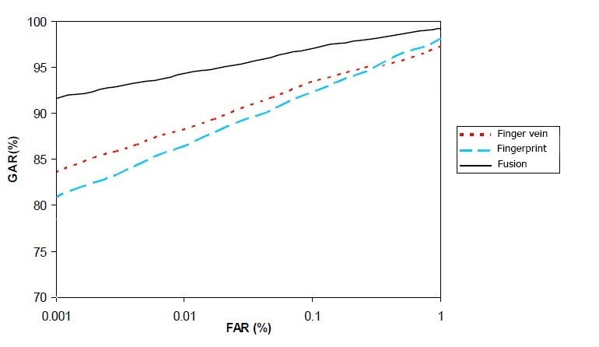

*Figure 6.2.* Performance gain obtained by Sum Rule based fusion with applying Min-Max normalization.

|  |  |  |  |  |
| --- | --- | --- | --- | --- |
| Normalization Technique | Fusion Technique | | | *Table 6.1.* Genuine Accept Rate (GAR) (%) of different normalization and fusion techniques at the 0.1% False Accept Rate (FAR) for the final Multimodal database. |
| Sum Rule | Max Rule | Min Rule |
| Min-Max | 97.8 | 92.0 | 94.9 |
| Z-score | 95.4 | 94.2 | 93.1 |
| Median | 91.5 | 92.5 | 90.8 |

The *Table 6.1* shows the recognition performance of the multimodal system when the scores are normalized using various techniques described above and combined utilizing the various fusion methods. We observe that the best performance is reached when a multimodal system employing the *sum of scores* method with *min-max* normalization technique.

At a FAR of 0.1%, the GAR

* of the fingerprint module is about 90.7%,
* of the finger vein is about 91.5%,

while that of the multimodal system is 97.8% when Min-Max normalization is used.

(*Figure 6.2.)*

# VII. Conclusion

In this paper the novel approach for personal recognition is presented.

This multimodal biometric system:

* uses fingerprint and finger vein images from ‘virtual’ users
* utilizes the Minutiae Extraction for fingerprints and the Scale-Invariant Feature Transform for images of finger vein.
* achieves the best accuracy while employing Min-Max normalization and Sum Rule for fusion.
* provides better performance than any of the uni-modal systems which use only one of the considered modalities.

The traits which are taken for proposed method are convenient for acquisition from one sensor. So it is possible to avoid extra costs for several sensors and raise of the time taken to acquire the biometric data.

It becomes increasingly difficult for an impostor to spoof multiple biometric traits. Thus, fusion of fingerprint and finger vein can be widely used in personal authentication applications in the future.

# References

[1] Handbook of Biometrics, A.K. Jain, P. Flynn, A.A. Ross

[2] Handbook of Multibiometrics, A.A. Ross, K. Nandakumar, A.K. Jain

[3] Hand Vein-based Multimodal Biometric Recognition, S. Bharathi, R. Sudhakar, Valentina E Balas

[4] Joint Iris and Facial Recognition Based on Feature Fusion and Biomimetic Pattern Recognitio, Ying Xu, FeiLuo, Yi-Kui Zhai and Jun-Ying Gan // Proceedings of the 2013 International Conference on Wavelet Analysis and Pattern Recognition, pages 202-208

[5] Unimodal and Multimodal Biometric Sensing Systems: A Review, M.O. Oloyede, G.P. Hancke, IEEE Access, volume 4, 2016

[6] Multi-biometric cohort analysis for biometric fusion, G. Aggarwal, N.K. Ratha, R.M. Bolle, IEEE 2008

[7] A review on vein biometric recognition using geometric pattern matching techniques, A. Agarwal, S. Maheshwari, G. Yadav, IEEE 2014

[8] Palm vein biometric identification system using local derivative pattern, A.F. Akbar, T.A.B. Wirayudha, IEEE 2016

[9] Palm-Dorsal Vein Recognition Method Based on Histogram of Local Gabor Phase XOR, Z. Meng, X. Gu, Journal of Signal Processing Systems 73(1) October 2013

[10] Multimodal Biometric Authentication Using Fingerprint and Iris Recognition in Identity Management, K. Vishi, S.Y. Yayiligan, 2013 Ninth International Conference on Intelligent Information Hiding and Multimedia Signal Processing, pages 334-341