**Robotics Software Nano-Degree Program**

**Sourav Pramanik**

**Udacity**

In this program the major focus was towards learning the concept of Localization and Mapping through the hands-on development of each individual blocks starting from building a world environment in GAZEBO and finally integrating the all the ROS packages together to run the home service robot.

**Project 1 :: Build My World**

In the first project we built a simple world environment which included a single floor structure designed in the model editor of the GAZEBO tool box. We developed the required plugin scripts in in C++ for the world along with configuring the CMakeLists.txt file. We also developed a simple robot using the SDF format. This simple environment developed in the first assignment is the base for the subsequent projects.

**Project 2 :: Go Chase It**

In the second project we build a robot and designed a simple algorithm to chase some white balls in the world we build in the earlier project. The foundation steps we followed here are making a URDF format file for the robot. This is required as against the SDF format used in the first assignment since in this project we want to include the ROS basics to communicate with the robot. We can use a URDF file to define a robot model, its Kino dynamic properties, visual elements and even model sensors for the robot. URDF can only describe a robot with rigid links connected by joints in a chain or tree structure. It cannot describe a robot with flexible or parallel links. We configure the various properties of the URDF file to make the final version of the robot, like enhancing it with wheel and joints on sides of the chassis. Finally, we added the sensory components like a CAMERA and a LIDAR module. This requires adding GAZEBO plugins to be added in the URDF file for the camera, lidar and the wheel joints. We also configure the RViz to visualize the sensor data published over ROS topic, like camera images, point clouds, ultrasonic measurements, lidar data, etc. The final requirement for the project is to create a simple C++ script to detect white balls in the world and chase those balls. We created two ROS nodes, “drive_bot” and “process_image” which communicate with each other to detect and move towards a white ball.

**Project 3 :: Where Am I**

In this project a localization algorithm is developed using Adaptive Monte Carlo Localization package. ROS packages like AMCL, teleop, etc are used.

The localization launch files included map server nodes, AMCL nodes, move base node.

The objectives achieved in this project are

1. The robot could localize itself after being teleported
2. The robot could follow a given nav_goal target to localize itself.

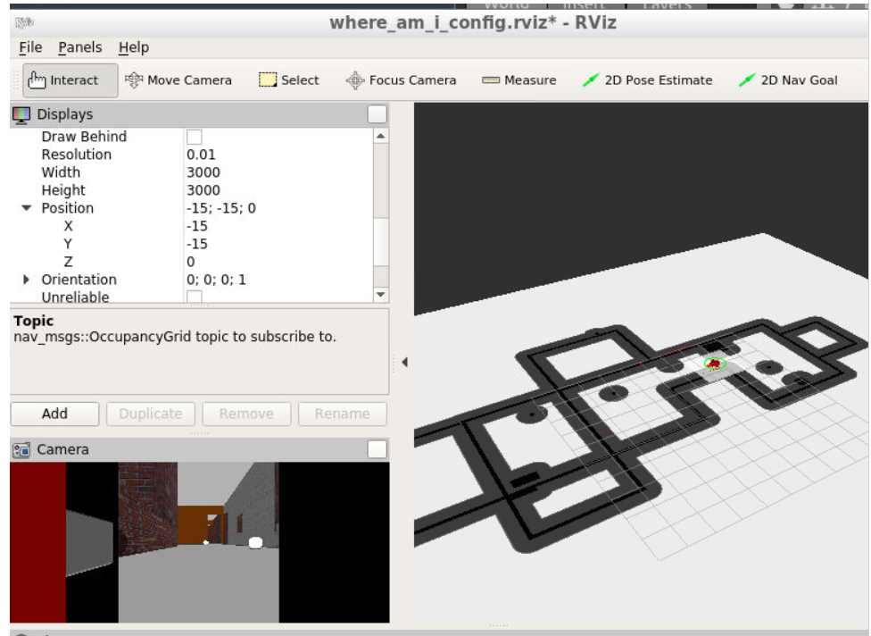

**Project 4 :: Map My World**

In this project we create a 2D occupancy grid and 3D octomap from a simulated environment using the robot with the RTAB-Map package.RTAB-Map (Real-Time Appearance-Based Mapping) is a popular solution for SLAM to develop robots that can map environments in 3D. RTAB-Map has good speed and memory management, and it provides custom developed tools for information analysis.

For this project we used the rtabmap_ros package, which is a ROS wrapper (API) for interacting with RTAB-Map.

In this project we created 3 basic launch files, mapping, teleop and localization. We used the RTABMAP ROS package to create map. We used and analyzed the Db map file generated. The map had 3 loop closures and we could identify the occupancy grid.

Link to the map file:

<https://drive.google.com/file/d/1GEV7rdrwHL6PZ4YOyU_Qll5zWHUkstRT/view?usp=sharing>

**Project 5 :: Home Service Robot**

This project is the outcome of all the project and learning we had from the past projects.