Manuscript Practice

Silvia P. Canelón

5/4/2021

# Getting started

## Set up an RStudio project

```{rcreate-project, eval=FALSE} # filepath ends with the name of your project # example: rmarkdown-manuscript

usethis::create_project( ‘/Users/scanelon/Documents/Repos/Teaching/rmarkdown-manuscript/’ )

```bash  
.  
├── .Rproj.user  
├── .gitignore  
├── R  
└── rmarkdown-manuscript.Rproj

## R Markdown

This is an R Markdown document. Markdown is a simple formatting syntax for authoring HTML, PDF, and MS Word documents. For more details on using R Markdown see <http://rmarkdown.rstudio.com>.

When you click the **Knit** button a document will be generated that includes both content as well as the output of any embedded R code chunks within the document. You can embed an R code chunk like this:

summary(cars)

## speed dist   
## Min. : 4.0 Min. : 2.00   
## 1st Qu.:12.0 1st Qu.: 26.00   
## Median :15.0 Median : 36.00   
## Mean :15.4 Mean : 42.98   
## 3rd Qu.:19.0 3rd Qu.: 56.00   
## Max. :25.0 Max. :120.00

## Including Plots

You can also embed plots, for example:

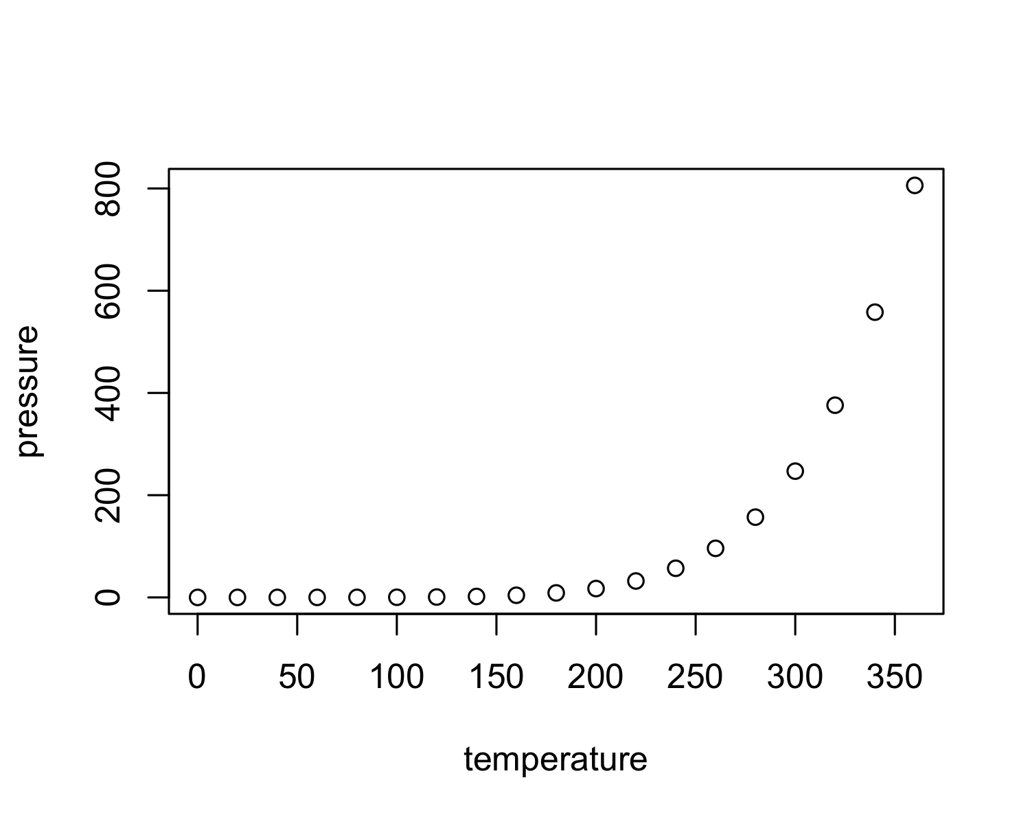

Note that the echo = FALSE parameter was added to the code chunk to prevent printing of the R code that generated the plot.