Forecasting US State Unemployment Rates Three Months Ahead
Team: outlier (Peichen Shen, Xutao Tian, Xiaoxi Gao) October 25, 2026
Affiliation: Brown University, DATA1030, Fall 2026
GitHub: https://github.com/spcddou/outlier-data1030-fall2026

Introduction
Using a state’s current and lagged unemployment rates, we predict its unemployment rate three reference months ahead. If the forecasts are sufficiently accurate, state employment agencies can plan staffing and service resources in advance. At this stage, we use ordinary least squares (OLS) regression to examine how much predictive power unemployment-rate history alone can provide.
Previous research has shown that the information available at the time of forecasting and the version of data used can both influence the results. The FRED-SD study by Bokun et al. (2024) forecast state-level unemployment rates, including a three-month horizon, and found that real-time data versus revised historical data can alter model comparison results. Şahin et al. (2021) used labor-market flow data to study national unemployment rate forecasts during the pandemic. Aaronson et al. (2020) used job-search activity to forecast state-level unemployment insurance claims.
Differences in data, targets, and methods prevent direct benchmark comparisons.

Data
We sent six batches of JSON POST requests through the Public Data API maintained by the U.S. Bureau of Labor Statistics (BLS, 2014) to retrieve seasonally adjusted monthly unemployment rates for the 50 states and the District of Columbia from the Local Area Unemployment Statistics program. The data cover the period from January 2014 to December 2024. The raw responses, request parameters, and UTC collection times were all preserved. The data was collected on the evening of October 14, 2026, Eastern Time, corresponding to October 15 in UTC.
The raw data table contains 6,732 rows and 3 columns, including state codes, months, and unemployment rates. Each row represents one month for a given region. Unemployment rates are expressed as percentages and are defined as the ratio of the number of unemployed persons to the labor force (BLS, 2017).
We checked for duplicate state-month records, incomplete monthly coverage, invalid rates, and annual-average observations. All 51 regions contain 132 monthly observations, with no missing or duplicate state-month records.
We then constructed unemployment rates for the previous 1, 3, 6, and 12 months within each state after aligning observations to a complete monthly calendar and set the unemployment rate for the same state three reference months later as the target variable. The complete modeling table has 5,967 rows and 9 columns. Model inputs include 5 numerical unemployment rate features and state categories. After coding the state categories, 50 dummy variables were created, resulting in a final input matrix with 55 columns. Date and future target values are not included as predictive features.
Observations from 2014 are primarily used to provide historical lags. The last three months of 2024 lack corresponding future labels and are therefore excluded from the modeling table. The observations are not independent and identically distributed (i.i.d.). Observations within a state may be serially correlated, and states may experience common shocks.

Exploratory Data Analysis
The first figure shows the changes in unemployment rates across states over time. Many regions exhibited a downward trend prior to 2020, followed by a sharp increase around 2020 and a gradual decline thereafter. The magnitude of change varies across states, and the model must account for both relatively stable and volatile periods.
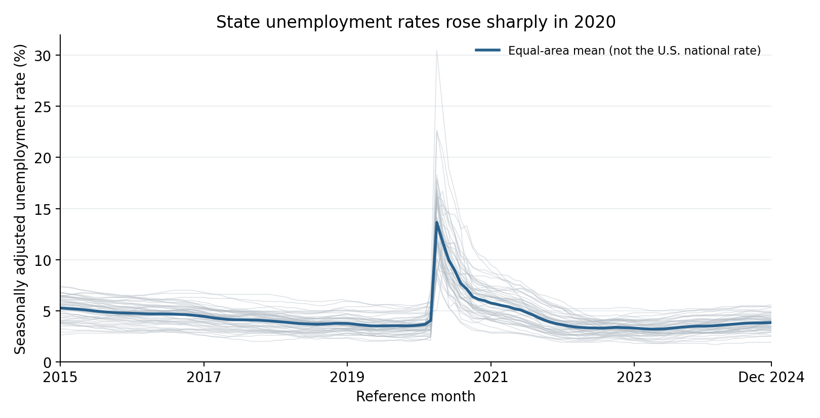
Figure 1: Seasonally adjusted monthly unemployment rates from 2015 to 2024. The gray line represent the 50 states and the District of Columbia, while the blue line represents the regionally equal-weighted average—not the official national unemployment rate. Source: BLS API data used in this study.
The second figure compares the current unemployment rate with the actual rate three reference months later. Among all 5,967 complete pairs, 86.1% of observations showed a change of no more than 0.5 percentage points within three months. State-level unemployment rates typically exhibit strong short-term persistence, and the data also contain observations that lie far from the equality line. The colors identify forecast-origin periods only and do not represent causal effects of the pandemic.
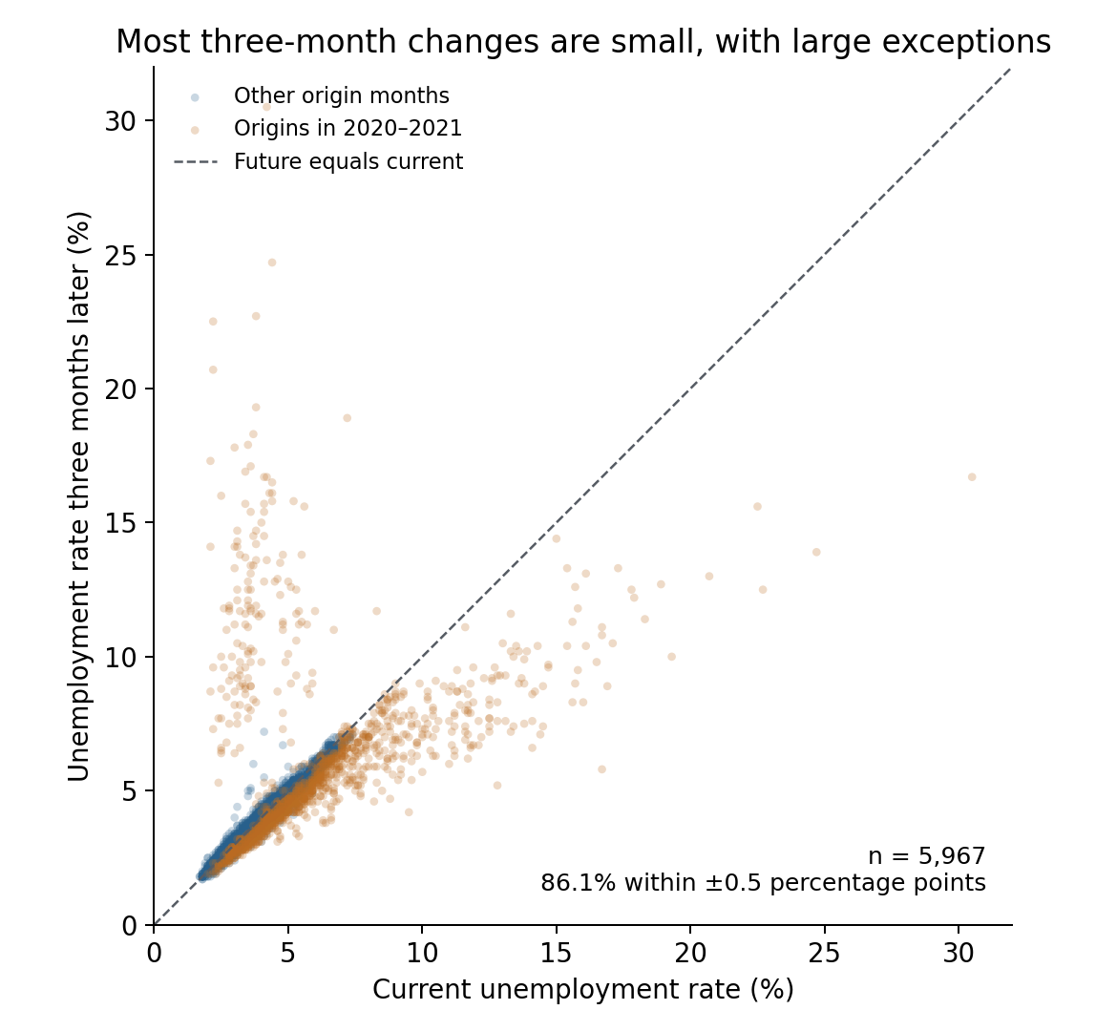
Figure 2: Current Unemployment Rate vs. Actual Unemployment Rate Three Reference Months Later. Each data point represents a state-month pair; the dashed line indicates equality between the two. This figure does not compare model predictions with actual values. Source: BLS API data from this dataset.
The third figure compares the distributions of the target variable between the training and testing periods. For the training reference months from 2020 to September 2021, the target unemployment rate ranged from 2.0% to 30.5%, while the testing target range was 1.7% to 5.6%. There are notable differences in the distributions between the two periods, but the current analysis cannot yet prove that this difference is responsible for the model’s negative R².
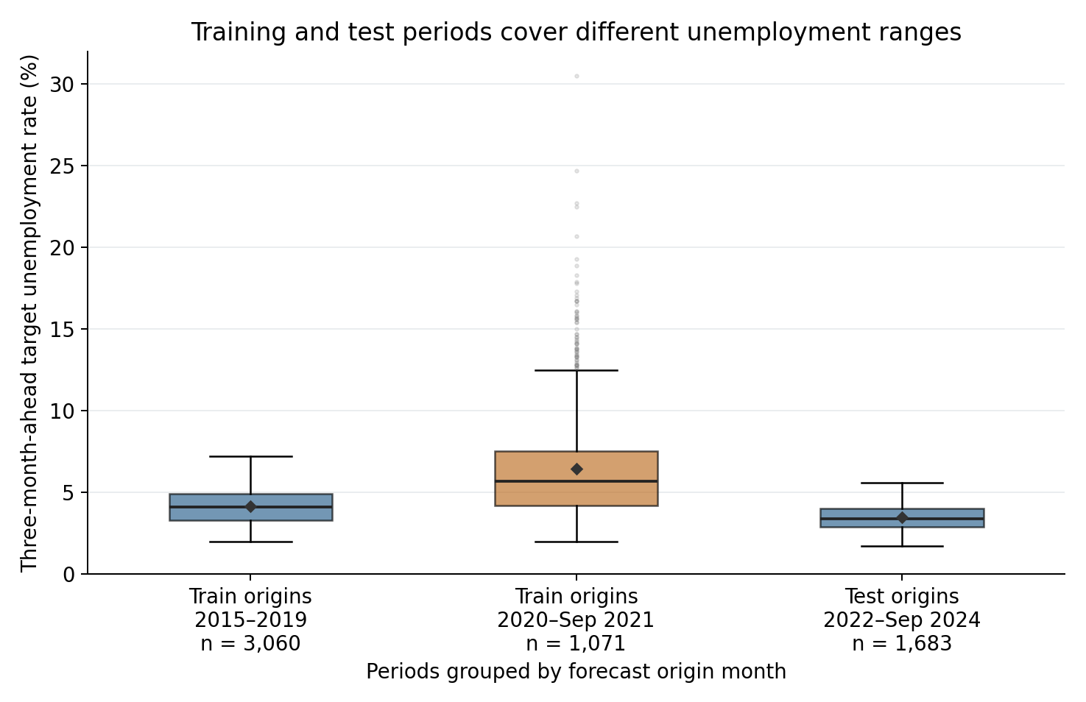
Figure 3: Distribution of future unemployment rates across different periods. Boxes represent the median and interquartile range; whiskers extend to the outermost observations within 1.5 times the interquartile range; dots represent observations outside this range; and diamonds represent the mean. Source: This set of BLS API data.
Figure 4 examines autocorrelation separately for all 50 states and DC using 81 training-origin months per area, January 2015–September 2021. We use the mean-centered definition underlying pandas' autocorrelation plot from Lecture 10. Short-lag autocorrelation is generally positive and declines with lag, although magnitudes differ across areas. This supports examining historical rates as predictors; it does not establish forecast accuracy or validate the selected lags.
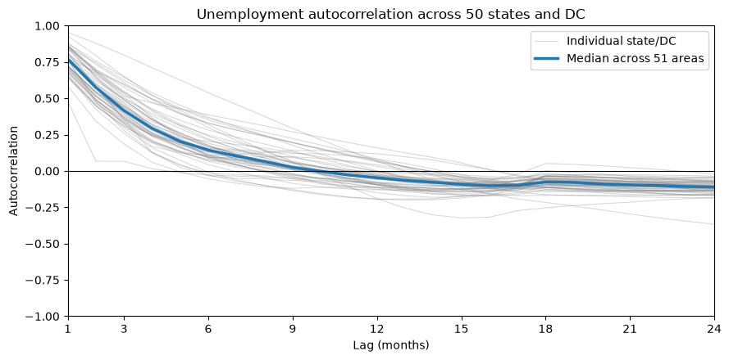
Figure 4. Training-period unemployment-rate autocorrelation across 50 states and DC. Gray lines show each area's autocorrelation; the blue line is the median across areas at each monthly lag. The median is not the autocorrelation of an average unemployment series. Source: our BLS API data.
Figures 1–3 include the already observed test period; Figure 4 uses training origins only. Any further model selection should use time-ordered validation within the training period. The existing test period must be disclosed as already inspected.

Problem description and potential impact
This project is a supervised learning regression task. The model uses regions and their historical information that have already appeared during training to predict the unemployment rate as a continuous numerical value. Month t represents the reference month to which the latest published data belongs, and the target is t plus 3 months. State-level data are generally released in the month following the reference month (BLS, 2025); therefore, “three months after the reference month” does not exactly correspond to “three months from the release date.” The current code does not reconstruct the exact historical release dates for each month.
The current model is an ordinary least squares regression with no tuned hyperparameters. All states share coefficients for five numerical features, while state dummy variables provide state-specific intercept adjustments. The training reference months span January 2015 through September 2021, totaling 4,131 rows. The test reference months span January 2022 through September 2024, totaling 1,683 rows. The 153 rows from the last three months of 2021 were excluded because their labels fell into 2022. All training label months precede the first test reference month, and the data was not shuffled.
Table 1. Test-set performance of OLS and the persistence benchmark
Metrics | Linear Regression | Persistence Benchmark
RMSE (percentage points) | 0.854 | 0.198
MAE (percentage points) | 0.772 | 0.141
R² | −0.164 | 0.938
Average Forecast Minus Actual (percentage points) | +0.769 | −0.028

On the test set, OLS substantially underperformed the persistence benchmark and overpredicted 98.5% of observations, with a mean signed error of +0.769 percentage points.
A negative R² indicates that the squared prediction error of the model is greater than the error resulting from ex post predictions using the actual mean of the test set. The R² of a test set can be less than zero; it is not equivalent to the square of a correlation coefficient (which must be non-negative), nor is it a negative prediction accuracy rate.
One hypothesis is that the high-volatility training period contributed to the model’s upward bias during the later, more stable test period. Other possible explanations include unstable coefficients caused by correlated lag features and differences in short-term unemployment dynamics across states. These explanations have not yet been tested.
Current performance does not support deployment. Because the evaluation weights every state-month equally, the reported scores do not represent population- or labor-force-weighted national performance.
This API snapshot contains revised historical data and does not represent the initially released data for each month. The BLS conducts monthly and annual revisions; annual historical smoothing may also utilize information from periods after the target month (BLS, 2018, 2025). Constructing lagged variables based on time alone does not prove that all source data were available at the time. The current work constitutes a retrospective evaluation using revised historical data, and the impact of data revisions on forecast errors has not yet been quantified.
Next, we will use time-ordered validation within the training period, model changes in unemployment rates, add recent-change, trend, rolling, and seasonal features, and compare OLS, Ridge, and nonlinear models.

References
Aaronson, D., Brave, S. A., Butters, R. A., Sacks, D. W., & Seo, B. (2020). Using the eye of the storm to predict the wave of COVID-19 UI claims (Working Paper No. 2020-10). Federal Reserve Bank of Chicago. https://doi.org/10.21033/wp-2020-10
Bokun, K. O., Jackson, L. E., Kliesen, K. L., & Owyang, M. T. (2024). FRED-SD: A real-time database for state-level data with forecasting applications (Working Paper No. 2020-031E). Federal Reserve Bank of St. Louis. https://doi.org/10.20955/wp.2020.031
Şahin, A., Tasci, M., & Yan, J. (2021). Unemployment in the time of COVID-19: A flow-based approach to real-time unemployment projections (NBER Working Paper No. 28445). National Bureau of Economic Research. https://doi.org/10.3386/w28445
U.S. Bureau of Labor Statistics. (2014, October 16). BLS public data API signatures (Version 1.0). https://www.bls.gov/developers/api_signature.htm
U.S. Bureau of Labor Statistics. (2017, December 5). Local Area Unemployment Statistics: Field definitions. https://www.bls.gov/help/def/la.htm
U.S. Bureau of Labor Statistics. (2018, January 9). Handbook of Methods: Local Area Unemployment Statistics—Calculation. https://www.bls.gov/opub/hom/lau/calculation.htm
U.S. Bureau of Labor Statistics. (2025, March 17). Local Area Unemployment Statistics: Frequently asked questions. https://www.bls.gov/lau/laufaq.htm

Appendix A AI Assistance Disclosure
OpenAI ChatGPT was used to review English grammar, improve wording and readability, and provide formatting suggestions.
AI interaction record: https://chatgpt.com/s/t_6ada2f46e8b08191b2131f57ea51a6a2

