LPO 7870 Research Design and Data Analysis II, 2025
Assignment 1

Submission Guidelines:
- Please submit via Brightspace an electronic copy of your solutions as a Microsoft Word or PDF document by January 27, at 4:00pm.
- This assignment may be completed individually or in pairs.
- If you work in pairs, you should submit one response, but you need to put both names on the document.
- You should copy and paste the main Stata outcomes such as graphs and tables. Pro-tip: if you use Courier New font, Stata output will line up as it does in the output window.
- You must also submit a .do file that provides the Stata code used to complete the assignment and answer each data analysis question. The .do file should have comments that identify which part of the code answers which question.

Question 1: Inference about population means (15 points)

Random samples of 50 self-identifying male and 50 self-identifying female students were administered a survey instrument to assess their self-concept in 8th grade. The male students scored an average of 23.2 on the assessment (with a standard error of 0.97) while the female students scored an average of 19.3 (with a standard error of 1.16).

- Provide an interpretation (in words) of the standard errors reported above. (3 points)
Standard error is the standard deviation of the sampling distribution. In this case, it tells you how much random sampling variation around the population mean for males and females exist for the self-concept measure. The measure for males will be slightly more precise than the measure for females.
- Based on these samples, construct 95% confidence intervals for the population mean self-concept for male and female 8th graders, respectively. Interpret. (5 points)
Assuming a known population standard deviation and thus using a z-test and normality:
Male: 95% CI: 23.2 ± 1.96*0.97 = [21.30, 25.10]
Female: 95% CI: 19.3 ± 1.96*1.16 = [17.03, 21.57]
95% confidence intervals have a 95% chance (across random samples) of including the true population mean. We can’t know whether these intervals do or do not contain the true population mean (for each respective gender), but there is a high chance that they do.
- Without doing any calculations, explain whether (and why) a 90% confidence interval for the population mean would be wider or narrower than the 95% confidence interval found in part b. (3 points)
It would be narrower. A lower confidence level means the interval will have a smaller chance (across random samples) of including the true population mean. The interval will be narrower—and thus more precise—but we are less confident it will include the true mean. Mathematically, the multiplier value used in the CI constructed above is smaller.
- Your colleague asks whether the estimated difference in mean self-concept between male and female students is statistically significant (at the 95% level). What would you answer and how did you determine this? (4 points)
First, we need to determine the difference: 23.2 - 19.3 = 3.9.
Then we can construct a confidence interval around this mean difference:
95% CI: 3.9 ± 1.96*SE(difference)
Now we need to calculate the standard error of the difference, which is a little mathematically complex. We need to first back out the standard deviation of each group from the standard error and the sample size.
Males: 0.97 = σ/√50; σ = 6.86
Females: 1.16 = σ/√50; σ = 8.20
Then we need to use the difference in means standard error estimator:
√(6.86^2/50 + 8.20^2/50)=1.51
Finally, we can construct the 95% CI using this standard error: 3.9 ± 1.96*1.51 = [0.94, 6.86]
Because the CI does not include 0, we can conclude that the difference is statistically significant at the 95% level.

Question 2: Minimum sample size (5 points)

You are preparing to collect survey data to estimate families’ mean travel time from home to school in a large urban school district. You would like your estimate to be correct to within 2 minutes in 95% of random samples. How large of a sample is needed to meet this requirement? Hint: A previous study of commuting time with a similar population suggests that 15 minutes is a reasonable approximation for the standard deviation (σ) of travel time to school. Show or explain your reasoning.

The phrase “would like your estimate to be correct to within 2 minutes in 95% of random samples” indicates that we want a confidence interval than is +/- 2 minutes of the true population mean 95% of the time. For a 95% confidence interval, we add and subtract 1.96 times the standard error (σ/√n). The hint suggests we should use 15 as σ.

So 2=1.96*(σ/√n). Using σ = 15, we can plug in and do some algebra.
2=1.96*(15/√n)
2=29.4/√n
2*√n =29.4
√n=29.4/2
√n=14.7
n=216
You would need 216 people in the sample to ensure this level of accuracy.

Question 3: Stata exercise – descriptive and inferential statistics (24 points – 4 each)

The file 25_cps_2008.dta contains data on the earnings and demographic characteristics of 10,651 working adults in 2008. A description of the variables and any labels the variables have been given can be viewed by using the describe command in Stata. The data was compiled from research files available for download at the Current Population Survey (CPS) website.

Download the dataset and load the data into Stata. Familiarize yourself with the variables in this dataset including what they measure, their level of measurement, their value labels, and any missing data.

See solutions.do file for stata code.

- Produce a histogram of the variable hours_pw. What do you notice? Are there nonsensical values? If so, you should modify the variable to account for those values and reproduce the histogram. Explain what you did and the implications of that action. (4 points)
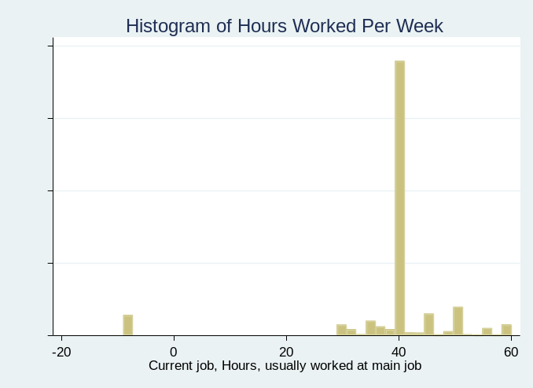
The histogram shows a lot of negative values which would be nonsensical for hours worked per week. It is not uncommon for statistical agencies to use negative values to indicate missing data. The best approach is to recode those values to missing. Doing so results in Stata omitting those observations in subsequent analyses. See the new histogram below after recoding negative values to missing.
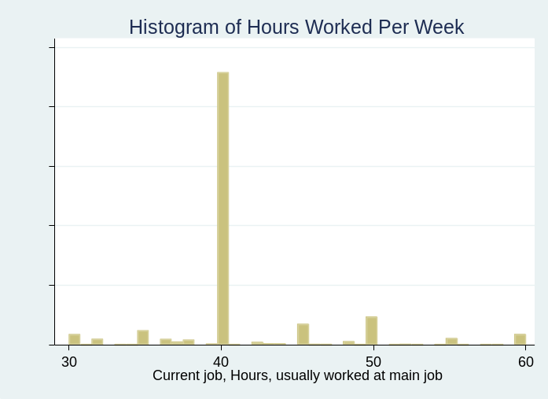
- The dataset contains a variable called earnings_pw which is the total earnings of an individual in a given week. However, hourly wages are often thought to be a better measure of economic status because wage comparisons aren't affected by differences in the number of hours worked per week. Construct a new variable called wages by dividing earnings_pw by hours_pw. The new variable wages now measures the hourly wage rate for individuals in the dataset. How many observations does this new variable have? Is that different from the total number of observations in the dataset? If so, why are they not the same? (4 points)
The new variable has 10,138 observations which is 513 fewer than in the full dataset. The 513 observations with missing values are the same cases that had negative values for hours worked per week that we changed to missing.
- What is the mean, min and max of hourly wages in the sample? What is the standard deviation of hourly wages? What is the median of hourly wages? (3 points)
Mean = $21.23
Min = $6.5
Max = $96.17
St dev = $12.43
Median = $17.67
- Let’s examine the gap in hourly wages between men and women. Begin by calculating the average wage of men and women in the sample.
Men wages average = $23.09
Women wages average = $19.14
  - What is the difference in the sample mean hourly wages between men and women?
$3.95, with men earning more
  - Conduct a t-test to test the null hypothesis that the average wages of men and women are equal. Report the results of this t-test and discuss your conclusion.
The $3.95 mean difference is highly statistically significant with a t-stat of over 16. We can confidently reject the null hypothesis of equal wages between men and women.
  - Now construct a 95% confidence interval separately for the mean hourly wages of men and women. Do these confidence intervals overlap?
Men: [22.73, 23.44]
Women: [18.82, 19.45]
No
- Produce a well-labelled scatterplot depicting the relationship between hourly wages and years of education. Do this and comment on the relationship between wages and years of education. Save your graph as a “PNG” or “TIFF” file and incorporate it into your problem set solutions. Please include a brief paragraph discussing the graph.
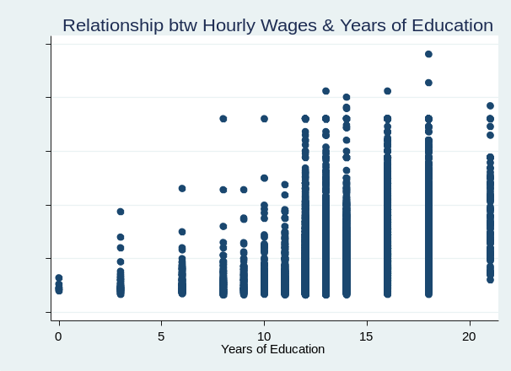
There is a clear positive correlation between hourly wages and years of education. People tend to earn more as they attain additional years of education. That said, there remains quite substantial variation of wages within each year of education.
- We can summarize this bivariate relationship further if we compute the average wage at each year of educational attainment and plot this average by years of education. To do so, use the following commands: (1) sort educ (2) by educ: egen mwage = mean(wage) (3) scatter mwage educ, title (“Scatterplot of Average Wages by Years of Education"). Note that egen is a special version of the generate command that allows you to calculate group averages and other types of statistics and retain these as part of your dataset. In this case, the egen command calculates the average wage by years of educational attainment. Once again comment on the relationship between years of education and average earnings. Also, once again save your graph as a “PNG” or “TIFF” file and incorporate it into your problem set. Please include a brief paragraph discussing the graph.
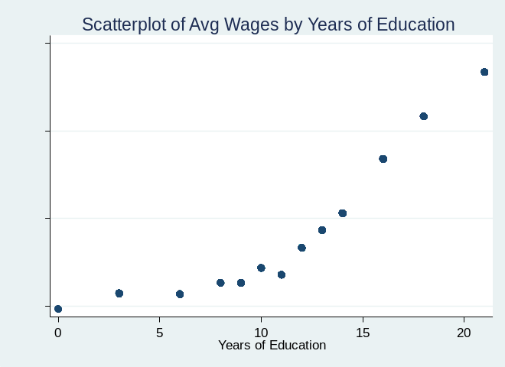
The same relationship we saw above exists with rising wages as years of education increases. This time, the relationship is much more obvious because we are plotting an average of the hourly wages for individuals with the same years of education.

