1/ Import Very Simple Ads

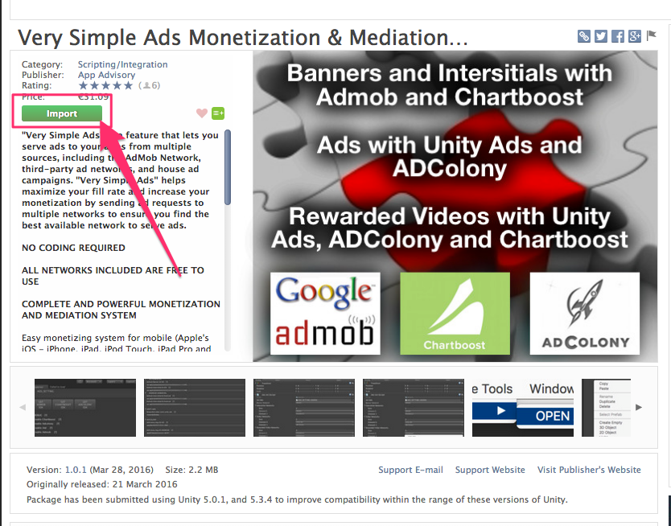

Then :

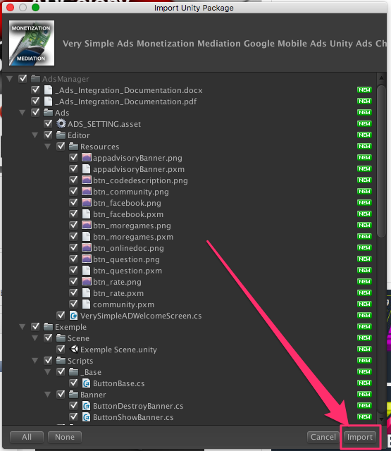

2/ Open the Ads Settings Editor :

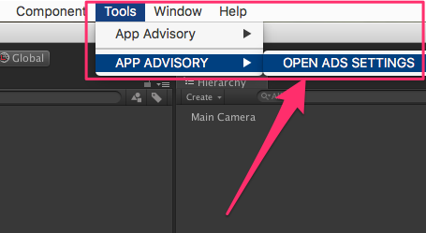

You should see :

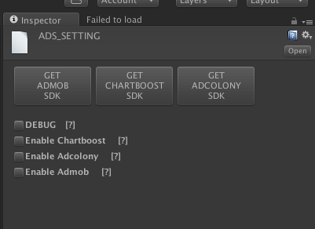

3/ Switch on a mobile platform :

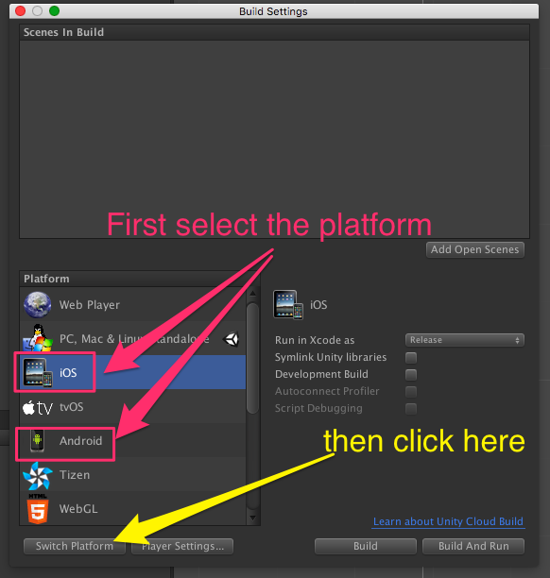

**ADMOB :**

1/ Get the SDK :

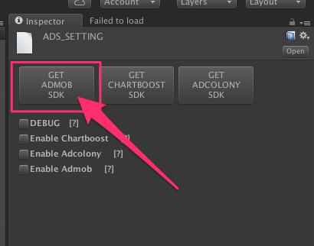

2/ Grab the last release :

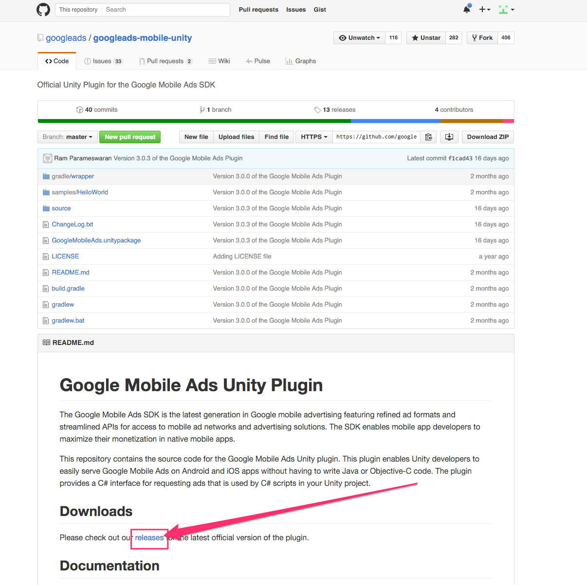

3/ And download the SDK

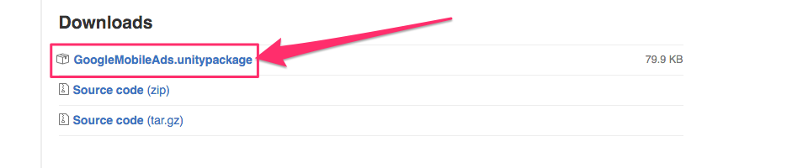

4/ Open the downloaded file (double click on it) and import it to your project :

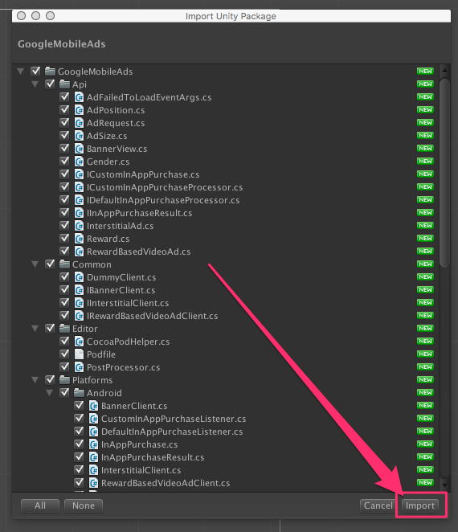

5/ Open th Ads Settings Editor again :



6/ Check the box to enable admob

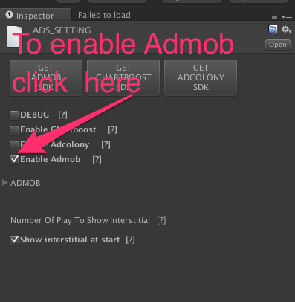

7/ Now you can enter your ids :

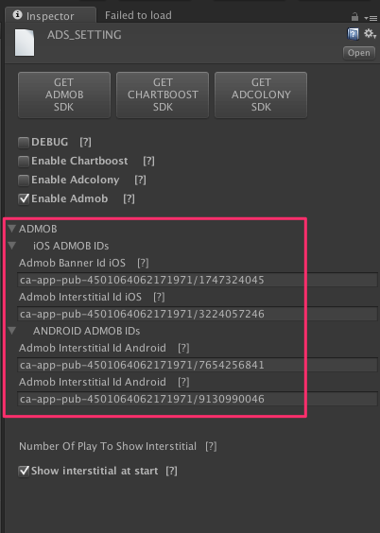

8/ You have to add the AdsInit to your scene now ! To do that :

* Right click on an empty space on the hierarchy (= not on a game object) :

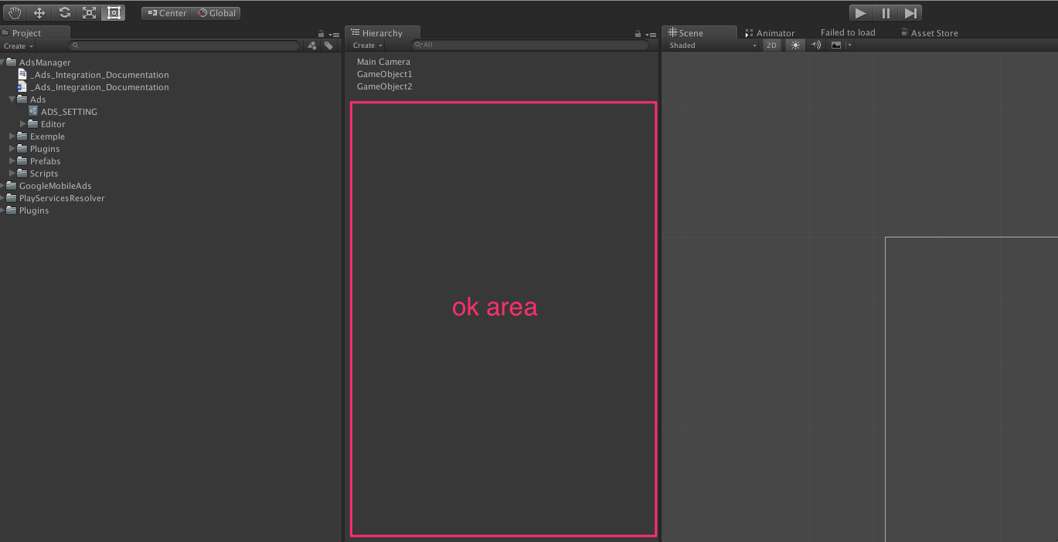

* And then select « CREATE AdsInit » :

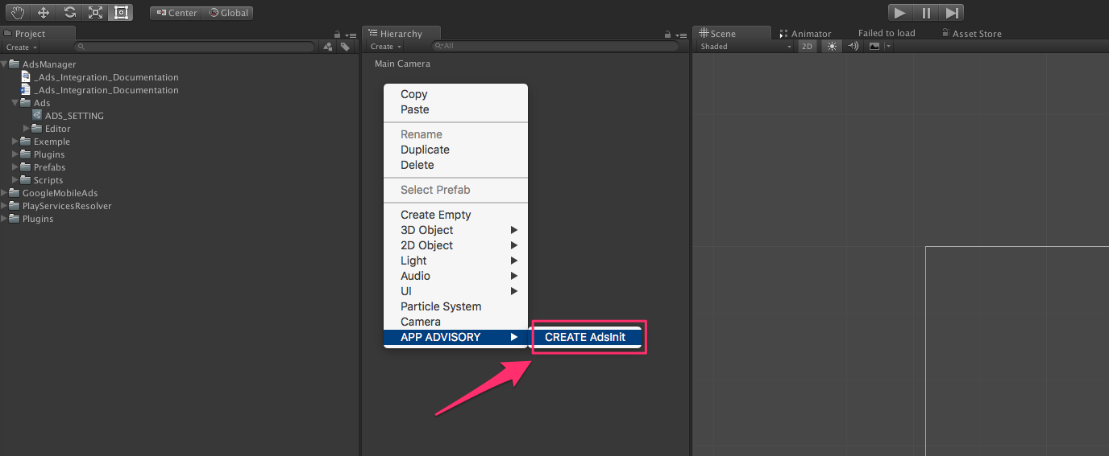

* And voilà !

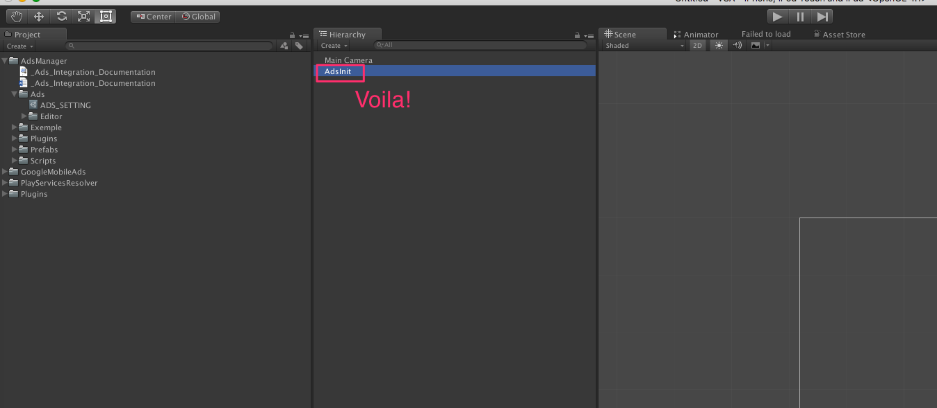

9/ Set banner, interstitial etc …

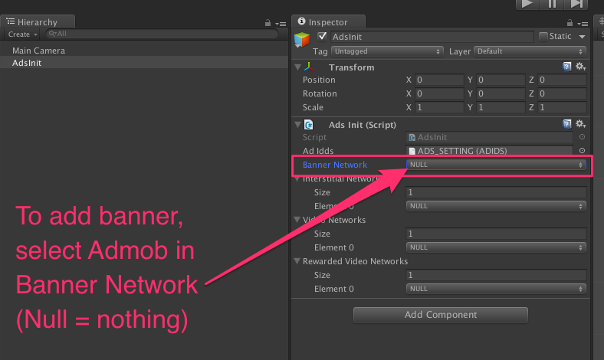

Like this :

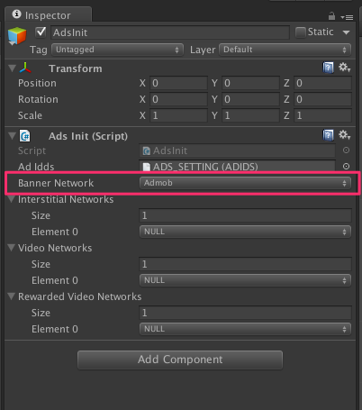

Same things for interstitial etc…

TO SHOW INTERSTITIAL :

Import AppAdvisory.ads :

../../../var/folders/3d/_68g_lwn0zb4d4rm9spylztm0000gn/T/com.skitch.skitch/DMD590DA4DE-5773-4C46-81CC-AE5E17692CD6/_Users_anthonybarouch_Desktop_VSA_Assets_AdsManager_Exemple_Scripts_Intertitial_ButtonShowInterstitial_cs_-_MonoDevelop-U

Call this method :

../../../var/folders/3d/_68g_lwn0zb4d4rm9spylztm0000gn/T/com.skitch.skitch/DMD22EF6B7F-49E9-4186-940A-72FF37FE89F7/_Users_anthonybarouch_Desktop_VSA_Assets_AdsManager_Exemple_Scripts_Intertitial_ButtonShowInterstitial_cs_-_MonoDevelop-U

TO SHOW REWARDED VIDEO :

Import AppAdvisory.ads :

../../../var/folders/3d/_68g_lwn0zb4d4rm9spylztm0000gn/T/com.skitch.skitch/DMD590DA4DE-5773-4C46-81CC-AE5E17692CD6/_Users_anthonybarouch_Desktop_VSA_Assets_AdsManager_Exemple_Scripts_Intertitial_ButtonShowInterstitial_cs_-_MonoDevelop-U

Call this method :

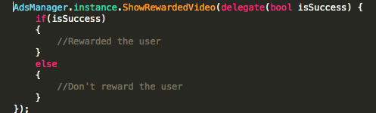

Or like this :

../../../var/folders/3d/_68g_lwn0zb4d4rm9spylztm0000gn/T/com.skitch.skitch/DMD0A1CBBA0-6391-40BC-A37A-114B2EE44A47/Assembly-CSharp_-_AdsManager_Exemple_Scripts_RewardedVideo_ButtonShowRewardedVideo_cs_-_MonoDevelop-U

