Gold Price Prediction using Fuzzy functions

Ayushka Nanda

Kalinga Institute of

Industrial Technology

Bachelor’s Degree In

Information Technology

Bhubaneswar,Odisha

22053502@kiit.ac.in

Aishwariya Mohanty

Kalinga Institute of

Industrial Technology

Bachelor’s Degree In

Information Technology

Bhubaneswar,Odisha

22053482@kiit.ac.in

Spandan Mohanty

Kalinga Institute of

Industrial Technology

Bachelor’s Degree In

Information Technology

Bhubaneswar,Odisha

22053471@kiit.ac.in

***Keywords— LSTM,Bi-LSTM,***

***Machine learning, Regression, Prediction,Fuzzy Functions, Gold prices.***

***Abstract-*The global gold market plays a crucial role in economic stability and investment diversification. This paper presents a hybrid approach to gold price prediction by integrating deep learning models — specifically Long Short-Term Memory (LSTM), Bidirectional LSTM (Bi-LSTM), and Linear Regression — with fuzzy logic techniques. The study aims to improve the accuracy of price predictions by accounting for the uncertainties and non-linearities in financial time series data. To achieve this, the researchers use fuzzy membership functions (Gaussian, Trapezoidal, Triangular, and Sigmoid) to preprocess and fuzzify input variables, enhancing the interpretability and adaptability of the predictive models. By comparing the performance of classical statistical methods with advanced deep learning and fuzzy-enhanced models, the study demonstrates that hybrid approaches significantly outperform traditional models, offering better accuracy and robustness for real-world forecasting.**

1. INTRODUCTION

The significance of gold within the global economy is multifaceted. Historically, gold has been used not only as a currency but also as a store of value and a hedge against economic downturns. Investors flock to gold in times of financial instability, which leads to complex market behaviors driven by factors beyond simple supply and demand.

Accurate gold price forecasting is thus of critical interest to financial analysts, investors, and policymakers. Traditional models such as linear regression and ARIMA have been used extensively in economic forecasting but are inherently limited

allowing models to learn complex, non-linear relationships.However, ANN models often required large datasets and were prone to over-fitting, especially when working with noisy financial data.

LSTM networks, a type of recurrent neural network (RNN), emerged as a leading solution for time series forecasting due to their ability to retain long-term dependencies and selectively filter relevant historical information.

Bi-LSTM networks further improved upon this by processing input data bidirectionally, capturing both past and future dependencies. Parallel to these advancements, fuzzy logic systems gained popularity in financial applications due to their robustness in dealing with imprecise, uncertain, or incomplete information.

Researchers have explored integrating fuzzy systems with machine learning models to enhance interpretability and reduce sensitivity to noise. This paper builds upon these foundations, proposing a comprehensive hybrid approach that leverages the strengths of both deep learning and fuzzy logic.

1. METHODOLOGY

The methodology section details the construction of the hybrid predictive system, which combines three core models with fuzzy preprocessing. The baseline **Linear Regression (LR)** model serves as a reference point, providing insight into the performance gap between classical and advanced methods.The **LSTM network** is selected for its proficiency in handling sequential data,

by their assumption of linear relationships and their difficulty in adapting to non-stationary, non-linear data.

This paper introduces a modern approach that integrates deep learning architectures, particularly LSTM and Bi-LSTM, which are capable of learning long-term dependencies and sequential patterns from historical data, with fuzzy logic systems that handle ambiguous, uncertain, or imprecise data inputs.

Fuzzy logic, inspired by human reasoning, allows systems to interpret information in degrees rather than binary true-false judgments, making it a powerful complement to machine learning models, especially in complex environments like financial markets.

The introduction frames the research challenge, outlines the importance of addressing non-linear dynamics and uncertainty in data, and positions the hybrid approach as a superior alternative to classical statistical forecasting models.

1. LITERATURE REVIEW

The literature review systematically examines prior studies in gold price forecasting, machine learning, and fuzzy systems integration. Early efforts relied heavily on econometric models such as ARIMA, GARCH, and linear regression, which could capture linear patterns and volatility clustering but struggled with non-linear dynamics and multivariate influences.

The introduction of machine learning approaches, particularly support vector machines (SVM), random forests, and artificial neural networks (ANN), represented a significant advancement,

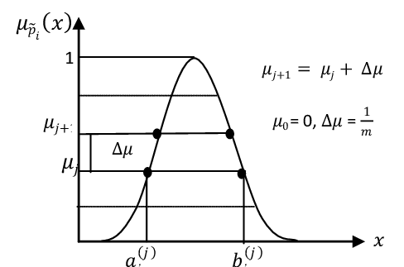

Fig 1. Gaussian Fuzzy number diagram

1. Trapezoidal: Flat-topped shapes capturing ranges of consistent membership.

In this study, the trapezoidal fuzzy number is employed to model uncertain input variables, defined mathematically by a membership function $μ_{\tilde{A}}\left(x\right)$ characterized by four parameters (a,b,c,d). The membership function increases linearly from zero to one between a and b, remains at unity between band c, and then decreases linearly from one to zero between c and d, as shown in equation (2).

${ μ}_{\tilde{A}}\left(x\right)=\left\{\begin{matrix}0 ,x<a \\ \frac{x−a}{b−a}, a≤x<b \\ \begin{matrix}1,b≤x≤c \\ \begin{matrix}\frac{d−x}{d−c}, c<x≤d \\ 0 ,x>d\end{matrix}\end{matrix}\end{matrix}\right.$ (2)

This structure allows the trapezoidal function to represent a range of values with full membership and gradual transitions at the boundaries, effectively capturing uncertainty and tolerance in the data.An additional benefit of the trapezoidal membership function is its interpretability, which allows domain experts to directly specify the parameters a, b, c, and d based on historical data, regulatory thresholds, or qualitative insights.

leveraging memory gates to manage long-term dependencies in historical price movements.

The **Bi-LSTM network** extends the LSTM framework by introducing bidirectional processing, enabling the model to simultaneously consider past and future context, which is particularly valuable in financial time series where forward-looking indicators and lagged effects co-exist. A central component of the methodology is the incorporation of fuzzy logic systems.

The paper employs four fuzzy membership functions:

1. Gaussian: Smooth bell-shaped curves, optimal for representing gradual transitions.

The Gaussian fuzzy number is utilized in this study to model input variables characterized by smooth and continuous uncertainty. Its membership function $μ_{\tilde{A}}\left(x\right)$ defined in equation (1), is controlled by a central mean mmm and a spread parameter $σ$, producing a bell-shaped curve symmetric around m.

$μ_{\tilde{A}}\left(x\right)= exp\left(−\frac{{\left(x−m\right)}^{2}}{2σ^{2}}\right)$ (1)

This formulation allows for a gradual and probabilistic interpretation of membership, providing a soft transition from full membership at the center to lower degrees as values deviate from mmm, making it especially effective for representing naturally occurring variations and measurement uncertainties.The Gaussian membership function is particularly well-suited for applications where uncertainties follow a normal distribution or where soft boundaries are preferred over abrupt transitions.

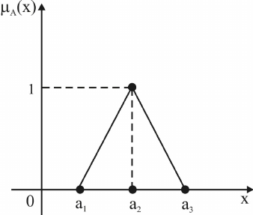

Fig 3.Triangular Fuzzy number diagram

4.Sigmoid: S-shaped curves for soft transitions near thresholds or boundaries. These membership functions are used to fuzzify input variables, transforming crisp numerical inputs (such as historical gold prices, oil prices, USD index, and inflation rates) into fuzzy variables.

This transformation enhances the model's ability to interpret ambiguous or noisy data. The hybrid architecture is trained and validated using historical datasets, with hyperparameter tuning conducted through grid search and performance evaluated via standard metrics.

The sigmoid fuzzy number is incorporated into this study as an alternative approach to modeling variables characterized by smooth, nonlinear transitions in their membership grades. Unlike linear or piecewise functions, the sigmoid function provides a continuous and differentiable curve, allowing gradual and asymptotic changes in membership values. The membership function for the sigmoid fuzzy set $\tilde{A}$ is mathematically defined in equation (4) as:

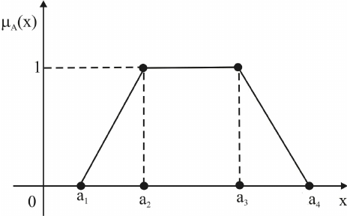

Fig 2. Trapezoidal Fuzzy number diagram

3.Triangular: Linear, peak-centered functions useful for modeling certainty around a specific value.

The triangular fuzzy number is employed in this research to model uncertain variables where the membership function can be defined by a single peak value and linear transitions on either side. This function offers a simple yet effective representation of uncertainty, especially when expert knowledge or empirical data suggests a most likely value surrounded by gradually less plausible outcomes. The membership function for a triangular fuzzy number $\tilde{A}$ is mathematically defined in equation (3) as:

${ μ}_{\tilde{A}}\left(x\right)= \left\{\begin{matrix}0,x<a \\ \begin{matrix}\frac{x−a}{b−a},a≤x<b \\ \frac{c−x}{c−b}, b≤x<c \\ 0,x≥c\end{matrix}\end{matrix}\right.$ (3)

where a,b,c are parameters representing the lower bound, the peak (mode), and the upper bound respectively, with $a≤b<c$ The membership function increases linearly from zero to one over the interval [a,b], reaches its maximum value of ${ μ}_{\tilde{A}}\left(b\right)=1 at x=b$ and then decreases linearly back to zero over the interval [b,c].Beyond a and c, the membership grade remains zero.

deep learning models.

The linear regression model is implemented using Scikit-learn, ensuring consistency in evaluation. Hyperparameters such as learning rate, batch size, number of layers, and number of neurons are optimized for the deep learning models.

Model evaluation is conducted using multiple metrics: RMSE assesses the average magnitude of prediction errors; MAE provides a straightforward average error magnitude; R² measures the proportion of variance explained by the model. To ensure generalizability, the models are tested on hold-out validation sets and cross-validated where applicable.Detailed implementation protocols are described training workflows, and parameter tuning strategies.

V.RESULTS

The results section presents an in-depth comparative analysis of the predictive models. The **Linear Regression** model, while simple and interpretable, underperforms on non-linear, volatile financial data, yielding high RMSE and MAE scores.

The **LSTM** model demonstrates marked improvement, effectively capturing time-dependent patterns and reducing prediction errors.The evaluation results identified the optimal fuzzy membership function for each predictive model, as summarized in Table 1.

$${ μ}_{\tilde{A}}\left(x\right)=\frac{1}{1+e^{−α(x−c)}} (4)$$

where α is a slope parameter controlling the steepness of the curve, and c is the center or inflection point of the function. The parameter α determines the rate at which the membership function transitions from low to high values; higher values of α result in steeper transitions, while lower values produce a smoother gradient.

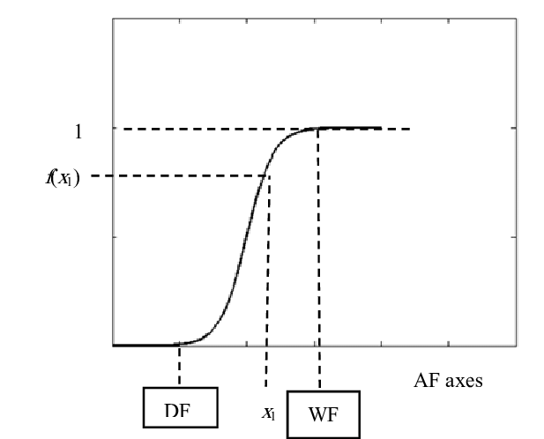

Fig 4.Sigmoid Fuzzy number diagram

IV.IMPLEMENTATION

The implementation phase covers the complete pipeline, beginning with data acquisition and preprocessing. Historical gold price data are sourced from reputable financial databases, along with complementary economic indicators like crude oil prices, the U.S. dollar index, and inflation rates.

Data preprocessing involves cleaning (removing anomalies, handling missing values), normalization (scaling values to a uniform range), and fuzzification using the aforementioned membership functions. For model training, the study utilizes Python-based frameworks such as TensorFlow and Keras, whichprovide robust tools for constructing and tuning

The fuzzy functions are incorporated into the model to represent ambiguous features and enhance its predictive performance. Evaluation metrics such as R-squared (R²), Mean Squared Error (MSE), and Root Mean Squared Error (RMSE) are used to assess the model’s performance with the fuzzy functions compared to a non-fuzzy version of the model.

|  |  |
| --- | --- |
| **Fuzzy Function** | **MSE** |
| Gaussian | 0.001271 |
| Triangular | 0.001476 |
| Sigmoid | 0.001325 |
| Trapezoidal | 0.003247 |

TABLE 3..Gold price results for Linear Regression model

After analyzing the results of the fuzzy functions presented in Table 3, it was found that the ‘Gaussian’ produced the most accurate results within the linear regression model. This fuzzy function achieved the lowest MSE and the highest R² value, indicating its superior performance in capturing the relationships between the input features and the target variable. Compared to the other fuzzy functions, it provided the most reliable predictions, effectively improving the model’s predictive capabilities.

Following the presentation of the LSTM,Bi-LSTM and Linear Regression model’s prediction results, Table 2 illustrates the corresponding average gold prices for the current day, the 3-day moving average, and the 5-day moving average, providing a comparative perspective on short-term price trends used in the forecasting process.

|  |  |  |
| --- | --- | --- |
| **Today's Price** | **3-Day Average** | **5-Day Average** |
| $2062.4 | $2072.73 | $2066.7 |

TABLE 4.Result of Average prices

|  |  |
| --- | --- |
| **Fuzzy Function** | **MSE** |
| Gaussian | 0.002024 |
| Triangular | 0.001942 |
| Sigmoid | 0.001881 |
| Trapezoidal | 0.004382 |

TABLE 1.Gold price results for LSTM model

Based on the evaluation results, the ‘Sigmoid’ fuzzy membership function was identified as the best-performing function for the LSTM model, achieving superior predictive accuracy compared to the other fuzzy membership functions tested.

The **Bi-LSTM** model achieves the best results, outperforming both LR and unidirectional LSTM due to its enhanced contextual understanding.The incorporation of fuzzy membership functions further improves performance across all models.Subsequently, the results from the Bi-LSTM model are presented, where the sigmoid fuzzy membership function yielded the best predictive performance, demonstrating superior accuracy compared to other membership functions.

|  |  |
| --- | --- |
| **Fuzzy Function** | **MSE** |
| Gaussian | 0.001585 |
| Triangular | 0.001509 |
| Sigmoid | 0.001629 |
| Trapezoidal | 0.003597 |

TABLE 2.Gold price results for Bi-LSTM model

Based on the evaluation results, the ‘Triangular’ fuzzy membership function was identified as the best-performing function for the Bi-LSTM model, achieving superior predictive accuracy compared to the other fuzzy membership functions tested.

The linear regression model is applied to predict the target variable with the integration of fuzzy functions to handle uncertainty and imprecision in the data

moving averages are calculated by averaging predicted values across respective window sizes, aiding in trend detection and short-term volatility mitigation. This approach provides a clearer understanding of underlying trends and supports more stable forecasting by leveraging complementary strengths of each model architecture.

Additionally, the paper discusses the practical implications of the findings, noting the potential application of the hybrid approach to other commodities and financial forecasting problems.

VI.CONCLUSION

This study presents a comprehensive and innovative approach to gold price forecasting by integrating deep learning and fuzzy logic systems. By combining the sequential learning capabilities of LSTM,Bi-LSTM and Linear Regression networks with the uncertainty-handling strengths of fuzzy logic, the hybrid models achieve superior predictive accuracy compared to traditional linear methods. The use of Gaussian, Trapezoidal, Triangular, and Sigmoid membership functions enhances the models' ability to process imprecise and noisy input data, providing robust and adaptable forecasting tools. The results underscore the importance of hybrid modeling strategies in financial applications, where volatility and non-linear interactions pose significant challenges.Beyond gold price prediction, the proposed framework offers a generalizable approach that can be applied to other financial assets,commodities, and time series problems characterized by

Specifically, models employing Gaussian and Sigmoid membership functions show superior resilience against noise, while Trapezoidal and Triangular functions offer strong performance when the input variables exhibit stable, well-defined ranges. Quantitative results highlight the significant reduction in prediction errors and the increase in R² scores for the fuzzy-enhanced Bi-LSTM model, confirming the value of combining deep learning with fuzzy logic preprocessing.

Visualizations, including prediction plots, error distributions, and comparative tables, provide comprehensive evidence of model performance.

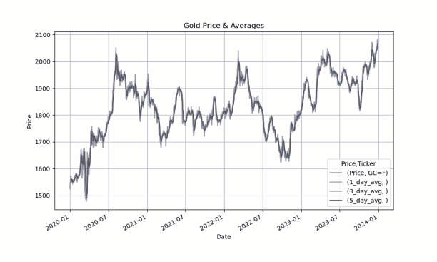

Fig 5.Gold price chart with moving averages

This graph illustrates the performance of moving average values derived from multiple forecasting models, namely Long Short-Term Memory (LSTM), Bidirectional LSTM (Bi-LSTM), and Linear Regression, applied to historical gold price data (GC=F).The plot demonstrates the original gold price time series alongside the 1-day, 3-day, and 5-day moving average predictions. These averages represent ensemble smoothing techniques where the outputs from the aforementioned models are averaged to enhance robustness and reduce noise.

Specifically, the present-day value denotes the immediate output average across models. The 3-day and 5-day

.

uncertainty and complexity. Future research directions include expanding the hybrid system to incorporate additional fuzzy rule-based inference mechanisms, exploring attention-based neural architectures, and testing the framework across diverse market conditions and asset classes.

Ultimately, this research contributes valuable insights to the field of financial forecasting, offering a flexible and powerful toolkit for navigating the complexities of dynamic global markets.

References

[1] S. Hochreiter and J. Schmidhuber, “Long Short-Term Memory,” Neural Computation, vol. 9, no. 8, pp. 1735–1780, 1997.

[2] L. Breiman, “Random Forests,” Machine Learning, vol. 45, no. 1, pp. 5–32, 2001.

[3] F. Chollet, Deep Learning with Python, 2nd ed., Manning Publications, 2021.

[4] Scikit-learn documentation: https://scikit-learn.org

[5] TensorFlow documentation: https://www.tensorflow.org